MINI PROJECT REPORT
on
BANK ACCOUNT MANAGEMENT SYSTEM
using Object Oriented Programming in C++
Submitted in partial fulfilment of the requirements of the course
[Object Oriented Programming using C++ / Course Code]
Submitted by
Student Name | : Kavish
UID / Roll No. | : 25bcd10107
Programme / Branch | : BCA Data Science
Section / Group | : 25BCD 2B
Semester | : 3RD
Under the guidance of | : Mr. Jitendra Kumar

University Institute of Engineering / Computing
Chandigarh University, Gharuan, Mohali, Punjab

CERTIFICATE
This is to certify that the mini project report entitled “Bank Account Management System using Object Oriented Programming in C++” is a bonafide work carried out by Kavish (UID: 25bcd10107, a student of BCA Data Science, Chandigarh University.

______________________
Project Guide
Jitendra Kumar
DECLARATION
I, Kavish, hereby declare that this mini project report titled “Bank Account Management System using Object Oriented Programming in C++” is my original work. Wherever the work of others has been used, it has been acknowledged in the references, and this work has not been submitted to any other institution for any degree or diploma.
Signature: _____________kavish_________
Kavish (UID: 25BCD10107)
Date: 29/09/2026
ACKNOWLEDGEMENT
I sincerely thank my project guide, Jitendra kumar, for the guidance and encouragement given throughout this mini project, and the Head of the Department and faculty members for providing the laboratory facilities. I also thank Chandigarh University for the opportunity to connect classroom theory with a practical project, and my family and friends for their support.
Kavish
ABSTRACT
This mini project presents a console-based Bank Account Management System written in C++ to demonstrate the principles of Object Oriented Programming. An abstract base class Account defines the common data and behaviour, while SavingsAccount and CurrentAccount inherit from it and override the rules for withdrawal and month-end processing. A Bank class manages the accounts and supports opening and closing accounts, deposits, withdrawals, transfers, statements, interest and fees. Errors are reported through a custom exception hierarchy, and data is stored in a text file.
The project demonstrates classes and objects, encapsulation, abstraction, inheritance, polymorphism, static members, friend functions, operator overloading, templates, exception handling, STL and file handling. It compiles without warnings under C++17, and all twelve test cases gave the expected results.
Keywords: OOP, C++, Inheritance, Polymorphism, Encapsulation, Abstraction, Banking
TABLE OF CONTENTS
Chapter 1: Introduction 5
1.1 Background 5
1.2 Problem Statement 5
1.3 Objectives 5
1.4 Scope 5
Chapter 2: OOP Concepts Used 5
Chapter 3: Requirements 6
3.1 Functional Requirements 6
3.2 Business Rules 6
3.3 Software Requirements 6
Chapter 4: System Design 7
4.1 Architecture 7
4.2 Class Diagram 7
4.3 Data File Format 8
Chapter 5: Implementation 8
Chapter 6: Testing and Output 10
6.1 Test Cases 10
6.2 Output Screenshots 10
Chapter 7: Conclusion and Future Scope 13
References 13
Appendix A: Complete Source Code 14

Chapter 1: Introduction

1.1 Background
Object Oriented Programming (OOP) organises a program around objects that combine data and the functions that operate on it. Because objects mirror real-world things such as a student or a bank account, OOP programs are easier to understand, test and extend than purely procedural ones. Banking is an ideal domain for learning OOP: it has clear entities (accounts, transactions), strict rules (minimum balance, overdraft) and different account types that share most features but differ in their rules – exactly what inheritance and polymorphism are designed for.

1.2 Problem Statement
Procedural banking programs keep balances in global variables that any function can change, and every new account type means editing many functions. This project builds a small banking system where account data is protected, new account types can be added without changing existing code, and errors are handled in a controlled way.

1.3 Objectives
- Apply the core principles of OOP (encapsulation, abstraction, inheritance, polymorphism) in C++.
- Implement deposit, withdrawal, transfer, statements, interest and fees, with the banking rules enforced inside the classes.
- Handle errors with custom exceptions and store data permanently using file handling.

1.4 Scope
The system is a single-user console application with Savings and Current accounts, automatic account numbers, a transaction history per account and file-based storage. Graphical interfaces, networking, security and databases are left as future work.

Chapter 2: OOP Concepts Used
Class and object. A class is a blueprint that declares data members and member functions; an object is an instance of it. A constructor initialises an object and a destructor cleans up when it is destroyed.
Encapsulation. Data and the functions that use it are wrapped together, and access is restricted with private, protected and public. The balance can only be changed through deposit() and withdraw(), so the rules can never be bypassed.
Abstraction. Only essential features are exposed. An abstract class has at least one pure virtual function (= 0), cannot be instantiated and defines a contract that derived classes must fulfil.
Inheritance. A derived class acquires the members of a base class (an “is-a” relationship), which promotes reuse. This project uses hierarchical inheritance: SavingsAccount and CurrentAccount both derive from Account.
Polymorphism. Compile-time polymorphism (overloading, templates) is resolved by the compiler; run-time polymorphism uses virtual functions so that the version called depends on the real type of the object. Bank calls withdraw() through an Account pointer and the correct account type responds.
Other features: static members (shared account counters), friend functions (output operator <<), operator overloading (+=, <), function templates (readValue<T>), exception handling (try/throw/catch), STL containers with smart pointers (vector<unique_ptr<Account>>) and file handling (ifstream/ofstream).

Chapter 3: Requirements

3.1 Functional Requirements
Table 3.1: Functional requirements
ID | Requirement | Description
FR1 | Open / close account | Create a Savings or Current account with a unique automatic number; remove an account.
FR2 | Deposit / withdraw | Add or remove money subject to the rules of the account type.
FR3 | Transfer | Move money between two accounts, rolling back if it cannot be completed.
FR4 | View details / statement | Show account details and the full transaction history.
FR5 | List accounts | Show all accounts sorted by balance (highest first).
FR6 | Month-end processing | Credit interest to savings accounts; debit the fee from current accounts.
FR7 | Persistence | Save accounts to a file on exit and reload them at start-up.

3.2 Business Rules
Table 3.2: Rules enforced by each account class
Rule | Savings Account | Current Account
Minimum balance | Rs. 500 (also minimum opening deposit) | None
Overdraft limit | Not allowed | Rs. 10,000
Maximum per withdrawal | Rs. 50,000 | No limit
Month-end action | Interest at 4% p.a. (balance × 4 / 100 / 12) | Maintenance fee of Rs. 100

3.3 Software Requirements
Any operating system (Windows, Linux or macOS), a C++17 compiler such as GNU g++ 9 or later, and a text editor or IDE (Code::Blocks, VS Code or Dev-C++). Only the standard library is used.

Chapter 4: System Design

4.1 Architecture
The user works through a console menu in main(). Input helpers validate every value and pass requests to the Bank object, which finds the target Account and calls its member functions. Rule violations are reported as exceptions, and accounts are stored in a text file (Figure 4.1).
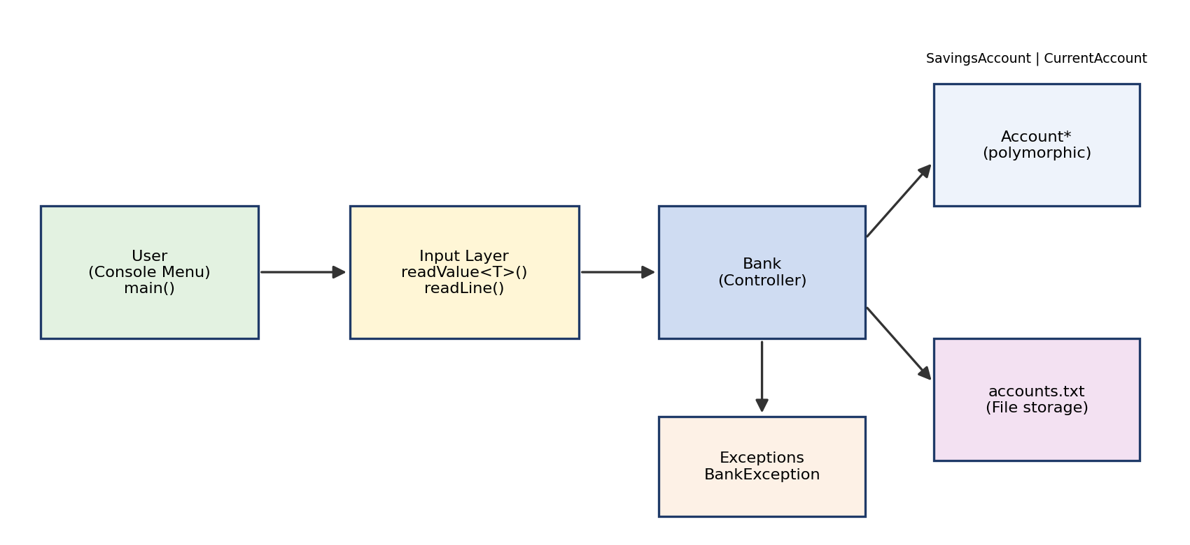
Figure 4.1: Layered architecture of the system

4.2 Class Diagram
Account is an abstract class with three pure virtual functions. SavingsAccount and CurrentAccount inherit from it, and Bank owns a collection of accounts (composition). The exception classes derive from std::runtime_error (Figure 4.2).
Table 4.1: Classes and responsibilities
Class | Responsibility
Account (abstract) | Holds account number, holder, balance and history; provides deposit(), statements and operators; declares getType(), withdraw(), monthEnd() as pure virtual.
SavingsAccount | Enforces minimum balance and per-withdrawal limit; credits monthly interest.
CurrentAccount | Allows overdraft up to Rs. 10,000; debits the monthly maintenance fee.
Bank | Owns all accounts; opens, closes and finds them; transfers money; lists, saves and loads accounts.
BankException and subclasses | InvalidAmount, InsufficientFunds and AccountNotFound exceptions for clear error reporting.

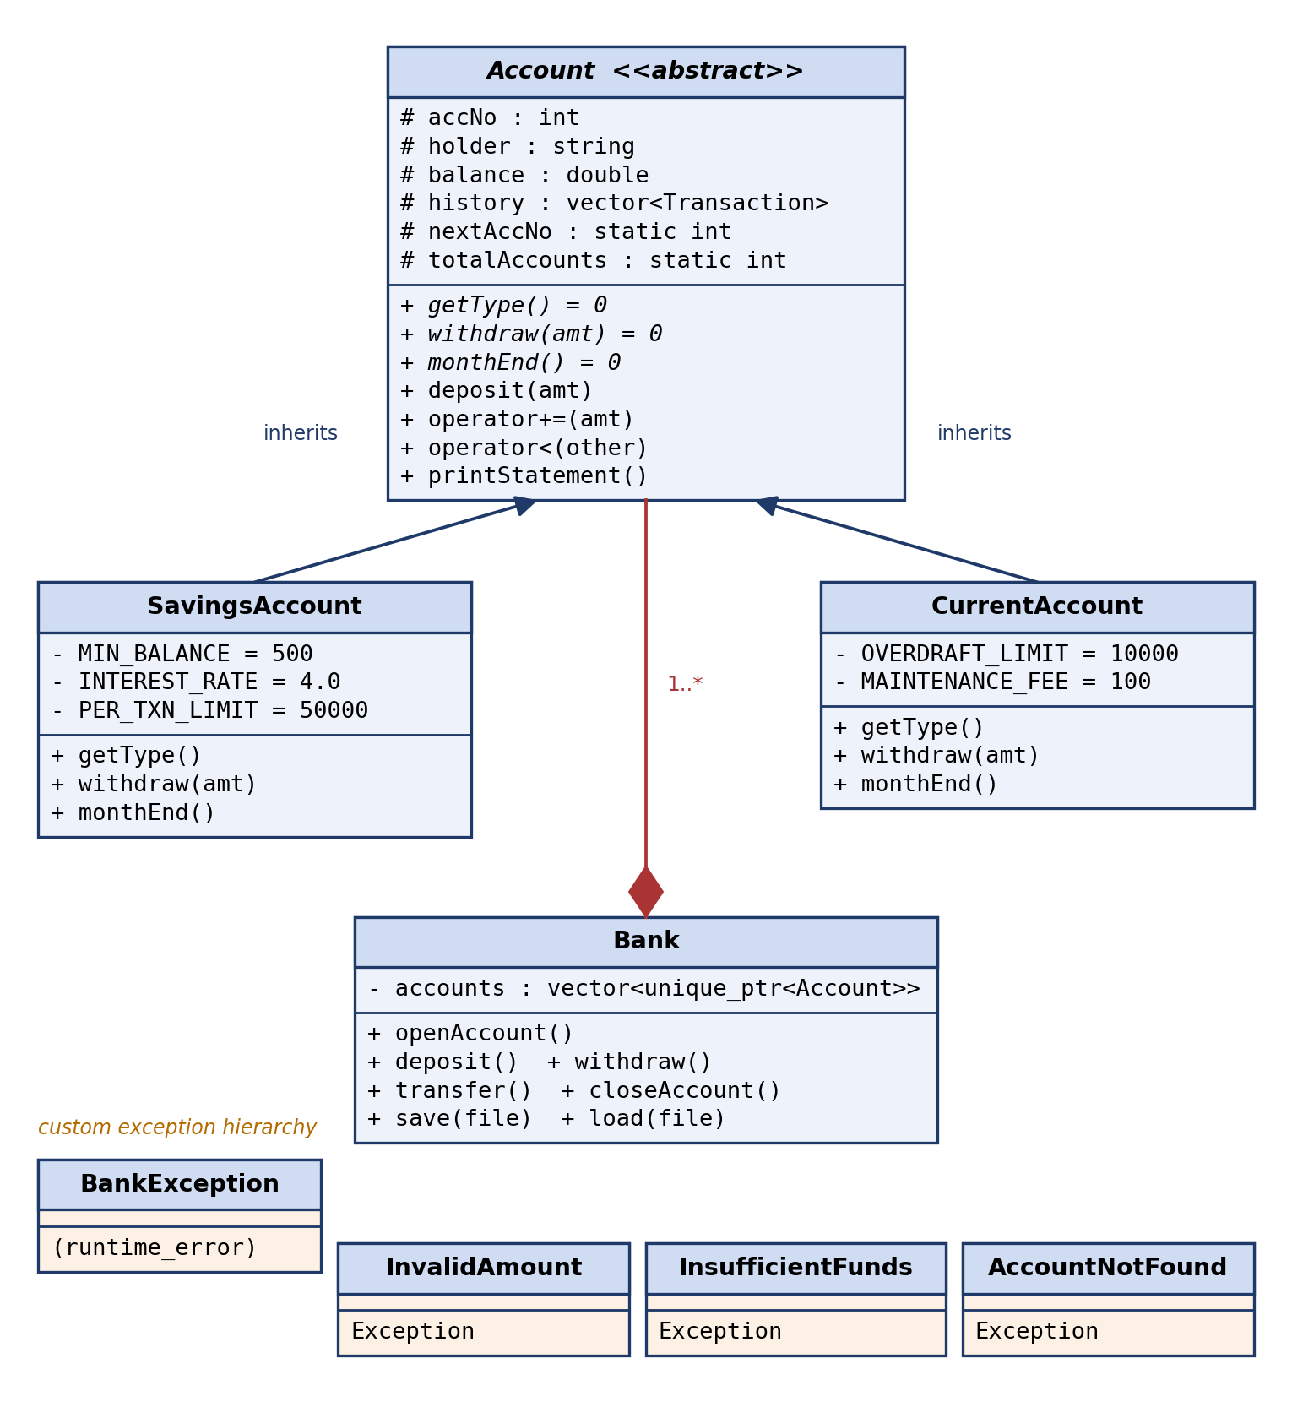
Figure 4.2: Class diagram of the Bank Account System

4.3 Data File Format
Accounts are saved in accounts.txt, one per line, as type|number|holder|balance:
Savings|1001|Aman Singh|5518.33
Current|1002|Riya Sharma|-8600.00

Chapter 5: Implementation
The program is written in standard C++17 in one file, bank_system.cpp (about 430 lines), and compiled with g++ -std=c++17 -Wall -Wextra -o bank bank_system.cpp without warnings. The key parts are shown below; the full listing is in Appendix A.

Abstraction, encapsulation and static members
class Account { // abstract class
protected:
int accNo; string holder; double balance;
vector<Transaction> history;
static int nextAccNo; // shared by all objects
static int totalAccounts;
public:
virtual string getType() const = 0; // pure virtual
virtual void withdraw(double amt) = 0;
virtual void monthEnd() = 0;
void deposit(double amt);
virtual ~Account() { --totalAccounts; }
};

Inheritance and overriding
class SavingsAccount : public Account {
public:
void withdraw(double amt) override {
if (amt <= 0) throw InvalidAmountException();
if (balance - amt < MIN_BALANCE)
throw InsufficientFundsException("...minimum balance...");
balance -= amt; record("Withdrawal", amt);
}
void monthEnd() override { // interest
double interest = balance * INTEREST_RATE / 100.0 / 12.0;
balance += interest; record("Interest Credit", interest);
}
};

Polymorphism, operator overloading and smart pointers
vector<unique_ptr<Account>> accounts; // owned by Bank

void Bank::withdraw(int no, double amt) { find(no).withdraw(amt); }
void Bank::applyMonthEnd() { for (auto& a : accounts) a->monthEnd(); }

Account& operator+=(double amt) { deposit(amt); return *this; }
bool operator<(const Account& o) const { return balance < o.balance; }
friend ostream& operator<<(ostream& os, const Account& a);

The Bank class never checks the account type: the virtual call selects savings or current rules automatically.

Exception handling and templates
template <typename T>
T readValue(const string& prompt) { // int, double, char
T v;
while (true) {
cout << prompt;
if (cin >> v) { cin.ignore(1000, '\n'); return v; }
cin.clear(); cin.ignore(1000, '\n');
cout << "Invalid input, please try again.\n";
}
}

try { ... }
catch (const BankException& e) { cout << "Error: " << e.what() << endl; }

Chapter 6: Testing and Output

6.1 Test Cases
Table 6.1: Test cases and results
ID | Test | Input | Expected result | Result
TC01 | Open savings account | S, Aman Singh, 5000 | Account 1001 created | Pass
TC02 | Savings below minimum opening | S, Test User, 100 | Error: minimum opening balance Rs. 500 | Pass
TC03 | Unknown account type | X, A, 500 | Error: unknown account type | Pass
TC04 | Valid deposit | 1001, 1500 | Balance 6500.00 | Pass
TC05 | Negative deposit | 1001, -50 | Error: amount must be greater than zero | Pass
TC06 | Savings rule violation | 1001, 10000 (or over 50,000) | Error: minimum balance / limit | Pass
TC07 | Current within / beyond overdraft | 1002, 11500 then 5000 | First succeeds (-9500); second: overdraft error | Pass
TC08 | Valid transfer | 1001 → 1002, 1000 | 1001: 5500.00; 1002: -8500.00 | Pass
TC09 | Transfer to same / missing account | 1001 → 1001; 1001 → 5555 | Error; balances unchanged | Pass
TC10 | Month-end processing | Option 8 | 1001: +18.33 interest; 1002: -Rs. 100 fee | Pass
TC11 | Text in numeric field | abc | “Invalid input” and re-prompt | Pass
TC12 | Persistence | Save & exit, run again | Accounts reloaded | Pass

6.2 Output Screenshots
The following screenshots were captured from actual runs of the program in a terminal. In Figures 6.2 onwards, the repeated main menu has been left out of the capture to save space.
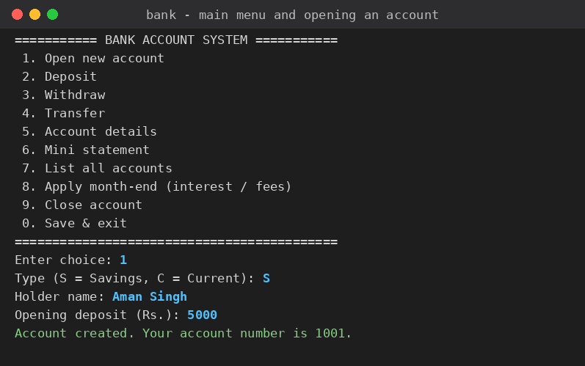
Figure 6.1: Main menu and opening a Savings account
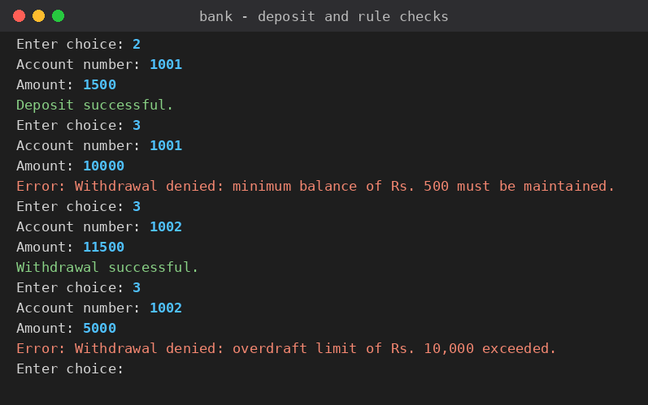
Figure 6.2: Deposit, minimum-balance rule and overdraft rule
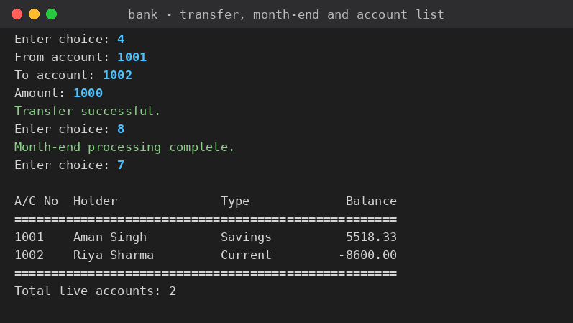
Figure 6.3: Transfer, month-end processing and account list
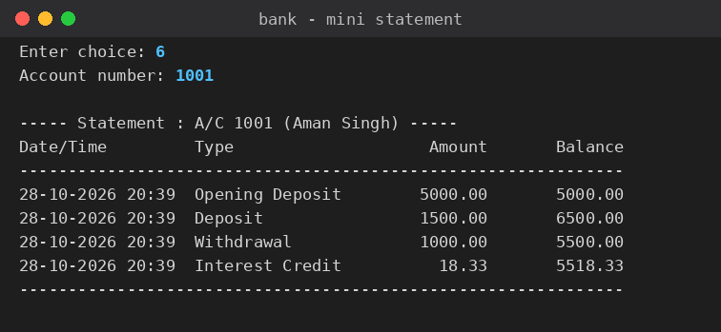
Figure 6.4: Mini statement of account 1001
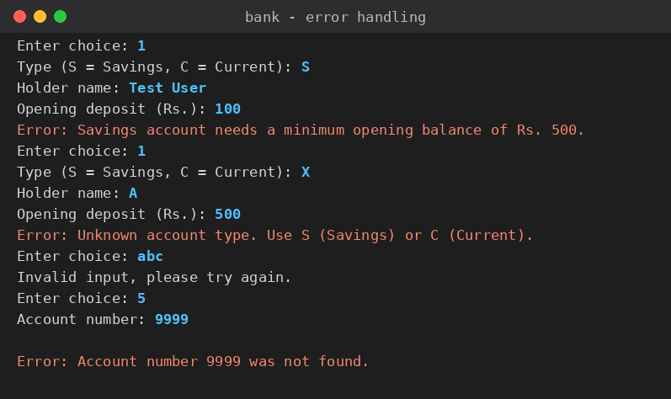
Figure 6.5: Error handling (invalid amount, unknown type, bad input, missing account)
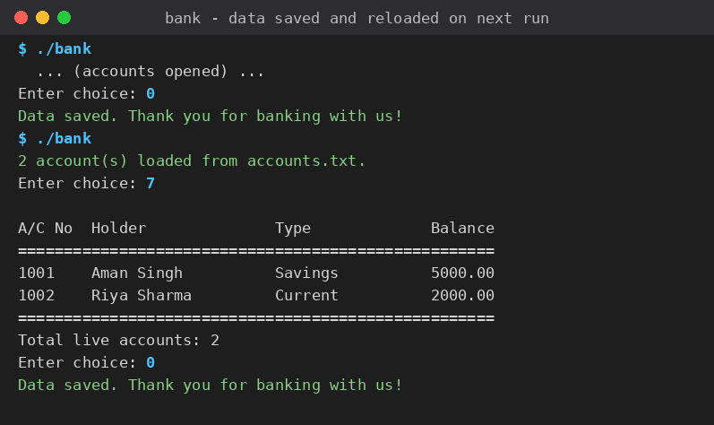
Figure 6.6: Data saved on exit and reloaded on the next run

Chapter 7: Conclusion and Future Scope
The project showed how OOP principles build a clean and extensible banking application. Data and rules are kept together in the account classes (encapsulation), the common interface is defined once in an abstract class (abstraction), savings and current accounts reuse it (inheritance), and Bank treats all accounts uniformly while each behaves according to its type (polymorphism). Templates, exceptions, smart pointers and file handling made the program robust, and all twelve test cases passed.
Limitations: single-user console program; transaction history is not saved to the file; no passwords; money is held in double. Future scope:
- Add a Customer class (one customer, many accounts) and more account types such as Fixed Deposit.
- Store data in a database, add login/PIN security, and build a graphical or web front end.
- Add unit tests (for example with Google Test) and loan or ATM modules.

References
[1] Stroustrup, B. (2013). The C++ Programming Language (4th ed.). Addison-Wesley.
[2] Balagurusamy, E. (2020). Object-Oriented Programming with C++ (8th ed.). McGraw Hill Education.
[3] Lafore, R. (2002). Object-Oriented Programming in C++ (4th ed.). Sams Publishing.
[4] Schildt, H. (2003). C++: The Complete Reference (4th ed.). McGraw-Hill.
[5] cppreference.com. C++ reference documentation. https://en.cppreference.com

Appendix A: Complete Source Code
File: bank_system.cpp (compile with g++ -std=c++17 -o bank bank_system.cpp)
/*
* ============================================================
* BANK ACCOUNT MANAGEMENT SYSTEM (Object Oriented Programming in C++)
* Mini Project - Chandigarh University
* ------------------------------------------------------------
* OOP concepts demonstrated:
* 1. Classes & Objects 6. Static members
* 2. Encapsulation 7. Friend function
* 3. Abstraction (abstract cls) 8. Operator overloading
* 4. Inheritance 9. Exception handling (custom)
* 5. Polymorphism (virtual) 10. Templates, STL, smart pointers,
* File handling
* ============================================================
*/
#include <iostream>
#include <iomanip>
#include <vector>
#include <memory>
#include <string>
#include <fstream>
#include <sstream>
#include <ctime>
#include <stdexcept>
#include <algorithm>
#include <limits>

using namespace std;

// ---------------------------------------------------------------
// Utility
// ---------------------------------------------------------------
string currentTime() {
time_t now = time(nullptr);
char buf[32];
strftime(buf, sizeof(buf), "%d-%m-%Y %H:%M", localtime(&now));
return string(buf);
}

// ---------------------------------------------------------------
// Custom exception hierarchy
// ---------------------------------------------------------------
class BankException : public runtime_error {
public:
explicit BankException(const string& msg) : runtime_error(msg) {}
};

class InvalidAmountException : public BankException {
public:
InvalidAmountException() : BankException("Amount must be greater than zero.") {}
};

class InsufficientFundsException : public BankException {
public:
explicit InsufficientFundsException(const string& msg) : BankException(msg) {}
};

class AccountNotFoundException : public BankException {
public:
explicit AccountNotFoundException(int no)
: BankException("Account number " + to_string(no) + " was not found.") {}
};

// ---------------------------------------------------------------
// Transaction record
// ---------------------------------------------------------------
struct Transaction {
string type;
double amount;
double balanceAfter;
string timestamp;
};

// Tag used to pick the "restore from file" constructors
struct RestoreTag {};

// ---------------------------------------------------------------
// Abstract base class : Account
// ---------------------------------------------------------------
class Account {
protected:
int accNo;
string holder;
double balance;
vector<Transaction> history;

static int nextAccNo; // shared by all accounts
static int totalAccounts; // live account counter

void record(const string& type, double amt) {
history.push_back({type, amt, balance, currentTime()});
}

public:
// Constructor for a brand-new account
Account(const string& name, double initial)
: accNo(nextAccNo++), holder(name), balance(initial) {
++totalAccounts;
if (initial > 0) record("Opening Deposit", initial);
}

// Constructor used while loading from file
Account(int no, const string& name, double bal, RestoreTag)
: accNo(no), holder(name), balance(bal) {
++totalAccounts;
if (no >= nextAccNo) nextAccNo = no + 1;
record("Balance Restored", bal);
}

virtual ~Account() { --totalAccounts; }

// ---- pure virtual functions make Account abstract ----
virtual string getType() const = 0;
virtual void withdraw(double amt) = 0;
virtual void monthEnd() = 0;

// ---- common behaviour ----
void deposit(double amt) {
if (amt <= 0) throw InvalidAmountException();
balance += amt;
record("Deposit", amt);
}

// Getters (encapsulation: data is read-only from outside)
int getAccNo() const { return accNo; }
const string& getHolder() const { return holder; }
double getBalance() const { return balance; }
const vector<Transaction>& getHistory() const { return history; }
static int getTotalAccounts() { return totalAccounts; }

// Operator overloading
Account& operator+=(double amt) { deposit(amt); return *this; }
bool operator<(const Account& other) const { return balance < other.balance; }

friend ostream& operator<<(ostream& os, const Account& a);

string serialize() const {
string safe = holder;
replace(safe.begin(), safe.end(), '|', ' ');
ostringstream ss;
ss << getType() << '|' << accNo << '|' << safe << '|' << fixed << setprecision(2) << balance;
return ss.str();
}

void printStatement() const {
cout << "\n----- Statement : A/C " << accNo << " (" << holder << ") -----\n";
cout << left << setw(18) << "Date/Time" << setw(18) << "Type"
<< right << setw(12) << "Amount" << setw(14) << "Balance" << "\n";
cout << string(62, '-') << "\n";
for (const auto& t : history) {
cout << left << setw(18) << t.timestamp << setw(18) << t.type
<< right << setw(12) << fixed << setprecision(2) << t.amount
<< setw(14) << t.balanceAfter << "\n";
}
cout << string(62, '-') << "\n";
}
};

int Account::nextAccNo = 1001;
int Account::totalAccounts = 0;

// Friend function: accesses protected data directly
ostream& operator<<(ostream& os, const Account& a) {
os << left << setw(8) << a.accNo << setw(20) << a.holder << setw(10) << a.getType()
<< right << setw(14) << fixed << setprecision(2) << a.balance;
return os;
}

// ---------------------------------------------------------------
// Derived class 1 : SavingsAccount
// ---------------------------------------------------------------
class SavingsAccount : public Account {
static constexpr double MIN_BALANCE = 500.0;
static constexpr double INTEREST_RATE = 4.0; // % per annum
static constexpr double PER_TXN_LIMIT = 50000.0;

static double validate(double initial) {
if (initial < MIN_BALANCE)
throw InsufficientFundsException("Savings account needs a minimum opening balance of Rs. 500.");
return initial;
}

public:
SavingsAccount(const string& name, double initial) : Account(name, validate(initial)) {}
SavingsAccount(int no, const string& name, double bal, RestoreTag t) : Account(no, name, bal, t) {}

string getType() const override { return "Savings"; }

void withdraw(double amt) override {
if (amt <= 0) throw InvalidAmountException();
if (amt > PER_TXN_LIMIT)
throw BankException("Savings accounts allow at most Rs. 50,000 per withdrawal.");
if (balance - amt < MIN_BALANCE)
throw InsufficientFundsException("Withdrawal denied: minimum balance of Rs. 500 must be maintained.");
balance -= amt;
record("Withdrawal", amt);
}

void monthEnd() override {
double interest = balance * INTEREST_RATE / 100.0 / 12.0;
balance += interest;
record("Interest Credit", interest);
}
};

// ---------------------------------------------------------------
// Derived class 2 : CurrentAccount
// ---------------------------------------------------------------
class CurrentAccount : public Account {
static constexpr double OVERDRAFT_LIMIT = 10000.0;
static constexpr double MAINTENANCE_FEE = 100.0;

public:
CurrentAccount(const string& name, double initial) : Account(name, initial) {}
CurrentAccount(int no, const string& name, double bal, RestoreTag t) : Account(no, name, bal, t) {}

string getType() const override { return "Current"; }

void withdraw(double amt) override {
if (amt <= 0) throw InvalidAmountException();
if (balance - amt < -OVERDRAFT_LIMIT)
throw InsufficientFundsException("Withdrawal denied: overdraft limit of Rs. 10,000 exceeded.");
balance -= amt;
record("Withdrawal", amt);
}

void monthEnd() override {
balance -= MAINTENANCE_FEE;
record("Maintenance Fee", MAINTENANCE_FEE);
}
};

// ---------------------------------------------------------------
// Bank : manages a collection of accounts (composition)
// ---------------------------------------------------------------
class Bank {
vector<unique_ptr<Account>> accounts;

Account& find(int no) {
for (auto& a : accounts)
if (a->getAccNo() == no) return *a;
throw AccountNotFoundException(no);
}

public:
int openAccount(char type, const string& name, double initial) {
unique_ptr<Account> acc;
if (type == 'S' || type == 's') acc = make_unique<SavingsAccount>(name, initial);
else if (type == 'C' || type == 'c') acc = make_unique<CurrentAccount>(name, initial);
else throw BankException("Unknown account type. Use S (Savings) or C (Current).");
int no = acc->getAccNo();
accounts.push_back(move(acc));
return no;
}

void deposit(int no, double amt) { find(no) += amt; }
void withdraw(int no, double amt) { find(no).withdraw(amt); } // runtime polymorphism

void transfer(int from, int to, double amt) {
if (from == to) throw BankException("Cannot transfer to the same account.");
Account& src = find(from);
Account& dst = find(to);
src.withdraw(amt);
try { dst.deposit(amt); }
catch (...) { src.deposit(amt); throw; } // roll back
}

void show(int no) { cout << "\n" << find(no) << "\n"; }
void statement(int no) { find(no).printStatement(); }

void closeAccount(int no) {
auto it = find_if(accounts.begin(), accounts.end(),
[no](const unique_ptr<Account>& a) { return a->getAccNo() == no; });
if (it == accounts.end()) throw AccountNotFoundException(no);
accounts.erase(it);
}

void applyMonthEnd() {
for (auto& a : accounts) a->monthEnd();
}

void listAll() const {
if (accounts.empty()) { cout << "\nNo accounts available.\n"; return; }
vector<const Account*> sorted;
for (const auto& a : accounts) sorted.push_back(a.get());
sort(sorted.begin(), sorted.end(),
[](const Account* x, const Account* y) { return *y < *x; }); // richest first

cout << "\n" << left << setw(8) << "A/C No" << setw(20) << "Holder" << setw(10) << "Type"
<< right << setw(14) << "Balance" << "\n" << string(52, '=') << "\n";
for (auto* a : sorted) cout << *a << "\n";
cout << string(52, '=') << "\n";
cout << "Total live accounts: " << Account::getTotalAccounts() << "\n";
}

void save(const string& file) const {
ofstream out(file);
if (!out) throw BankException("Could not open file for writing.");
for (const auto& a : accounts) out << a->serialize() << "\n";
}

int load(const string& file) {
ifstream in(file);
if (!in) return 0;
string line;
int count = 0;
while (getline(in, line)) {
istringstream ss(line);
string type, no, name, bal;
if (!getline(ss, type, '|') || !getline(ss, no, '|') ||
!getline(ss, name, '|') || !getline(ss, bal, '|')) continue;
try {
int n = stoi(no);
double b = stod(bal);
if (type == "Savings")
accounts.push_back(make_unique<SavingsAccount>(n, name, b, RestoreTag{}));
else if (type == "Current")
accounts.push_back(make_unique<CurrentAccount>(n, name, b, RestoreTag{}));
else continue;
++count;
} catch (const exception&) { /* skip corrupt line */ }
}
return count;
}
};

// ---------------------------------------------------------------
// Input helpers (function template)
// ---------------------------------------------------------------
template <typename T>
T readValue(const string& prompt) {
T v;
while (true) {
cout << prompt;
if (cin >> v) { cin.ignore(numeric_limits<streamsize>::max(), '\n'); return v; }
if (cin.eof()) throw BankException("Input ended.");
cin.clear();
cin.ignore(numeric_limits<streamsize>::max(), '\n');
cout << "Invalid input, please try again.\n";
}
}

string readLine(const string& prompt) {
cout << prompt;
string s;
if (!getline(cin, s)) throw BankException("Input ended.");
return s;
}

void printMenu() {
cout << "\n=========== BANK ACCOUNT SYSTEM ===========\n"
<< " 1. Open new account\n"
<< " 2. Deposit\n"
<< " 3. Withdraw\n"
<< " 4. Transfer\n"
<< " 5. Account details\n"
<< " 6. Mini statement\n"
<< " 7. List all accounts\n"
<< " 8. Apply month-end (interest / fees)\n"
<< " 9. Close account\n"
<< " 0. Save & exit\n"
<< "===========================================\n";
}

// ---------------------------------------------------------------
// main
// ---------------------------------------------------------------
int main() {
const string FILE_NAME = "accounts.txt";
Bank bank;
int loaded = bank.load(FILE_NAME);
if (loaded) cout << loaded << " account(s) loaded from " << FILE_NAME << ".\n";

while (true) {
try {
printMenu();
int choice = readValue<int>("Enter choice: ");

switch (choice) {
case 1: {
char t = readValue<char>("Type (S = Savings, C = Current): ");
string name = readLine("Holder name: ");
double amt = readValue<double>("Opening deposit (Rs.): ");
int no = bank.openAccount(t, name, amt);
cout << "Account created. Your account number is " << no << ".\n";
break;
}
case 2: {
int no = readValue<int>("Account number: ");
bank.deposit(no, readValue<double>("Amount: "));
cout << "Deposit successful.\n";
break;
}
case 3: {
int no = readValue<int>("Account number: ");
bank.withdraw(no, readValue<double>("Amount: "));
cout << "Withdrawal successful.\n";
break;
}
case 4: {
int from = readValue<int>("From account: ");
int to = readValue<int>("To account: ");
bank.transfer(from, to, readValue<double>("Amount: "));
cout << "Transfer successful.\n";
break;
}
case 5: bank.show(readValue<int>("Account number: ")); break;
case 6: bank.statement(readValue<int>("Account number: ")); break;
case 7: bank.listAll(); break;
case 8: bank.applyMonthEnd(); cout << "Month-end processing complete.\n"; break;
case 9: {
bank.closeAccount(readValue<int>("Account number: "));
cout << "Account closed.\n";
break;
}
case 0:
bank.save(FILE_NAME);
cout << "Data saved. Thank you for banking with us!\n";
return 0;
default:
cout << "Invalid choice.\n";
}
} catch (const BankException& e) {
if (string(e.what()) == "Input ended.") { bank.save(FILE_NAME); return 0; }
cout << "Error: " << e.what() << "\n";
}
}
}

