

| Unit Name: | **Managing Software Development Projects** |
| --- | --- |
| Unit Code: | **PROJ6001** |
| Tutor’s name: | **Mr Tenzin Norbu and Dr Babu Pillai** |
| Assignment No.: | **Assessment 2** |
| Assignment Title: | **Report** |
| Due date: | **27-11-2023** |
| Date submitted: | **27-11-2023** |

Declaration:

*I have read and understand the Rules Relating to Awards (*[*Rule 3 Section 18 – Academic Misconduct Including Plagiarism*](http://policies.scu.edu.au/view.current.php?id=00140#s18)*) as contained in the SCU Policy Library. I understand the penalties that apply for plagiarism and agree to be bound by these rules. The work I am submitting electronically is entirely my own work.*

| **Student Name** | **Student Id** | **Task No.** |
| --- | --- | --- |
| Anil Singh | 24053839 | 2.a |
| Alshan Rajbanshi | 23926422 | 2.b |
| M.G. Gimhani Kavishika | 24097251 | 3 |

REQUEST FOR PROPOSAL

**Contents**

Collaborative Project Using Git 1

INFORMATION TO PROVIDE VENDORS 2

Quick Facts about ABB's Requirements 2

Background on Aussie Business Buzz 2

Contact Information 2

Schedule for RFP Process 2

Criteria for Decision Making 3

Summary of the Project 4

Project Overview 4

Primary Goals 4

Secondary Goals 5

Budget Allocation 5

General Scope 6

Time Frame 6

Business Requirements 7

Creative/Design Requirements 8

Functional Requirements 9

Content-type/Content Development Needs 10

Existing Technical Environment/Requirements 10

Preferred Working Relationship Requirements 11

Ongoing Support and Maintenance Requirements 12

INFORMATION REQUEST FROM VENDORS 13

Vendor company information 13

Company background/history 13

Quick overview of services and capabilities 13

Management or key personnel bios 13

Contact information 14

Vendor’s proposed solution 14

Basic summary of the solution 14

Solution methodology/process 15

Development plan 15

List of tasks 15

Timeline 16

Details on proposed solution 16

Original ideas – strategy, creative, etc. 16

Features and functionality 17

Options and add-ons 17

Scalability 17

Technical requirements 18

Preliminary design compositions (voluntary) 18

Proposed budget 19

Cost of services 19

Required 3rd party Costs 19

Support and maintenance 19

List of deliverables 20

Ownership 20

Proposed Project Team 21

Vendor references 23

Show examples of previous work 23

Provide client References 23

List awards/accolades and special certifications 23

Software Development Methods, Processes, and Techniques 24

Scrum Methodology 26

Development Team play crucial roles 27

Waterfall Methodology 29

Guidelines for Choosing Between Scrum and Waterfall for CRM Software Development 33

Conclusion 35

References 36

# **Collaborative Project Using Git**

|  |
| --- |
|  |
|  |

# **INFORMATION TO PROVIDE VENDORS**

## **Quick Facts about ABB's Requirements**

Aussie Business Buzz (ABB) seeks an integrated system to revolutionize its operations across multiple branches. The system aims to streamline customer relations, marketing strategies, stock management, and comprehensive reporting for efficient decision-making.

## **Background on Aussie Business Buzz**

ABB is a thriving technology products retailer specializing in PCs, laptops, phones, routers, device repairs, and mobile accessories. With plans for expansion and a vision to evolve its system over time, ABB envisions a dynamic solution to support its current and future needs.

## **Contact Information**

| **Contact Information** | **Details** |
| --- | --- |
| RFP Coordinator | Dr Babbu Pillai |
| RFP Coordinator Position | Project Manager |
| RFP Coordinator Email | Babu.pillai@abb.com |
| Technical Lead | Mr Tenzin Norbu |
| Technical Lead Position | Chief Technology Officer |
| Technical Lead Email | Tenzin.norbu@abb.com |
| Organization Name | Aussie Business Buzz |
| Organization Address | 297 Hay St, Perth WA 6004 |
| Organization Website | [www.aussiebusinessbuzz.com](http://www.aussiebusinessbuzz.com) |

## **Schedule for RFP Process**

| **RFP Schedule** | **Timeline** |
| --- | --- |
| RFP Announcement | December 1 |
| RSVP Deadline | December 4 |
| Vendor Conference Calls | December 8-11 |
| Proposal Submission Deadline | December 22 |
| Finalist Selection | December 28 |
| Vendor Finalist Presentations | January 5-7 |
| Final Vendor Selection | January 11 |
| Targeted Project Start Date | January 25 |

## **Criteria for Decision Making**

The criteria for vendor selection are crucial to ensure alignment with our objectives and facilitate an informed decision-making process. Clear articulation of these criteria will not only guide vendors in their proposals but also harmonize the evaluation process among decision-makers.

1. **Solution Alignment with Requirements:**
   * The extent to which the proposed solution aligns with ABB's outlined needs across customer relations, marketing, stock management, and reporting systems.
2. **Scalability and Adaptability:**
   * Vendor's ability to provide a solution that can scale seamlessly with ABB's expansion plans and evolving requirements, demonstrating flexibility and adaptability.
3. **Innovative Approach and Value Proposition:**
   * Proposals showcasing innovative ideas or approaches beyond the specified requirements, presenting additional value and potential for long-term enhancement.
4. **Cost-Effectiveness and Budget Adherence:**
   * Cost considerations encompassing the proposed budget against the offered features and services, ensuring a balance between value and cost-efficiency.
5. **Vendor Track Record and References:**
   * Evaluation of the vendor's past performance, successful implementations, and references from similar projects to gauge reliability and credibility.
6. **Technical Expertise and Solution Quality:**
   * Assessment of technical capabilities, quality of proposed solutions, and potential impact on ABB's operational efficiency.
7. **Project Management and Support:**
   * Evaluation of proposed project management methodologies, timelines, and ongoing support commitments to ensure a smooth implementation process.

## **Summary of the Project**

The project at Aussie Business Buzz (ABB) aims to revolutionize operations across multiple branches through an integrated system. This initiative focuses on improving customer relations, refining marketing strategies, optimizing stock management, and enabling comprehensive real-time reporting. Key goals involve establishing a robust customer database, utilizing it for targeted marketing, enhancing stock management efficiency, and providing accessible reporting. Key performance indicators center on improved customer engagement, streamlined inventory turnover, and operational efficiencies. The project aims to commence on [Start Date], with a target for full operational capability by [Completion Date], enabling ABB's expansion while adapting to market changes.

## Project Overview

### **Primary Goals**

The ultimate business goal for this project at Aussie Business Buzz (ABB) is to implement an integrated system that revolutionizes operations across multiple branches.

1. **Efficient Customer Relations:** Develop a robust database for customer information, purchase history, repair logs, etc.
2. **Modernized Marketing Strategies:** Implement a comprehensive marketing system utilizing digital platforms.
3. **Streamlined Stock Management:** Establish a system managing products, repair parts, and inter-branch stock visibility.
4. **Management Reporting:** Enable comprehensive reporting accessible across all ABB locations for informed decision-making.

### **Secondary Goals**

* Leverage a robust customer database for targeted marketing campaigns and personalized engagement strategies.
* Enhance stock management efficiency through streamlined inventory tracking, reducing holding costs, and optimizing stock levels.
* Provide accessible, real-time reporting mechanisms for informed decision-making across all branches.
* Improve customer engagement metrics, fostering stronger relationships and loyalty among the client base.
* Streamline inventory turnover rates to optimize product availability and reduce excess or outdated stock.
* Achieve operational efficiencies in internal processes, aiming for smoother workflows and resource utilization.

### **Budget Allocation**

| **Budget Item** | **Estimated Amount** |
| --- | --- |
| Overall Project Budget Range | $200,000 - $450,000 |
| Budget Drivers | Revenue-based allocation, Milestone achievements |

This budget range provides an estimated ballpark figure for the overall project, allowing vendors to assess if their proposals align with ABB's budgetary expectations. The budget drivers include considerations such as revenue-based allocation or milestone achievements, outlining how the budget is calculated and influenced by specific business factors.

### **General Scope**

The scope of this project at Aussie Business Buzz delineates the essential parameters while encouraging innovative input:

* **Need-to-Haves**:
  + Customer Database Integration: Implement a robust database for customer information, purchase history, and repair tracking.
  + Marketing System Development: Enable digital marketing via email, social media, and potential website integration.
  + Stock Management System: Establish inventory control for products, repair parts, and cross-branch access.
  + Reporting Mechanism: Facilitate real-time reporting accessible across all branches for informed decision-making.
* **Nice-to-Haves**:
  + Innovations in Customer Engagement: Proposals for unique customer engagement methodologies or tools.
  + Advanced Analytics: Additional analytical capabilities for marketing insights or inventory forecasting.
  + Scalability Enhancements: Suggestions for scalable solutions aligning with future expansion plans.

### **Time Frame**

The project is expected to commence on January 25, 2023 and should be fully operational by May 30, 2023.

| **Project Phase** | **Timeline** |
| --- | --- |
| Project Commencement | January 25, 2023 |
| Milestone 1: Database Planning | January 15, 2023 |
| Milestone 2: Database Implementation | February 1, 2023 |
| Milestone 3: Marketing Strategy Finalization | February 15, 2023 |
| Milestone 4: Marketing System Development | March 1, 2023 |
| Milestone 5: Stock Management Analysis | March 15, 2023 |
| Milestone 6: Stock System Implementation | April 5, 2023 |
| Milestone 7: Reporting Mechanism Setup | April 25, 2023 |
| Milestone 8: Integration Testing | May 10, 2023 |
| Full Operational Capacity | May 30, 2023 |

### **Business Requirements**

The project at Aussie Business Buzz entails adherence to specific business rules and legal considerations:

**Business Rules:**

1. **Customer Data Privacy**: Compliance with data privacy regulations, ensuring secure handling and storage of customer information.
2. **Inventory Management Standards**: Adherence to established inventory management protocols for accurate stock tracking and control.
3. **Marketing Compliance**: Adherence to marketing regulations and ethical practices in all marketing communications.
4. **Service Quality Standards**: Maintaining service quality standards in device repairs and customer service across all branches.

**Legal Considerations:**

1. **Data Protection Laws**: Compliance with local and international data protection laws governing customer data handling and privacy.
2. **Consumer Protection Regulations**: Adherence to consumer rights and protections in marketing, sales, and service provisions.
3. **Contractual Obligations**: Ensuring the project aligns with existing contractual obligations with suppliers, partners, or stakeholders.

### **Creative/Design Requirements**

The project at Aussie Business Buzz entails specific creative and design considerations:

**Branding and Design Guidelines:**

1. **Logo and Brand Consistency**: Ensuring alignment with the existing Aussie Business Buzz logo and brand guidelines for all design elements.



1. **Color Palette and Typography**: Adhering to specified color schemes, typography, and visual style consistent with the brand's image.

**Ad Creative Parameters:**

1. **Ad Content Guidelines**: Establishing parameters for ad content creation, including messaging, imagery, and tone, to resonate with the brand's identity and values.
2. **Platform-Specific Design**: Tailoring ad creatives to suit various platforms (e.g., social media, email) while maintaining brand consistency.

**Look and Feel of Site/Application:**

1. **User Interface (UI) and User Experience (UX)**: Emphasizing intuitive navigation, user-friendly interface, and seamless user experience across all touchpoints.
2. **Visual Design Preferences**: Specific preferences for visual aesthetics, layout structures, and overall site/application design.

### **Functional Requirements**

The project at Aussie Business Buzz necessitates various functional aspects to align with its business objectives:

1. **Customer Database Functionality**:
   * **Customer Information Management**: Capture and store customer details, purchase history, and repair requests.
   * **Search and Retrieval**: Efficient retrieval of customer data for analysis and service provision.
2. **Marketing System Functionality**:
   * **Multichannel Marketing Integration**: Incorporate email, social media, and website integration for cohesive marketing strategies.
   * **Prospective Customer Data Collection**: Capture and manage data of potential customers through the existing ABB website.
3. **Stock Management System**:
   * **Product Inventory Management**: Track products for sale, repair parts, and automatic stock ordering from wholesalers.
   * **Inter-Branch Stock Accessibility**: Enable cross-branch access to products and parts as needed.
4. **Reporting Mechanism**:
   * **Real-Time Reporting**: Develop comprehensive reporting functionalities accessible across all branches for informed decision-making.

### **Content-type/Content Development Needs**

For the project at Aussie Business Buzz, considerations regarding content and its development are as follows:

**Content Strategy:**

1. **Existing Strategy or Need for Assistance**: Clarification on whether there's an established content strategy or a need for assistance in devising a content development plan aligned with project goals.
2. **Content Sources**: Identification of content sources—whether existing or requiring development—such as text copy and imagery.
3. **Vendor's Role in Content Creation**: Determination of expectations regarding content creation—whether the vendor is expected to handle content creation entirely or if ABB will provide pre-prepared content.

**Content Types and Rich Media:**

1. **Content Types**: Specification of content types—text, images, videos, etc.—and their intended use within the project.
2. **Rich Media Considerations**: Clarification on the requirement or inclusion of rich media elements like Flash animations, streaming audio, or video content.

### **Existing Technical Environment/Requirements**

For the project at Aussie Business Buzz, consideration of the current technical environment and requirements is crucial:

**Technology Platform Preference:**

1. **Platform Preferences**: Specification of any preferred technology platforms or systems already in use within the organization.
2. **Integration Requirements**: Identification of specific hardware or software systems that must integrate or align with the proposed solution.

**Hardware/Software Integration:**

1. **Specialized Tools/Platforms**: Mentioning any specialized hosted tools or platforms essential for operations.
2. **Server Software and Operating Systems**: Any specific server software or operating systems that the proposed solution needs to be compatible with or integrated into.
3. **Application Servers and Databases**: Details about existing application servers, databases, or hosting environments requiring integration or compatibility.

### **Preferred Working Relationship Requirements**

For the project at Aussie Business Buzz, the preferred working relationship with a vendor involves specific considerations:

**Optimal Working Relationship:**

1. **Vendor Collaboration**: Envisioning a collaborative and communicative partnership with the vendor to ensure project success.
2. **Vendor Capabilities**: Clarification on vendor capabilities—whether in-house or outsourced—and the preference regarding capabilities and resources.

**Outsourcing or Subcontracting:**

1. **Vendor's Outsourcing Practices**: Determination of ABB's stance on the vendor's outsourcing or subcontracting practices for project components.
2. **Capability Preferences**: Expressing preferences—whether for a vendor with all capabilities in-house or one that might utilize outsourcing for specific project aspects.

**Involvement of Other Departments or Parties:**

1. **Direct Engagement with Other Entities**: Identification of any other departments, agencies, or third parties involved in the project—clarifying if the vendor must engage directly with them or solely through ABB.

### **Ongoing Support and Maintenance Requirements**

For the project at Aussie Business Buzz, considerations regarding ongoing support and maintenance entail:

**Envisioned Support Needs:**

1. **Support Scope**: Clarification on the anticipated support needs post-implementation—whether it involves technical assistance, troubleshooting, or system updates.
2. **Maintenance Requirements**: Determination of ongoing maintenance expectations for system health and performance optimization.

**Current Resources and Vendor Suggestions:**

1. **Existing Support Resources**: Description of current support resources within ABB, if any, and their capacity.
2. **Vendor's Proposed Support**: Request for the vendor to provide suggestions or recommendations regarding ABB's ongoing support needs based on their expertise and experience.

# INFORMATION REQUEST FROM VENDORS

## Vendor company information

### Company background/history

ABC Corporation is a vendor company, which is a software development company and provides software development services to small to medium-sized organizations. The company has more than 10 years of experience and it also has expertise in the development and design of tech products by meeting the specific timeline, budget, and use case.

### Quick overview of services and capabilities

The company combines the core functionality of the business process and can enhance the software system with the features and capabilities for the specific requirement. The company works with the clients by understanding the needs of the customers and create custom solutions. It also provides ongoing maintenance and support for the software that they create for the clients.

### Management or key personnel bios

The management team or the key personnel bios include:

* Product owner
* Project manager
* Software architect
* Test engineer
* Software engineer
* Business analyst
* UX/UI designer

### Contact information

| Product owner | Philip.ssd23@gmail.com |
| --- | --- |
| Project manager | Brown.smith123@hotmail.com |
| Project Sponsor | Hayden_nickey01@gmail.com |
| Software architect | james.west123@gmail.com |
| Test engineer | Pramilie2432@gmail.com |
| Software engineer | angus.cloud.2333@gmail.com |
| Business analyst | john_brook_1233@gmail.com |
| UX/UI designer | Stewart_lily123@gmail.com |

## Vendor’s proposed solution

The vendor proposed to develop and implement a customer database, a marketing system, and a stock management system, which will help Aussie Business Buzz to fulfil their needs and requirements. The selected vendor will be responsible for supporting the system develop as well as maintain the systems for the contracted period.

## Basic summary of the solution

The solution includes a customer database management, a marketing system, stock management system, and reporting method. With the customer database, ABB will be able to make the relationship with the customer stronger and with the marketing system, the company can undertake marketing and promotional campaign easily that will help them to reach to more customers regarding the other branches. With the stock management system, the company will be able to manage their stock effectively.

## Solution methodology/process

### Development plan

A software development plan refers to an organized management of the process and execution of the software project (Akbar *et al.* 2023). The following stages of the development plan should be followed by the organization.

1. Developing project goal and scope
2. Building an effective software development team
3. Planning of the project
4. Designing and prototyping
5. Ensuring stakeholder involvement and communication
6. Monitoring and adjusting the plan.
7. Development and Programming
8. Quality assurance and testing of the coding
9. Deployment of the software
10. Support and maintenance

### List of tasks

The tasks that will be followed during the software development project are:

1. Gathering the requirements along with general planning
2. Designing the software
3. Designing the UX and UI
4. Development of the software
5. Architecting the systems
6. Programming the solution
7. Developing the integration
8. Running testing of the software
9. Setting the software live

### Timeline

| Activities | Due date |
| --- | --- |
| Gathering the requirements | 15 days |
| General planning | 17 days |
| Identifying stakeholders | 10 days |
| Preparing the project plan | 12 days |
| Designing the user interface | 22 days |
| Architecture of the software | 25 days |
| Coding | 25 days |
| Developing integration | 25 days |
| Running software testing | 10 days |
| Setting the software live | 2 days |
| Project closure | 1 day |

## Details on proposed solution

### Original ideas – strategy, creative, etc.

The customer relations database in ABB will improve the customer relationship and will also help in increasing the revenue of the business. This will be a company-based planning, which will involve specific technology and action.

The marketing system in the organization will help in developing significant marketing approach that will promote the brand to the target audience. This solution will also include capabilities like marketing channel, target audience personas, key performance indicators, and brand objectives.

The stock management system will help the organization in employing the safety stock inventory. With this solution, the company will be able to safeguard any potential surge and can strain the existing stock of the products.

### Features and functionality

1. **The customer relations database**

Management of the contacts, database management, tracking interaction with clients, sales automation, business intelligence, business reporting, staff management, and automation of workflow.

1. **The marketing system**

Email marketing, social media marketing, promotions, campaigns, identifying new opportunities, reducing marketing costs, and optimizing the price strategy for the marketing plans.

1. **The stock management system**

Inventory or stock management, inventory cost reduction, inventory tracking, integration between inventory functions and sales, management of orders, purchasing parts of the device, and shipping.

1. **The reporting mechanism**

The development of the comprehensive report that will be accessible for the authorized person across the branches of the organization.

### Options and add-ons

* Language Support – Grammarly and Google Translate
* Ad Blocker Software
* Online Conference features – Google Hangouts, Cisco Webex, Skype, Zoom Meetings
* Social Media Integration
* Search Engine Optimization
* E-commerce Integration
* Anti- Malware Protection and Privacy Control
* HTTPS Everywhere / Privacy Badger
* Password Manager Secure Add-Ons Tools

### Scalability

The vendor will design the solutions, which will continue to function effectively and will also help in increasing the number of users. The solutions will be able to handle the variations of workload and will meet the demand of the business.

### Technical requirements

1. The software requirement

* Windows operating system (Windows 10 and 11)
* SQL
* MYSCQL community server
* VS-code
* Command prompt
* Oracle WebLogic server domain
* Oracle Database

1. The hardware requirement

* CPU
* Processor with a speed of 1.4 GHz or faster
* Hard disk with minimum of 6 GB
* RAM with minimum 512 MB

## Preliminary design compositions (voluntary)

The preliminary design will include the assessment of the current situation of the organization, survey, and preliminary engineering activities. The preliminary design document will also include schematic or flowchart of each system, clear definition of the subsystem of the document, and the requirements of the component. A high-level outline of the system designs will be provided. Testing and selection process, ERD diagram, cyber security measures, prototyping will be included.

## Proposed budget

| Phases | Cost ($AUD) |
| --- | --- |
| Gathering the requirements | $20000 AUD |
| General planning | $15000 AUD |
| Identifying stakeholders | $10000 AUD |
| Preparing the project plan | $25000 AUD |
| Designing the user interface | $50000 AUD |
| Architecture of the software | $40000 AUD |
| Coding | $90000 AUD |
| Developing integration | $100000 AUD |
| Running software testing | $10000 AUD |
| Setting the software live | $50000 AUD |
| Project closure | $10000 AUD |
| Total | **420,000 AUD** |

### Cost of services

| Trainings | $20000 AUD |
| --- | --- |
| Configuration management | $5000 AUD |
| Integration Testing | $5000 AUD |
| Acceptance and Deployment | $10000 AUD |
| TOTAL | **$40000 AUD** |

### Required 3rd party Costs

| Technical Services | $12000 AUD |
| --- | --- |
| Disaster Recovery | $18000 AUD |
| Hardware | $50000 AUD |
| **TOTAL** | **$80000 AUD** |

### Support and maintenance

| Hosting | $1800 AUD |
| --- | --- |
| iOs + Android Fees | $2800 AUD |
| Software licenses and SaaS Accounts | $1200 AUD |
| Debugging | $5200 AUD |
| Design updates | $12000 AUD |
| Code refactoring | $18000 AUD |
| **TOTAL** | **$41000 AUD** |

## List of deliverables

The following are the deliverables of the project of Aussie Business Buzz:

1. Project proposal
2. Requirement document
3. Detailed functional specification document
4. Project Plan
5. Infrastructure design document
6. Database design document
7. Project review document
8. Project schedule
9. Project communication plan
10. Risk management plan
11. Test plan
12. Test results
13. Progress report
14. Deployment and release document
15. Final report

## Ownership

| Activities | Ownership |
| --- | --- |
| Gathering the requirements | Project Manager, Business Analyst |
| General planning | Project Manager |
| Identifying stakeholders | Project Manager |
| Preparing the project plan | Project Manager |
| Designing the user interface | UX/UI Designer |
| Architecture of the software | Software Architect |
| Coding | Software Developer |
| Developing integration | Software Developer |
| Running software testing | Tester |
| Setting the software live | Project Manager, Business Analyst |
| Project closure | Project Manager |

## Proposed Project Team

* **Project Sponsor**

The project sponsor *(Mr. Nickey Hayden)* in this project will have three key responsibilities and he will ensure that the project aligns with the objectives, goals, and strategy of the business. The project sponsor will also ensure successful project execution and project planning.

* **Project Manager**

The project manager *(Mr. Brown Smith)* will take all the responsibilities of the project and will manage all the activities of the project. He will be responsible for writing proposal of the project, estimating the cost, project staffing, monitoring and control of the project, risk management, managerial report preparation, scheduling, interfacing with clients, and software configuration management.

* **Business Analyst**

The business analyst *(Mr. John Brook)* will be responsible for analyzing the domain of the business, documenting the process, outlining the business requirements, and ensuring that the project aligns with the business model. Business analysts in this project will also bridge the gap between the development team and the stakeholders and will interpret the business requirements of the software development project.

* **Software Developer**

The software developer *(Mr. Angus Cloud)* will be responsible for identifying, designing, and installing the software system for the organization Aussie Business Buzz. The software development team will also be responsible for requirement analysis, where they will work with the end users and the customers. They will also work on the programming of the software.

* **Software Tester**

The software tester *(Mr. Pramilie Anderson)* of this project will have the responsibility of defining the testing activities of the software for the subordinates, checking whether the team has the required resources for executing the testing activities, preparing the status report for the testing activities, interacting with the customers, and updating the project manager regarding the progress of the software testing. He will also be responsible for developing test cases as well as prioritizing the activities. He will execute all the report defects and the test cases and will conduct testing.

* **UX/UI Designer**

The UX/UI designer *(Mr. Stewart Houdand)* will ensure that the user experience of the database system, marketing system, and stock management system is easy and smooth for the users. This will also be ensured by the UX/UI designer that there is no such complex process or step within the system. He will balance as well as implement the key factors related to user design in the software that will be developed and implemented for the organization.

* **Software Architect**

The software architect *(Mr. James West)* will be responsible for designing the high-level concepts along with the user interface layouts for the three software for Aussie Business Buzz. He will also collaborate with the software engineers and the developers for ensuring that the software project meets all the requirements. He will mainly focus on the development, implementation, support, and maintenance of the project.

## Vendor references

### Show examples of previous work

| Mr. Sajan Pradhan (Owner)  Paramount Media Tech  87 Fulham Street, Kewdale, WA, 6105  +61 32473276  [Sajan.pradhan12@gmail.com](mailto:Sajan.pradhan12@gmail.com)   * Asus & HP Laptops * PCs accessories * iPhone 14 mobile devices | Miss Georgia Station (Department Manager)  Forseca Luminous Pvt. Ltd  87 Noalimba Avenue, Long Plain, New South Wales, 2360  (02) 32262321  [Georgia.station.forseca.luminous@gmail.com](mailto:Georgia.station.forseca.luminous@gmail.com)   * NETUM 2D Barcode Scanner * EZVIZ Security Camera * PXTON Walkie Talkies |
| --- | --- |
| Mr. Adam Gilcrist (System Manager)  Edison Tech  26 Cuuningham Street, Wetmar, Queensland, 4422  (07) 4577523  [Adam.gilcrist.edisontech@gmail.com](mailto:Adam.gilcrist.edisontech@gmail.com)   * GL.iNet Cisco Router * Integrated Networking System Implemented | **Mr. Kwok Chan (Store Manager)**  Pock Tech Sadio  65 Ugoa Street, Kew, New South Wales, 2439  (02) 865242233  [**Kwok.chan.pocktec.sadio@gmail.com**](mailto:Kwok.chan.pocktec.sadio@gmail.com)   * **Dell PCs (for Company)** * **Desktop Corded Telephone** |

### Provide client References

| Reference No | 273487 | 122353 | 987621 |
| --- | --- | --- | --- |
| Company Name | Edison Tech | Pock Tech Sadio | Forseca Luminous Pvt. Ltd |
| Address | 26 Cuuningham Street, Wetmar, Queensland, 4422 | 65 Ugoa Street, Kew, New South Wales, 2439 | 87 Noalimba Avenue, Long Plain, New South Wales, 2360 |
| Contact Person | Adam Gilcrist | Kwok Chan | Georgia Station |
| Contact | (07) 4577523 | (02) 865242233 | (02) 32262321 |

### List awards/accolades and special certifications

1. SEMC (Software Engineering Master Certification)
2. MCSD (Microsoft Certified Solutions Developers)
3. Certified Web Professional
4. (CISM) Certified Information Security Manager

# Software Development Methods, Processes, and Techniques

An organization can function, adapt, support its business, provide value to its customers, ecosystem, and workforce, and keep its value delivery front and center when its culture, leadership, and governance are agile. The Agile mindset represents an evolution of philosophy in software development that prioritizes customer satisfaction, flexibility, and teamwork over lengthy documentation and inflexible processes. Its foundation is the Agile Manifesto, which lists important principles like putting people before processes, embracing change, involving customers, and delivering work incrementally.

As agile development specifies, VUCA, or **volatility, uncertainty, complexity,** and **ambiguity**, are factors that influence today's business environment. Agile is becoming a strategic approach that many organizations are using to navigate these challenges. In this setting, having an agile mindset (AM) is essential for success. Four dimensions make up agile mindset’s conceptualization such as a positive outlook on learning, cooperative exchange, empowered self-guidance, and customer co-creation. The research results imply that AM has a beneficial effect on organizational performance through its influence on strategic agility (Eilers et al., 2022).

Working closely with clients throughout the development process and soliciting ongoing feedback to make sure the finished product satisfies their needs is a top priority for the agile mindset. It prioritizes teamwork and open communication over extensive documentation, and it places a high value on usable software. Agile teams are supposed to be flexible and receptive to requirements that change. The impact of the Agile methodology on business processes is shown in the following Figure 1.

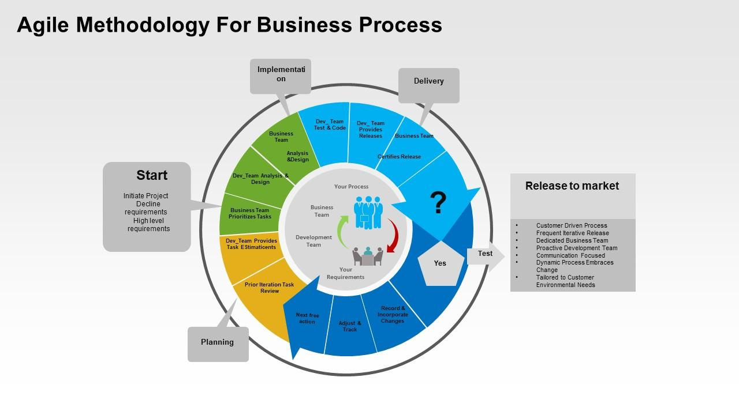



Small, incremental software releases are encouraged by an agile mindset, which fosters adaptability and continuous improvement. Agile teams put quality first, own the process, and hold frequent retrospectives. Workload balance guarantees long-term productivity and guards against burnout. Encouraging openness and visibility makes progress evident to the whole team.

As the Figure 2 illustrates VERSIONONE's annual reports list several benefits of the Agile framework, including improved project visibility and the ability to manage priorities that change. However, between 2009 and 2020, problems like low maturity, overestimating the true power of Agile, project diversity and complexity, and a misinterpretation of the true Agile value proposition cost people 23% of their credibility. High expectations, an overestimation of Agile’s power, and an ignorance of Agile's value proposition are the causes of this defeat (Bagiu et al., 2022).

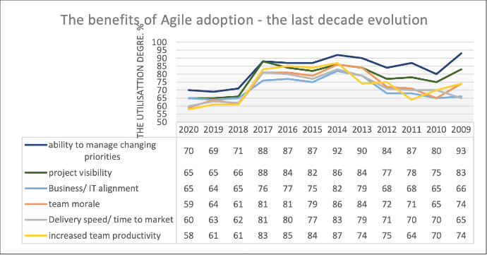



**Scrum Methodology**

Scrum is an Agile framework for software development that emphasizes incremental and iterative development. Twenty years after the Agile Software Development Manifesto was published, agile approaches are now widely used, with Scrum emerging as the most well-liked member of the family.

Although it can be used for different types of teamwork, software development teams are the main users of Scrum, a well-liked agile project management framework. It is made up of roles, meetings, and resources that cooperate to organize and oversee work. Figure 3 shows the process of scrum methodology with scrum artifacts such as product backlog, sprint backlog, sprint planning, sprint, daily standups, sprint retrospectives, sprint reviews, etc.

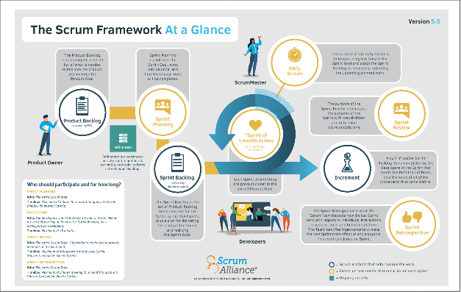

entails two- to four-week-long sprints in which the Product Owner, Scrum Master, and

### Development Team play crucial roles

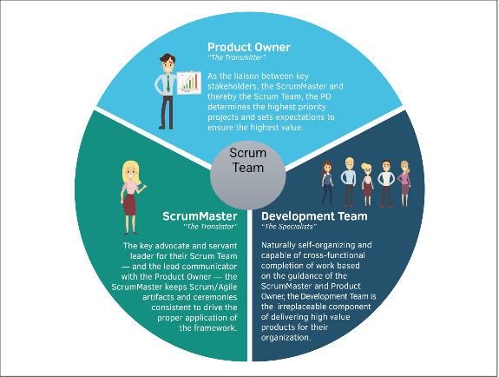

In addition to representing the interests of the customer and guaranteeing value delivery, the Product Owner is in charge of prioritizing the backlog of products. The Scrum Master promotes teamwork and streamlines the procedure. At the conclusion of each sprint, the self-organizing, cross-functional development team produces a shippable product.

Scrum has been adopted in different contexts, resulting in a range of modifications and adaptations. Since Scrum is not applied uniformly but rather customized to meet specific needs, the challenges associated with customization are recognized. Here users can use automated scrum tools such as Jira, ClickUp, etc. and the projects should be integrated with version controlling systems (Github, GitLab, etc).

Five values were added to the Scrum Guide in 2016 to help direct a scrum team's work, decisions, and conduct. Their success depends on these ideals.

Scrum teams require commitment because every member is critical to the team's success. It's critical to communicate work progress frequently, preferably during stand-ups. To be brave means to have the guts to try new things and challenge the status quo. The workflow is centered on focus, and a sprint offers structure and focus. Daily stand-ups encourage transparency by enabling teams to talk about obstacles and ongoing work. An agile team needs respect because it acknowledges each member's contribution to the team's work during a sprint. Respect is shown for the product owner, stakeholders, scrum master, and each other as well as for each other's successes (Atlassian , n.d.).

According to the Info.digital.ai., State of Agile 2022, Scrum has increased over the last three years, from 58% in the 14th survey to 87% in the current one (Figure 6). Moreover, the use of kanban has grown from 7% to 56%. Iterative has increased from 4% to 20%, while Scrumban has grown from 10% to 27%. With a rise from 37% in 2015 to 53% this year, the Scaled Agile Framework (SAFe) continues to be the most widely used framework (Figure 5). In addition, Scrum@Scale/Scrum of Scrums has increased, and Lean Management has increased from 2% to 8%.

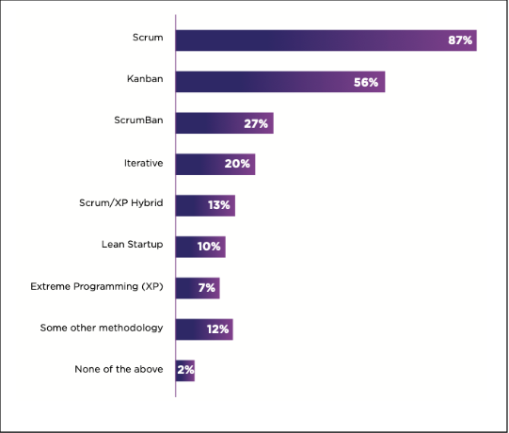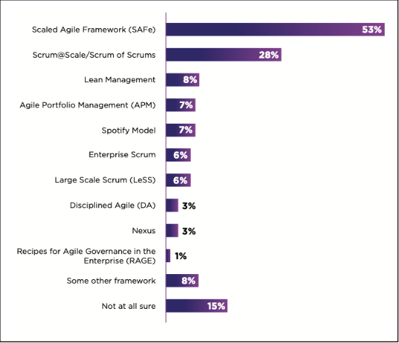

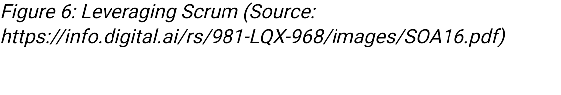

**Waterfall Methodology**

The requirements, design, implementation, testing, deployment, and maintenance phases make up the four stages of the Waterfall Methodology, a conventional, linear approach to software development. It entails compiling thorough documentation of the system requirements, organizing and drafting the system architecture, coding the program in accordance with design guidelines, locating and repairing bugs, putting the program into use in a production setting, and offering continuous maintenance and support.

The Waterfall methodology consists of six phases, namely requirement gathering, Analysis, Design, Implementation, Testing, and Maintenance (Figure 7). It is a conventional and sequential approach to software development. While the Design phase entails planning the solution and producing a detailed design, the Analysis phase entails carefully analyzing the software requirements. While the Testing phase makes sure the software satisfies the requirements and fulfils its intended function, the Implementation phase writes and codes the code into an operational application (K&C, 2021). During the maintenance phase, the software is changed to enhance its functionality and quality.

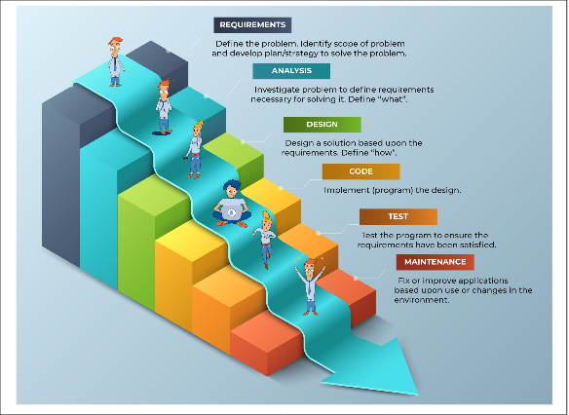



According to the Aroral,( 2021) Waterfall is an organized method that works well for small projects with stable requirements because it has clear technical documentation, accurate cost estimation, and accurate time estimation. However, it is not appropriate for large projects due to its lack of flexibility and upfront requirements. Waterfall development allows for development without frequent input from competitors or customers and works best with a clear final product vision, well-defined requirements, and infrequent design changes.

In order to meet the demands of diverse projects that are impacted by time-to-market constraints, emerging technologies, and market conditions, project management employs a variety of procedural models. When describing the **differences between Agile and Waterfall** methodologies, Agile is a flexible, iterative process that recognizes the difficulties in obtaining all of the requirements and works under the assumption that errors could result in less-than-ideal software. It places a high priority on creating a Minimum Viable Product (MVP) with the fewest features possible. This MVP is then continuously improved based on feedback and user behavior.

By using an iterative loop-back approach, the risk of devoting a substantial amount of time and resources to a product that might not meet user needs or effectively compete with alternatives is reduced. Problems can be quickly found and fixed without completely rebuilding a complicated, defective product.

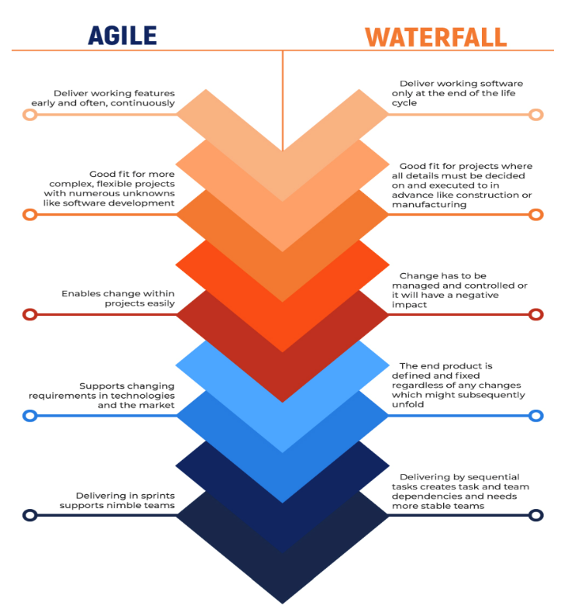



The approaches taken by Waterfall and Agile methodologies to software product development are different. According to the International Research Journal of Modernization in Engineering Technology and Science (2023), Agile has brief development sprints and is cooperative, flexible, and adaptive. It improves time-to-market, product quality, and customer satisfaction by reacting swiftly to market trends and customer needs. Waterfall development is methodical, structured, and could take longer. When deciding between Agile and Waterfall, one should take organizational, team, and project needs into account as well as variables like flexibility, customer involvement, and change-adaptability. Determining the best methodology based on project requirements and organizational objectives requires careful consideration. When it comes to equality, quality, and customer satisfaction, a comparative examination of agile and waterfall methodologies has stated in the following Table 1.

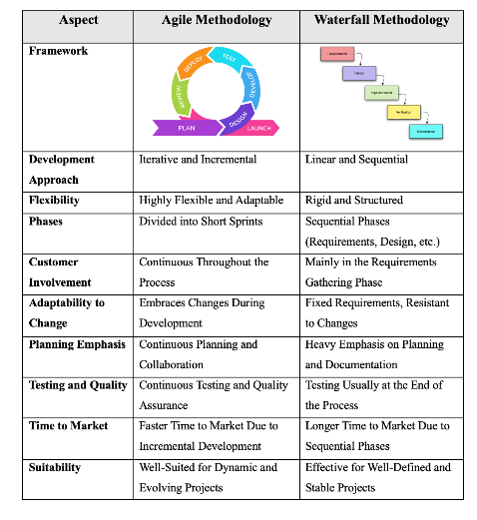

Traditional project management provides stability and predictable resources because it follows a traditional waterfall process. Agile approaches, such as Scrum and Kanban, place a high value on ongoing customer collaboration and incremental planning with short-term objectives. By combining the best features of both approaches, hybrid approaches aim to manage subprojects in an agile manner while adhering to plan-driven processes to achieve a comprehensive "big picture". Choosing the best procedural model for a project while taking into account its unique features and context is the difficult part. The decision-making process includes evaluations based on scope, time, costs, organizational context, and project team characteristics, as well as exclusion criteria. When deciding between classical and agile methodologies, project scope is frequently the most important consideration (Thesing et al., 2021).

# Guidelines for Choosing Between Scrum and Waterfall for CRM Software Development

Businesses must implement CRM if they want to enhance customer interactions and stay competitive. The decision between Agile and Waterfall methodologies has a big impact on how well CRM implementations work. The process of implementing CRM, value delivery, visibility, risk management, project size and complexity, flexibility and adaptability, user involvement, and decision-making considerations are important factors to consider (Difference between agile vs waterfall, 2022).

When developing CRM system, selecting between Scrum and Waterfall is essential, particularly when working with international financial institutions. Waterfall is appropriate for projects with well-defined requirements and little uncertainty, whereas Scrum is advised for those with incomplete, ambiguous, or changing requirements as the above stated information.

While Waterfall primarily involves users at the start and finish of the project, Scrum is preferred for ongoing user involvement throughout the project.

Because of the iterative process of Scrum is, it is appropriate for projects that need to quickly adjust to changing requirements such as once a project starts, Waterfall is less flexible. Whereas Waterfall measures progress less frequently, and risks are discovered later in the process, Scrum offers continuous project visibility, enabling faster risk identification and resolution.

The dynamics and structure of the team should also be considered here. Scrum encourages teams to work together across functional boundaries and autonomously, whereas Waterfall adheres to a hierarchical structure with clear roles and duties. The incremental delivery strategy prioritises early assurance that development satisfies user expectations and continuous value addition (Chuck Schaeffer, 2016).

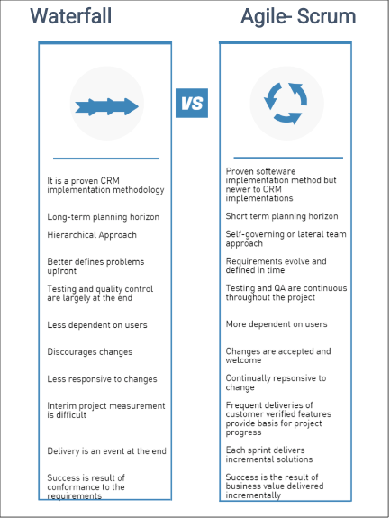



## Conclusion

As a result, **Scrum** is advised for the development of CRM software because it can manage changing requirements, encourage ongoing user participation, and offer quicker adaptability.

To get the most out of Scrum, though, the development team must be properly trained in its tenets. Throughout the development lifecycle, regular assessments of the project's progress and flexibility in response to shifting requirements can be important. After carefully considering the advantages and disadvantages of both approaches, the development the author has make a decision that helps to achieve the goal of providing a CRM system that works for Aussie Business Buzz.

This can be concluded from this paper that with software development project, the organization Aussie Business Buzz will be able to improve their business process, where customer relations database, marketing system, and stock management system will be developed and implemented. Therefore, the organization will need association of the vendor, who will work on the project and will provide them the required systems within the estimated budget and time. On the other hand, in terms of project management methodology, this n be said that agile methodology will be one of the most suitable methods that can be implemented by the organizations for managing the project effectively.

# References

1. Aroral, H.K., 2021. Waterfall Process Operations in the Fast-paced World: Project Management Exploratory Analysis. *International Journal of Applied Business and Management Studies*, *6*(1), pp.91-99.
2. Atlassian (n.d.) *What is Scrum? [+ how to start]*, *Atlassian*. Available at: https://www.atlassian.com/agile/scrum#continued (Accessed: 21 November 2023).
3. Bagiu, N., Avasilcăi, S. and Rusu, B., 2022. TRADITIONAL VS. AGILE: THE CHALLENGE MINDSET SHIFT IN PROJECT MANAGEMENT. *Review of Management & Economic Engineering*, *21*(4).
4. Chuck Schaeffer, (2016) *Agile versus Waterfall for CRM Implementation Success*, *CustomerThink*. Available at: https://customerthink.com/agile-versus-waterfall-for-crm-implementation-success/ (Accessed: 22 November 2023).
5. Difference between agile vs waterfall (2022) *Rolustech*. Available at: https://www.rolustech.com/blog/implement-crm-organization-agile-waterfall#:~:text=Usually%2C%20Agile%20implementation%20for%20CRM,the%20scope%20of%20the%20project. (Accessed: 21 November 2023).
6. Eilers, K., Peters, C. and Leimeister, J.M. (2022) ‘Why the agile mindset matters’, *Technological Forecasting and Social Change*, 179, p. 121650. doi:10.1016/j.techfore.2022.121650.
7. *Info.digital.ai*. (2022) Available at: https://info.digital.ai/rs/981-LQX-968/images/SOA16.pdf (Accessed: 20 November 2023).
8. Optimizing the product development process for speed to market, quality, and customer satisfaction: A Comparative Study of Agile and waterfall methodologies (2023) *International Research Journal of Modernization in Engineering Technology and Science* [Preprint]. doi:10.56726/irjmets36854.
9. Thesing, T., Feldmann, C. and Burchardt, M. (2021) ‘Agile Versus Waterfall Project Management: Decision model for selecting the appropriate approach to a project’, *Procedia Computer Science*, 181, pp. 746–756. doi:10.1016/j.procs.2021.01.227.
10. *What is a ScrumMaster and what do they do?: Scrum alliance* (n.d.) *Scrum Alliance Certification*. Available at: https://www.scrumalliance.org/what-is-a-scrum-master (Accessed: 18 November 2023).
11. *What is the Waterfall Software Development Methodology and is it still relevant?* (2021) *K&C*. Available at: https://kruschecompany.com/waterfall-software-development-methodology/ (Accessed: 21 November 2023).