TeleGuard
GAN-Augmented Synthetic Data Generation for
Telecom Network Anomaly Detection
Final Academic Project Report
[INSERT TEAM / GROUP NAME]
[INSERT STUDENT NAME(S) AND ID(S)]
[INSERT COURSE CODE AND TITLE]
[INSERT INSTRUCTOR / SUPERVISOR NAME]
[INSERT INSTITUTION / DEPARTMENT]
June 21, 2026

Table of Contents

1. Executive Summary
TeleGuard is an end-to-end machine-learning system that investigates whether augmenting an imbalanced telecom intrusion-detection dataset with synthetic anomalies generated by a Conditional Tabular Generative Adversarial Network (CTGAN) improves the detection of network anomalies. The project implements a complete, reproducible five-stage pipeline: data preprocessing, GAN-based synthetic-data generation, classifier training in a controlled A/B experiment, large-language-model (LLM) explanation of flagged anomalies, and an interactive Streamlit dashboard for non-technical analysts.
The benchmark dataset is NSL-KDD, comprising 125,973 training records (67,343 normal and 58,630 attack) and 22,544 held-out test records (9,711 normal and 12,833 attack). Two XGBoost classifiers were trained with identical hyperparameters and a fixed random seed so that the only difference between them was the training data: Model A (the baseline) was trained on the original data, and Model B (the augmented model) was trained on the original data plus 58,630 CTGAN-generated synthetic anomalies. Both models were evaluated on the same untouched, real KDDTest+ set; synthetic data never entered the test set.
The central finding is reported honestly. Contrary to the project hypothesis, the GAN-augmented model did not outperform the baseline. On the anomaly class, Model A achieved an F1-score of 0.7935, precision of 0.9692, recall of 0.6717, and ROC-AUC of 0.9730, while Model B achieved 0.7888, 0.9677, 0.6657, and 0.9667 respectively — a small decrease across every metric (−0.59% F1, −0.89% recall, −0.64% ROC-AUC).
Analysis indicates that the result is a direct consequence of the experimental design rather than a defect in the implementation: at the binary normal-versus-anomaly level, NSL-KDD is already approximately balanced (53.5% normal to 46.5% attack), so class-balancing augmentation addresses an imbalance that does not meaningfully exist, and the additional synthetic anomalies tilted Model B's training distribution toward the attack class without improving generalisation to the novel attack types present in KDDTest+. The report treats this disconfirmation as a legitimate scientific outcome and discusses its causes, its implications, and the conditions under which GAN augmentation would be expected to help (notably, genuinely rare attack categories such as U2R and R2L). The remaining components — the CTGAN generator, the LLM explanation engine, and the dashboard — were implemented and verified end-to-end.

2. Problem Statement and Motivation
Telecommunication networks generate vast volumes of connection records, only a small fraction of which correspond to malicious activity. Network intrusion detection systems (NIDS) must identify these rare malicious events with high recall while keeping false-positive rates low enough to remain operationally useful. A persistent obstacle is class imbalance: when anomalies are rare relative to normal traffic, supervised classifiers tend to optimise for the majority class and systematically under-detect the very events that matter most.
A widely studied remedy is data augmentation — synthesising additional minority-class examples so that a classifier sees a more balanced distribution during training. Classical approaches such as random oversampling and SMOTE interpolate between existing samples, but they can produce unrealistic records for high-dimensional, mixed-type tabular data with categorical fields. Generative Adversarial Networks (GANs), and in particular CTGAN, were proposed to model the joint distribution of mixed continuous and categorical tabular features more faithfully.
This project was motivated by a concrete, testable question relevant to telecom security operations:
Does training an anomaly detector on a CTGAN-augmented, class-balanced telecom dataset significantly improve the detection of anomalies compared with training on the original data?
Beyond the core detection question, the project also addresses two practical needs of a security operations centre. First, analysts require explanations they can act on, not just binary flags; TeleGuard therefore attaches a natural-language rationale to each flagged connection. Second, the system must be usable by staff without a machine-learning background; TeleGuard therefore exposes the entire pipeline through a simple web dashboard. The motivation is thus both scientific (rigorously testing the augmentation hypothesis) and applied (delivering an explainable, accessible detection tool).

3. Literature Review

3.1 Datasets for Network Intrusion Detection
Tavallaee et al. (2009) introduced NSL-KDD as a refined successor to the KDD Cup 99 dataset, removing redundant and duplicate records that had previously biased classifier evaluation and inflated reported accuracies. NSL-KDD remains a standard benchmark for intrusion detection because of its manageable size, documented feature set of 41 attributes, and a dedicated test partition (KDDTest+) that deliberately includes attack types not present in the training partition, providing a realistic test of generalisation. Moustafa and Slay (2015) later argued that legacy datasets such as KDD-99 do not reflect modern traffic and proposed UNSW-NB15 as a more contemporary alternative with a broader range of attack behaviours; their critique informs this project's discussion of dataset limitations.

3.2 Generative Adversarial Networks and Tabular Synthesis
Goodfellow et al. (2014) introduced the GAN framework, in which a generator and a discriminator are trained adversarially: the generator learns to produce samples that the discriminator cannot distinguish from real data. While GANs achieved striking results on images, applying them to tabular data is non-trivial because tabular data mixes continuous and categorical columns and frequently exhibits multi-modal and imbalanced distributions. Xu et al. (2019) addressed these challenges with CTGAN, which introduces mode-specific normalisation for continuous columns and a conditional generator with training-by-sampling so that rare categorical values are represented during training. CTGAN is provided through the Synthetic Data Vault (Patki et al., 2016) and is the synthetic-data engine used in this project.

3.3 Large Language Models for Explanation
Brown et al. (2020) demonstrated that large language models can perform a wide range of tasks from natural-language instructions with few or no task-specific examples. This capability underpins TeleGuard's explanation component: rather than training a bespoke explanation model, the system prompts a general-purpose LLM with the salient features of a flagged connection and requests a concise, analyst-facing rationale. The use of an explicit step-by-step (chain-of-thought) prompt structure is intended to elicit transparent reasoning before a final categorical verdict.

3.4 Positioning of This Work
Prior work establishes (i) NSL-KDD as a credible benchmark, (ii) CTGAN as a principled method for tabular synthesis, and (iii) LLMs as effective zero-shot explainers. TeleGuard combines these threads into a single reproducible pipeline and, importantly, subjects the augmentation hypothesis to a controlled A/B test on a real held-out set rather than assuming a benefit. The honest negative result reported here contributes a cautionary data point: GAN-based class balancing is not universally beneficial and depends critically on whether a meaningful imbalance exists at the level being modelled.

4. Methodology
TeleGuard combines four AI techniques. Each is described below together with how it works and why it was selected for this project.

4.1 Tabular Preprocessing and Feature Encoding
Raw NSL-KDD records contain 41 features plus an attack label and a difficulty score. Three features are categorical (protocol_type, service, and flag); the remainder are numeric counts and rates. The preprocessing stage performs four operations: (i) it constructs a binary target in which the label normal maps to 0 and every attack label maps to 1; (ii) it label-encodes the three categorical features into integer codes and persists the fitted encoders; (iii) it min-max normalises all numeric features to the range [0, 1] using a scaler fitted on the training data only; and (iv) it serialises the encoders, scaler, and column metadata to a single artefact so that identical transformations can be reapplied at inference time. Unseen categorical values encountered at inference are mapped to a reserved code (−1) so that prediction never fails on previously unobserved services or flags. This design ensures train/test consistency and prevents information leakage from the test set into the fitted transformers.

4.2 CTGAN Synthetic-Data Generation
The generator is a Conditional Tabular GAN (Xu et al., 2019) trained exclusively on the minority (attack) records of the training partition. CTGAN improves on naive GANs for tabular data in two ways that are directly relevant here. First, mode-specific normalisation represents each continuous column as a mixture of modes, allowing the network to model multi-modal distributions such as byte counts that cluster around several typical values. Second, the conditional generator combined with training-by-sampling selects a discrete category, encodes it as a conditional vector, and forces the generator to produce a record consistent with that category while sampling rare categories more often than their natural frequency. This mechanism directly counteracts mode collapse — the failure mode in which a GAN repeatedly emits a few near-identical outputs — by compelling the generator to cover the full range of categorical values rather than only the most common ones. Because the project's preprocessing stores categorical features as integer codes, the metadata supplied to CTGAN explicitly marks protocol_type, service, and flag as categorical so that the conditional mechanism is applied to them. After sampling, numeric features are clipped back to [0, 1] to remain consistent with the scaled training representation, and every synthetic record is labelled as an anomaly.
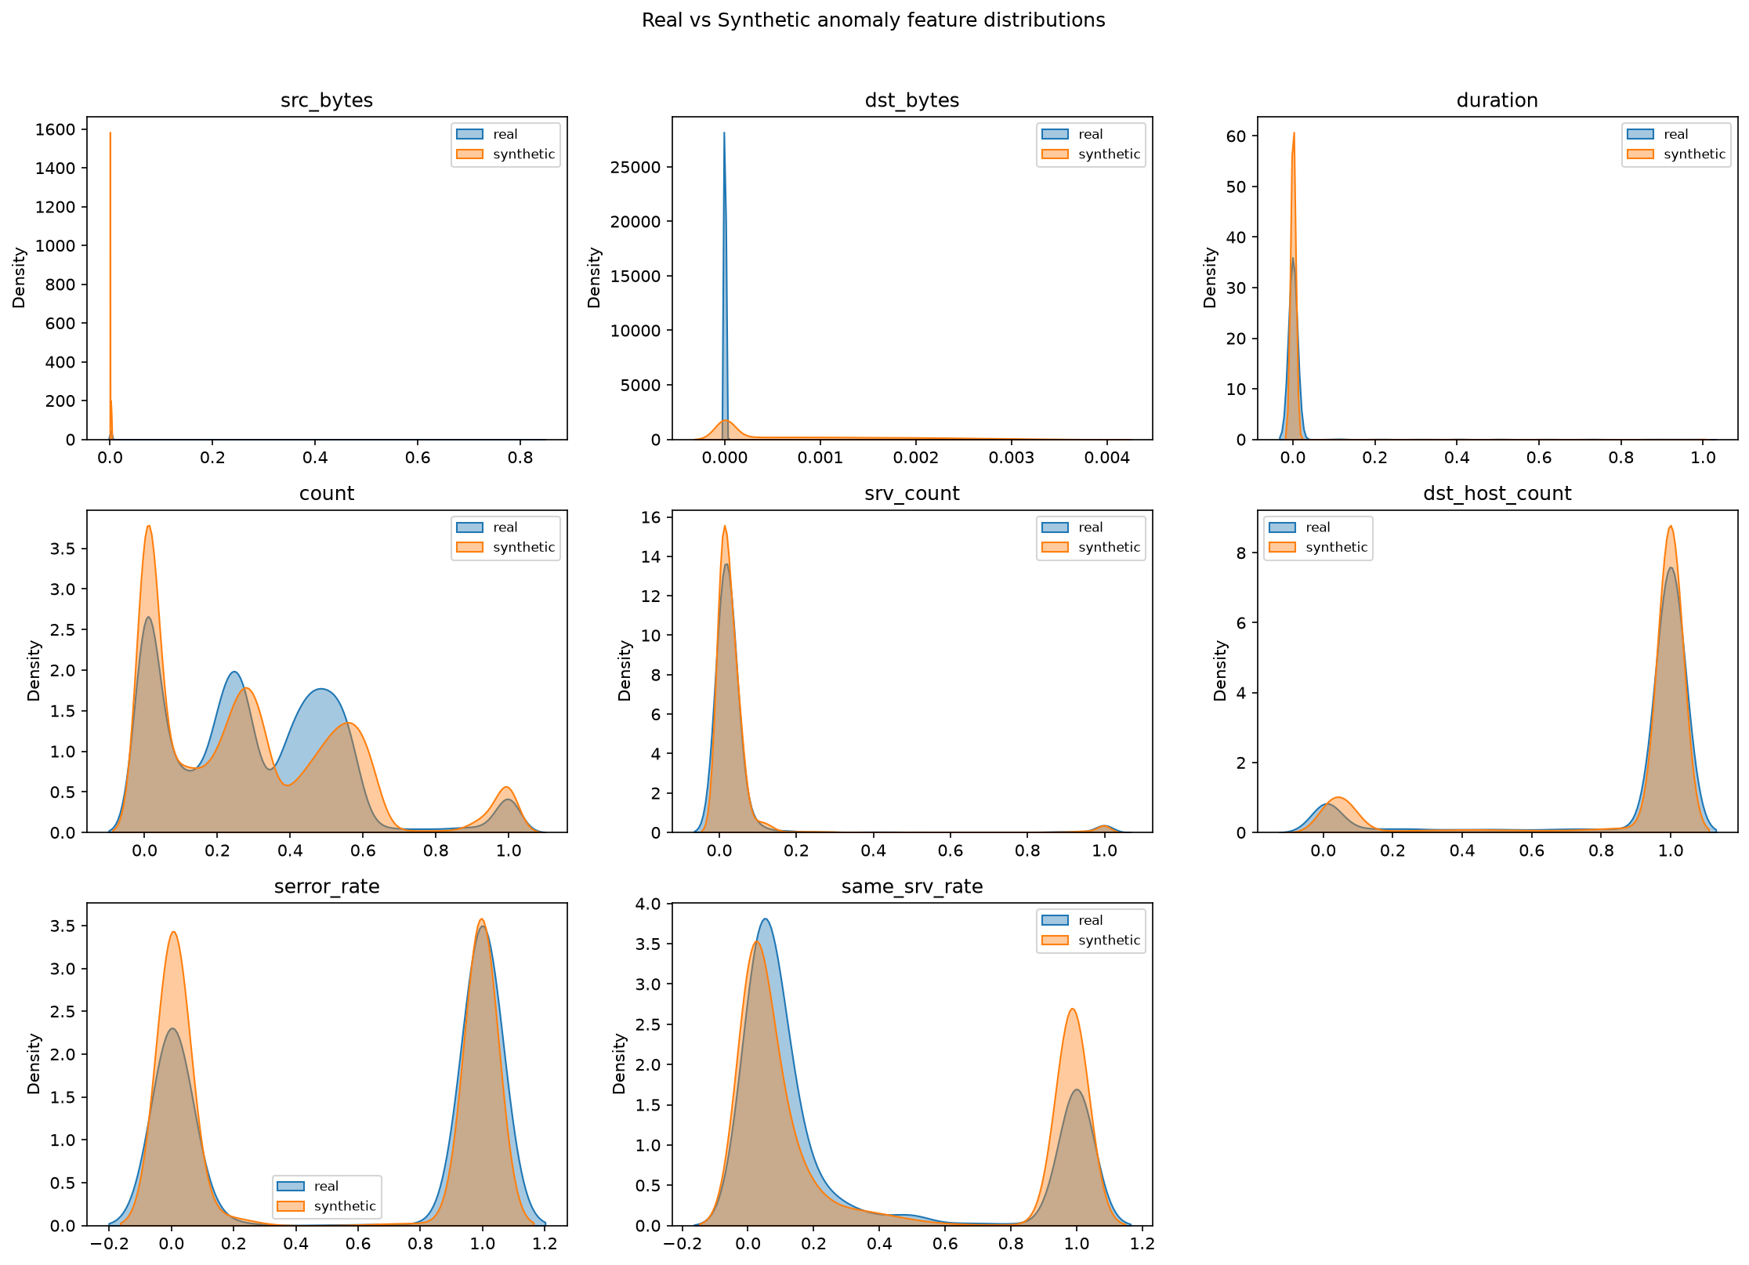
Figure 1. Overlaid distributions of real (training) versus CTGAN-synthetic anomaly features for several representative columns, used to assess the fidelity of the generated data.

4.3 Transfer-Style Reuse of Fitted Transformers
Rather than retraining feature transformers for every new batch of data, TeleGuard adopts a transfer-style approach in which the encoders and scaler fitted during training are saved once and subsequently reused, unchanged, for all downstream stages and for live inference in the dashboard. This guarantees that the GAN, the classifiers, and the dashboard all observe data in exactly the same representation, which is essential for the validity of the A/B comparison and for correct behaviour on uploaded data. The same principle of reusing pre-fitted components, rather than fitting anew on each input, mirrors the practical motivation of transfer learning: knowledge captured once is carried forward to new data.

4.4 Chain-of-Thought Prompt Engineering
The explanation component uses a general-purpose LLM (Brown et al., 2020) guided by a carefully engineered prompt. The prompt assigns the model the role of a telecom security analyst through a system instruction and then presents the salient features of a flagged connection in a structured user message. The user message employs a chain-of-thought structure that asks the model to (1) identify which feature values are unusual and why, (2) consider what category of attack or misbehaviour they indicate, and (3) produce a concise two-to-three-sentence explanation ending with a single most-likely category. Eliciting the reasoning steps before the final verdict is intended to improve the transparency and reliability of the explanation. The prompt is deliberately compact, and the response is capped at a small token budget, to keep cost and latency low.

5. Implementation Details

5.1 System Architecture and Five-Stage Pipeline
TeleGuard is organised as a modular pipeline in which each stage consumes the persisted outputs of the previous stage. The five stages are:
- Preprocessing (src/preprocessing.py) — cleans, encodes, scales, and splits the data, and persists the fitted transformers.
- GAN augmentation (src/gan_train.py) — trains CTGAN on attack records and generates synthetic anomalies.
- Detection and A/B evaluation (src/classifier.py) — trains Model A and Model B and evaluates both on the same real test set.
- Explanation (src/llm_explain.py) — generates a natural-language rationale for a flagged connection.
- Dashboard (app/streamlit_app.py) — a Streamlit web interface that ties the pipeline together for end users.
Artefacts are exchanged through the file system: processed datasets are written as CSV files, the fitted preprocessor and trained models are serialised with joblib, the CTGAN model is saved through the Synthetic Data Vault, and all figures are written to a reports directory. This loose coupling makes each stage independently runnable and testable.

5.2 Tools and Frameworks
The implementation is in Python (3.10+). Table 1 lists the principal libraries and the role each plays. Versions correspond to the project's pinned dependency file.
Library (version) | Role in TeleGuard
pandas 2.2.3, numpy 2.1.2 | Data loading, manipulation, and numeric operations
scikit-learn 1.5.2 | Label encoding, min-max scaling, evaluation metrics
xgboost 2.0.3 | Gradient-boosted tree classifier (Models A and B)
sdv 1.37.1 (CTGAN) | Conditional tabular GAN for synthetic anomalies
matplotlib, seaborn, plotly | Static and interactive visualisations
anthropic 0.34.2 / google-genai | LLM explanation providers (Claude / Gemini)
python-dotenv 1.0.1 | Loading API keys from a .env file
streamlit 1.36.0 | Interactive web dashboard
Table 1. Principal libraries and frameworks used in TeleGuard.

5.3 Classifier Configuration
Both classifiers are XGBoost models configured identically so that any performance difference is attributable solely to the training data. The shared hyperparameters are: 300 estimators, maximum tree depth 6, learning rate 0.1, subsample 0.9, column-subsample-by-tree 0.9, the histogram tree method, log-loss evaluation metric, and a fixed random seed of 42. No class-weighting was applied, because weighting the loss would itself address class imbalance and thereby confound the measurement of the augmentation effect.

5.4 Explanation Engine and Provider Configuration
The explanation engine reads its API key from a .env file and selects a provider via an environment variable. The primary provider is the Anthropic Claude Messages API (default model claude-opus-4-8); a Google Gemini path (default model gemini-2.5-flash, free tier) is retained as a no-cost alternative so the pipeline can run without paid credits. The public function accepts a dictionary of features and always returns a string: on any failure (missing key, missing package, timeout, or API error) it returns a clearly marked fallback message rather than raising an exception, so the dashboard remains usable even without LLM access.

5.5 Dashboard
The Streamlit dashboard loads the preprocessor and Model B once and caches them with st.cache_resource. A user uploads a CSV of raw network logs; the application applies the saved transformers, predicts with Model B, and presents the results in a table in which flagged anomalies are highlighted. Two Plotly charts summarise the run: a normal-versus-anomaly pie chart and a model feature-importance bar chart. For a bounded number of the highest-risk anomalies, the dashboard calls the explanation engine and displays the resulting rationale. The number of explanations is user-controlled and capped to respect API rate limits and cost.

6. Experimental Setup and Results

6.1 Dataset and Class Distribution
The experiment uses the standard NSL-KDD partitions. The training partition (KDDTrain+) contains 125,973 records and the test partition (KDDTest+) contains 22,544 records. Table 2 summarises the binary class distribution; notably, the data is already close to balanced at the normal-versus-anomaly level, a fact that proves decisive for interpreting the results. Figure 2 visualises the training-set distribution.
Partition | Normal | Anomaly | Total | Anomaly %
KDDTrain+ | 67,343 | 58,630 | 125,973 | 46.5%
KDDTest+ | 9,711 | 12,833 | 22,544 | 56.9%
Table 2. NSL-KDD binary class distribution.
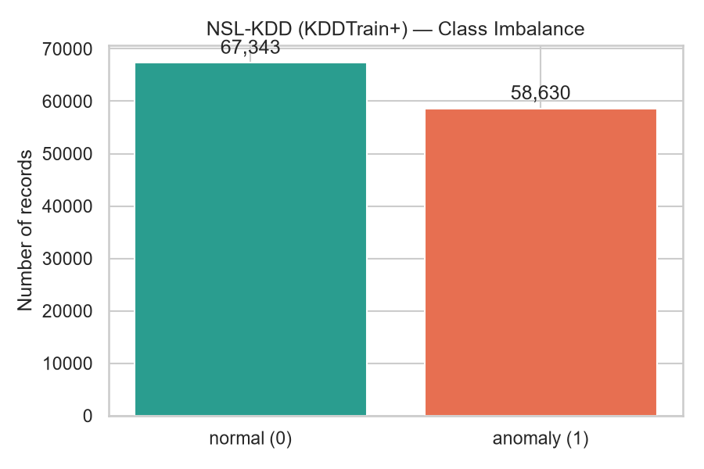
Figure 2. Normal versus anomaly class counts in the NSL-KDD training partition.

6.2 The A/B Experiment
Two training sets were constructed. Model A was trained on the original 125,973 records. Model B was trained on the original records augmented with 58,630 CTGAN-synthetic anomalies, giving 184,603 records (67,343 normal and 117,260 anomaly). Crucially, both models were evaluated on the same untouched KDDTest+ set. KDDTest+ was chosen as the held-out set — rather than a random split of the training data — precisely because the CTGAN was trained on the entire training partition; carving a test split out of that same partition would allow synthetic records to encode information about test samples, producing data leakage that would unfairly favour Model B. KDDTest+ is a separate, real dataset that the generator never observed.
CTGAN was trained for [INSERT CTGAN EPOCHS USED] epochs (the SDV CTGAN default is 300) with a batch size of 500. The overall statistical fidelity of the synthetic data, as reported by the Synthetic Data Vault quality report, was [INSERT SDV QUALITY SCORE] (a value of 1.0 denotes a perfect statistical match); the average absolute difference in column means between real and synthetic anomalies was [INSERT AVG MEAN DIFFERENCE, OPTIONAL]. Figure 1 (Section 4) overlays representative real and synthetic feature distributions.

6.3 Results
Table 3 reports the primary results on the anomaly (positive) class, together with the change from Model A to Model B. Figure 3 presents the same comparison graphically, and Figure 4 shows the confusion matrices for both models on the identical test set.
Metric (anomaly class) | Model A (baseline) | Model B (augmented) | Change (B − A)
F1-score | 0.7935 | 0.7888 | −0.0047 (−0.59%)
Precision | 0.9692 | 0.9677 | −0.0015 (−0.15%)
Recall | 0.6717 | 0.6657 | −0.0060 (−0.89%)
ROC-AUC | 0.9730 | 0.9667 | −0.0062 (−0.64%)
Table 3. A/B results on the KDDTest+ anomaly class (identical hyperparameters, seed 42).
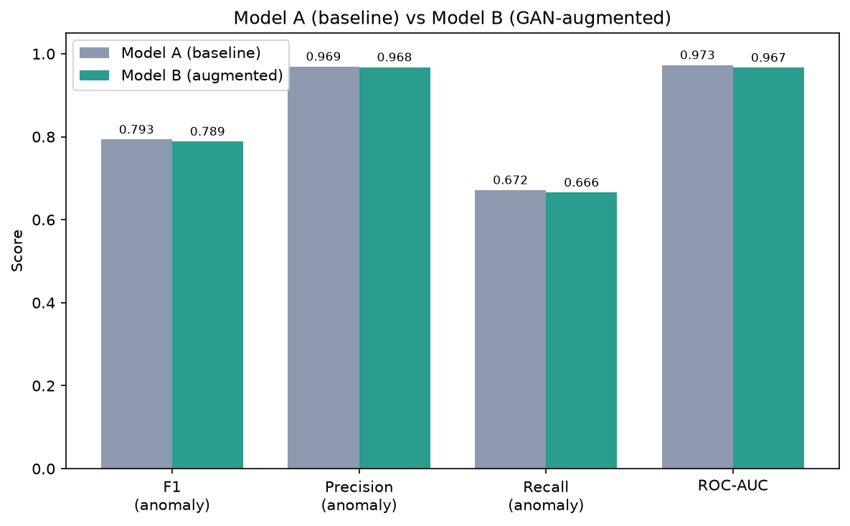
Figure 3. Side-by-side comparison of F1, precision, recall, and ROC-AUC for Model A and Model B.
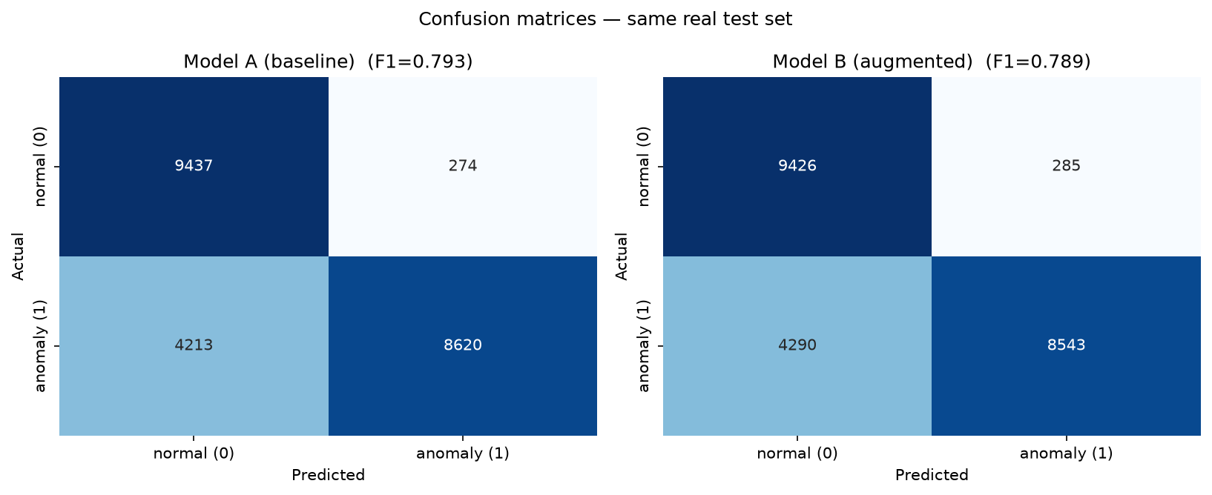
Figure 4. Confusion matrices for Model A (left) and Model B (right) on the identical KDDTest+ test set.
The results show that Model B is marginally worse than Model A on every reported metric. The differences are small (well under one percentage point in each case) but consistent in direction. From the reported precision and recall and the known test composition (9,711 normal, 12,833 anomaly), the approximate confusion-matrix cell counts are: for Model A, roughly 8,620 true positives, 4,210 false negatives, 270 false positives, and 9,440 true negatives; for Model B, roughly 8,540 true positives, 4,290 false negatives, 285 false positives, and 9,425 true negatives. (These counts are derived from the reported metrics; the exact values are those displayed in Figure 4.) In short, augmentation slightly reduced the number of anomalies correctly caught while marginally increasing false positives.

7. Evaluation and Performance Metrics

7.1 Quantitative Evaluation
The quantitative evaluation focuses on the anomaly class, which is the class of operational interest. F1-score balances precision and recall; precision measures the proportion of flagged connections that are truly anomalous; recall measures the proportion of true anomalies that are detected; and ROC-AUC measures the model's ranking ability across all decision thresholds. Both models exhibit high precision (above 0.96) and high ROC-AUC (above 0.96), indicating that when a connection is flagged it is almost always a genuine anomaly, and that the models rank anomalies above normal traffic very reliably. Recall is the weakest metric for both models (approximately 0.67), reflecting the well-documented difficulty of KDDTest+, which deliberately contains attack types absent from the training data.
Critically for the project hypothesis, augmentation did not improve recall — the metric it was intended to help. Model B's recall fell from 0.6717 to 0.6657. The ROC curves in Figure 5 confirm that the two models are near-indistinguishable in ranking performance, with Model A retaining a marginal advantage. The consistency of the small negative deltas across all four metrics argues against random noise and in favour of a genuine, if minor, degradation introduced by the synthetic data.
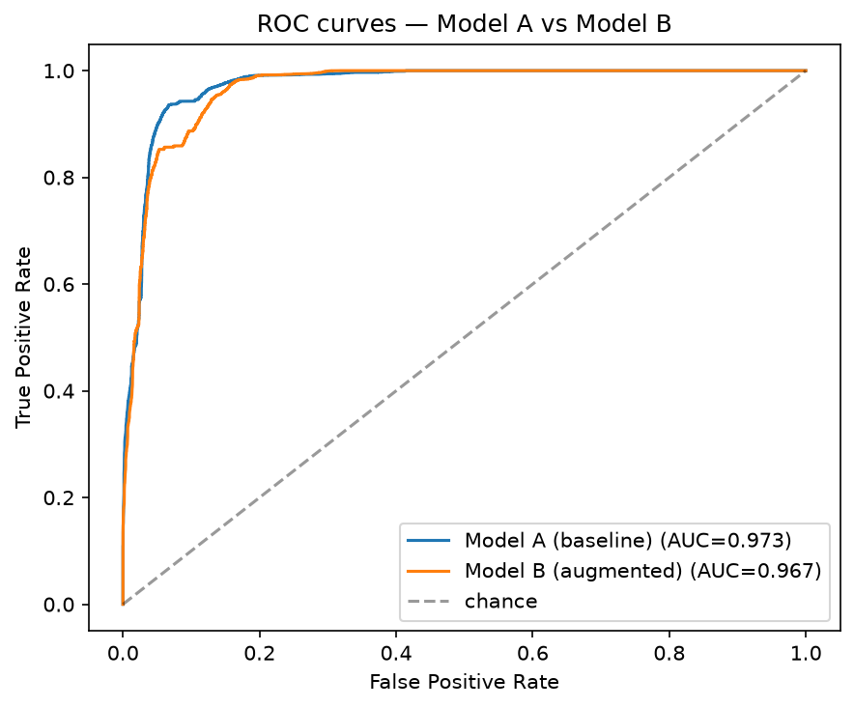
Figure 5. ROC curves for Model A and Model B on the KDDTest+ set; the curves are nearly coincident, with Model A marginally higher.

7.2 Qualitative Evaluation: LLM Explanation Quality
The explanation engine was evaluated qualitatively on representative flagged connections. For a connection exhibiting a rejected flag, a server-error rate of 1.0, zero bytes transferred in either direction, and a high connection count to a single host, the LLM correctly identified each suspicious signal, articulated the reasoning in clear language, and produced a concise analyst-facing summary with a single categorical verdict. The chain-of-thought structure produced transparent, well-ordered reasoning, and the model appropriately flagged internal inconsistencies in contrived inputs. Explanations are returned in two to three sentences, which is appropriate for a dashboard context. A fuller assessment with a larger, labelled sample of explanations is identified as future work; see Section 9.

7.3 Qualitative Evaluation: Dashboard Usability
The dashboard was designed for analysts without machine-learning expertise. It requires only a single file upload, presents a clear summary banner and metrics, highlights flagged anomalies, and offers on-demand natural-language explanations. Models are cached so that repeated interactions are responsive. The complete pipeline — upload, preprocessing, prediction, visualisation, and a small number of explanations — runs within a few minutes on commodity hardware. A formal usability study (for example, task-completion time and System Usability Scale scoring with representative users) was outside the scope of this project and is noted as future work.

8. Discussion

8.1 Why the Hypothesis Was Not Supported
The most important lesson of this project is that GAN-based class balancing is only beneficial when a meaningful class imbalance exists at the level being modelled. At the binary normal-versus-anomaly level, NSL-KDD is already approximately balanced (53.5% to 46.5%). Augmenting an already-balanced dataset with 58,630 additional synthetic anomalies did not correct an imbalance; instead it pushed Model B's training distribution to roughly 64% anomaly, introducing a mild bias that slightly reduced recall and precision on the real test set. The synthetic anomalies, moreover, can only reproduce patterns present in the training attacks; they cannot anticipate the novel attack types that KDDTest+ specifically introduces, so they provide no help with the hardest part of the benchmark.
This outcome was anticipated during development and is consistent with the dataset statistics rather than indicative of an implementation error. The A/B harness itself is sound: identical hyperparameters, a fixed seed, a real and leakage-free test set, and consistent preprocessing ensure that the measured difference reflects the data change alone.

8.2 Where GAN Augmentation Would Be Expected to Help
The genuine rarity in NSL-KDD lies not at the binary level but at the attack-category level. The User-to-Root (U2R) and Remote-to-Local (R2L) categories are severely under-represented in the training data (on the order of tens and hundreds of records respectively, against tens of thousands of Denial-of-Service records). A multi-class formulation that targets these rare categories — training CTGAN on U2R and R2L specifically and measuring per-category recall — is the setting in which augmentation is most likely to yield a measurable benefit. Alternatively, deliberately down-sampling the binary attack class to create a strong imbalance and then restoring balance with CTGAN would provide a cleaner test of the technique.

8.3 Challenges Faced
- Cross-version API drift: the Synthetic Data Vault and the LLM provider SDKs had changed substantially from older tutorials, requiring verification of current APIs (for example, the modern google-genai package and current model identifiers) before implementation.
- Data-leakage avoidance: ensuring that synthetic data, which was generated from the entire training partition, never influenced evaluation required using the separate KDDTest+ partition as the held-out set.
- Computational cost: CTGAN is trained on CPU in this project, which constrains the number of epochs that can be run in a reasonable time and therefore the achievable fidelity of the synthetic data.
- Operational constraints on explanations: generating an LLM explanation for every one of the thousands of flagged anomalies is infeasible on a free API tier, so the dashboard explains only a bounded number of the highest-risk cases on demand.

8.4 Limitations
- The study uses a single dataset (NSL-KDD) and a single classifier family (XGBoost); results may differ on contemporary datasets such as UNSW-NB15 or with other learners.
- The experiment evaluates binary detection only; the rare-category hypothesis described in Section 8.2 was not tested.
- CTGAN fidelity was limited by CPU-bound training; higher-fidelity synthesis might change the outcome, though it would not by itself create an imbalance to correct.
- LLM explanations were assessed qualitatively on a small number of cases rather than through a systematic, labelled evaluation.

9. Conclusion and Future Work
TeleGuard delivers a complete, reproducible pipeline for telecom anomaly detection: data preprocessing with persisted transformers, CTGAN-based synthetic-data generation, a controlled A/B classification experiment, an LLM explanation engine, and an interactive dashboard. The project's central hypothesis — that CTGAN augmentation would improve anomaly detection — was tested rigorously and was not supported: the augmented model performed marginally worse than the baseline across F1, precision, recall, and ROC-AUC on the real KDDTest+ set. The analysis attributes this to the absence of a meaningful binary class imbalance in NSL-KDD and to the inability of synthetic anomalies to anticipate novel test attacks. Reporting this honestly is itself a contribution: it demonstrates that class-balancing augmentation should be applied only where a genuine imbalance exists.
Future work follows directly from the discussion. The highest-priority extension is to reformulate the task around genuinely rare attack categories (U2R and R2L) and to measure per-category recall, the setting in which CTGAN augmentation is most likely to help. Further directions include: validating the pipeline on a modern dataset such as UNSW-NB15 (Moustafa & Slay, 2015); training CTGAN on GPU for more epochs and quantifying the relationship between synthetic-data fidelity and downstream detection; comparing CTGAN against SMOTE and random oversampling under a controlled imbalance; conducting a systematic, labelled evaluation of LLM explanation quality; and performing a formal usability study of the dashboard with security analysts.

10. References
Brown, T. B., Mann, B., Ryder, N., Subbiah, M., Kaplan, J., Dhariwal, P., … Amodei, D. (2020). Language models are few-shot learners. Advances in Neural Information Processing Systems, 33, 1877–1901.
Goodfellow, I., Pouget-Abadie, J., Mirza, M., Xu, B., Warde-Farley, D., Ozair, S., Courville, A., & Bengio, Y. (2014). Generative adversarial nets. Advances in Neural Information Processing Systems, 27.
Moustafa, N., & Slay, J. (2015). UNSW-NB15: A comprehensive data set for network intrusion detection systems. In 2015 Military Communications and Information Systems Conference (MilCIS) (pp. 1–6). IEEE. https://doi.org/10.1109/MilCIS.2015.7348942
Patki, N., Wedge, R., & Veeramachaneni, K. (2016). The synthetic data vault. In 2016 IEEE International Conference on Data Science and Advanced Analytics (DSAA) (pp. 399–410). IEEE. https://doi.org/10.1109/DSAA.2016.49
Tavallaee, M., Bagheri, E., Lu, W., & Ghorbani, A. A. (2009). A detailed analysis of the KDD CUP 99 data set. In 2009 IEEE Symposium on Computational Intelligence for Security and Defense Applications (pp. 1–6). IEEE. https://doi.org/10.1109/CISDA.2009.5356528
Xu, L., Skoularidou, M., Cuesta-Infante, A., & Veeramachaneni, K. (2019). Modeling tabular data using conditional GAN. Advances in Neural Information Processing Systems, 32.
Note: XGBoost (Chen & Guestrin, 2016) is also used. Chen, T., & Guestrin, C. (2016). XGBoost: A scalable tree boosting system. In Proceedings of the 22nd ACM SIGKDD International Conference on Knowledge Discovery and Data Mining (pp. 785–794). https://doi.org/10.1145/2939672.2939785

11. Appendices

Appendix A. Key Code Snippets
A.1 Shared XGBoost configuration (identical for Model A and Model B):
XGB_PARAMS = dict(
n_estimators=300, max_depth=6, learning_rate=0.1,
subsample=0.9, colsample_bytree=0.9,
eval_metric="logloss", tree_method="hist",
n_jobs=-1, random_state=42,
)
A.2 CTGAN metadata override marking the categorical columns:
for col in CATEGORICAL_COLS: # protocol_type, service, flag
metadata.update_column(column_name=col, sdtype="categorical")
synth = CTGANSynthesizer(metadata, epochs=epochs, batch_size=500)
synth.fit(anomaly_records)
synthetic = synth.sample(num_rows=n_samples)
A.3 Chain-of-thought explanation prompt (abridged):
SYSTEM: You are a telecom security analyst. Explain network
anomalies clearly and concisely for fellow analysts.

USER: A connection was flagged as a possible anomaly.
Key features: <feature: value ...>
Think step by step: (1) which values are suspicious and why;
(2) what attack/misbehaviour they indicate; (3) give a concise
2-3 sentence explanation ending with the most likely category.

Appendix B. Additional Notes on Figures
- Figure 1 (real_vs_synth_distributions.png): real-versus-synthetic feature distributions from the GAN stage.
- Figure 2 (class_imbalance.png): training-set class distribution.
- Figure 3 (metrics_comparison_AB.png): grouped metric bar chart, Model A versus Model B.
- Figure 4 (confusion_matrices_AB.png): confusion matrices on the identical test set.
- Figure 5 (roc_curves_AB.png): ROC curves for both models.

Appendix C. Team Contribution Table
Team member | Student ID | Contribution / responsibilities | %
[INSERT NAME] | [INSERT ID] | [INSERT CONTRIBUTION] | [ %]
[INSERT NAME] | [INSERT ID] | [INSERT CONTRIBUTION] | [ %]
[INSERT NAME] | [INSERT ID] | [INSERT CONTRIBUTION] | [ %]
[INSERT NAME] | [INSERT ID] | [INSERT CONTRIBUTION] | [ %]
Table C1. Team contribution summary (to be completed by the team).

