

**MAIN SUPERVISORMISS**

**MS. NADUNI JAYATHILAKE**

**A.K.RANAWEERA -ITBNM-2110-0046**

|  |
| --- |
| Microcontroller-Driven Indoor Hydroponic Fodder Syst  **[Design and Methodology]** |

Table of Contents

**1. Introduction** 3

**Feasibility Study** 3

**2.1 Technical Feasibility** 3

**2.2 Economic Feasibility** 4

**2.3 Operational Feasibility** 4

**3. Fact Finding Techniques** 5

**3.1 Demographics and Experience** 6

**3.2 Challenges Faced** 6

**3.3 Expectations for Hydroponic Systems** 7

**3.4 Investment Willingness** 8

**3.5 Importance of Sustainability** 8

**3.6 Additional Insights** 8

**4 Requirement Analysis** 8

**4.1 Functional Requirements** 8

**4.2 Non-Functional Requirements** 9

5 System Design 9

**5.1 Control Mechanisms** 10

**5.2 Data Collection** 10

**5.3 Power Management** 11

**6 Diagram** 11

**6.1 ER Digram** 11

**6.2 block Diagram** 12

**6.3 Circuit Diagram** 12

# **1. Introduction**

Hydroponics represents a revolutionary approach to agriculture that allows plants to grow in a nutrient-rich water solution, eliminating the need for soil. This method has gained significant traction in recent years due to its ability to enhance crop yields, conserve water, and facilitate cultivation in urban environments where traditional farming is impractical. In this project, we aim to design and implement a sophisticated hydroponic system that not only supports plant growth but also integrates advanced monitoring and control mechanisms to optimize growing conditions.

The primary objectives of this project include creating a hydroponic system that can adapt to varying environmental conditions, such as temperature fluctuations, while effectively managing water levels and nutrient delivery. Additionally, we will explore the integration of renewable energy sources, specifically solar power, to enhance sustainability. This methodology chapter outlines the comprehensive approach taken in our project, including a feasibility study, fact-finding techniques, requirement analysis, and a detailed description of the methodology employed in the development of our hydroponic system.

# **Feasibility Study**

## **2.1 Technical Feasibility**

The technical feasibility of the hydroponic system is a critical aspect that involves evaluating the necessary components and technologies required for successful implementation. Our system will consist of several key components:

Water Reservoir: The heart of the hydroponic system, this tank will store the nutrient-rich water solution that feeds the plants. The size and material of the reservoir will be selected based on the scale of the hydroponic operation and the types of plants being cultivated.

Pumps: Water pumps are essential for circulating the nutrient solution from the reservoir to the plants. We will explore various pump types, including submersible and inline pumps, to determine the most efficient option for our system.

Sensors: A network of sensors will be employed to monitor critical environmental parameters. These include:

Water Level Sensors: To ensure that the reservoir maintains an adequate water supply.

CO2 Sensors: To measure carbon dioxide levels in the growing environment, which is vital for photosynthesis.

Temperature Sensors: To monitor the ambient temperature and regulate heating or cooling systems as needed.

Control System: An automated control system will be designed to manage the operation of pumps and sensors, ensuring that plants receive optimal growing conditions.

By evaluating these components, we will determine the technical requirements necessary for constructing a functional and efficient hydroponic system.

## **2.2 Economic Feasibility**

Conducting an economic feasibility analysis is essential to assess the cost-effectiveness of the hydroponic system. This analysis will include a detailed breakdown of both initial setup costs and ongoing operational expenses. Key financial considerations will include:

Initial Setup Costs: This encompasses the purchase of equipment such as water pumps, tanks, lighting systems, sensors, and solar panels. We will compile a list of suppliers and obtain quotes to estimate the total investment required.

Operational Costs: Ongoing costs will include electricity for pumps and lighting, water usage, and nutrient solutions. We will analyze the potential savings from utilizing solar panels, which can significantly reduce electricity costs over time.

Cost-Benefit Analysis: A thorough cost-benefit analysis will be conducted to evaluate the return on investment (ROI). This will involve comparing the initial and ongoing costs against the expected benefits, such as increased crop yields and reduced resource consumption.

Through this analysis, we aim to establish the economic viability of the hydroponic system, ensuring that it is a sustainable investment.

## **2.3 Operational Feasibility**

Operational feasibility examines the practicality of running the hydroponic system effectively. This involves evaluating the skills and knowledge required for system management. Key aspects include:

User Training: Comprehensive training sessions will be developed for users to ensure they understand how to operate and maintain the system. This training will cover topics such as monitoring sensor data, adjusting nutrient concentrations, and troubleshooting common issues.

Maintenance and Accessibility: We will assess the ease of accessing system components for maintenance and repair. A well-designed system should allow for straightforward maintenance procedures to minimize downtime.

Adaptability: The system's ability to adapt to varying environmental conditions will be evaluated. This includes the capacity to modify growing conditions in response to changes in temperature, humidity, and light availability.

By addressing these operational considerations, we aim to create a hydroponic system that is not only effective but also user-friendly and sustainable.

# **3. Fact Finding Techniques**

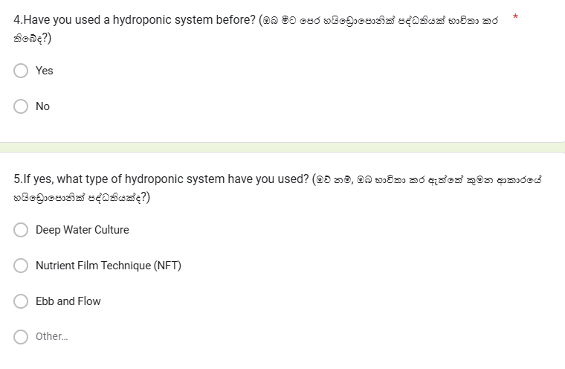To gather relevant information regarding the healthcare band system, a Google form was distributed to families in Sri Lanka specially Urban areas, covering various age groups. This method allowed for the identification of general challenges and specific needs related to the growing plants. Most frequently requested

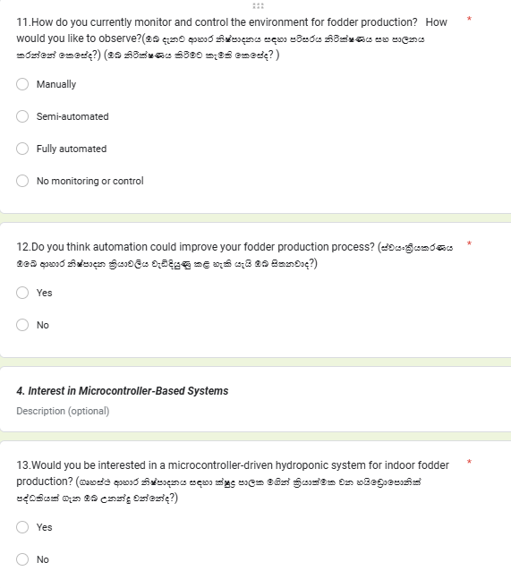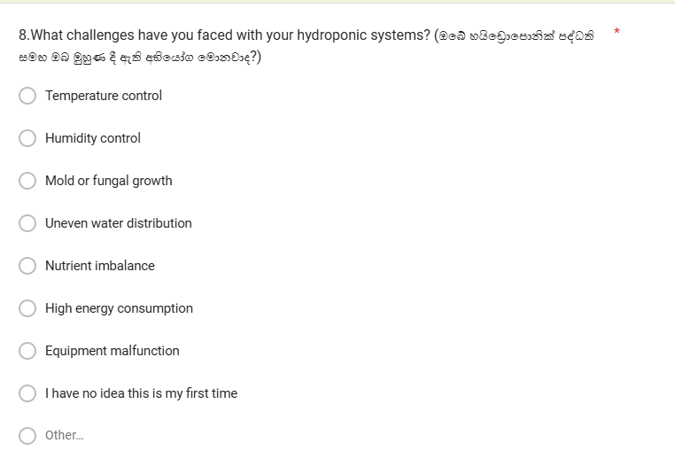

Based on the google form responses for your survey on hydroponic systems, the following analysis summarizes the key findings and insights regarding user preferences, challenges, and expectations for a microcontroller-driven indoor hydroponic fodder system:

## **3.1 Demographics and Experience**

Respondents were primarily between the ages of 18 and 25, including students and professionals in agriculture and related fields. A few had prior farming or hydroponic experience, utilizing systems like Nutrient Film Technique (NFT) and Deep Water Culture. Most participants were new to hydroponics, indicating a growing interest in this technology among younger demographics and non-traditional farmers.

## **3.2 Challenges Faced**

The high cost of equipment and labor requirements were the most frequently cited challenges. Other issues included maintaining consistent growth, humidity control, and the lack of automation in existing systems. These concerns highlight areas where technological advancements and cost-effective solutions could greatly benefit users.

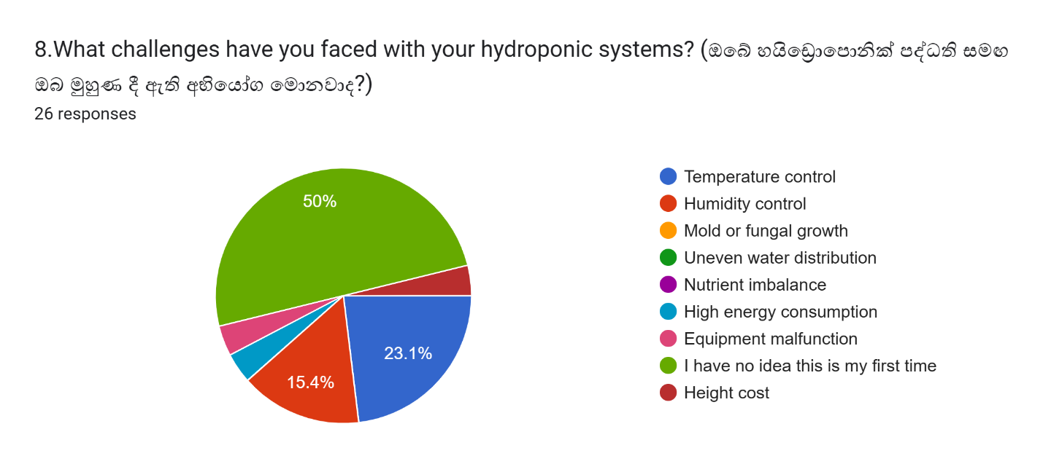

## **3.3 Expectations for Hydroponic Systems**

Participants expressed a strong interest in features like:

* **Automated Watering**: To reduce manual intervention and ensure consistent hydration.
* **Temperature and Humidity Monitoring**: Critical for maintaining an optimal environment for fodder production.
* **Light Control**: To support plant growth, particularly in indoor settings.
* **Nutrient Dosing**: For precise delivery of nutrients, improving growth and yield.

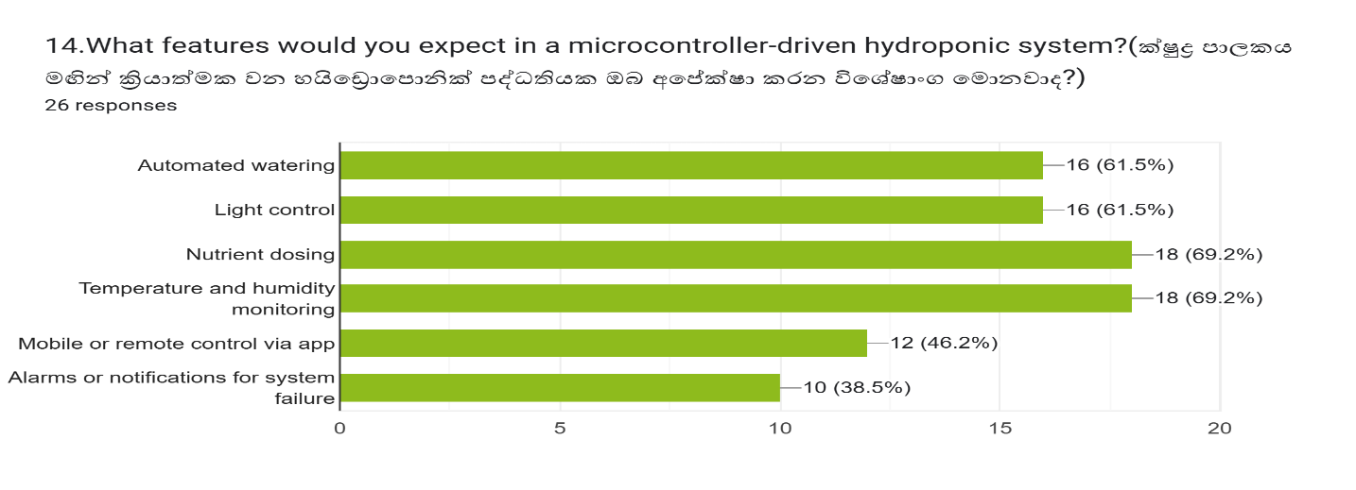

## **3.4 Investment Willingness**

Most respondents were willing to invest between **LKR 60,000 and LKR 80,000**, while a few preferred systems under **LKR 60,000** or were open to higher-cost options exceeding **LKR 100,000**. This indicates a diverse range of affordability among users, necessitating scalable solutions to cater to different budgets.

## **3.5 Importance of Sustainability**

Water conservation and energy efficiency were deemed highly important by most respondents. Many expressed interest in systems powered by renewable energy, such as solar panels, to reduce operating costs and environmental impact.

## **3.6 Additional Insights**

Respondents emphasized the need for:

* Cost-effective solutions to make hydroponics accessible, especially in regions like Sri Lanka, where traditional farming methods dominate.
* Increased awareness programs conducted in collaboration with agriculture departments to educate farmers on the benefits and usage of hydroponic systems.

# **4 Requirement Analysis**

## **4.1 Functional Requirements**

1. **Monitoring and controlling water levels.**

The system uses water level sensors to track the water levels in the reservoir and activates the pump automatically to refill when levels are low, ensuring consistent hydration for plant growth.

1. **Automatically turn on lights when getting darkness**

This feature uses a light sensor (LDR) to detect darkness. When the light level drops below a set threshold, the system automatically turns on LED grow lights to ensure plants get enough light for growth. The lights turn off when natural light returns.

1. **Adjusting temperature based on environmental conditions.**

Temperature sensors detect deviations from the optimal range, triggering cooling fans or heaters to maintain a stable environment for plant growth.

1. **Providing alerts for low water levels or nutrient deficiencies.**

The system provides alerts for low water levels or nutrient deficiencies, ensuring timely action. It also changes the water in the pipes at set intervals to maintain cleanliness and nutrient balance for optimal plant growth.

## **4.2 Non-Functional Requirements**

Reliability: The system must consistently perform its functions without failure.

Usability: The user interface should be intuitive and easy to navigate, allowing users to monitor and control the system with minimal training.

Scalability: The system should be designed to accommodate future expansions or modifications, allowing for the addition of more plants or advanced features.

# 5 System Design

The design of the hydroponic system will incorporate several key components working in harmony. The water reservoir will be the heart of the system, supplying nutrient-rich water to the plants. A network of pumps will circulate water through the growing medium, ensuring that plants receive adequate nutrients and moisture.

Layout: The system layout will be designed to maximize space efficiency and accessibility. Vertical farming techniques may be employed to allow for more plants in a smaller area.

Growing Medium: A suitable growing medium, such as rock wool or coconut coir, will be selected to support plant roots while allowing for efficient water and nutrient uptake.

## **5.1 Control Mechanisms**

To maintain optimal growing conditions, the system will employ control mechanisms that respond to environmental changes. For instance:

Temperature Control: If the temperature rises above a predetermined threshold, the system will activate cooling fans or misters to lower the temperature. Conversely, if temperatures drop too low, heating elements will be engaged.

Water Level Management: The system will continuously monitor water levels in the reservoir, automatically activating pumps to refill as needed. Users will receive alerts if water levels drop below a safe threshold.

Nutrient Delivery: The system will be programmed to deliver precise amounts of nutrients based on plant growth stages, ensuring that plants receive optimal nutrition throughout their lifecycle.

## **5.2 Data Collection**

Data collection will be a critical aspect of the hydroponic system. Sensors will continuously monitor water levels, CO2 levels, and temperature, transmitting this data to the control software. Key features of the data collection process include:

Real-Time Monitoring: Users will be able to access real-time information through a user-friendly interface, allowing for timely adjustments to the system.

Historical Data Logging: Historical data will be logged for analysis, enabling users to identify trends and make informed decisions based on past performance.

Data Analysis Tools: The software will include data analysis tools to help users interpret sensor data and optimize growing conditions based on historical trends.

## **5.3 Power Management**

To ensure sustainability, the hydroponic system will integrate solar panels as an alternative power source. Key aspects of the power management system include:

Solar Panel Installation: Solar panels will be installed in a location with maximum sunlight exposure, ensuring efficient energy generation.

Battery Backup: A battery backup system will store excess energy generated by the solar panels, providing power during periods of low sunlight or high demand.

Power Management System: The system will be designed to automatically switch between solar power and battery power, ensuring uninterrupted operation. Users will be able to monitor energy consumption and production through the user interface

# **6 Diagram**

## **6.1 ER Digram**

**­­­­**

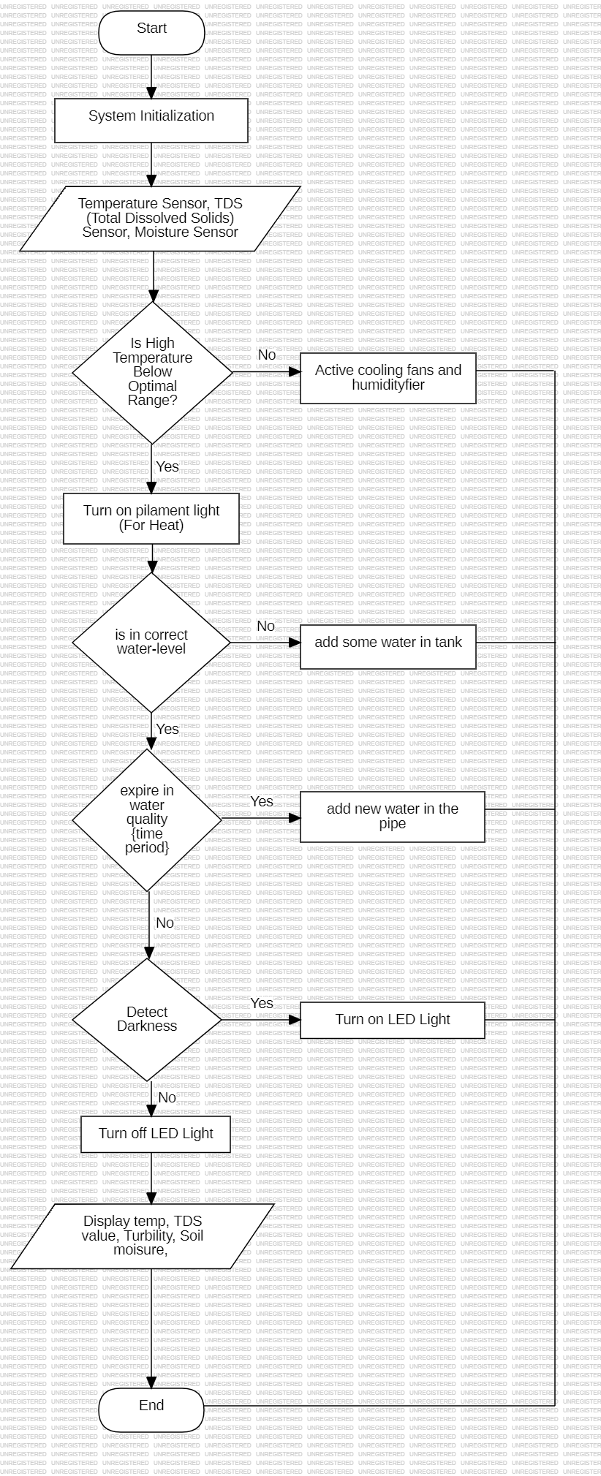

## **6.2 block Diagram**

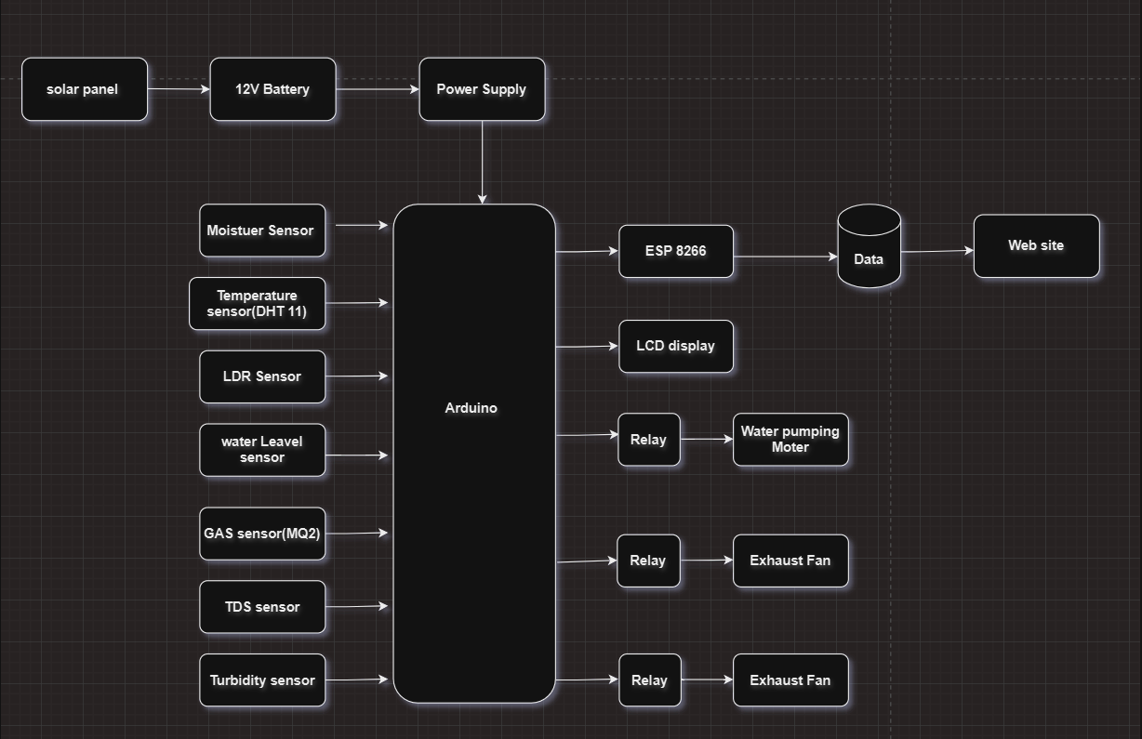

## **6.3 Circuit Diagram**