**VPN Setup & Testing – Task 8**

**1. VPN Setup Steps**

**Step 1: Chose a VPN Provider**  
Selected VeePN Free extension in Brave browser.

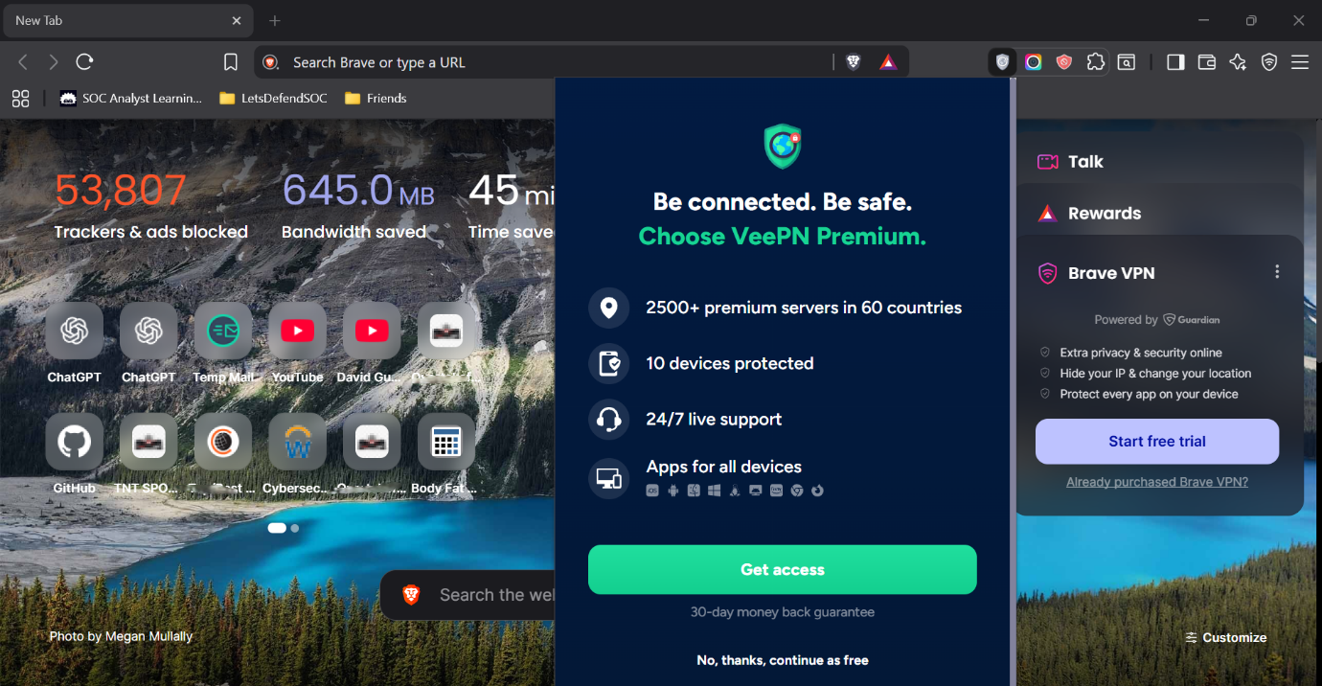

**Step 2: Installed the VPN Client**  
Added VeePN extension to Brave.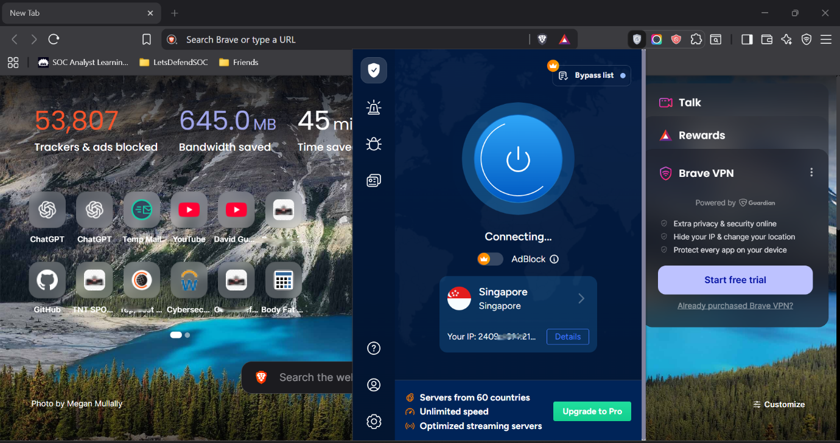

**Step 3: Connected to a Server**  
Chose Singapore as the VPN location.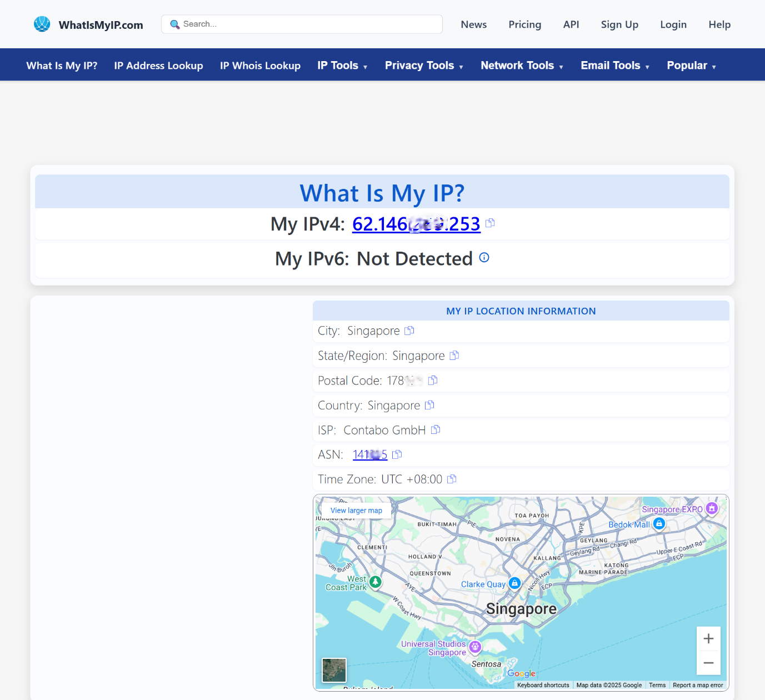

**Step 4: Verified IP Change**  
Before VPN: Local ISP IP.  
After VPN: Singapore IP (62.xxx.xxx.253, ISP: Contabo GmbH).

**Step 5: Checked DNS Leak Protection**  
Used dnsleaktest.com – showed Singapore IP, no leaks detected. 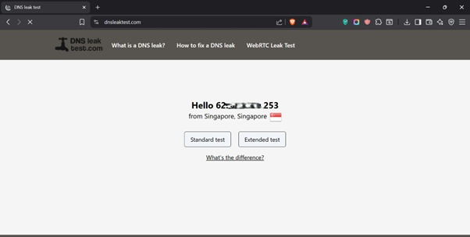

**Step 6: Tested Internet Speed**  
With VPN: Download 0.87 Mbps / Upload 1.65 Mbps.  
Without VPN: Download 149.15 Mbps / Upload 4.59 Mbps.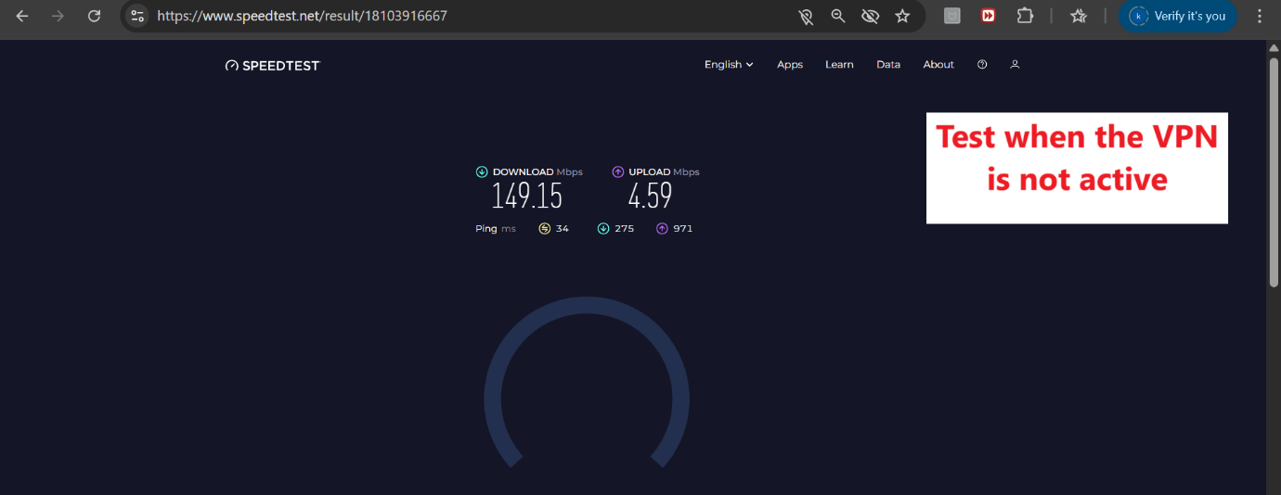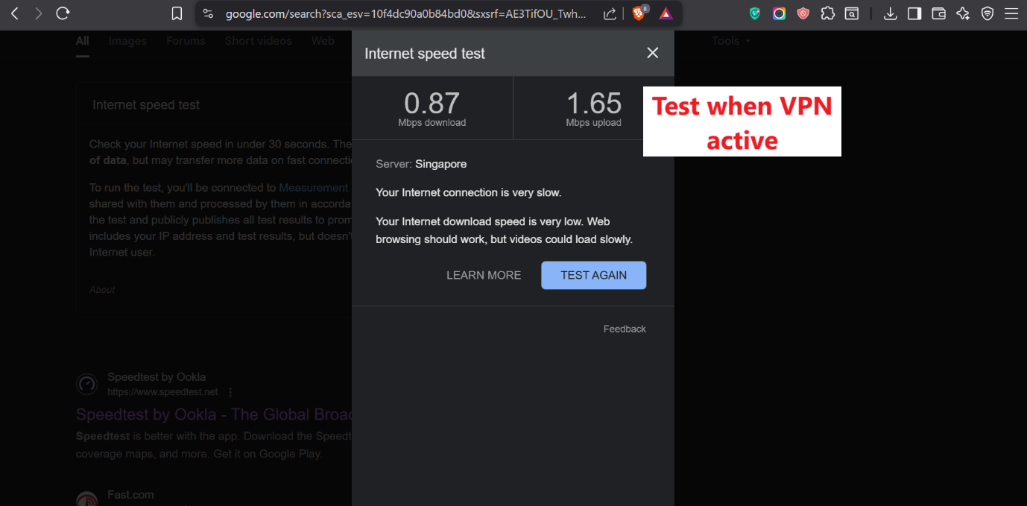



**Step 7: Verified Encrypted Traffic**  
Browsed securely with new IP.

**Step 8: Disconnected VPN**  
Compared speed & IP to original.

**2. Findings**

* VPN successfully hid the real IP and showed Singapore location.
* Traffic was routed through VPN tunnel, securing data from local ISP monitoring.
* Significant speed drop when VPN active, especially download speed.
* No DNS leaks detected; DNS queries were routed through VPN server.

**3. VPN Benefits**

* Hides real IP & location.
* Encrypts internet traffic.
* Protects data from eavesdroppers on public Wi-Fi.
* Allows bypassing geo-restrictions.

**4. VPN Limitations**

* Can reduce internet speed significantly.
* Free VPNs may have limited server locations and data caps.
* Not a guarantee of complete anonymity (VPN provider can log data).
* Some websites/services may block VPN traffic.