Kavit Shah
BIA-656 Advanced Data Analytics and Machine Learning
Assignment – 2

1(a)
Ans: The expected log return is not zero. Yes, there are serial correlation in the log returns as the image below tells about it.
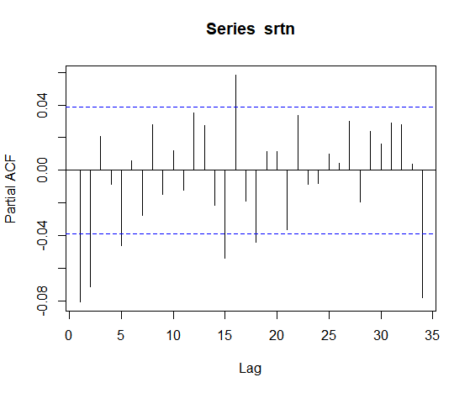
After conducting the ARCH-LM Test we have following conclusions (Significance level = 0.05):
ARCH LM-test; Null hypothesis: no ARCH effects

data: srtn
Chi-squared = 784.76, df = 12, p-value < 2.2e-16

Since the p-value is lower than 0.05 the Null Hypothesis is rejected which tells us that, there is an ARCH-effect on the log returns.
1 (b)
Ans: The fitted model was ARMA (1,1) + GARCH (2,1) and the QQ-plot of Standardized Residuals is as follows:
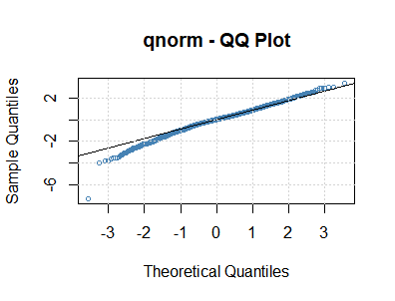

1 (c)
Ans: The fitted model was ARMA (1,1) + GARCH (2,1)
The model testing was done using the Ljung-box test
Box-Ljung test

data: sresidual
X-squared = 9.7969, df = 12, p-value = 0.6338

Box-Ljung test

data: sresidual^2
X-squared = 5.9847, df = 12, p-value = 0.9169

1 (d)
Ans: The fitted model is ARMA (1,1) + APARCH (1,1) with student-t innovations to the data
Prediction from 1 step to 5 steps ahead:
0-roll forecast [T0=1976-12-09 19:00:00]:
Series Sigma
T+1 0.0017632 0.02195
T+2 0.0011712 0.02178
T+3 0.0008559 0.02161
T+4 0.0006880 0.02144
T+5 0.0005986 0.02127

The volatility prediction of the model:
> sigma(p1) ### volatility prediction
1976-12-09 19:00:00
T+1 0.02195131
T+2 0.02177878
T+3 0.02160853
T+4 0.02144051
T+5 0.02127471

2 (a)
Ans:
One Sample t-test

data: srtn1
t = 4.2198, df = 608, p-value = 2.819e-05
alternative hypothesis: true mean is not equal to 0
95 percent confidence interval:
0.005655242 0.015501584
sample estimates:
mean of x
0.01057841
The expected log return is not zero as we do the t-test. Yes, there are serial correlation in the log returns as the acf and pacf plots below tells about it.

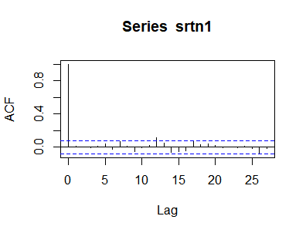
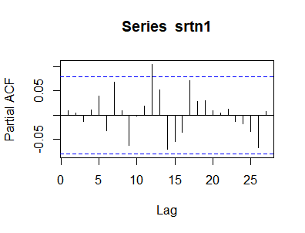
The start of the series does not show any significant correlation but later there is a value greater than the significance line on lag 12 as seen above in both the graphs.

After conducting the ARCH-LM Test we have following conclusions (Significance level = 0.05):

ARCH LM-test; Null hypothesis: no ARCH effects

data: srtn1
Chi-squared = 94.125, df = 12, p-value = 7.812e-15

Since the p-value is lower than 0.05 the Null Hypothesis is rejected which tells us that, there is an ARCH-effect.

2 (b)
Ans: The fitted model is GARCH (1,1) and the result below are for the model-fit. High p-values results in a good model.
Box-Ljung test

data: standardresi
X-squared = 14.91, df = 12, p-value = 0.2464

Box-Ljung test

data: standardresi^2
X-squared = 12.834, df = 12, p-value = 0.3813

2 (c) 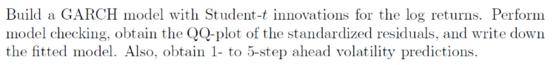
Ans: The model fitted is GARCH (1,1) the output below gives us the volatility predictions of step-1 to step-5

sigma(predict1) ### volatility prediction
1971-09-01 20:00:00
T+1 0.04481666
T+2 0.04594494
T+3 0.04698098
T+4 0.04793459
T+5 0.04881413

The QQ-Plot of the Standardized Residuals is given below:
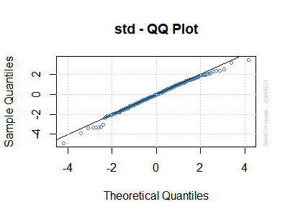

3 (a)
Ans:
Since the Weighted Ljung-Box test for 12 lags gives high p-values for Standardized Residuals and Squared Residuals. This shows the model is good.
The results of model testing are shown below.
Ans: Box-Ljung test

data: sresiduals
X-squared = 14.91, df = 12, p-value = 0.2464

Box-Ljung test

data: sresiduals^2
X-squared = 12.834, df = 12, p-value = 0.3813
Joint Statistic: 0.9051
Individual Statistics:
mu 0.18686
omega 0.15567
alpha1 0.15927
beta1 0.16566
gamma1 0.05508

The leverage effect is shown by gamma(γ): It shows that the null hypothesis is not rejected as the value of the gamma1 is higher > 0.05 and the Null Hypotheses is accepted meaning that the leverage effect is very close to zero

3 (b)
Ans:
Optimal Parameters
------------------------------------
Estimate Std. Error t value Pr(>|t|)
mu 1.157266 0.228350 5.0680 0.000000
omega 3.031673 1.050280 2.8865 0.003895
alpha1 0.048810 0.030121 1.6205 0.105132
beta1 0.823399 0.037896 21.7278 0.000000
gamma1 0.080484 0.044828 1.7954 0.072589
After the running the model we get Beta value as 0.8233 which is significant. The beta is the measure of how risky an asset is compared to the overall market. The premium is adjusted for the risk of the asset.
An asset with zero risk and, therefore, zero beta, for example, would have the market risk premium canceled out. On the other hand, a highly risky asset, with a beta of 0.8, would take on almost the full premium.

