Following will be the details of the results from Task 1 & 2:

Notes: The codes unlisted in the external files are recorded in this document

Values in red are results of the calculations

import numpy as np

import pylab as p

#Establish parameters

mu=0.1;sigma=0.26;S0=39;n=n_simulations=100

#Creating Brownian paths

t=np.linspace(0,3,n+1)

dB=p.randn(1,n+1)/p.sqrt(n);dB[:,0]=0

B=dB.cumsum(axis=1)

#Calculating stocks prices

mr=mu-0.5*sigma*sigma

St=p.zeros_like(B);St[:,0]=S0

St[:,1:]=S0*p.exp(mr*t[1:]+sigma*B[:,1:])

#Calculating mean and variance

p.mean(St[:,100])

E[St[:,100]]= 41.032634100716976

p.var(St[:,100])

Var[St[:,1000]]=0.0 #Only one path was plotted

Task 1(b)

The graph of the simulated GBM is as follows

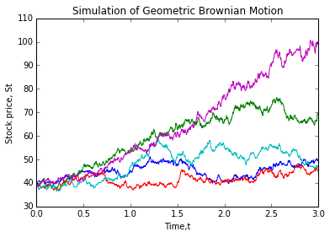

Mean=py.mean(S[:,1000]) #Average of all stock prices from 5 simulations at time 3

Mean

E[S[:,1000]]= 62.110161885928775

Variance=py.var(S[:,1000]) #Variance of stock prices at time 3

Variance

Var[S[:,1000]]= 437.3556852528958

Calculating probabilities

mask=S[:,1000] > 39

Probability=sum(mask)/n_paths

print('P(S[:,1000]>39)=' + str(Probability))

P(S[:,1000]>39)= 1.0

#Calculating expectation

mask=S[:,1000] > 39 #number of values more than 39

Probability = S[:,1000] * mask #retrieving values greater than 39

Expectation= sum(Probability)/sum(mask)

print('E(S[:,1000]|S[:,1000]>39)=' + str(Expectation))

E(S[:,1000]|S[:,1000]>39)= 62.1101618859

Task 1(c) : Following is the graphed Mean Reverting SDE

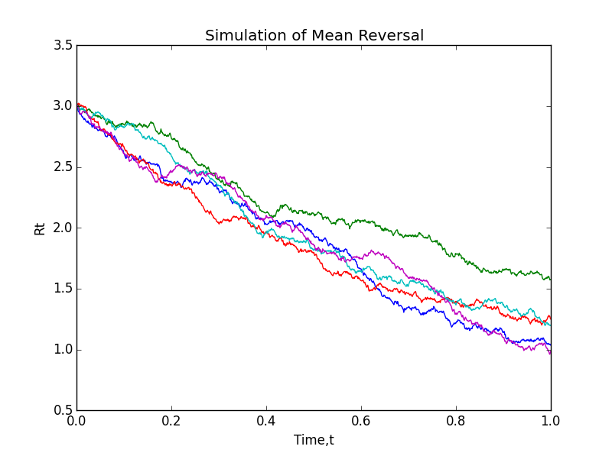

E[R(1)]

p.mean(R[:,1000])

E[R(1)]= 1.2093141565137997

P[R(1)>2]

mask=R[:,1000] > 2

Probability=sum(mask)/n_paths

print('P(R[:,1]>2)=' + str(Probability))

P(R[:,1]>2)=0.0

The FTSE Bursa Malaysia KLCI will consist of the largest 30 companies ranked by full market capitalisation, i.e. before the application of any investability weightings, in the FTSE Bursa Malaysia EMAS Index. The number of constituents in this index is fixed.

Source:

|  |  |  |  |  |  |  |
| --- | --- | --- | --- | --- | --- | --- |
| No. | ICB Supersector | Constituent Name | Code | Net Mcap (Billion) | PE Ratio | Weightage% |
| 1. | Banks | CIMB Group Holdings Berhad | 1023 | 46.69 | 17.57 | 4.661401915 |
| 2. | Banks | HONG LEONG BANK BHD | 5819 | 24.05 | 11.19 | 2.401086229 |
| 3. | Banks | HONG LEONG FINANCIAL GROUP BHD | 1082 | 16.22 | 9.96 | 1.619360442 |
| 4. | Banks | MALAYAN BANKING BHD | 1155 | 88.04 | 12.42 | 8.789672833 |
| 5. | Banks | PUBLIC BANK BHD | 1295 | 73.37 | 15.21 | 7.325060152 |
| 6. | Banks | RHB CAPITAL BHD | 1066 | 19.01 | 9.19 | 1.897906413 |
| 7. | Banks | AMMB HOLDINGS BHD | 1015 | 16.92 | 8.82 | 1.689246528 |
| 8. | Media | ASTRO MALAYSIA HOLDINGS BERHAD | 6399 | 15.76 | 28.32 | 1.5734353 |
| 9. | Telecommunications | AXIATA GROUP BERHAD | 6888 | 55.35 | 24.27 | 5.525992632 |
| 10. | Food & Beverage | BRITISH AMERICAN TOBACCO (M) | 4162 | 18.45 | 20.05 | 1.841997544 |
| 11. | Telecommunications | DIGI.COM BHD | 6947 | 41.83 | 21.02 | 4.176192806 |
| 12. | Travel & Leisure | GENTING BHD | 3182 | 30.75 | 16.44 | 3.069995907 |
| 13. | Travel & Leisure | GENTING MALAYSIA BERHAD | 4715 | 24.10 | 20.24 | 2.406078093 |
| 14. | Health care | IHH HEALTHCARE BERHAD | 5225 | 48.76 | 63.76 | 4.868065054 |
| 15. | Personal & Household Goods | IOI CORPORATION BHD | 1961 | 26.67 | 64.92 | 2.662659864 |
| 16. | Real Estate | KLCC PROP&REITS-STAPLED SEC | 5235SS | 12.73 | 26.6 | 1.270928387 |
| 17. | Industrial Goods & Services | KUALA LUMPUR KEPONG BHD | 2445 | 23.98 | 29.21 | 2.394097621 |
| 18. | Telecommunications | MAXIS BERHAD | 6012 | 49.41 | 30.18 | 4.932959276 |
| 19. | Industrial Goods & Services | MISC BHD | 3816 | 35.26 | 15.99 | 3.520261973 |
| 20. | Chemicals | PETRONAS CHEMICALS GROUP BHD | 5183 | 50.64 | 21.83 | 5.055759113 |
| 21. | Oil & Gas | PETRONAS DAGANGAN BHD | 5681 | 20.45 | 37.01 | 2.041672075 |
| 22. | Oil & Gas | PETRONAS GAS BHD | 6033 | 42.74 | 22.78 | 4.267044717 |
| 23. | Food & Beverages | PPB GROUP BHD | 4065 | 18.23 | 18.14 | 1.820033346 |
| 24. | Oil & Gas | SAPURAKENCANA PETROLEUM BHD | 5218 | 14.27 | 12.07 | 1.424677775 |
| 25. | General Industries | SIME DARBY BHD | 4197 | 51.42 | 20.53 | 5.13363218 |
| 26. | Telecommunications | TELEKOM MALAYSIA BHD | 4863 | 24.66 | 32.5 | 2.461986961 |
| 27. | Utilities | TENAGA NASIONAL BHD | 5347 | 69.3 | 9.25 | 6.918722482 |
| 28. | Automobile & Parts | UMW HOLDINGS BHD | 4588 | 11.99 | 20.6 | 1.19704881 |
| 29. | Industrial Goods & Services | WESTPORTS HOLDINGS BERHAD | 5246 | 13.91 | N/A | 1.38873636 |
| 30. | Utilities | YTL CORPORATION BHD | 4677 | 16.67 | 14.81 | 1.664287212 |

Source: Note: The constituents list was last updated on 22 June 2015 (http://www.bursamalaysia.com/misc/system/equity_market_statistics/FBMKLCI.pdf)

Task 2(b): Following shows the moving average of stock 4162.KL (British American Tobacco Malaysia Bhd)

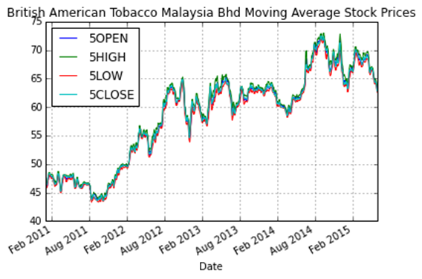

#Calculating the correlation of FTSEKLCI with BATM

Out[48]:

5CLOSE NaN

5HIGH NaN

5LOW NaN

5OPEN NaN

Adj Close 0.903636

Close 0.889367

High 0.885543

Low 0.893789

Open 0.889828

Volume 0.287579

dtype: float64