**SQL ASSIGNMENT**

Chapter1:

1. Write a query to create a simple table Movies including columns movie_id , movie_name, release_year, rental_rate.

Query:

Create Table movies (movie_id Integer, movie_name Text, release_year Integer, rental_rate Numeric (5,2));

Select * From movies;

Output:

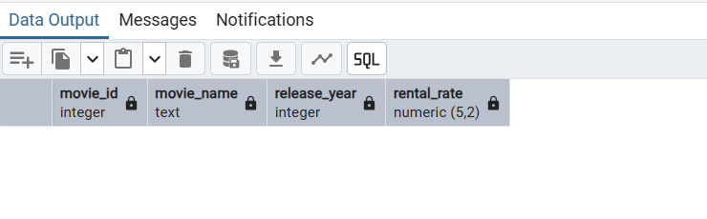

1. Write a query to insert 5 records with your own value into the table Movies against each

column. The release_year must be 2016, 2017, 2022, 2025, 2023.

Query:

Insert into movies (movie_id, movie_name, release_year, rental_rate)

Values (1, 'interstellar',2016, 500),

(2,'lion king', 2017, 700),

(3,'mufasa', 2022, 650),

(4,'toy story', 2025, 500),

(5,'the matrix', 2023, 750);

Select * From movies;

Output:

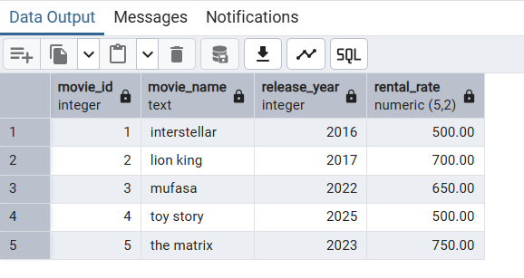

1. Write a query to insert rows from film table to Movies table.

Query:

Insert into movies (movie_id, movie_name, release_year, rental_rate)

Select film_id, title, release_year, rental_rate

from film;

Select * from movies;

Output:

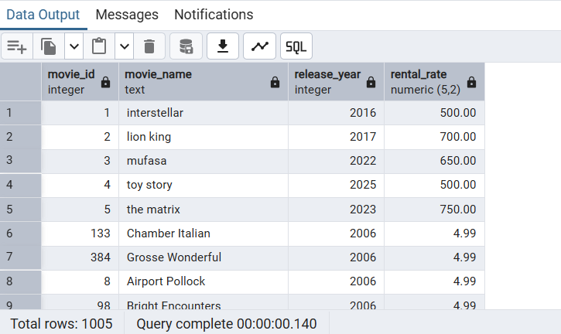

1. Write a query to update the rental_rate to 999 for those Movies whose release_year is greater than 2022.

Query:

Update movies Set rental_rate='999' where release_year>2022;

Select * from movies;

Output:

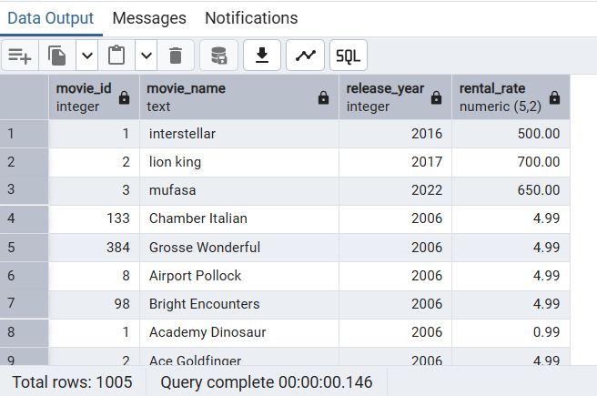

1. Delete the rows from the Movies table where the rental_rate is 999.

Query:

Delete from movies where rental_rate = 999;

Select * from movies;

Output:

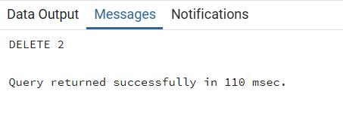

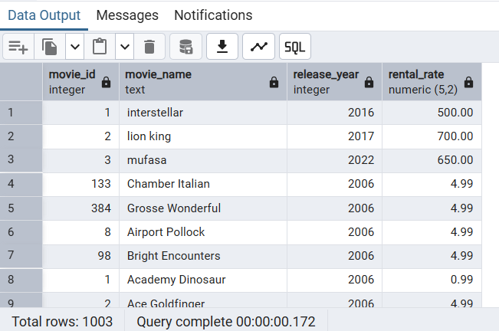

1. Drop the table Movies.

Query:

Drop table movies;

Output:

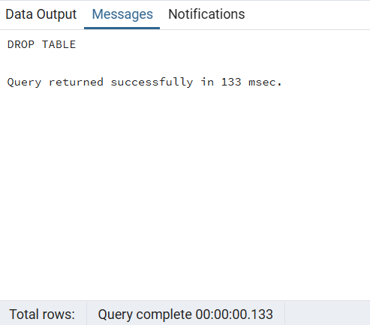

Chapter 2

1. Display all the names of the customers with store_id = 1.

Query:

Select first_name, last_name from customer where store_id = 1;

Output:

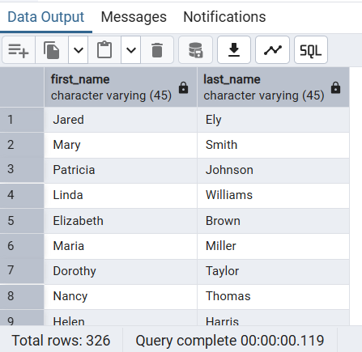

1. Display all the customer names ordered in descending order of their address.

Query:

Select first_name, last_name, address_id from customer order by address_id desc;

Output:

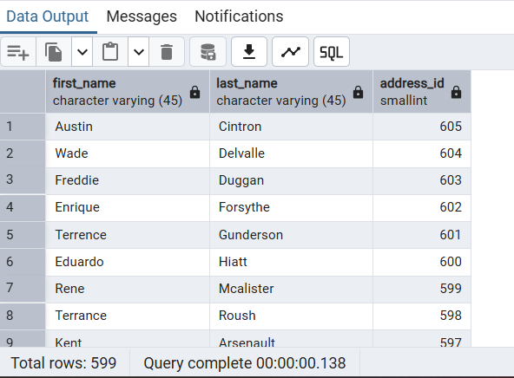

1. Display the addresses whose phone number is empty.

Query:

Select * from address where phone = '';

Output:

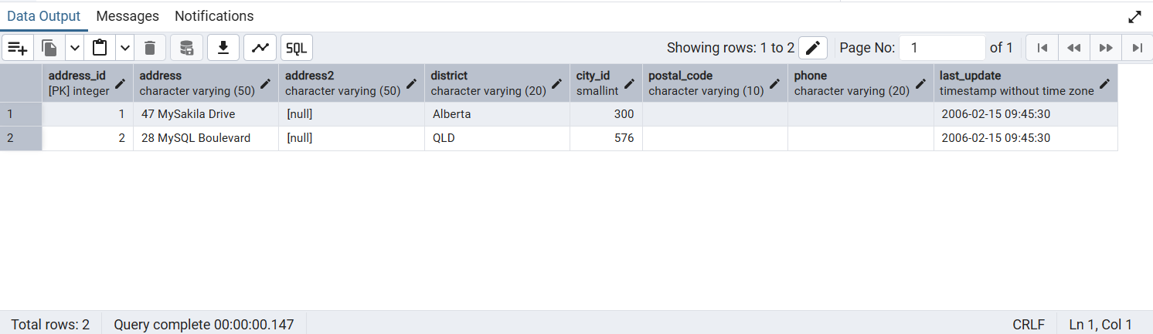

1. Display all the distinct years of the movie released from the films.

Query:

Select distinct release_year from film;

Output:

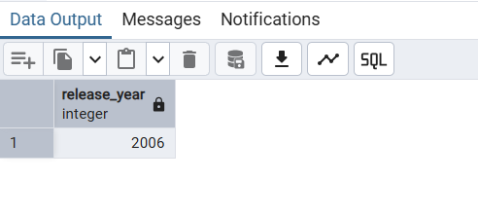

5. Display the names of the customers whose first names start with A and last name

ends with ‘l’.

Query:

Select first_name, last_name from customer

where first_name like 'A%' and last_name like '%l';

Output:

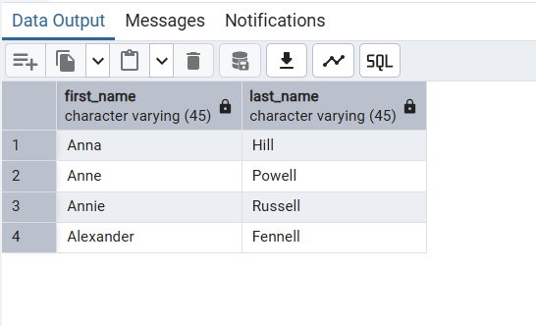

6. Display the address whose city id is in between 30 and 190.

Query:

Select * from address where city_id between 30 and 190;

Output:

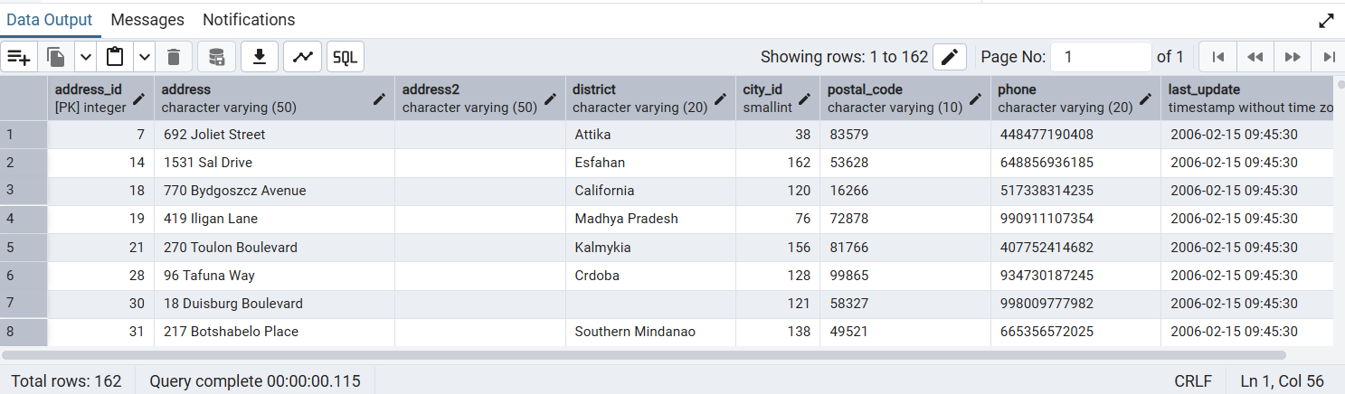

7. Display the address whose city id is in between 30 and 190 and whose district is

Texas.

Query:

Select * from address

where city_id between 30 and 190

and lower(district) = 'texas';

Output:

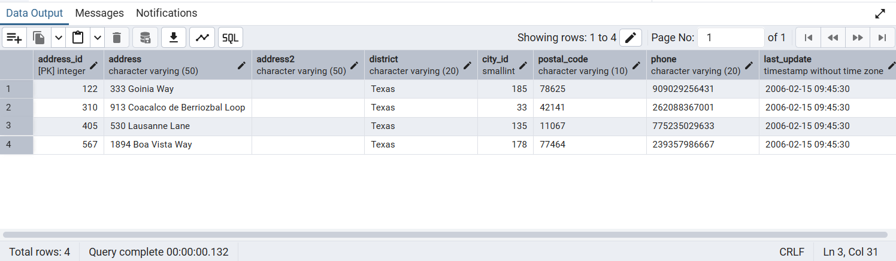

8. Display all the inventories whose film id is 1 or 2.

Query:

Select * from inventory where film_id = 1 or film_id = 2;

Output:

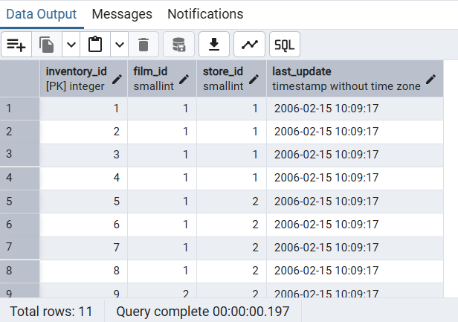

9. Display all the records whose city_id is not 200.

Query:

Select * from address where city_id != 200;

Select * from city where city_id != 200;

Output:

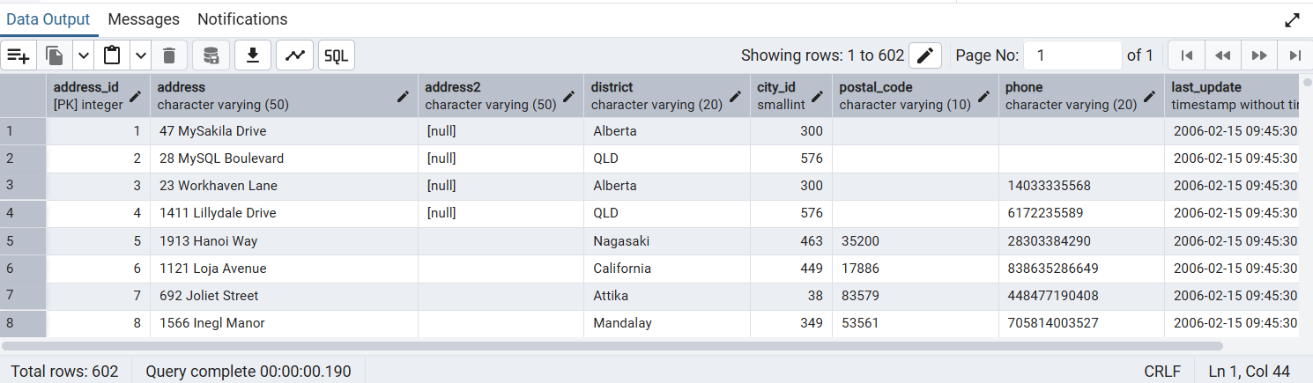

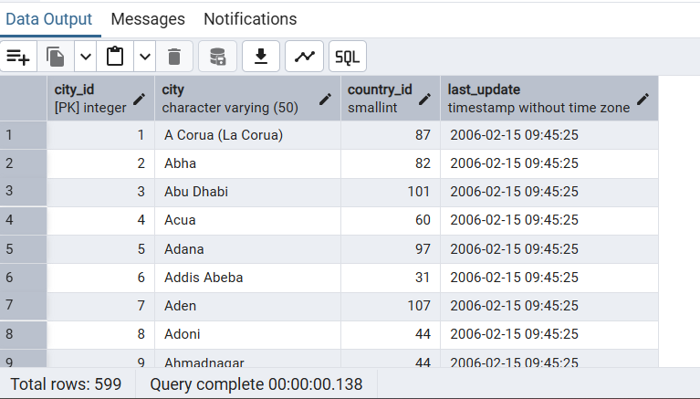

10. Write a query to create a table Movies and set NOT NULL and PRIMARY KEY

constraints for movie_name and movie_id .

Query:

Create table movies

(movie_id Integer not null primary key ,

movie_name Text not null ,

release_year Integer,

rental_rate Numeric(6,2));

Select * from movies;

Output:

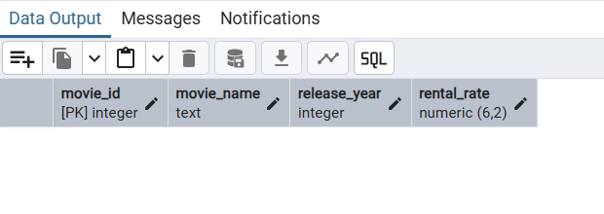

Chapter 3

1. What is the movie(s) that was rented the most.

Query: (Joined rental, inventory and film tables)

SELECT f.film_id, f.title, COUNT(*) AS rental_count

FROM rental r

JOIN inventory i ON r.inventory_id = i.inventory_id

JOIN film f ON i.film_id = f.film_id

GROUP BY f.film_id, f.title

ORDER BY rental_count DESC

LIMIT 1;

Output:

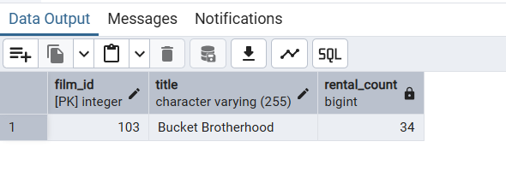

1. Display each movie and the number of times it got rented.

Query:

Select f.film_id, f.title, Count(*) As rental_count

From rental r

Join inventory i On r.inventory_id = i.inventory_id

Join film f On i.film_id = f.film_id

Group by f.film_id, f.title

Order by rental_count Desc;

Output:

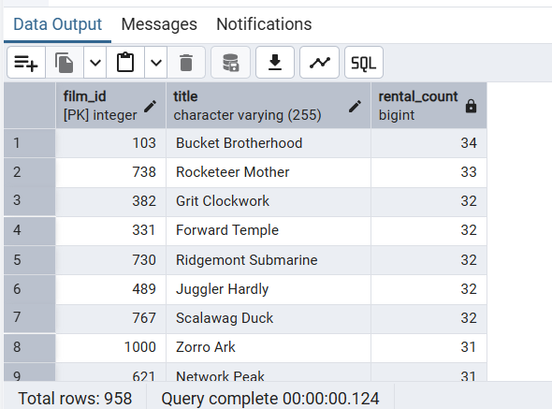

1. Show the number of movies each actor acted in.

Query: (Joined actor, film_actor and film tables)

Select a.actor_id, a.first_name , a.last_name ,

count(*)as film_count

from actor a

join film_actor fa on a.actor_id = fa.actor_id

join film f on fa.film_id = f.film_id

group by a.actor_id, a.first_name , a.last_name

order by film_count Desc;

Output:

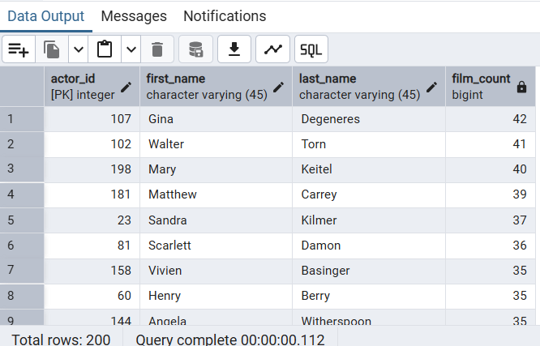

1. Display the names of the actors that acted in more than 20 movies.

Query:

Select a.actor_id, a.first_name , a.last_name ,

count(*)as film_count

from actor a

join film_actor fa on a.actor_id = fa.actor_id

join film f on fa.film_id = f.film_id

group by a.actor_id, a.first_name , a.last_name

Having count(*) > 20

order by film_count desc;

Output:

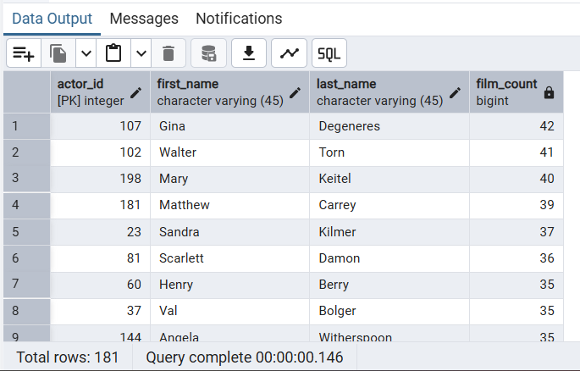

1. For each store, display the number of customers that are members of that
2. store.

Query: (Joined store and customer tables)

Select s.store_id , count(c.customer_id) as member_count

from store s

join customer c on s.store_id = c.store_id

group by s.store_id;

Output:

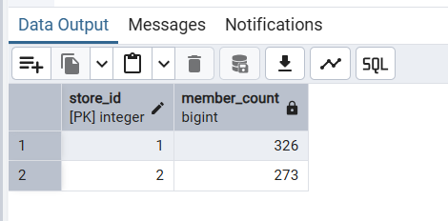

1. What is the highest total_payment done.

Query:

Select customer_id,sum(amount)as Total_Highest_Payment

from payment

group by customer_id

order by Total_Highest_payment desc

Limit 1;

Output:

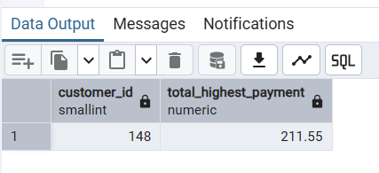

1. What is the name of the customer who made the highest total payments.

Query:

Select c.customer_id, c.first_name, c.last_name, sum(p.amount)as Total_Highest_Payment

from payment p

join customer c on p.customer_id = c.customer_id

group by c.customer_id, c.first_name, c.last_name

order by Total_Highest_payment desc

Limit 1;

Output:

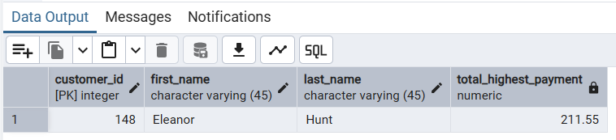

1. How many actors have 8 letters only in their first_names.

Query:

Select count(*) from actor

where length(first_name)=8;

Output:

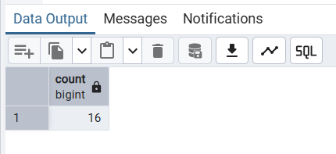

1. Display the movies offered for rent in store_id 1 and not offered in
2. store_id 2.

Query: (Joined film and inventory tables)

Select f.film_id, f.title, i.store_id

from film f

join inventory i on f.film_id = i.film_id

group by f.film_id, f.title, i.store_id

having i.store_id = 1

order by f.film_id desc;

Output:

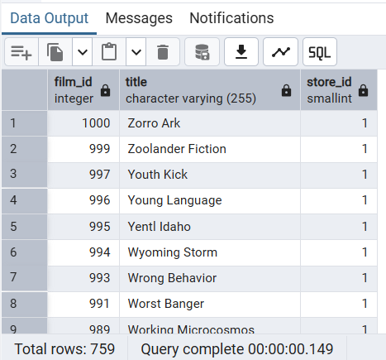

1. Display the movie title for the most rented movie in the store with
2. store_id 1.

Query: ( Joined rental, film and inventory table)

Select f.film_id, f.title, i.store_id, Count(*) As rental_count

From rental r

Join inventory i On r.inventory_id = i.inventory_id

Join film f On i.film_id = f.film_id

Group by f.film_id, f.title ,i.store_id

Having i.store_id = 1

Order by rental_count Desc

Limit 1;

Output:

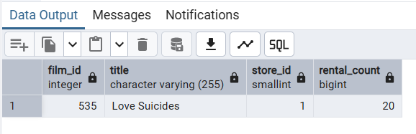

Chapter 4

1. Find the names of the customers had bought DVD for rent for more than 5

days?

Query:

Select Concat(c.first_name,'',c.last_name)as Fullname

from Customer c

Join rental r on c.customer_id = r.customer_id

where Extract (Day From r.return_date - r.rental_date) > 5;

Output:

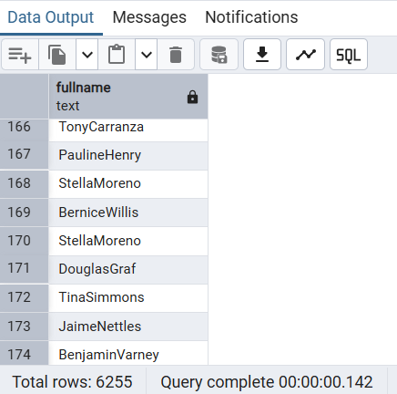

2. Find the city with maximum number of Staff ?

Query:

Select c.city_id, c.city, count(s.staff_id)as StaffCount

from city c

join address a on c.city_id = a.city_id

join staff s on s.address_id = a.address_id

group by c.city_id, c.city

order by StaffCount desc

Limit 1;

Output:

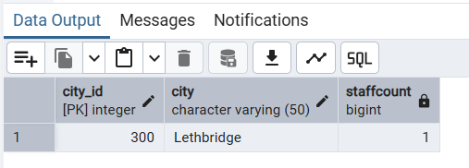

3. Find the Staff Names in a city "Barcelona"?

Query:

Select s.staff_id, concat(s.first_name,' ',s.last_name),c.city

from staff s

join address a on s.address_id = a.address_id

join city c on c.city_id = a.city_id

where c.city = 'Barcelona';

Output: The city Barcelona has no staff.

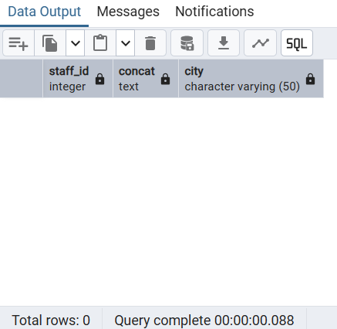

4. List all the stores with their address.

Query:

Select s.store_id, a.address, a.district, c.city, a.postal_code

from city c

join address a on c.city_id = a.city_id

join store s on a.address_id = s.address_id;

Output:

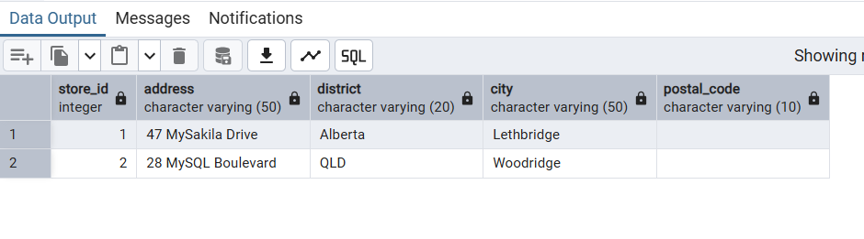

5. Find the films which were not rented ?

Query:

select f.film_id, f.title

from film f

where f.film_id not in (

select i.film_id

from inventory i

join rental r on r.inventory_id = i.inventory_id

);

Output:

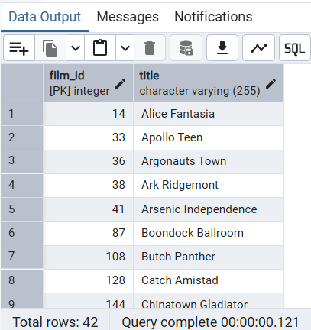

6. Find the film which has maximum number of inventory ?

Query:

select f.film_id, f.title, count(i.inventory_id)as inventoryCount

from film f

join inventory i on f.film_id = i.film_id

group by f.film_id,f.title

order by inventoryCount desc

limit 1;

Output:

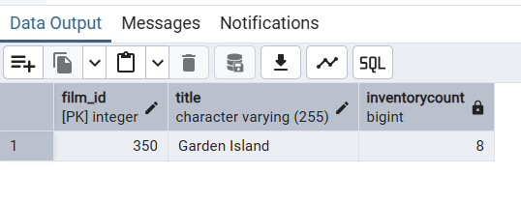

7. Find the name of the store which has maximum inventory ?

Query: (Joined 4 tables here)

Select s.store_id,concat(a.address ,' ', a.district,' ',c.city)as StoreLocation,

count(i.inventory_id)as inventoryCount

from store s

join inventory i on s.store_id = i.store_id

join address a on s.address_id = a.address_id

join city c on c.city_id = a.city_id

group by s.store_id, concat(a.address ,' ', a.district,' ',c.city)

order by inventoryCount desc

Limit 1;

Output:

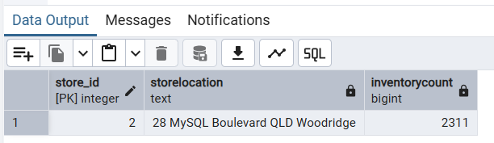

8. Find the actors who have not acted in a film ?

Query:

select actor_id, concat(first_name,' ',last_name)as ActorName

from actor

where actor_id not in (

select actor_id from film_actor

);

Output:

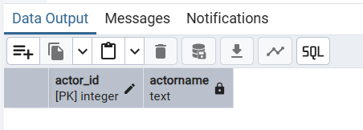

It means all the actors have acted in alteast one film. To verify that I have verified the actor’s count in both the tables.

Select count(distinct(actor_id)) from actor;

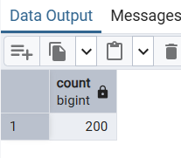

Select count(distinct(actor_id)) from film_actor;

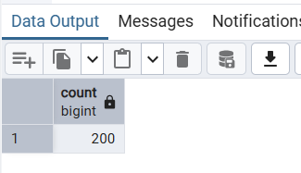

9. Show the number of rented movies under each rating.

Query:

Select f.rating , Count(r.rental_id)as rentalCount

from rental r

join inventory i on r.inventory_id = i.inventory_id

join film f on f.film_id = i.film_id

group by f.rating;

Output:

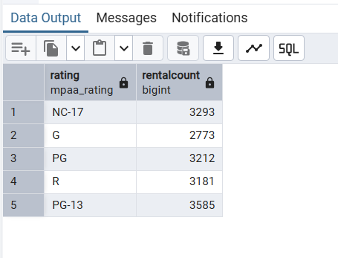

Chapter 5:

1. Create view on table film on columns film_id and title.

Query:

Create view film_view as

select film_id , title from film;

Select * from film_view;

Output:

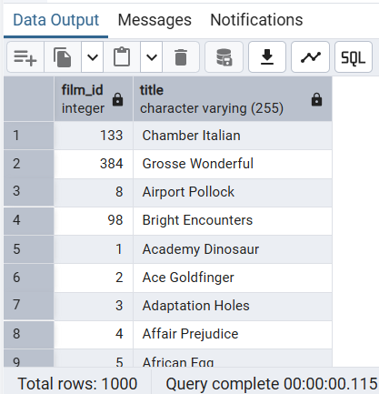

2. Create a view to locate the rental_rate is 4.99.

Query:

Create view rental_rate_view as

Select film_id, title, language_id,rental_duration,length, replacement_cost,rating

from film where rental_rate = 4.99;

Select * from rental_rate_view;

Output:

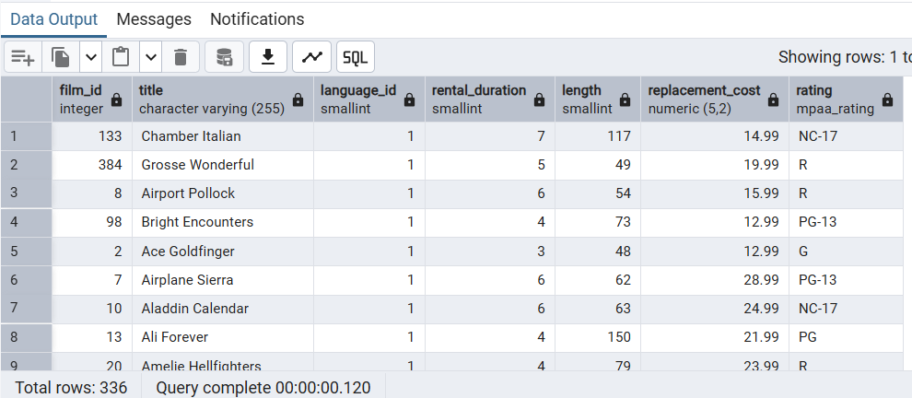

3. Drop the view for the table film.

Query:

Drop view if exists film_view;

Output:

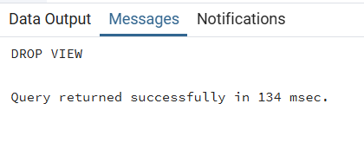

Chapter 6:

1. Create index on ‘film’ table.

Query:

Create index film_index on film(title);

To list the Index:

Select indexname , indexdef from pg_indexes

Where tablename = 'film';

Output 1:

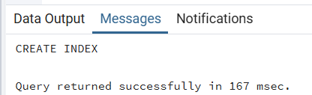

Output 2: Listing the index

Latest film_index that I have created.

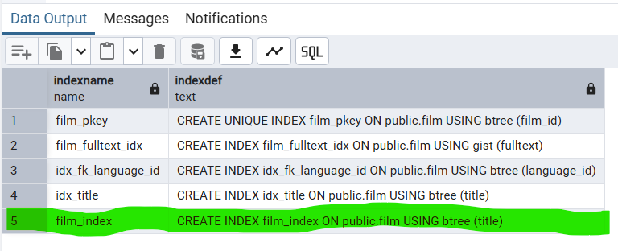

2. Create index on the on the ‘customer’ table using the first_name and the

last_name.

Query:

Create index customer_index on customer(first_name ,last_name);

Select indexname , indexdef

from pg_indexes

Where tablename = 'customer';

Output:

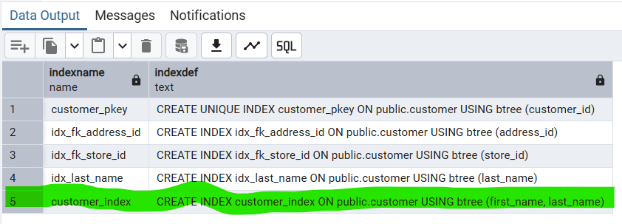

3. Write a Query to drop the indexes.

Query:

Drop index film_index;

Drop index customer_index;

Output:

Dropping film_index

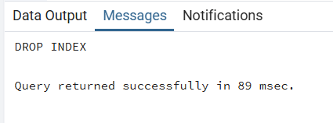

Dropping customer index

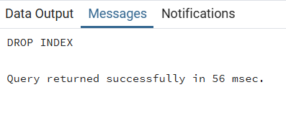

Chapter 7:

1. Create a trigger function while performing insert on the ‘film’ table.

Query:

-- Crating an audit table--

Create Table film_insert_log (

film_id int,

title text,

inserted_at timestamp Default Current_Timestamp

);

Output:

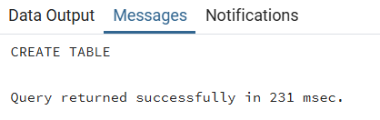

Query:

--Creating Trigger Function--

Create or Replace Function log_film_insertion()

Returns Trigger as $$

Begin

Insert into film_insert_log(film_id, title)

Values (NEW.film_id, NEW.title);

Return New;

End;

$$ Language plpgsql;

Output:

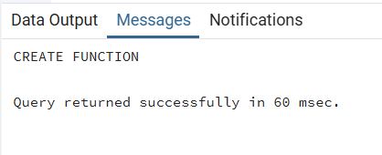

Query:

Create Trigger trg_log_film_insert

After Insert On film

For Each Row

Execute Function log_film_insertion();

Output:

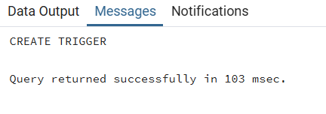

Query:

--Inserting New row—

INSERT INTO film (title, description, release_year, language_id, rental_duration, rental_rate, replacement_cost, rating)

VALUES ('Modern World', 'Fancy', 2025, 1, 5, 4.99, 19.99, 'PG');

Output:

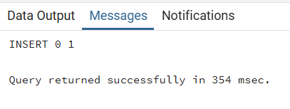

Query: Checking the audit table

Select * From film_insert_log;

Output:

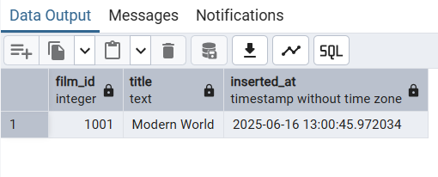

1. Delete the trigger.

Query:

Drop Trigger trg_log_film_insert on film;

Output:

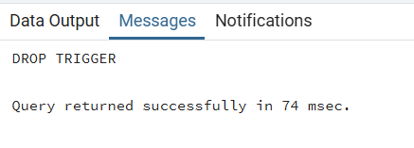

Chapter 8:

1. Create a table. Write a stored procedure to insert data in to the created table.

Query: Table Creation

Create table workers(

Id serial Primary key,

Name text,

Salary integer

);

Select * from workers;

Output:

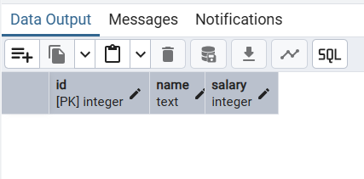

Query: Creating Procedure

Create or Replace Procedure insert_worker_val(

P_name text,

P_salary integer

)

Language plpgsql as $$

Begin

Insert into workers(Name , Salary)

values(P_name, P_salary);

End;

$$

Output:

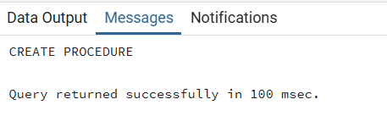

Query: Calling the Procedure with Parameters

Call insert_worker_val('Suganya', 50000);

Call insert_worker_val('Mala',40000);

Call insert_worker_val('Nila',45000);

Call insert_worker_val('Mugil',43000);

Call insert_worker_val('Malar',30000);

Call insert_worker_val('Mani',60000);

Output:

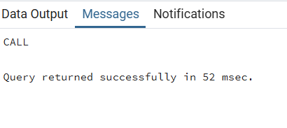

Final table view:

Select * from workers;

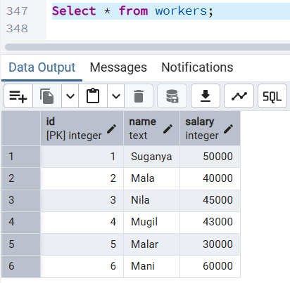

2. Write a stored procedure to select the customers who rented from store_id 2.

Query:

Create or Replace Procedure get_customers_from_store_2()

Language plpgsql

As $$

Begin

-- Select customers who rented from store_id 2

Raise Notice 'Customer List from Store 2:';

Perform

c.customer_id, c.first_name, c.last_name

From customer c

Join rental r On c.customer_id = r.customer_id

Join inventory i On r.inventory_id = i.inventory_id

Where i.store_id = 2;

End;

$$;

Output:

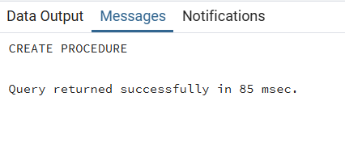

Query: To call the procedure to view Customer details

CALL get_customers_from_store_2();

Output:

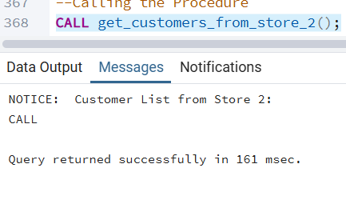

In Stored Procedure we cannot return the results, we can perform only the particular action and raise notice. If we would like to view or display the output we need to use Functions instead.

Query: Same query in Functions

Create or Replace Function get_customers_from_store(p_store_id INT)

Returns Table (customer_id INT, first_name TEXT, last_name TEXT)

Language sql

As $$

Select Distinct c.customer_id, c.first_name, c.last_name

From customer c

Join rental r On c.customer_id = r.customer_id

Join inventory i On r.inventory_id = i.inventory_id

Where i.store_id = p_store_id;

$$;

Output:

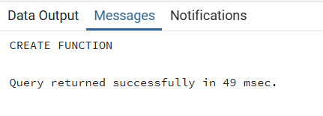

Query: Calling the Function

Select * From get_customers_from_store(2);

Output:

