1.Write a program to concatenate following dictionaries to create a new one.

**Program :-**

**def** dict1():  
 d = {}  
 n = int(input(**"Enter elements of dictionary"**))  
 **for** i **in** range(n):  
 key = int(input(**"key = "**))  
 value = int(input(**"value = "**))  
 d[key] = value  
 **return** d  
d1 = dict1()  
d2 = dict1()  
d3 = dict1()  
print(**"dict1 ="**,d1,**"\ndict2 ="**,d2,**"\ndict3 ="**,d3)  
dic4 = {}  
**for** i **in** (d1, d2, d3):  
 dic4.update(i)  
print(**"Concatenated dictionary ="**,dic4)

**Output :-**

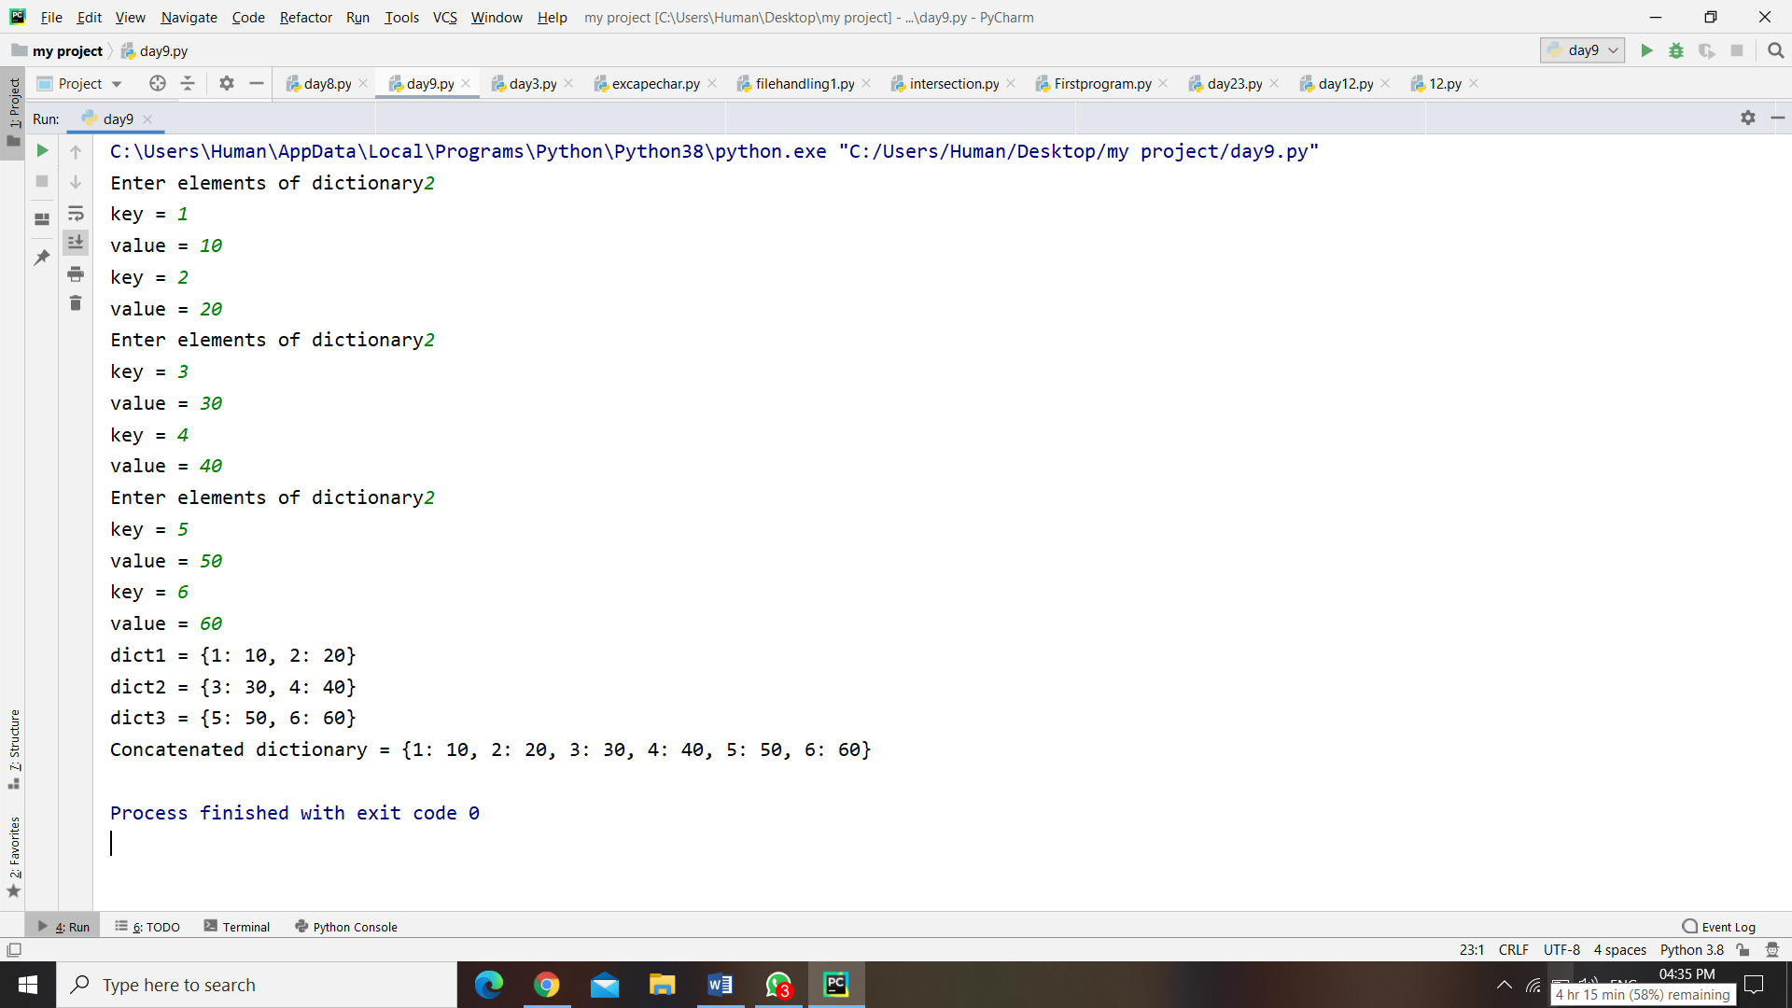

2. Write a Program to check whether a given key already exists in a dictionary

**Program :-**

dict = {}  
n= int(input(**"Enter elements ="**))  
**for** i **in** range(n):  
 key = int(input(**"key: "**))  
 value = int(input(**"value: "**))  
 dict[key] = value  
print(**"Dictionary ="**,dict)  
x = int(input(**"enter any key to check = "**))  
**if** x **in** dict:  
 print(**'Key exist in the dictionary'**  
**else**:  
 print(**'Key is not exist in the dictionary'**)

**Output :-**

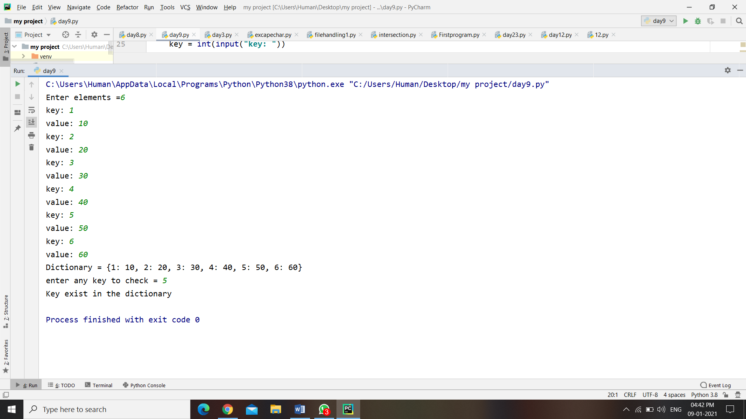

3. Write a Program to generate and print a dictionary that contains a number (between 1 and n) in the form (x, x*x).

**Program :-**

n = int(input(**"Enter any number = "**))  
dict={key:key * key **for** key **in** range(1,n+1)}  
print(**"Dictionary ="**,dict)

**Output :-**

