
Internet Network Routing Optimizer
Final Project Report
Submitted by
KAVITA KUMARI
(UID: 26MCI10091)
Master of Computer Applications
IN
Artificial Intelligence and Machine Learning (MCA AI & ML)
UNIVERSITY INSTITUTE OF COMPUTING (UIC)
CHANDIGARH UNIVERSITY
Under the Supervision of
[Ms.Kawaljit Kaur]
OCTOBER 2026

Internet Network Routing Optimizer

Introduction:
Dijkstra's algorithm is an algorithm for finding the shortest paths between nodes in a graph, which may represent, for example, road networks or computer networks.
Dijkstra's original variant found the shortest path between two nodes, but a more common variant fixes a single node as the "source" node and finds shortest paths from the source to all other nodes in the graph, producing a shortest-path tree.
- It can be either directed or undirected.
- It works on graphs with non-negative weighted edges.
- It is applied on a connected graph.
Pseudo Code:
Initialize the distance of each router to infinity
Initialize the distance of the source router to 0
Insert the source router into a priority queue
While the priority queue is not empty
Extract the router u with the minimum distance
For each router v which is adjacent to u
v's distance = min(v's old distance, u's distance + latency(u, v))
If v's distance is updated: set previous[v] = u and add v to the queue
Reconstruct the shortest path using previous[]

For example, consider source router as R1 and destination router as R7. The shortest path from R1 to R7 can be calculated as shown below (shortest path highlighted in red):
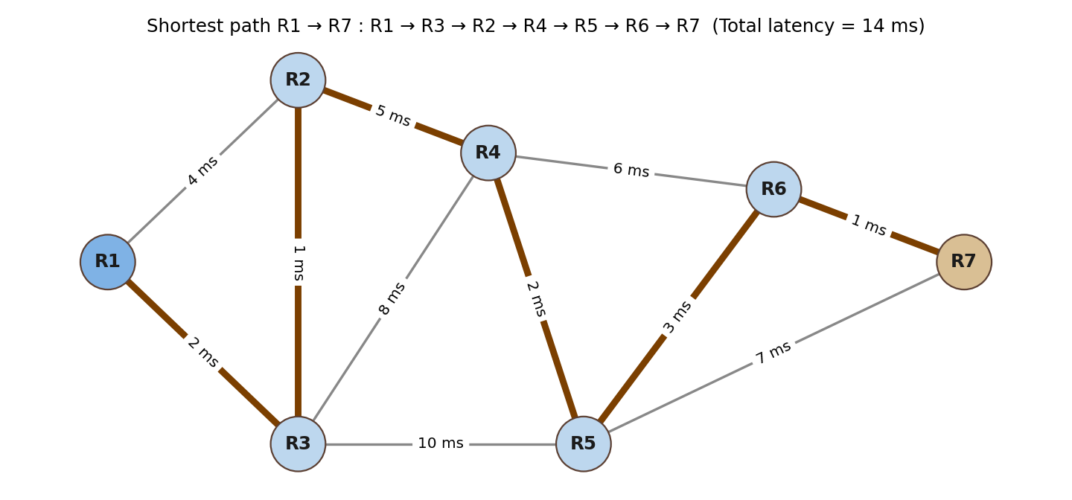
Fig 1: Network graph – routers as nodes, latency (ms) as edge weights
Motivation:
The main aim of the project is to design an Internet Network Routing Optimizer using an algorithm. The algorithm should find the minimum-latency route between a source router and a destination router in a network, so that data packets reach the destination as fast as possible. The system also displays the network as a graph and highlights the selected route.
Graph Construction:
We considered routers as nodes and the latency (in ms) of the connection between two routers as edge weights. The solution is implemented in Python with the network data stored in JSON (data.json).
Sample data:
Router data
"routers": [
{ "id": "R1" },
{ "id": "R2" }
],
Connection data
"connections": [
{
"source": "R1",
"destination": "R2",
"latency": 4
},
],
Attributes considered:
Routers as nodes
Latency between routers as the edge weights with connected vertices
Source and destination routers selected by the user
For instance, find the shortest path between source router u and destination router v using Dijkstra's Algorithm?
Solution: -
1) Create a set sptSet (shortest path tree set) that keeps track of routers included in the shortest path tree, i.e., whose minimum distance from source is calculated and finalized. Initially, this set is empty.
2) Assign a distance value to all routers in the input graph. Initialize all distance values as INFINITE. Assign distance value as 0 for the source router so that it is picked first.
3) While sptSet doesn't include all routers
a) Pick a router u which is not in sptSet and has the minimum distance value (using a priority queue / min-heap).
b) Include u in sptSet.
c) Update the distance value of all adjacent routers of u. For every adjacent router v, if the sum of the distance value of u (from source) and the latency of edge u-v is less than the distance value of v, then update the distance value of v and set previous[v] = u.
4) Reconstruct the path from destination back to source using previous[] and display it with the total latency.
Working Flowchart
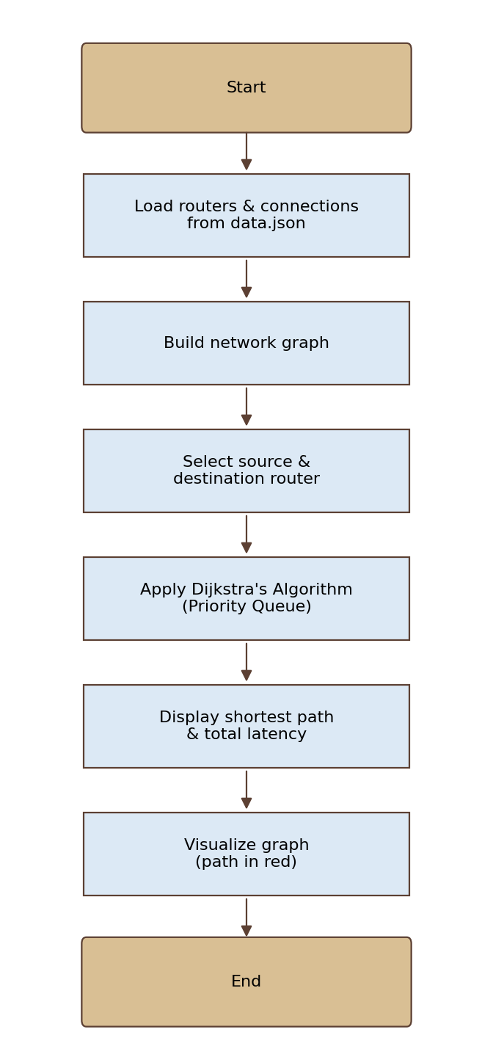
Fig 2: Flowchart of the project

Output:
The user selects the source and destination routers. The algorithm calculates the minimum-latency route from the source to the destination, displays the route along with the total latency, and highlights the path in red on the network graph.
Screenshot:
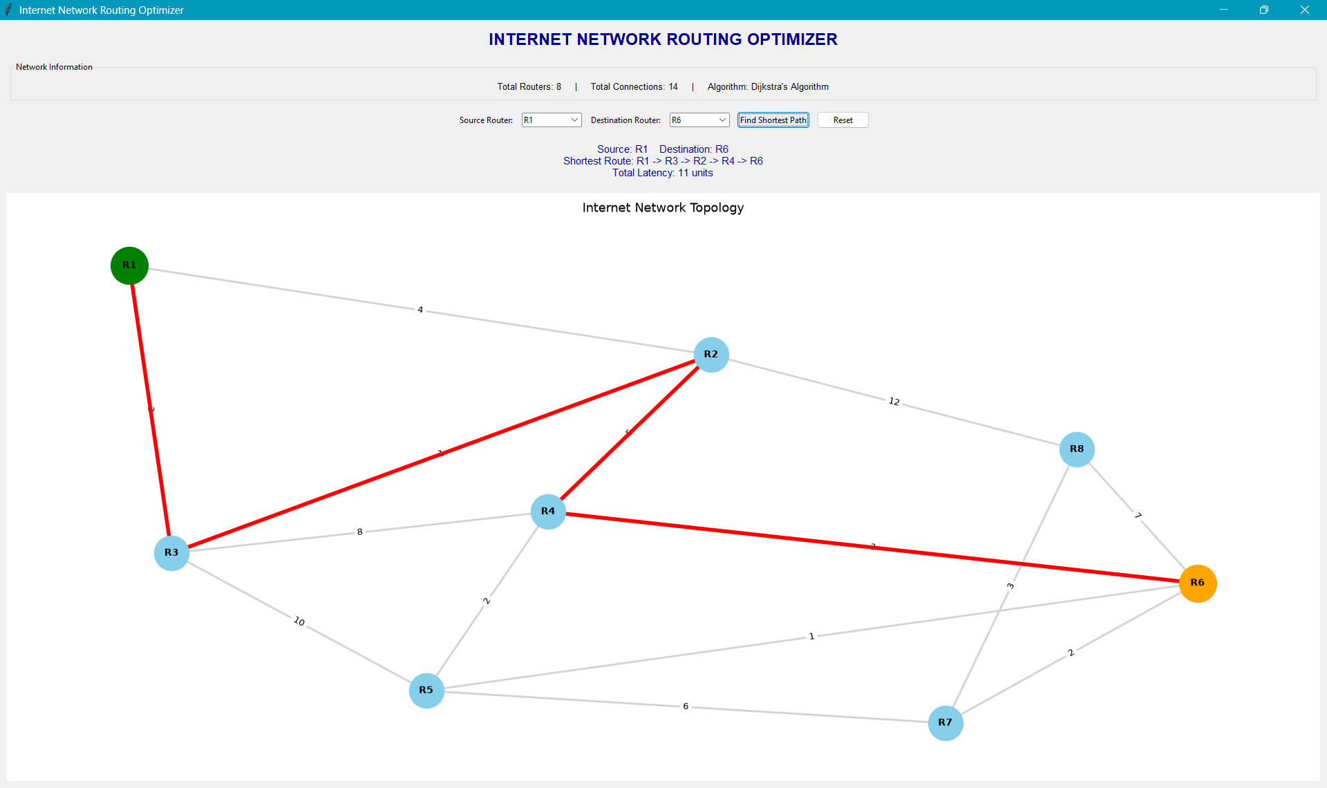
Fig 3: Project output – shortest path and total latency
Sample result (R1 → R7)
Router | Distance from R1 (ms) | Previous Router
R1 | 0 | —
R2 | 3 | R3
R3 | 2 | R1
R4 | 8 | R2
R5 | 10 | R4
R6 | 13 | R5
R7 | 14 | R6

Shortest path: R1 → R3 → R2 → R4 → R5 → R6 → R7 Total latency: 14 ms
Conclusion:
Dijkstra's algorithm finds the shortest path between two nodes. Here we found the minimum-latency path between the selected source and destination routers. Distances to all routers are initialized to infinity, the source is set to 0, and the router with minimum distance is repeatedly extracted from the priority queue while its neighbours are relaxed. The previous-router array is then used to reconstruct the route, which is displayed and highlighted on the graph.

Time complexity: assuming V is the number of routers and E is the number of connections, the time complexity of our algorithm using a priority queue (min-heap) is O((V + E) log V).
Space complexity: O(V + E) for the graph, distance array, previous array and priority queue.
Code:
https://github.com/Kavitakumri23/DAA-Project.git
References:
https://www.geeksforgeeks.org/dijkstras-shortest-path-algorithm-greedy-algo-7/

