Prompt 1 — Create the basic lab application

Create a simple educational web application for an undergraduate AIML laboratory.
Title:
Discrete Probability Distributions
The application will eventually contain:
1. Binomial Distribution
2. Poisson Distribution
3. Geometric Distribution
For now, implement only the basic application structure and the Binomial Distribution module.
Keep the UI simple and clean. Do not add unnecessary features.
Create a navigation/header with:
- Home
- Binomial
- Poisson
- GeometricOnly the Binomial page needs to be functional at this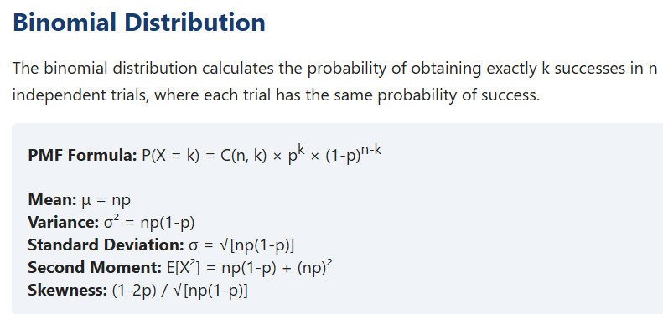
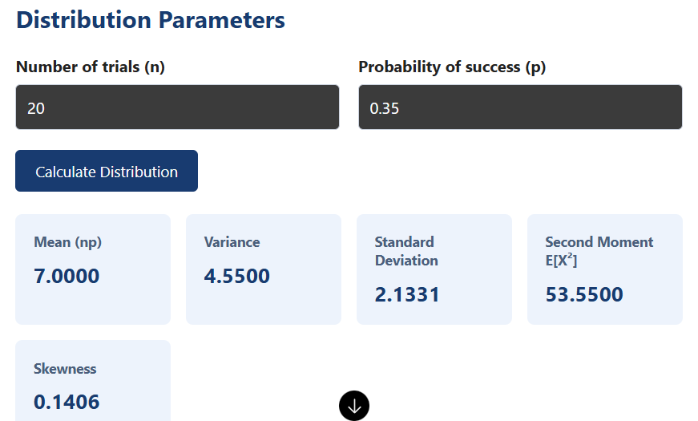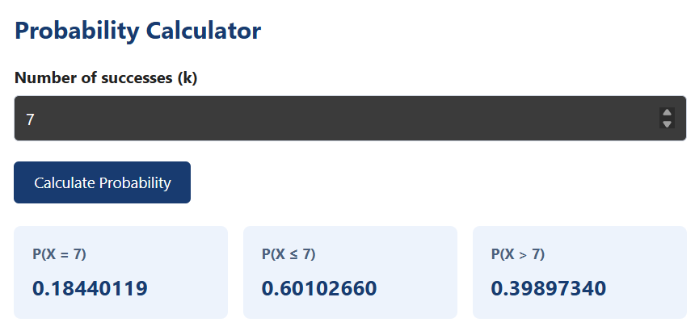
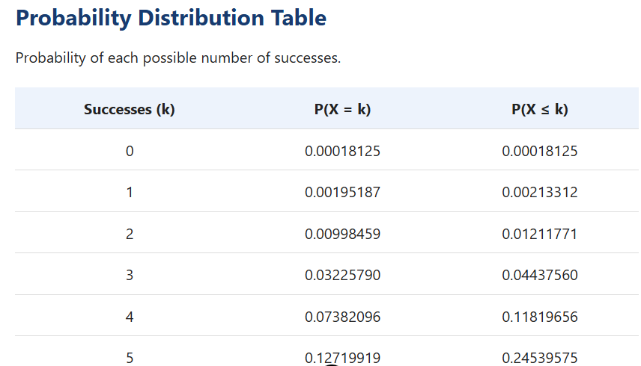
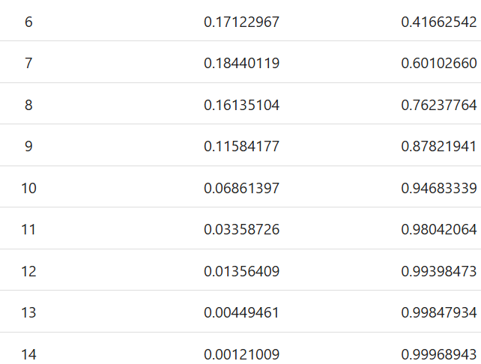
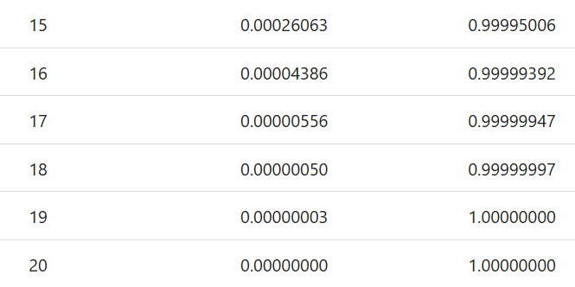

Binomial Distribution
Prompt 2 — Add Binomial inputs

Implement the Binomial Distribution section.
Add two input controls:
- Number of trials n
- Probability of success p
Set default values:
n = 20
p = 0.35
Validate the inputs:
- n must be a positive integer
- p must be between 0 and 1
Display the selected values clearly.
Do not add simulation yet.
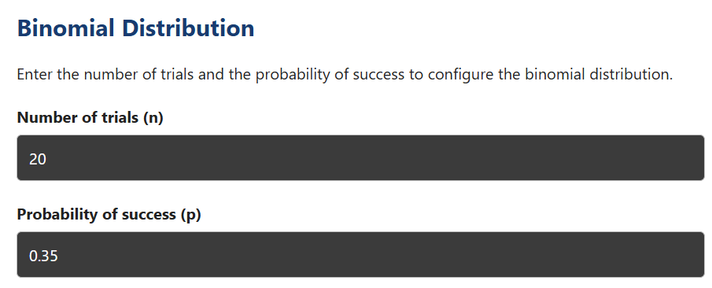
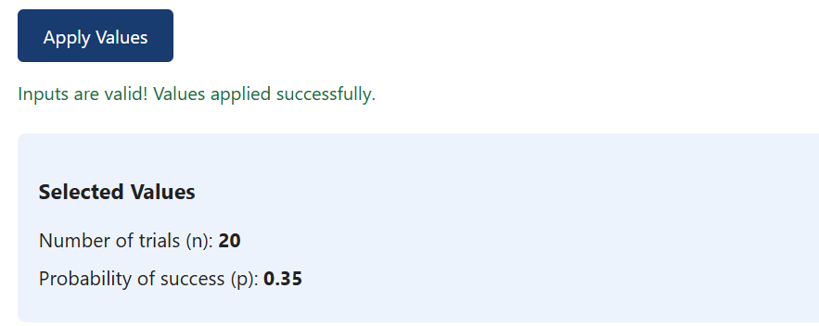
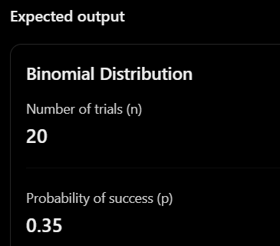

Prompt 3 — Calculate Binomial statistics

Add the Binomial probability calculations using the selected n and p.
Calculate and display:
- Mean
- Variance
- Standard deviation
- Second moment E[X²]
- Skewness
Use the following formulas:
Mean:
np
Variance:
np(1-p)
Second moment:
Variance + Mean²
Skewness:
(1-2p) / sqrt(np(1-p))
Display the results in simple statistic cards.
For the default values n=20 and p=0.35, verify that the mean is 7 and variance is 4.55.
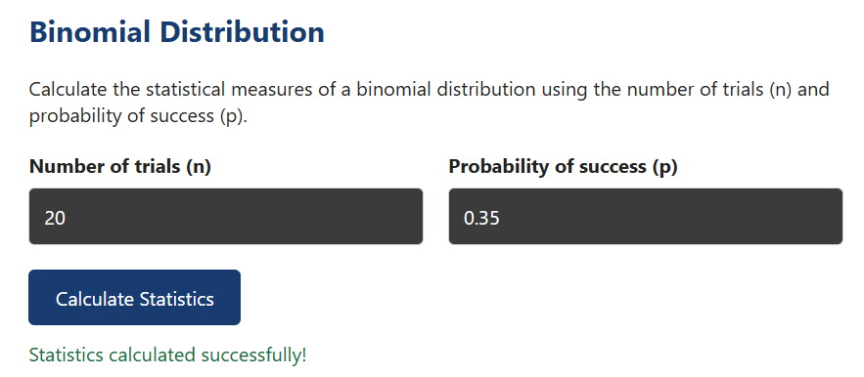
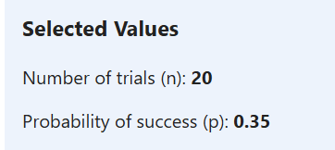
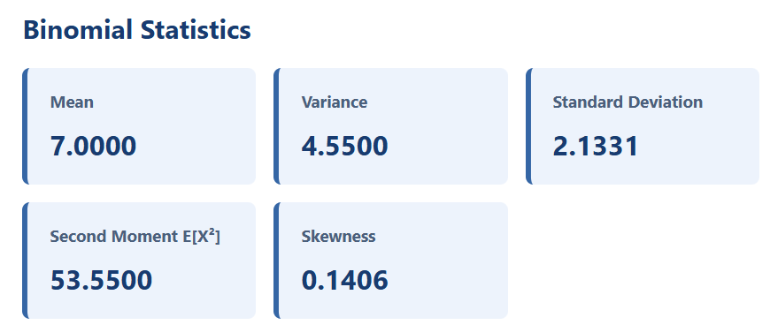
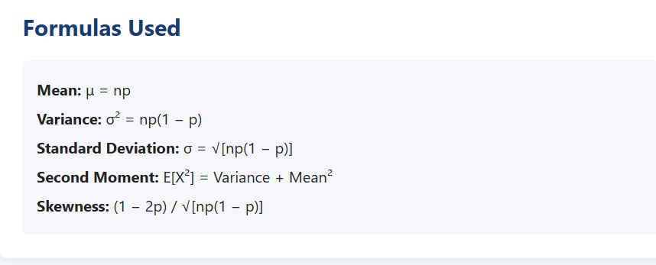
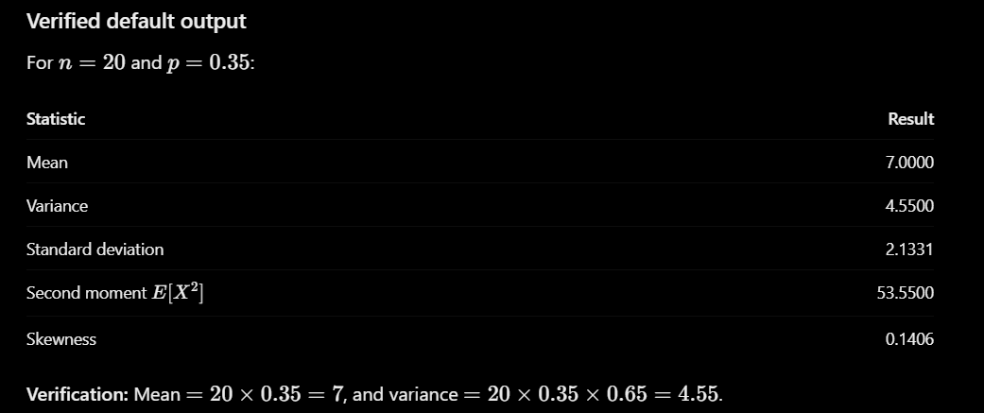

Prompt 5 — Add CDF

Add a Binomial CDF calculator.
Allow the student to enter k.
Calculate:
P(X <= k)
Also calculate:
P(X > k) = 1 - P(X <= k)
Display both results.
Explain:
“P(X <= k) means the probability of getting k or fewer successes.”
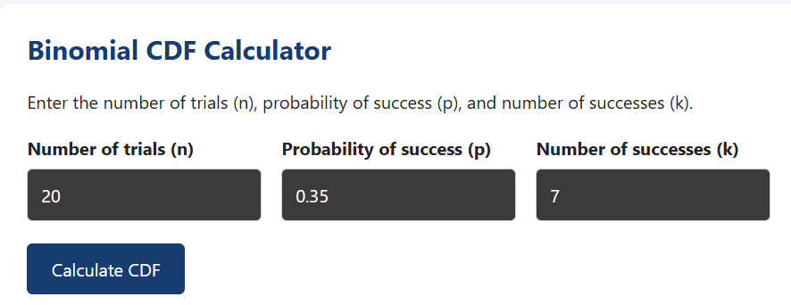
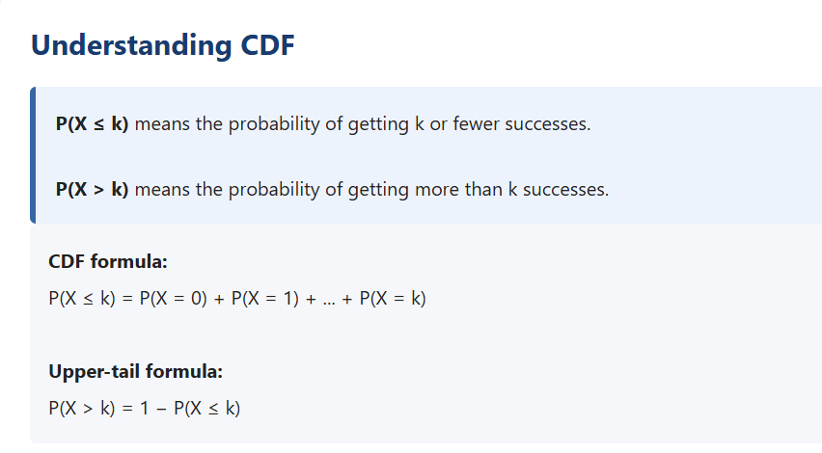
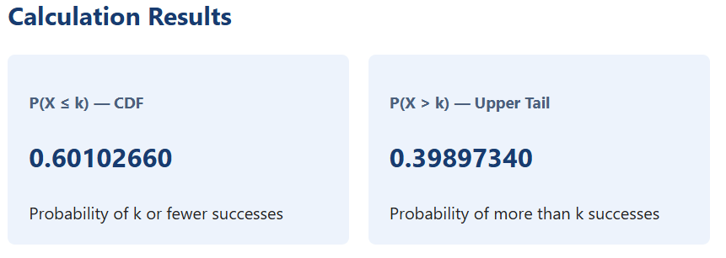
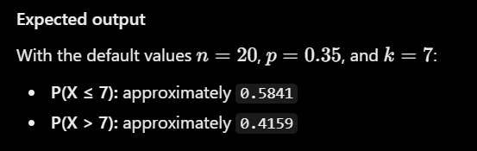

Prompt 6 — Add Binomial PMF graph

Add a bar chart showing the Binomial PMF.
X-axis:
Number of successes X
Y-axis:
Probability P(X)
Plot values for:
X = 0, 1, 2, ..., n
Use the current values of n and p.
Add a vertical dashed reference line at the mean.
Add a tooltip showing:
X = value
P(X=value) = probability
Update the graph automatically whenever n or p changes.
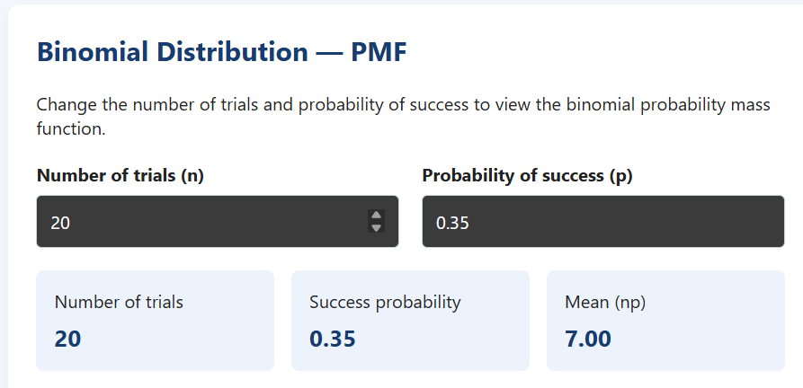

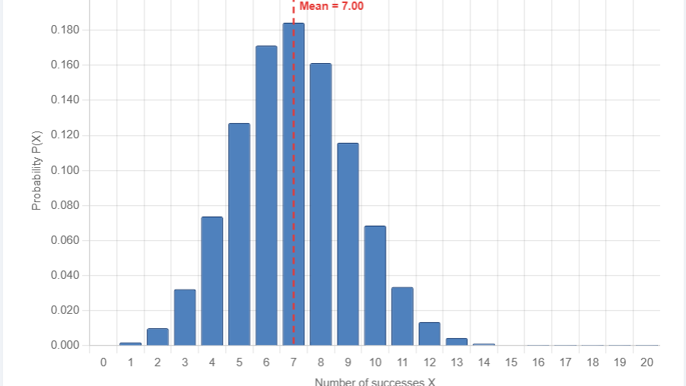
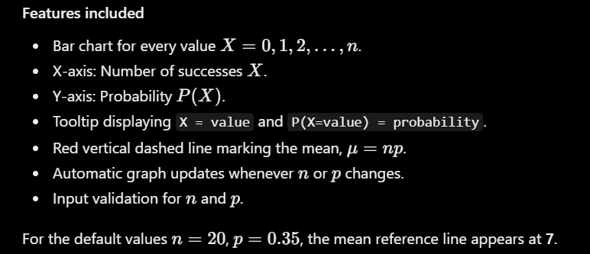

Exercise 1 – Interactive Binomial Distribution UI

Use the Binomial Distribution module developed in the lab application.
Configure the application with:
- Number of trials: n = 15
- Probability of success: p = 0.6
Using the UI, determine:
1. Mean and variance of the distribution.
2. (P(X=9)) — probability of exactly 9 successes.
3. (P(X<=10)) — probability of at most 10 successes.
4. Observe the PMF graph and identify the region where the probability is highest.
5. Write a brief inference from the visualization.
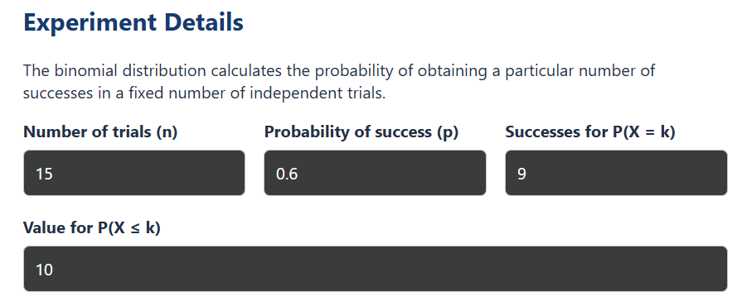
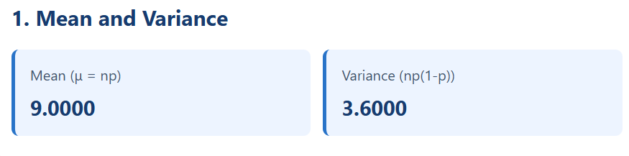
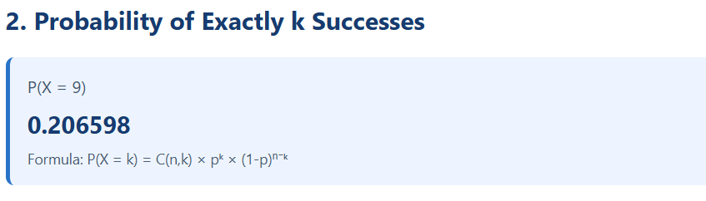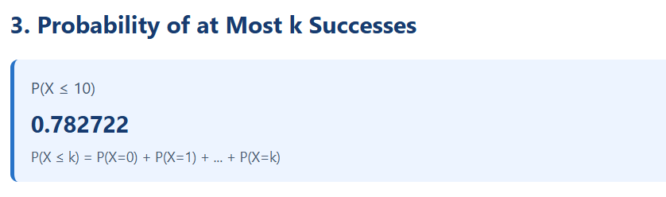
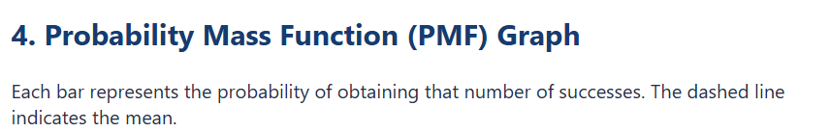
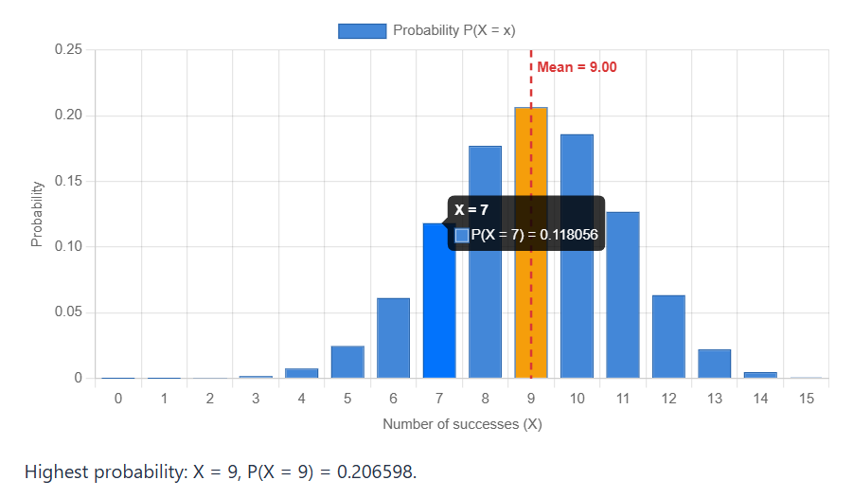
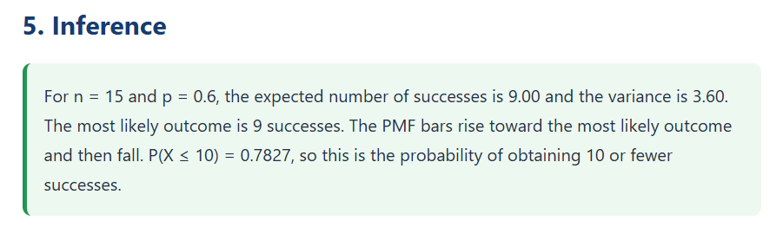
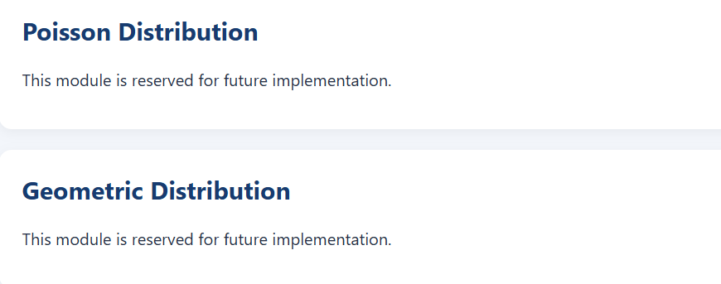

Exercise 2 – Interactive Poisson Distribution UI
Use the Poisson Distribution module developed in the lab application.
Consider an AI-based monitoring system where the average number of events is: λ=6

Using the UI, determine:
1. Mean and variance of the distribution.
2. (P(X=8)) — probability of exactly 8 events.
3. (P(X<=5)) — probability of at most 5 events.
4. Compare the Poisson PMF graphs for λ = 2, 6, and 10 using the application.
5. Observe how increasing λ changes the distribution and write a brief inference from the graph.
