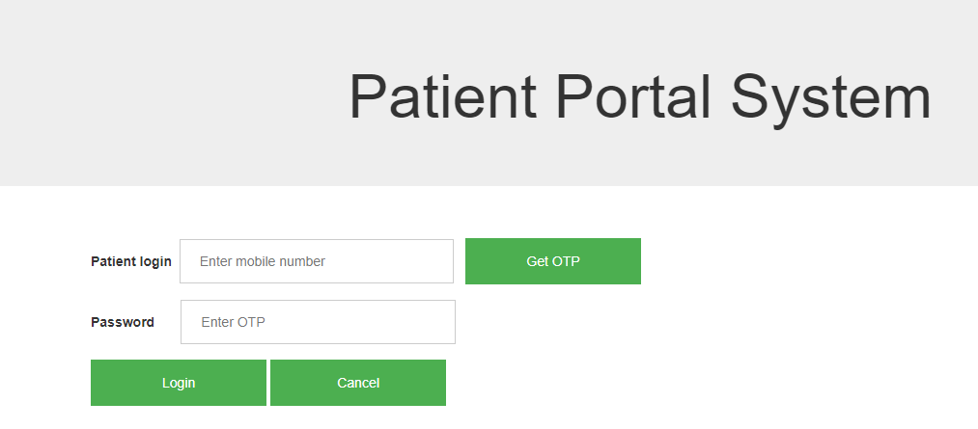

<!DOCTYPE html>

<html lang="en">

<head>

<title>Bootstrap Example</title>

<meta charset="utf-8">

<meta name="viewport" content="width=device-width, initial-scale=1">

<link rel="stylesheet" href="https://maxcdn.bootstrapcdn.com/bootstrap/3.3.7/css/bootstrap.min.css">

<script src="https://ajax.googleapis.com/ajax/libs/jquery/3.2.1/jquery.min.js"></script>

<script src="https://maxcdn.bootstrapcdn.com/bootstrap/3.3.7/js/bootstrap.min.js"></script>

</head>

<body>

<div class="jumbotron text-center">

<h1>Patient Portal System</h1>

</div>

<style>

form {

border: 3px solid #f1f1f1;

}

input[type=int], input[type=password] {

width: 25%;

padding: 12px 20px;

margin: 8px 0;

display: inline-block;

border: 0.05px solid #ccc;

box-sizing: border-box;

}

button {

background-color: #4CAF50;

color: white;

padding: 14px 10px;

margin: 8px 0;

border: none;

cursor: pointer;

width: 16%;

}

button:hover {

opacity: 0.8;

}

cancelbtn {

width: 50%;

padding: 10px 18px;

background-color: #FA8072;

}

.container {

padding: 16px;

}

span.psw {

float: right;

padding-top: 16px;

}

/* Change styles for span and cancel button on extra small screens */

@media screen and (max-width: 300px) {

span.psw {

display: block;

float: none;

}

.cancelbtn {

width: 100%;

}

}

</style>

<body>

<div class="container">

<label><b>Patient login</b></label>&nbsp;

<input type="int" placeholder="Enter mobile number" name="num" required>&nbsp;&nbsp;&nbsp;<button type="submit">Get OTP</button>

</br>

<label><b>Password</b></label>&nbsp;&nbsp;&nbsp;&nbsp;&nbsp;&nbsp;

<input type="password" placeholder="Enter OTP" name="otp" required>

<br>

<button type="submit">Login</button>

<button type="button" class="cancelbtn">Cancel</button>

</div>

</form>

</body>

</html>

<!DOCTYPE html>

<html>

<title>W3.CSS Template</title>

<meta charset="UTF-8">

<meta name="viewport" content="width=device-width, initial-scale=1">

<link rel="stylesheet" href="https://www.w3schools.com/w3css/4/w3.css">

<link rel="stylesheet" href="https://www.w3schools.com/lib/w3-theme-black.css">

<link rel="stylesheet" href="https://fonts.googleapis.com/css?family=Roboto">

<link rel="stylesheet" href="https://cdnjs.cloudflare.com/ajax/libs/font-awesome/4.7.0/css/font-awesome.min.css">

<style>

html,body,h1,h2,h3,h4,h5,h6 {font-family: "Roboto", sans-serif;}

.w3-sidebar {

z-index: 3;

width: 250px;

top: 43px;

bottom: 0;

height: inherit;

}

</style>

<body>

<!-- Navbar -->

<div class="w3-top">

<div class="w3-bar w3-theme w3-top w3-left-align w3-large">

<a class="w3-bar-item w3-button w3-right w3-hide-large w3-hover-white w3-large w3-theme-l1" href="javascript:void(0)" onclick="w3_open()"><i class="fa fa-bars"></i></a>

<a href="#" class="w3-bar-item w3-button w3-theme-l1">Logo</a>

<a href="#" class="w3-bar-item w3-button w3-hide-small w3-hover-white">Home</a>

<a href="#" class="w3-bar-item w3-button w3-hide-small w3-hover-white">About us</a>

<a href="#" class="w3-bar-item w3-button w3-hide-small w3-hover-white">speciality</a>

<a href="#" class="w3-bar-item w3-button w3-hide-small w3-hover-white">contact</a>

</div>

</div>

<!-- Sidebar -->

<nav class="w3-sidebar w3-bar-block w3-collapse w3-large w3-theme-l5 w3-animate-left" id="mySidebar">

<a href="javascript:void(0)" onclick="w3_close()" class="w3-right w3-xlarge w3-padding-large w3-hover-black w3-hide-large" title="Close Menu">

<i class="fa fa-remove"></i>

</a>

</nav>

<script>

// Get the Sidebar

var mySidebar = document.getElementById("mySidebar");

// Get the DIV with overlay effect

var overlayBg = document.getElementById("myOverlay");

// Toggle between showing and hiding the sidebar, and add overlay effect

function w3_open() {

if (mySidebar.style.display === 'block') {

mySidebar.style.display = 'none';

overlayBg.style.display = "none";

} else {

mySidebar.style.display = 'block';

overlayBg.style.display = "block";

}

}

// Close the sidebar with the close button

function w3_close() {

mySidebar.style.display = "none";

overlayBg.style.display = "none";

}

</script>

</body>

</html>

