Micro Services Problem statement

Part-1–Micro Services creation

1.Create following 4 micro service applications

a.Product-Catalog-Service

b.Price-Service

c.Cart-Service

d.Order-Service

2.Configure following port number for above created applications

a.Product-Catalog-Service : 8081

b.Price-Service: 8082

c.Cart-Service: 8083

d.Order-Service: 8084

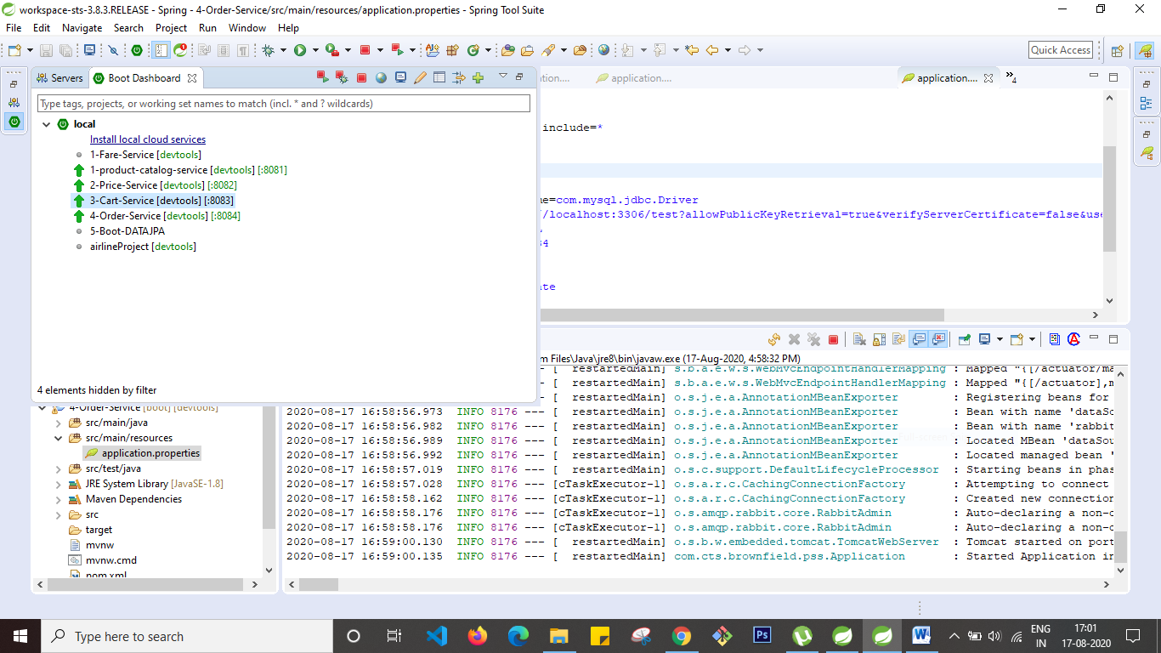

Add following business scenarios for the above-mentioned micro servicesa.Product-Catalog-Service: Create a RestController for adding a single product as JSON, or for adding multiple products as Array of JSON objects.

Details for Product object properties are given below.

Table/Collection name : Product

Properties:

@Id

@GeneratedValue

private int id;

private String name;

private double price;

private String description;

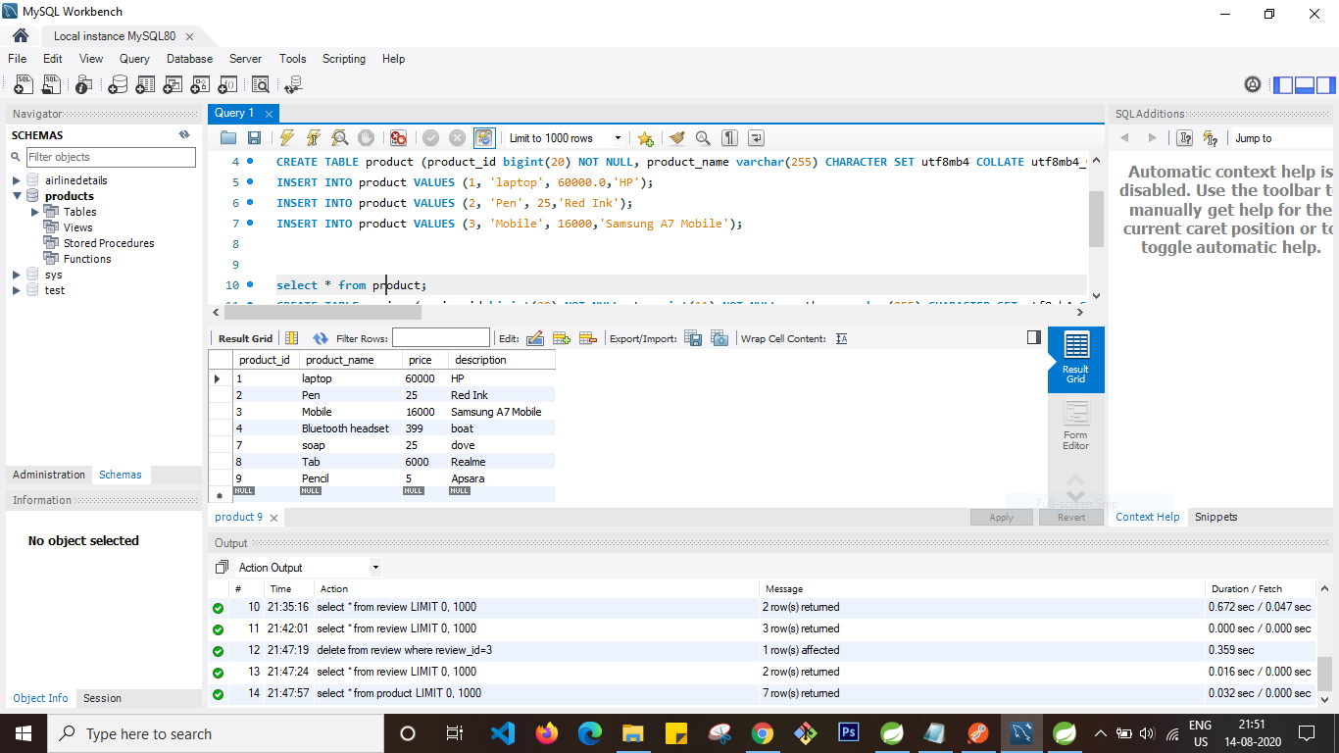

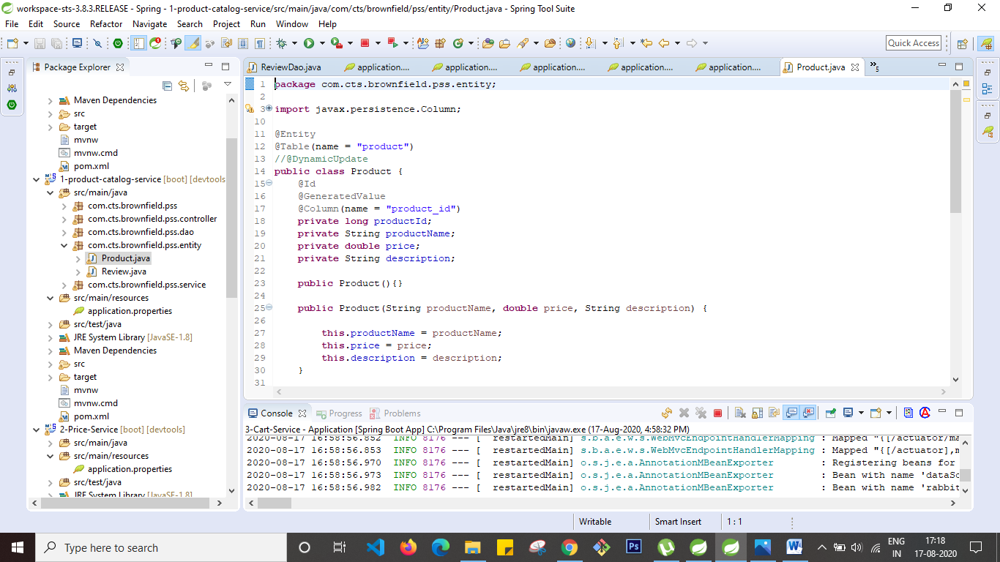

Table/Collection name: Review

Properties:

@Id

@GeneratedValue

private int reviewId;

private int stars;

private String author;

private String body;

@ManyToOne

@JoinColumn(name = "id")

private Product product;

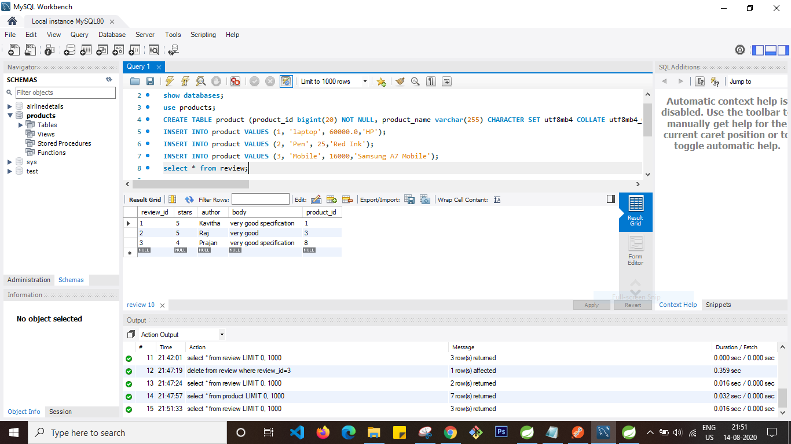

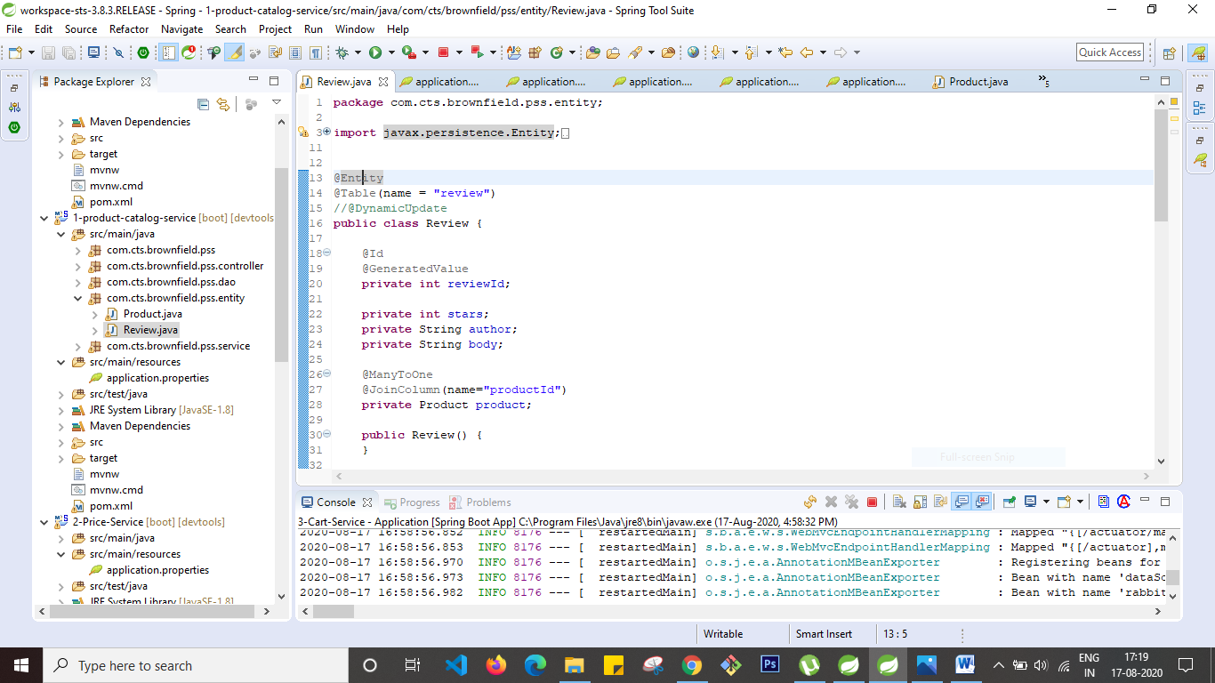

Now Create end point url to retrieve Product and Reviews information

Finding all products

GETrequest: <http://localhost:8081/api/products>

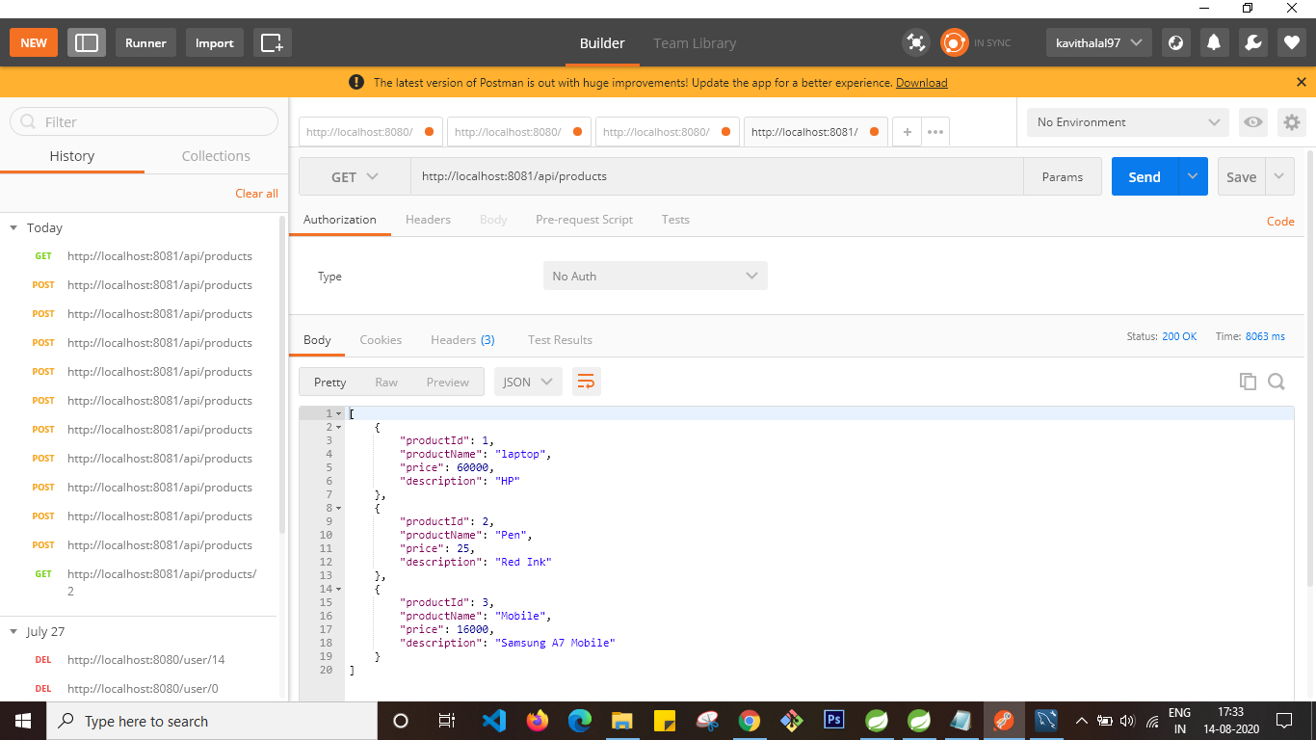

Finding specified product. (ex: finding a product whose id is 1)GETrequest: <http://localhost:8081/api/products/1>

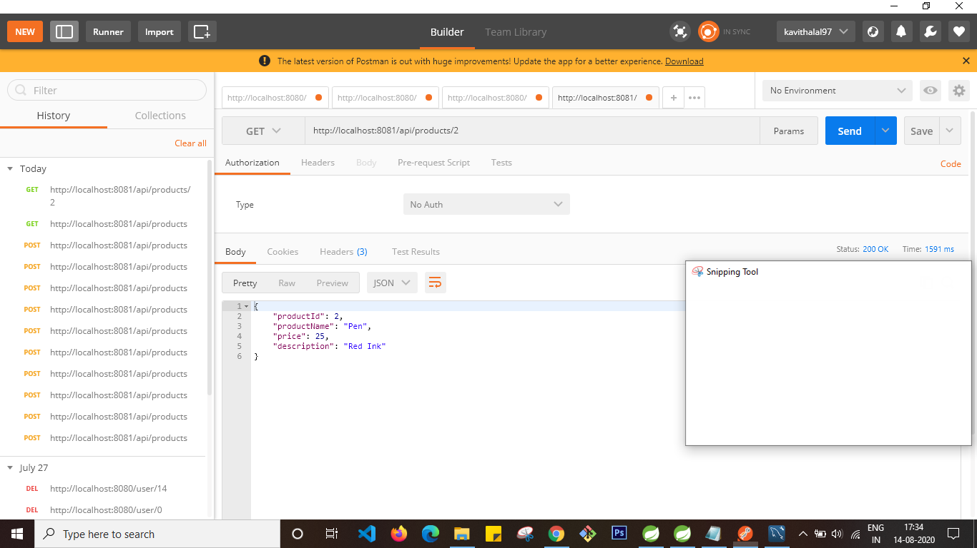

Finding all products by product name.(ex: any product having a letter ‘e’)

GETrequest: <http://localhost:8081/api/products/byName/e>

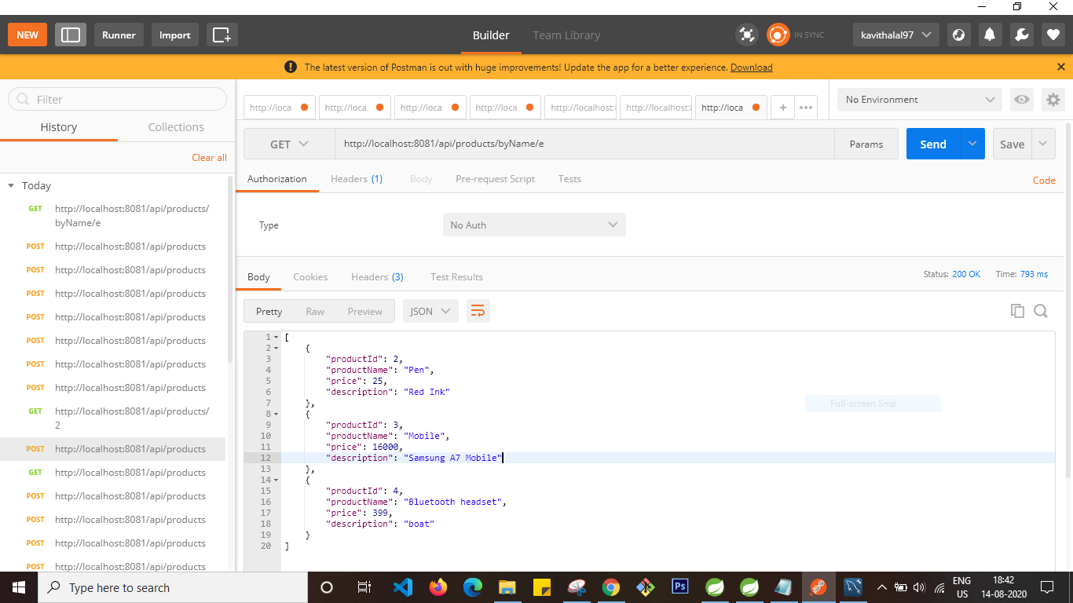

Posting a single productPOSTrequest : <http://localhost:8081/api/products>

Input body

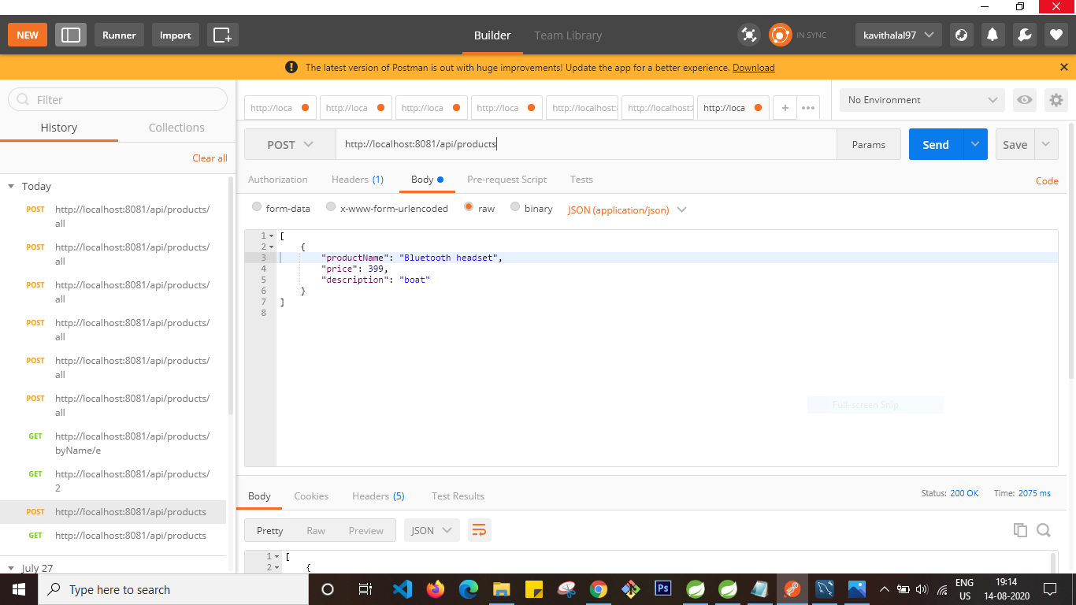

Result:

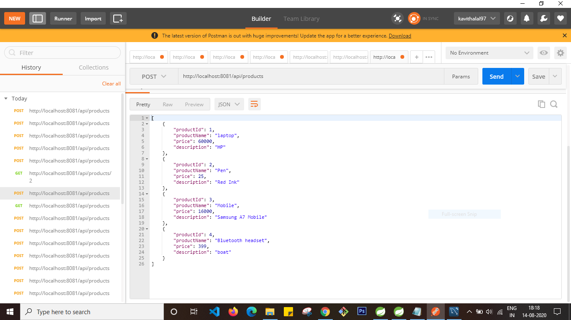

Posting more than a productPOSTrequest: <http://localhost:8081/api/products/all>

Input body

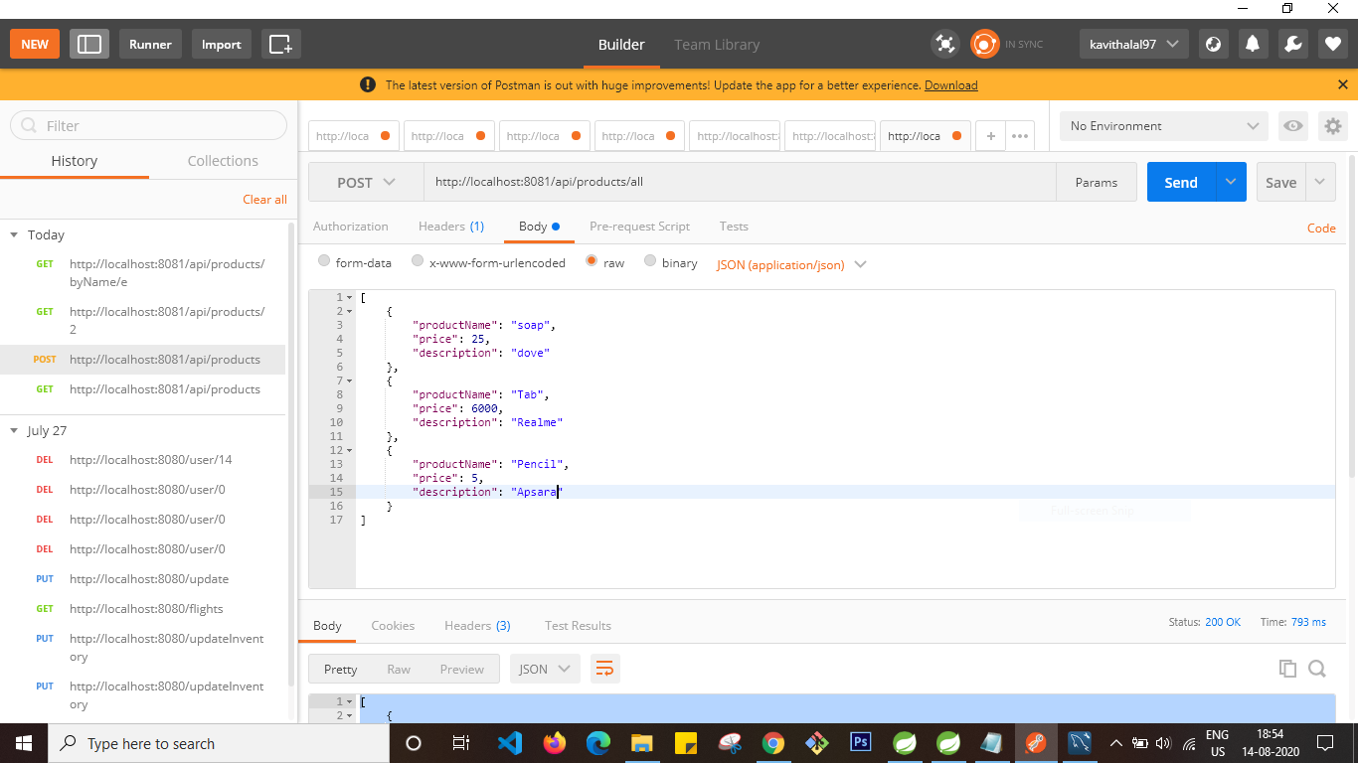

Result

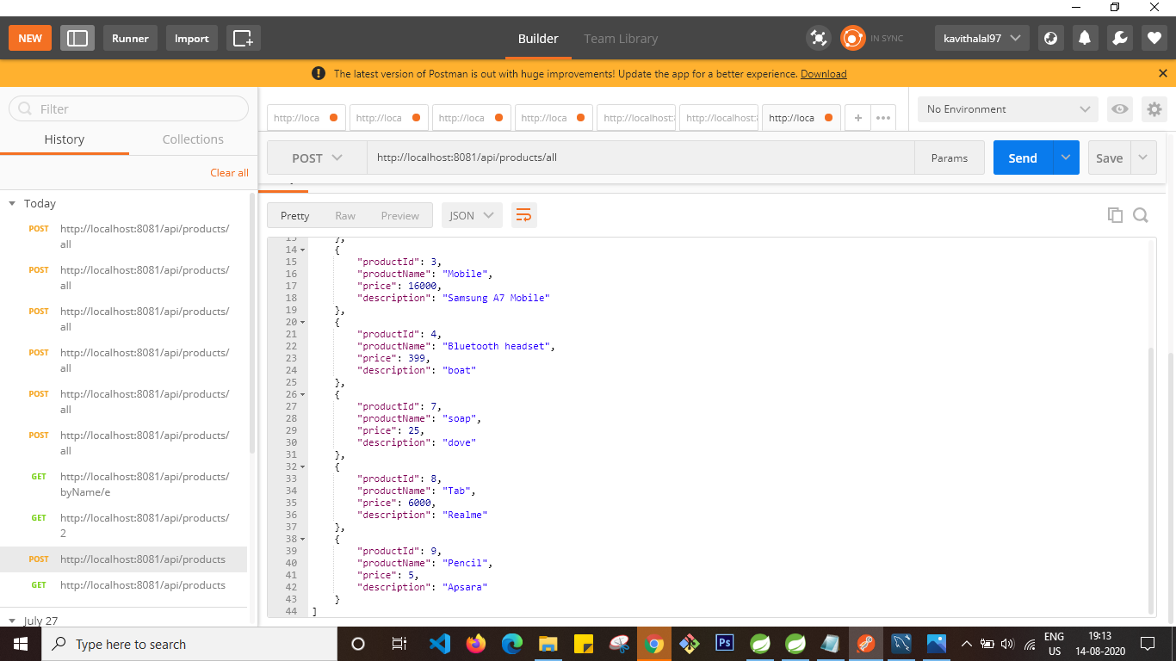

Finding a product with ReviewsGETrequest: <http://localhost:8081/api/products/3/reviews>

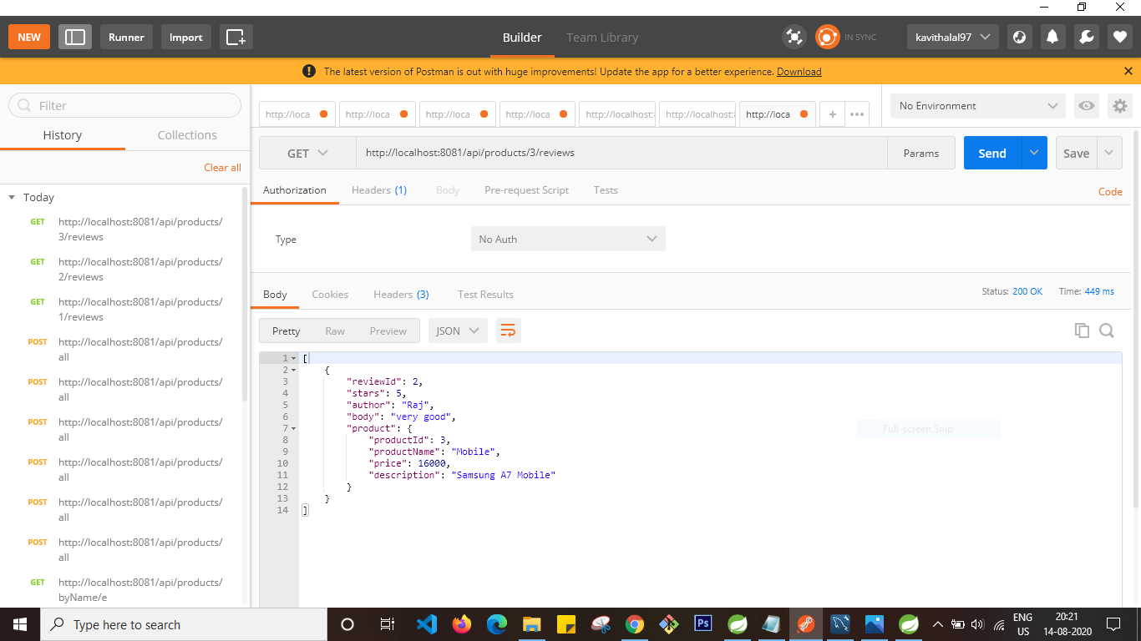

Posting a review for a specified product

POSTrequest : <http://localhost:8081/api/products/6/reviews>

Input body

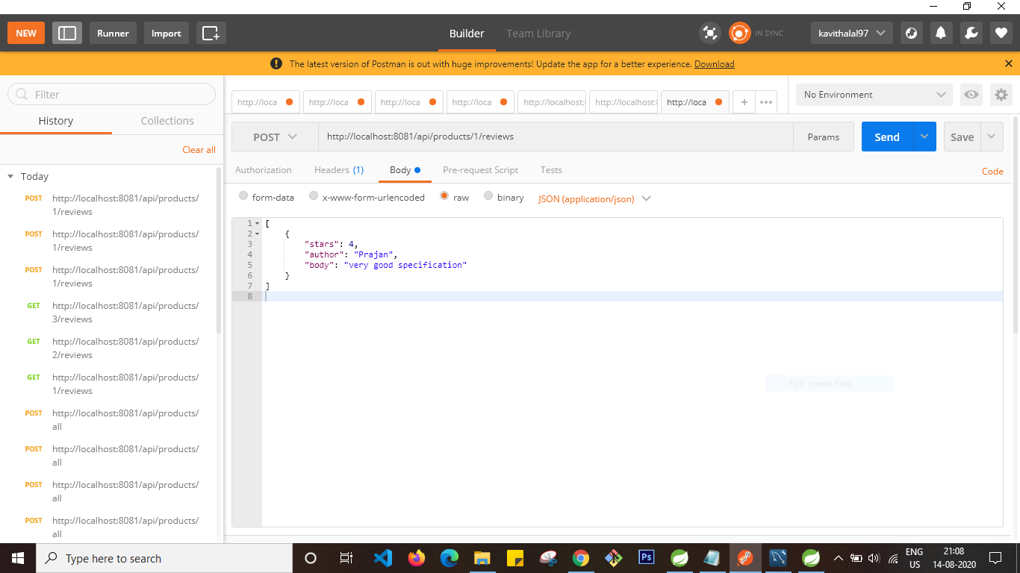

Result:

