**A6 - Design Thinking and More - place in Dropbox and Upload to GitHub**

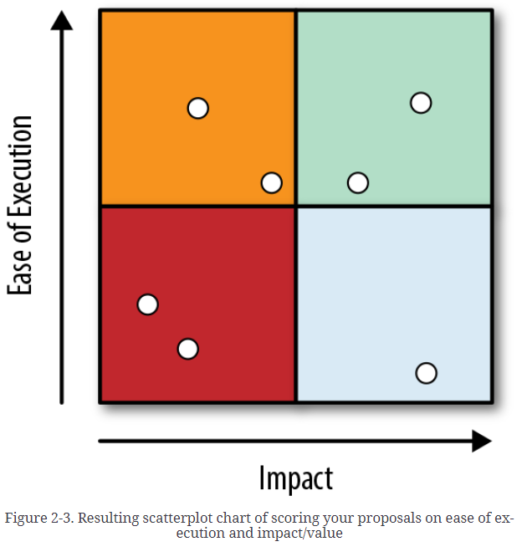

Architects and strategists are explained in Chapter 1 but the intriguing aspect is that it also discusses how different organizations' changes in strategy or realizing their strengths and changing the path of strategy, have benefited them greatly in the long term. The three principles of becoming an Architect in the IT business are extremely useful in understanding the "blueprint" of the job title's expected outputs. Also, understanding a Strategist's major task is critical to understanding their role in a company's success.

In the templates chapter, eight patterns were reviewed to help communicate the strategy and architectural decisions to a range of audiences at various levels. The patterns given here will assist IT teams, management, and decision-making executives, as well as customers. Templates included here: Build/Buy/Partner, Due Diligence, Architecture Definition, One-Slider, Use Case Map, Priority Map, Directional Costing, Technology Radar

Thinking this way, will help in quickly solving small problems. Consider MECE (Mutually Exclusive, Collectively Exhaustive) and create a Logic Tree and then create a collection of hypotheses. After that, complete a PESTEL (Political, Economic, Social, Technological, Environmental and Legal factors) study and a scenario planning exercise. Lastly, draw your futures funnel diagram and do back casting. This will certainly fine-tune the analysis. If you're developing a more specialized, localized plan for, say, switching database vendors, you may take the PESTEL study more lightly, or ignore it entirely, and go on to the next set of patterns: those for understanding your industry's environment.

The fourth chapter provided a few patterns that might help examine the industry and use them within the IT strategy. The Ansoff Growth Matrix, Porter's Five Forces, and the SWOT pattern were among them. The patterns will assist with the development of a plan based on company's position.

**GitHub link:**

<https://github.com/KavithaLakshminarasaiah/IT496/blob/main/Kavitha_Radarplot.ipynb>

**IBM Baggage:**

**IBM Course:**

