A7 - Understanding Naive Bayes Model

Question: This person has long hair - Is this person a man or woman? We need the probabilities of the following:

P (woman | long hair)

P (man | long hair)

Note that if we’re working with two gender labels only:

P (woman | long hair) + P (man | long hair) =1

So, we need to calculate only one of the above conditional probabilities. Label the following probability tree with the information that we have:

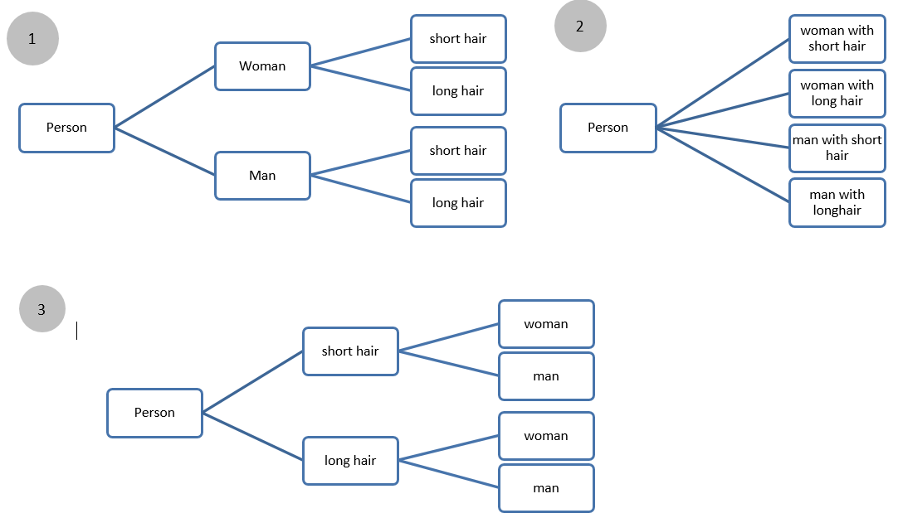

Fill out the table below with the available information, then calculate the missing probabilities, write formulas for future reference.

|  |  |  |
| --- | --- | --- |
| Marginal probabilities | Given conditional probabilities | Joint probabilities |
| P(woman) | P (short hair | woman)  0.5 | P (woman & short hair)  0.25 |
| P(man) | P (long hair | woman)  0.5 | P (woman & long hair)  0.25 |
| P (long hair) | P (short hair | man)  0.96 | P (man & short hair)  0.48 |
| P (short hair) | P (long hair | man)  0.04 | P (man & long hair)  0.02 |
| Questioned  conditional probabilities | P (woman | long hair)  = P (women & long) / P (man & long) + P (women & long)  = 0.25 / 0.02 + 0.25  P (woman | long hair) = 0.92 | |
| P (man | long hair)  = P (man & long) / P (man & long) + P (women & long)  = 0.02 / 0.02 + 0.25  P (man | long hair) = 0.08 | |
| P (woman | short hair)  = P (woman & short) / P (man & short) + P (women & short)  = 0.25 / 0.25 + 0.48  P (woman | short hair) = 0.34 | |
| P (man | short hair)  = P (man & short) / P (man & short) + P (women & short)  = 0.25 / 0.25 + 0.48  P (man | short hair) = 0.66 | |