Database Creation:
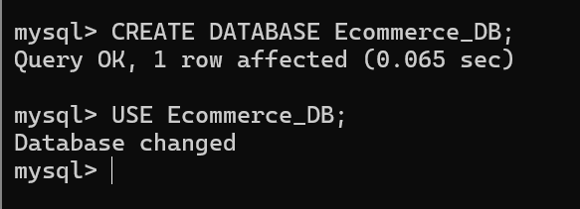
CREATE DATABASE Ecommerce_DB;

Creations of E-commerce Tables and insertion scripts:
Customers table:
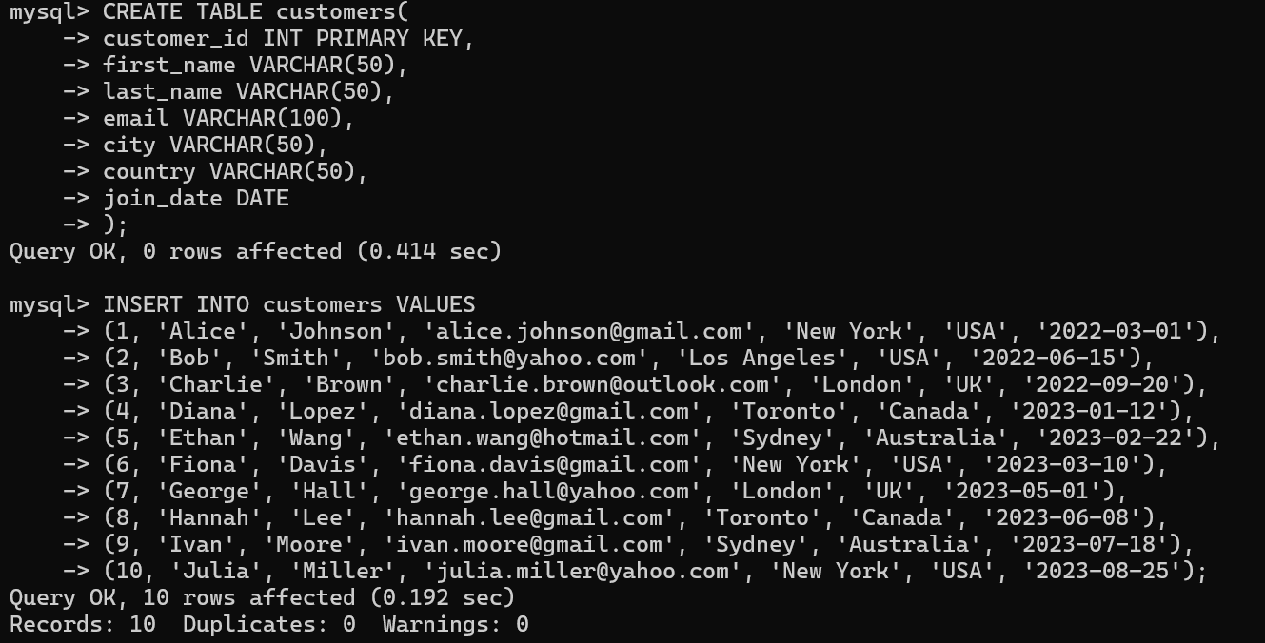
Product table
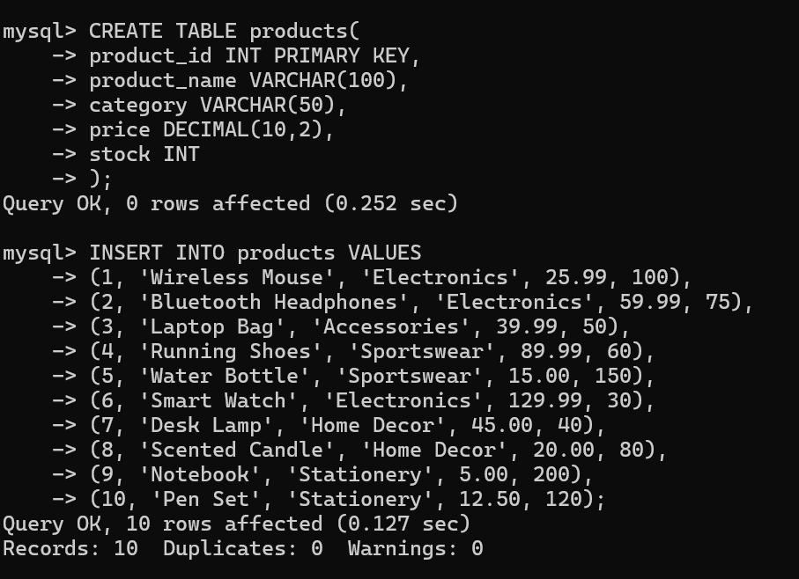

Orders table

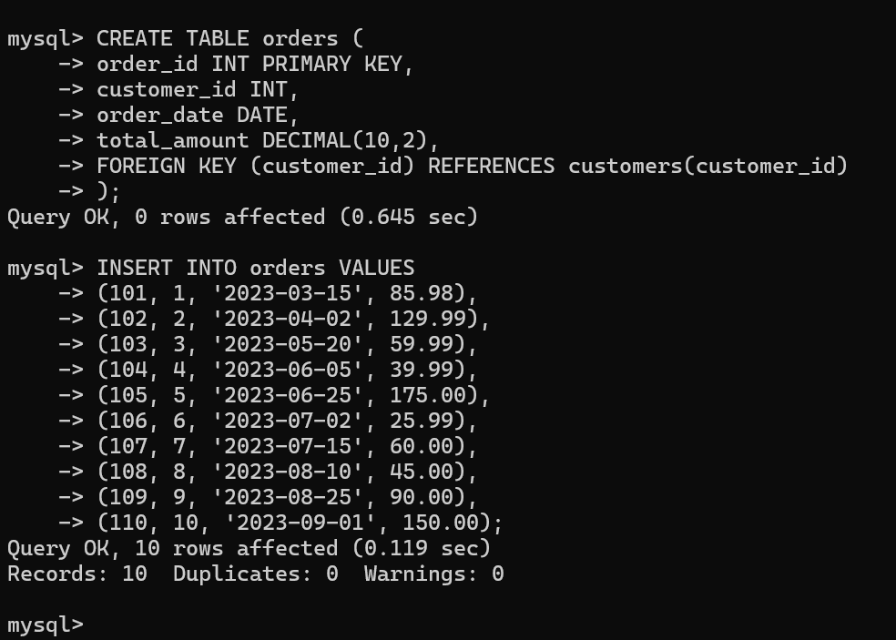
Order_details table:

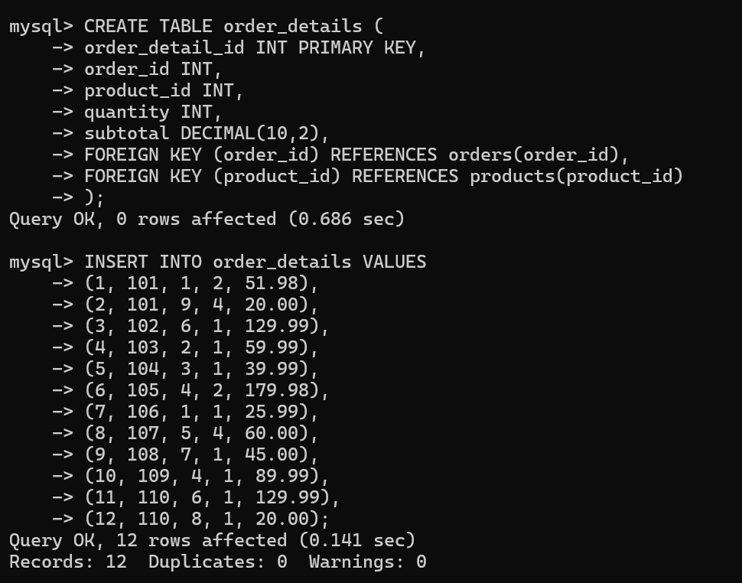

Basic SELECT & WHERE

1.List all customers from the USA.
select * from customers where country='USA';

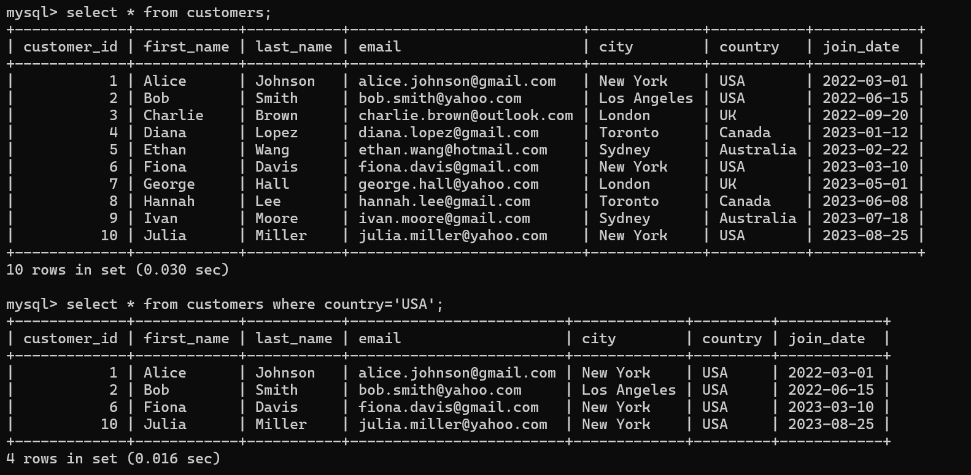
2.Find all products in the “Electronics” category costing more than $50.
select * from products where category = 'Electronics' and price>50;

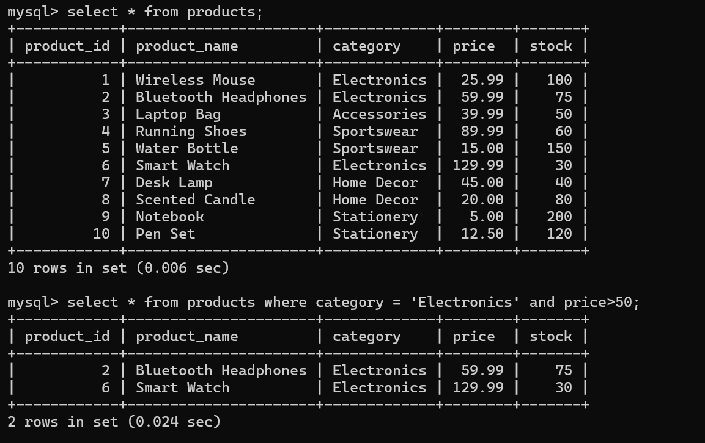

3.Show orders placed after June 2023.
select * from orders where order_date>'2023-06-23';
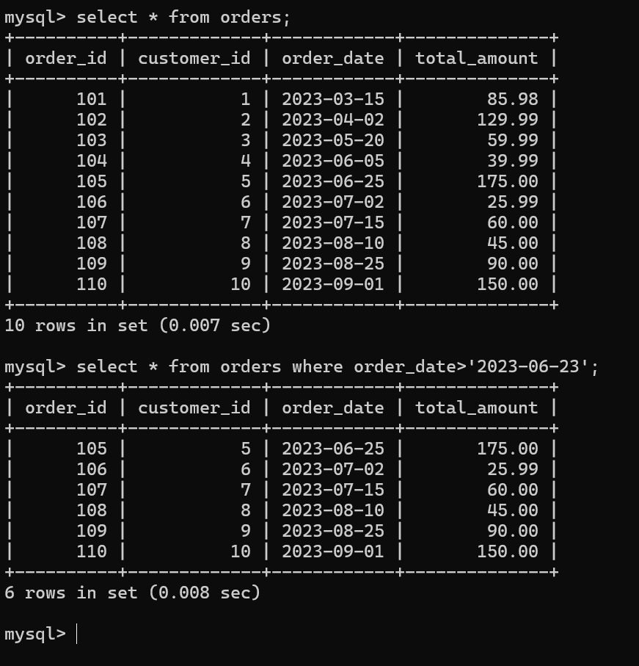

ORDER BY & LIMIT
1.List the top 5 most expensive products.
select * from products
order by price desc
LIMIT 5;
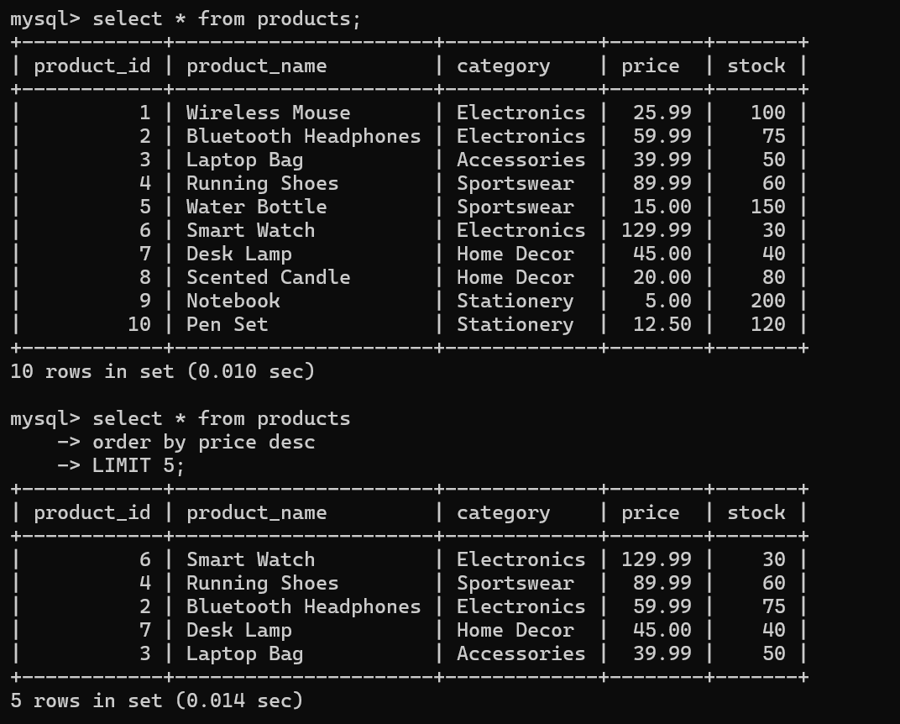

2.Display customers ordered by their join date (newest first).

SELECT *
FROM customers
ORDER BY join_date DESC;
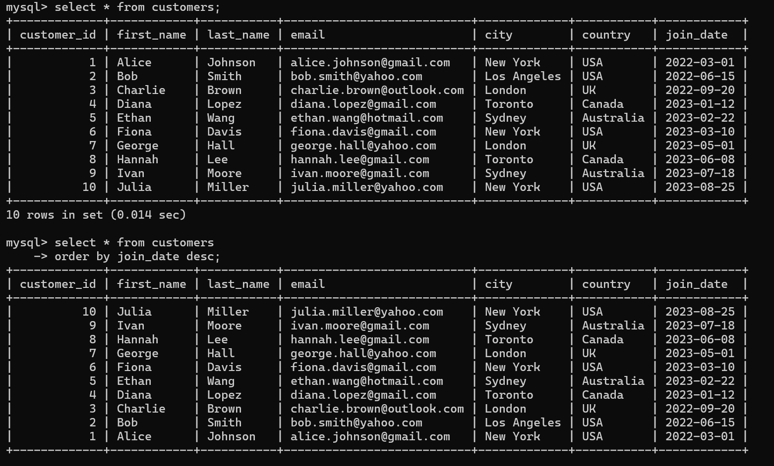
GROUP BY & Aggregate Functions

1.Find the total number of customers in each country.
select country, count(*) as 'Total number of customers'
from customers
group by country;

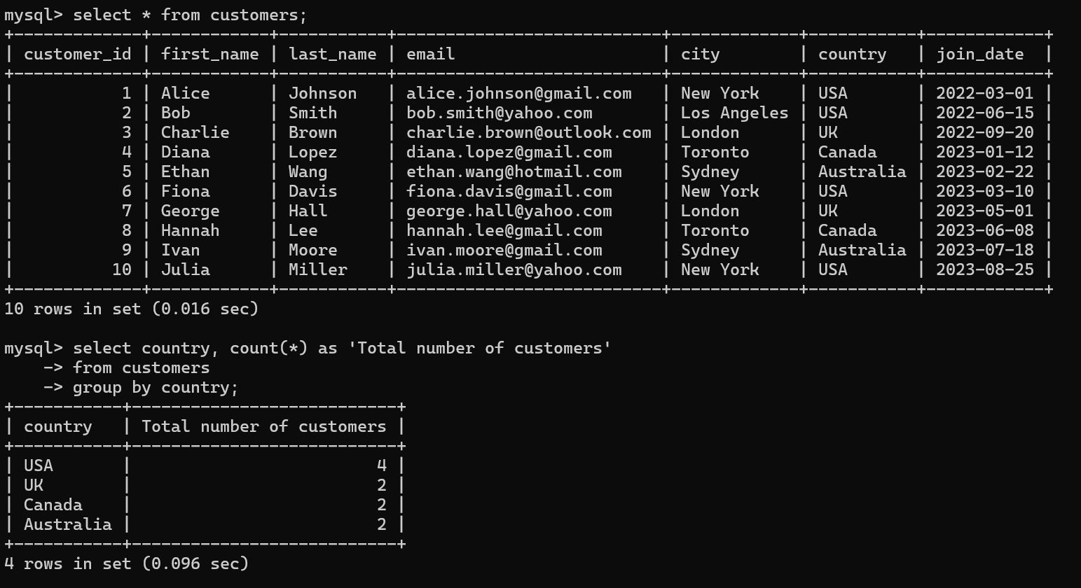
2.Calculate the average order total per customer.
select customer_id, AVG(total_amount)
from orders
group by customer_id;

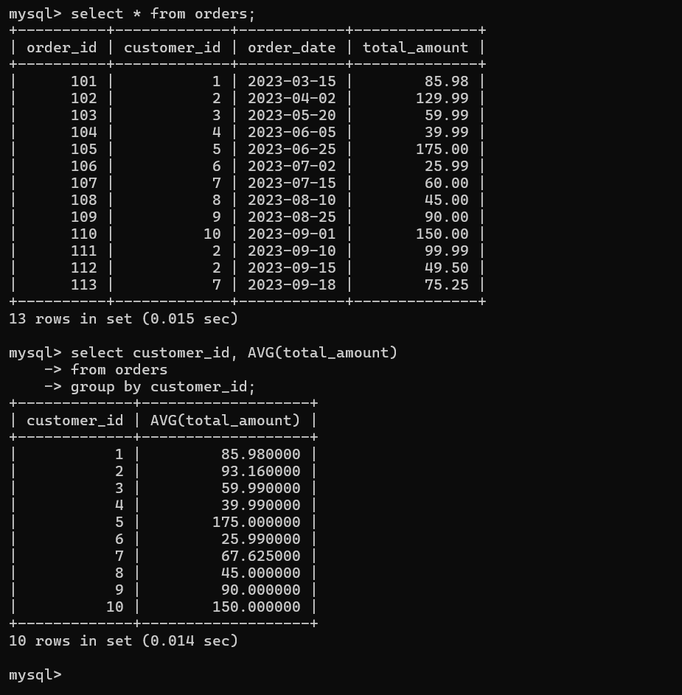
3.Find the total revenue per product.
select product_id, SUM(subtotal)
from order_details
group by product_id;
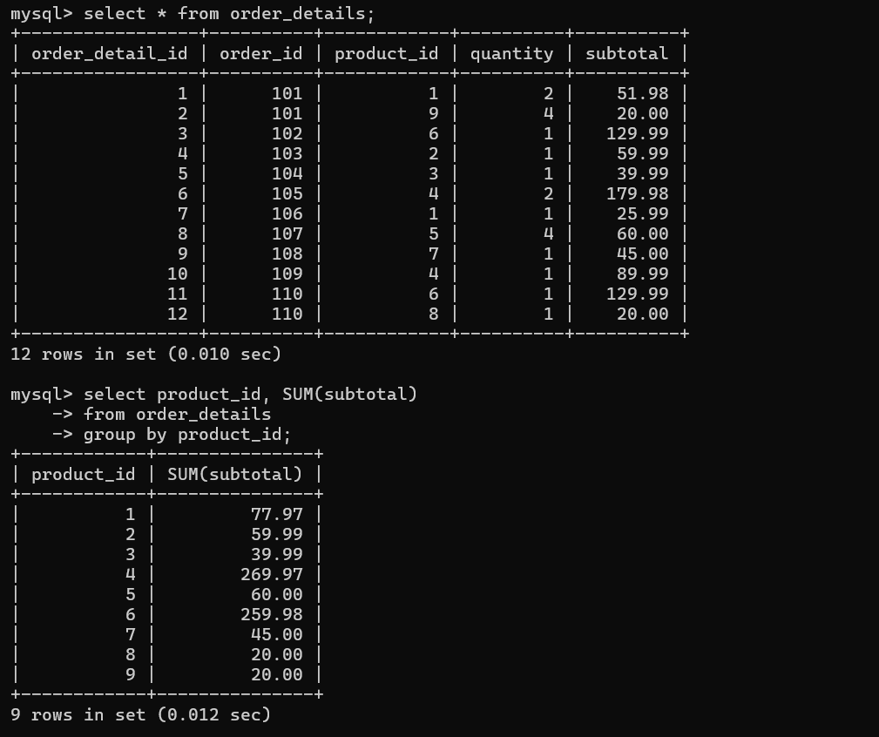
JOINS (INNER, LEFT, RIGHT)

1.Show all orders with customer name and total amount.
select o.order_id, c.customer_id, c.first_name, c.last_name, o.total_amount
from orders o
join customers c on o.customer_id = c.customer_id;

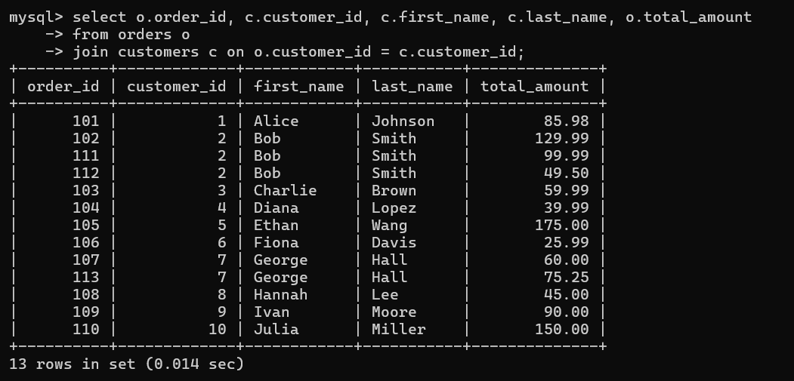
2.List each customer and their total order value.
select c.customer_id, count(*) as 'total_number_of_orders'
from customers c
join orders o on c.customer_id=o.customer_id
group by o.customer_id;

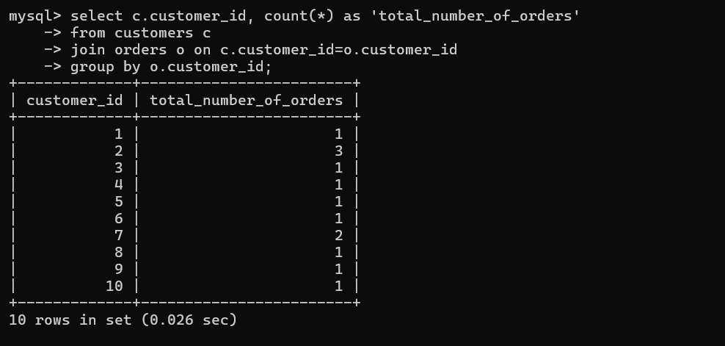

3.Get a list of all products and the number of times they’ve been ordered.
select p.product_id, p.product_name, count(*) as 'Total_number_of_orders'
from products p
join order_details o on o.product_id = p.product_id
group by o.product_id;
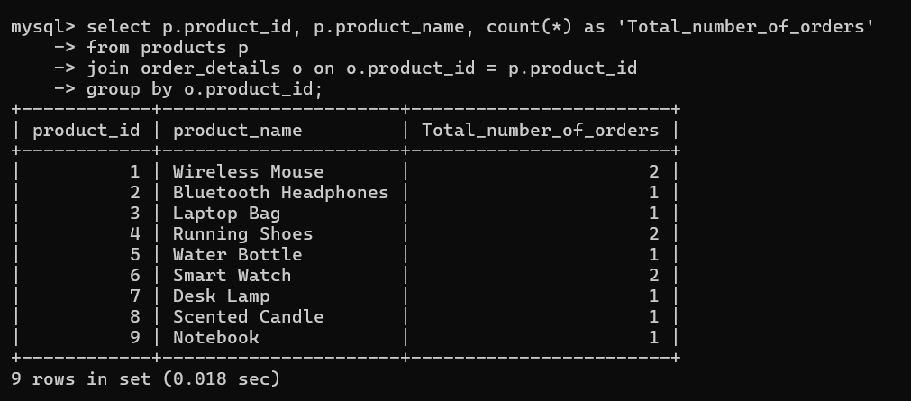
Subqueries

1.Find customers who have spent more than the average total order amount.
select * from (
select customer_id, sum(total_amount) as amount
from orders
group by customer_id) as temp
where amount > (select AVG(total_amount) from orders);

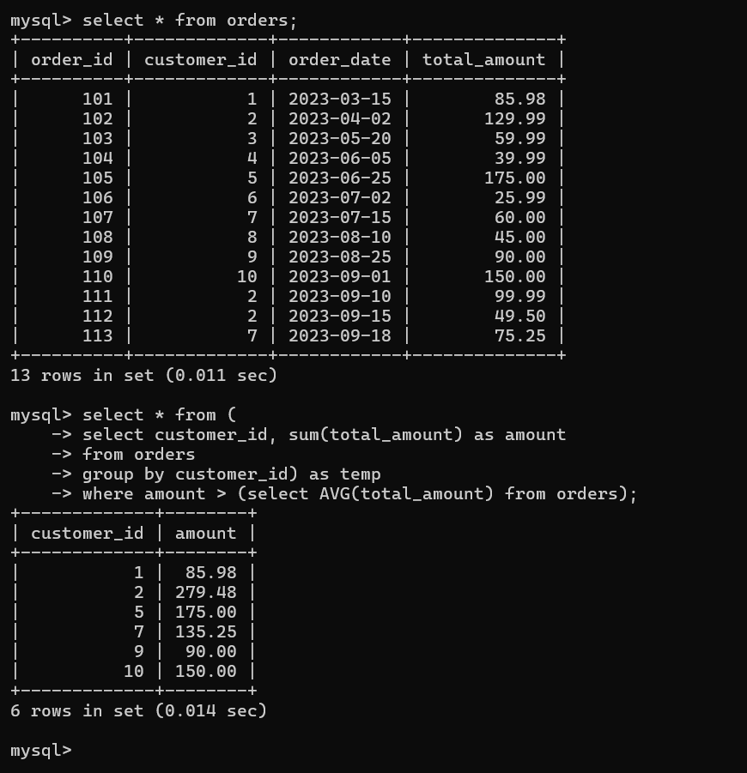

2.Find products that cost more than the average price in their category.

select product_id, product_name, p.category, avg_price, price
from products p
left join (select category, AVG(price) as avg_price
from products group by category) as temp on temp.category=p.category
where p.price>temp.avg_price;
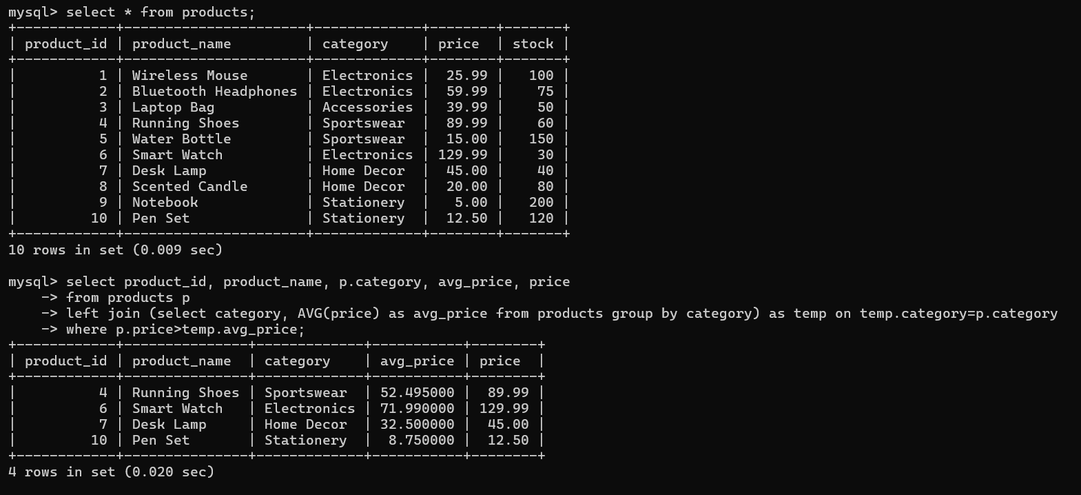
Views

1.Create a view showing customer name, product purchased, quantity, and order date.

CREATE VIEW customer_orders AS
select o.customer_id, c.first_name, c.last_name, p.product_name, od.quantity, o.order_date
from orders o
join order_details od on od.order_id = o.order_id
join products p on p.product_id = od.product_id
join customers c on c.customer_id = o.customer_id;
select * from customer_orders;
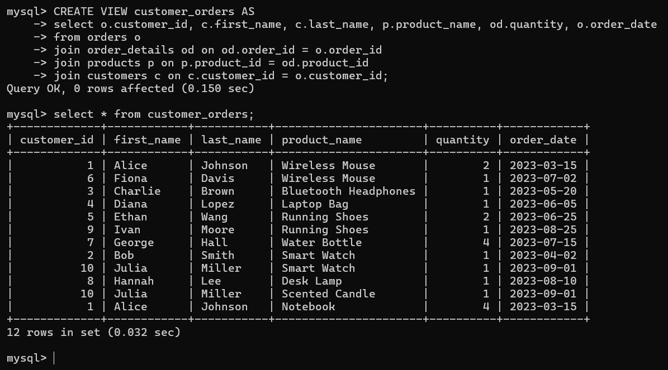
2.Create a view summarizing total revenue by category.

CREATE VIEW total_revenue_by_category AS
select p.category, sum(od.subtotal) as total_revenue
from products p
join order_details od on od.product_id = p.product_id
group by p.category;
select * from total_revenue_by_category;

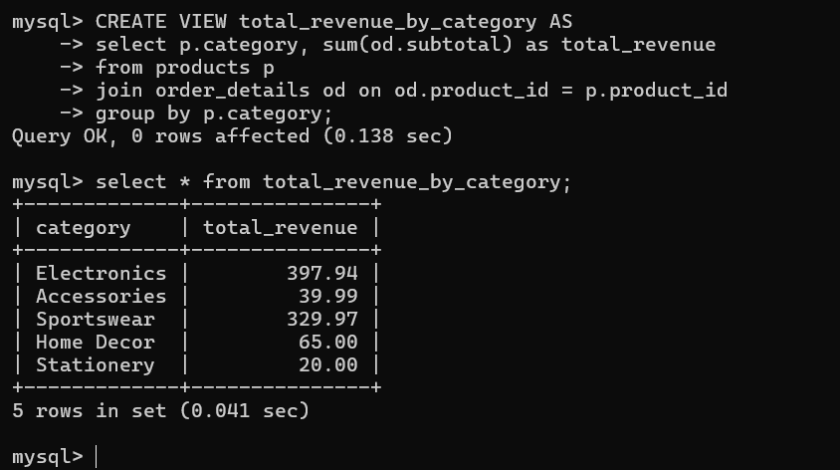

Indexing & Optimization

1.Create an index on the order_date column of the orders table.
CREATE INDEX idx_order_date
ON orders (order_date);

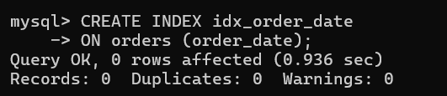

2.Create a composite index on customer_id and order_id in the order_details table.
CREATE INDEX idx_customer_order
ON order_details (order_id, product_id);

