DBMS
Unit-1
1.Aim: Oracle Database Installation Process.
Step 1:
Insert Pen drive and Run Setup
Insert the pen drive containing the Oracle Database software. Locate the setup.exe file and double-click it to start the installation process.


Step 2:
Preparing to Install
The InstallShield Wizard will prepare the installation by extracting the required files.

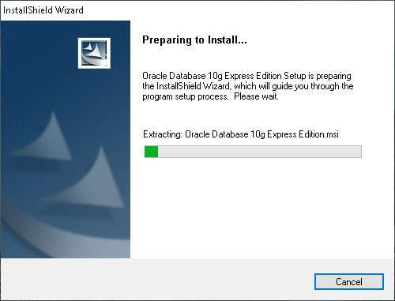

Step 3:
Select Maintenance Option
You will be prompted to either Repair or Remove Oracle Database 10g Express Edition. Choose Repair to reinstall all necessary components, then click Next.
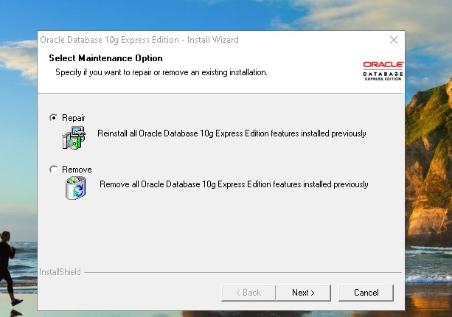

Step 4:
Setup Status
The installation wizard will show the progress of the installation process. Wait until the setup completes.
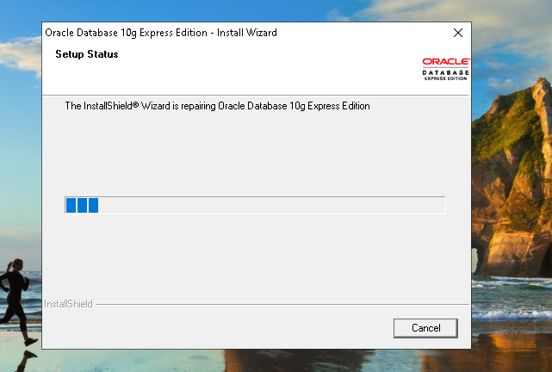

Step 5:
Installation Complete
Once the process is completed, the wizard will display a confirmation message. Click Finish to complete the installation.
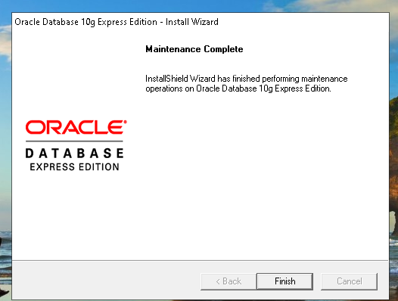

RESULT:
Oracle Database was installed and configured successfully. The database started without errors, and basic SQL queries ran correctly, confirming the installation was successful.

2.Aim:Implementing a University Database System.
Description:
This experiment creates a University Database with STUDENT, COURSE, and ENROLLMENT tables. The STUDENT table stores student details, the COURSE table holds course information, and the ENROLLMENT table links students to their courses using primary and foreign keys for easy record management.

Student Table:
Creating student table:
Query: create table student ( Sid int, Sname varchar(50), dept varchar(20),year int
,primary key(Sid));

Inserting values into the student table:
Query: insert into student values (1, 'Lubber', 'CSE', 2);
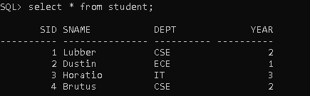

Creating Course table:
Query: create table course ( Cid int, Cname varchar(20), credits int, primary key(Cid));

Inserting values into the Course table:
Query: insert into course values (205,'DBMS',3);
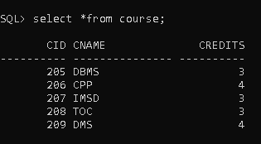

Creating Enrollment table:
Query:create table enrollment (Sid int, Cid int, grade varchar (5), primary key (Sid, Cid), foreign key (Sid) references student (Sid), foreign key (Cid) references course (Cid) );

Inserting values into the Enrollment table:
Query: insert into enrollment values (1, 205, 'A');
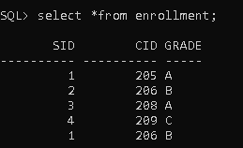
RESULT:
The University Database was created successfully with all tables and relationships. Data can be stored and retrieved correctly, ensuring proper links between students, courses, enrollments, and instructors.
Unit-2
1.Aim:Querying and modifying the database by using Data Manipulation Language commands -Select , Insert, Update, Delete.
Description:
This experiment uses DML commands — SELECT, INSERT, UPDATE, and DELETE to query and modify data in the Sailors, Boats, and Reserves database. These commands help retrieve, add, modify, and remove records, enabling efficient data management.
Sailors Table:
Creating table sailors:
Query: create table Sailors (Sid int, Sname varchar (20), Rating int, Age real,
primary key (Sid));

Inserting values into the sailor’s table:
Query: insert into Sailors values (22, 'Dustin', 7, 45);
add 9 more tuples like this…….

Select all data from sailors table
Query: select *from sailors;
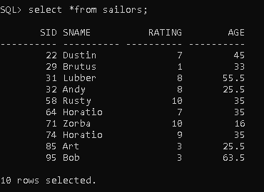
Creating table boats:
Query: create table boats (bid int, bname varchar (20), color varchar (20), primary
key(bid));

Insert values into the boats table:
Query: insert into boats values (101, 'Interlake', 'blue');
add 3 more tuples like this…….
Select all data from Boats table
Query: select *from boats;
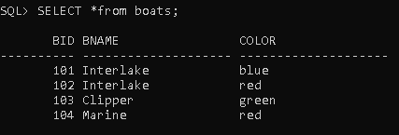
Create table reserves:
Query: create table reserves ( sid int, bid int, day date, foreign key (sid) references
sailors(sid), foreign key (bid) references boats(bid));

Insert values into the reserves table:
Query: insert into reserves values (22, 101, to date('10-oct-1998','dd-mon-yyyy'));

Select all data from reserves table:
Query: select *from reserves;
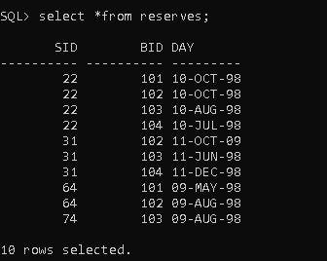
find sid of sailors who reserves altleast one boat:
Query: select distinct(sid) from reserves;
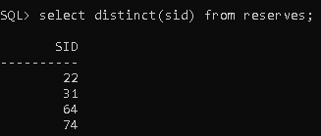

find the sid of sailors who have reserved the boat with bid = 103.
Query: select sid from reserves where bid = 103;
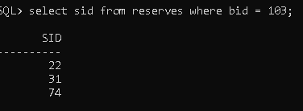

Display all sailors who are above 25 years old.
Query: select sname, age from sailors where age > 25;
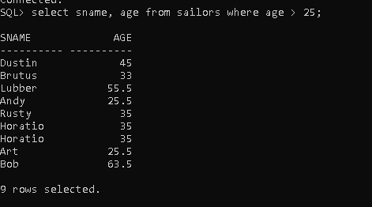

Find the names of sailors who have not reserved any boat.
Query: select sname from sailors where sid not in (select sid from reserves);
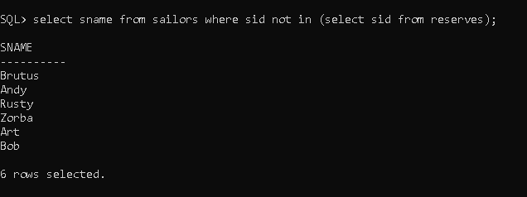
Find the sailors who reserved at least one boat on the same day as sailor with sid=22.
Query: select sname from sailors where sid in (select sid from reserves where day in (select day from reserves where sid = 22 ));
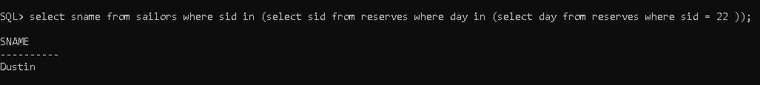

Find the names of sailors who are older than the youngest sailor.
Query: select sname, age from sailors where age > (select min(age) from sailors);
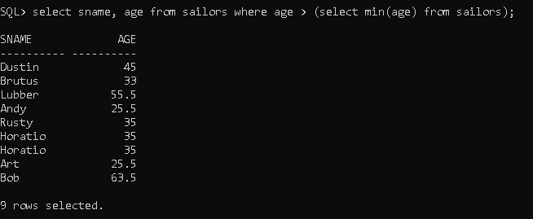

Find the names of sailors who are older than sailor ‘Dustin’.
Query: select sname, age from sailors where age > (select age from sailors where sname = 'Dustin');
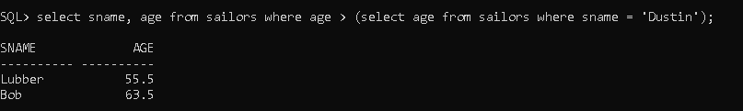

Find the names of sailors who have the highest rating.
Query: select sname from sailors where rating = (select max(rating) from sailors);
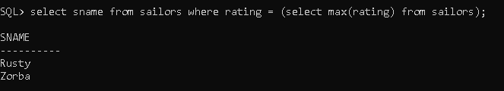

Write an SQL query to display the names of sailors who have reserved a red or
greenboat.
Query: select distinct(sname) from sailors s,reserves r, boats b where s.sid = r.sid
and r.bid = b.bid and (b.color='red' or b.color='green');
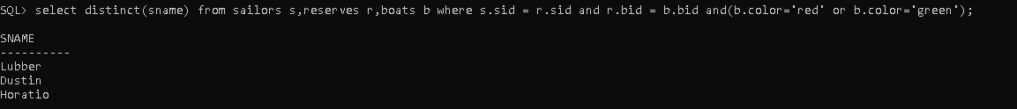

Write an SQL query to display the sid of sailors who have reserved a red or Green boat.
Query: select distinct(s.sid) from sailors s,reserves r, boats b where s.sid = r.sid
and r.bid = b.bid and (b.color='red' or b.color='green');
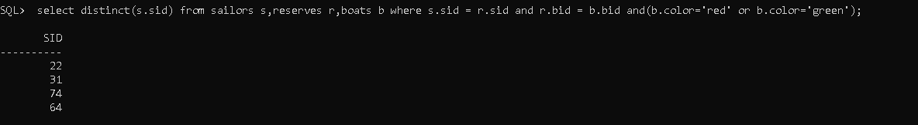

find the colors of boats reserved by lubber
Query: select distinct(color) from boats where bid in (select bid from reserves where sid = (select sid from sailors where sname='Lubber'));
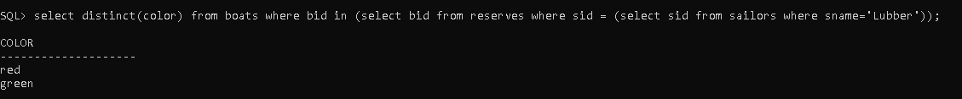

find the max age of sailors in each rating level
Query: select rating, max(age) as max_age from sailors group by rating;
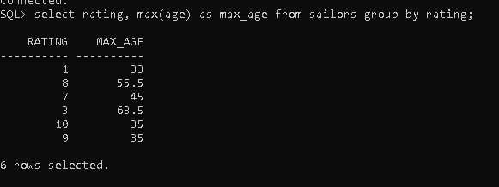

Change the color of boat with bid = 103 to 'yellow'.
Query: update boats set color = 'yellow' where bid = 103;
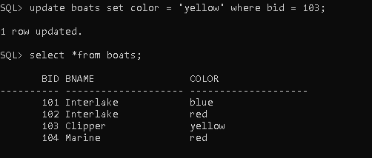

Update the rating of sailor 'Dustin' to 10.
Query: update sailors set rating = 10 where sname = 'Dustin';
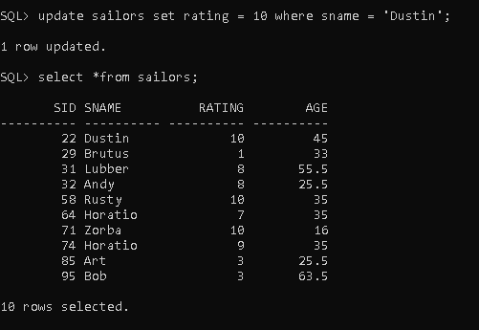

Delete the reservation made by sailor with sid = 22.
Query: delete from reserves where sid = 22;
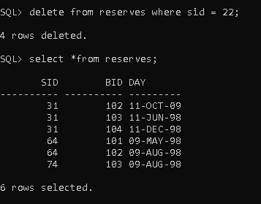

RESULT:
All DML commands (SELECT, INSERT, UPDATE, DELETE) were executed successfully. Data was retrieved, added, modified, and removed correctly from the database tables.
2.Aim: Implementation of Aggregate Functions – Sum, Avg, Min, Max, Count. Use group-by and having clause.
Description:
This experiment uses SQL aggregate functions — SUM, AVG, MIN, MAX, and COUNT — along with GROUP BY and HAVING clauses to summarize and filter grouped data, helping in easy analysis like finding averages or counts per group.
Find the maximum age of sailors in each rating level.
Query: select rating, max(age) as max_age from sailors group by rating;
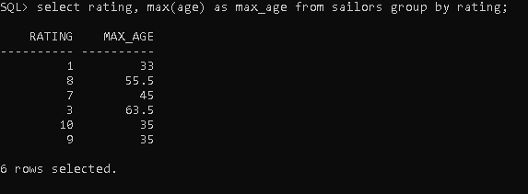

Count how many sailors are there in each rating.
Query: select rating, count(*) as total_sailors from sailors group by rating;
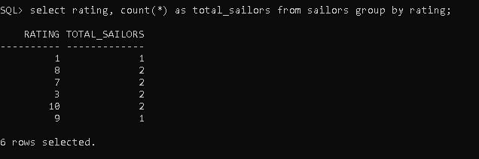

Find ratings of sailors where the maximum age is greater than 40.
Query: select rating, max(age) as max_age from sailors group by rating having max(age) > 40;
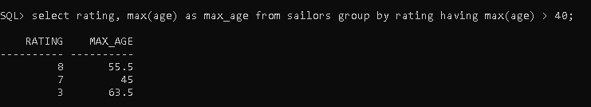

Find the total age of sailors in each rating.
Query: select rating, sum(age) as total_age from sailors group by rating;
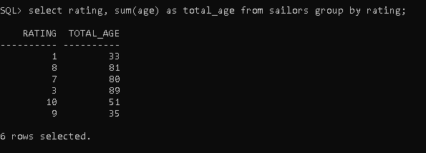

Find the minimum age of sailors in each rating.
Query: select rating, min(age) as min_age from sailors group by rating.
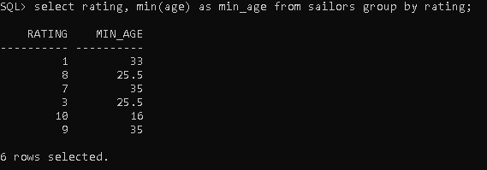
RESULT:
Aggregate functions (SUM, AVG, MIN, MAX, COUNT) were applied successfully. Data was grouped using GROUP BY, and conditions were filtered using HAVING, producing correct summarized results.

Unit-3
1. Aim: To perform various join operations such as natural join, equi-join, inner join, left outer join, right outer join, and outer join, and to analyze their effect on query results.
DESCRIPTION:
Join operations are used to combine data from two or more tables based on a related column.
They help in retrieving information spread across multiple tables in a relational database.

Natural Join: Automatically joins tables based on columns with the same name and compatible data types.
Query: select *from Sailors s NATURAL JOIN Reserves r;
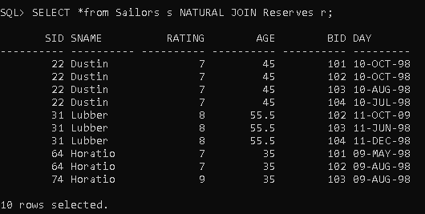

Inner Join: Returns only the rows that have matching values in both tables.
Query: select * from Sailors s INNER JOIN Reserves r ON s.sid = r.sid;
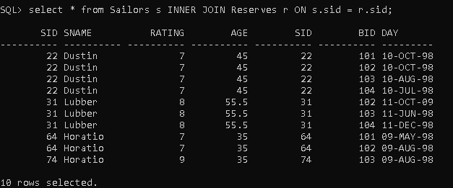
Left Outer Join: Returns all rows from the left table and matching rows from the right table; unmatched right rows show as NULL.
Query:select * from Sailors s LEFT OUTER JOIN Reserves r ON s.sid = r.sid;
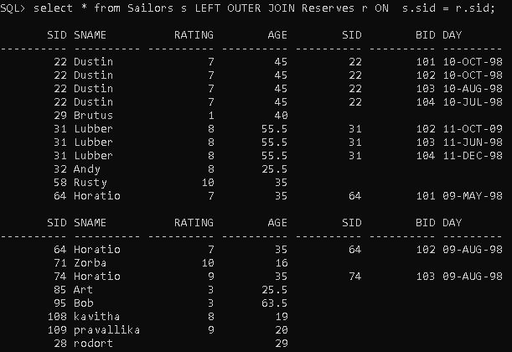

Right Outer Join: Returns all rows from the right table and matching rows from the left table; unmatched left rows show as NULL.
Query: select * from Sailors s RIGHT OUTER JOIN Reserves r ON s.sid = r.sid;
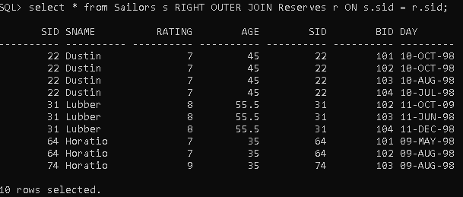
Full Outer Join: Returns all rows when there is a match in either table; unmatched rows from both sides show as NULL.
Query: select * from Sailors s FULL OUTER JOIN Reserves r ON s.sid = r.sid;
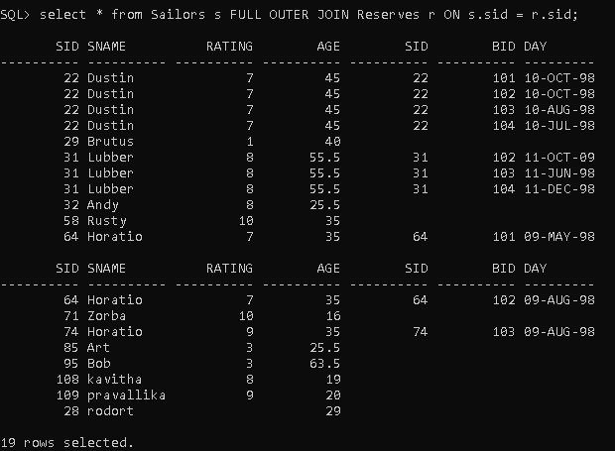

Equi Join: Joins two tables using a specific equality condition (e.g., table1.col = table2.col).
Query: select s.sid, s.sname, r.bid, r.day from Sailors s, Reserves r where s.sid = r.sid;
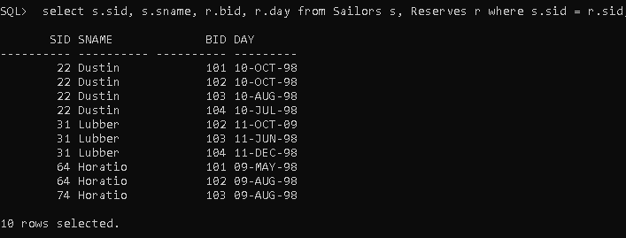
Result:
All join queries ran successfully, combining data from the Sailors and Reserves tables. Inner and Equi Joins displayed only the matching records, while Left, Right, and Full Outer Joins include unmatched rows as NULL. This experiment demonstrated how different types of joins retrieve and display data in various ways.
2. AIM:To perform SQL set operations like UNION, INTERSECT, and Set Difference using Sailors and Reserves tables.
DESCRIPTION:
Set operations combine or compare results from multiple queries. UNION merges rows from both queries without duplicates, INTERSECT returns common rows, and MINUS shows rows from the first query not present in the second.

UNION:
Query: select sid fromSailors union select sid from Reserves;
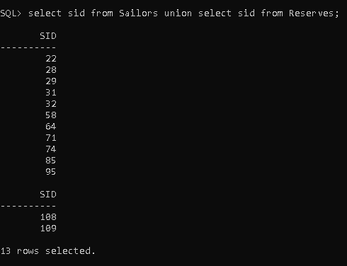

INTERSECT:
Query: select sid from Sailors Intersect select sid from Reserves;
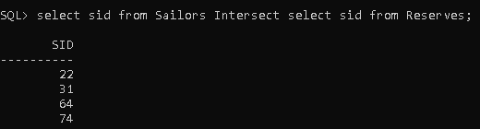
Set Difference:
Query: select sid from Sailors minus select sid from Reserves;
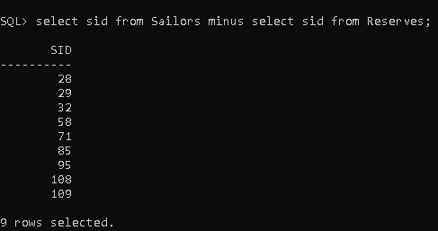

RESULT:
All set operations executed successfully. UNION showed all unique Sailors from both tables, INTERSECT displayed only Sailors who made reservations, and MINUS listed Sailors without any reservations. The experiment demonstrated how set operations can combine and compare data efficiently.

3. AIM:To retrieve data using nested and correlated subqueries on Sailors and Reserves tables.
DESCRIPTION:
Nested subqueries run first and pass results to the outer query. Correlated subqueries depend on the outer query for their values and execute for each outer row. These queries help extract specific conditional data.

Nested Subquery: Sailors who reserved boat 101
Query: select sname from Sailors where sid in (select sid from Reserves where bid = 101);
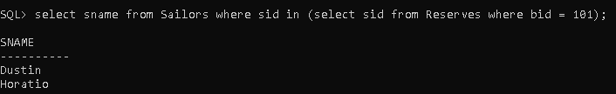

Correlated Subquery: Sailors who reserved at least one boat
Query: select sname from Sailors s where exist (select * from Reserves r where r.sid = s.sid);
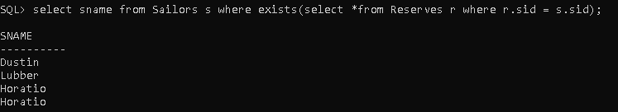

RESULT:
Nested and correlated subqueries executed successfully. The nested query retrieved Sailors who reserved boat 101, and the correlated query listed all Sailors who had made any reservation. The experiment showed how subqueries can extract conditional data efficiently.

4.AIM:To create a view showing Sailors with the boats they reserved and a materialized view summarizing boat reservations.
DESCRIPTION:
A view is a virtual table based on a query, simplifying data retrieval. A materialized view stores query results physically for faster access. Views also help in controlling access to sensitive data.

Create a View: Sailor reservations
Query: create view SailorReservations as select s.sid, s.sname, r.bid, r.date from Sailors s join Reserves r on s.sid = r.sid;

View:
Query:select * from SailorReservations;
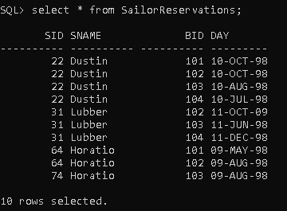

Update a View :
Query:update SailorReservations set date = '12-nov-99' where sid =64;
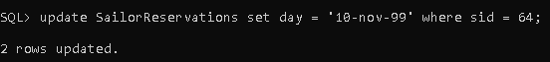

Materialized View: Count of reservations per boat
Query:create materialized view BoatSummary as select bid, COUNT(sid) AS Total_Reservations from Reserves group by bid;

RESULT:
The view displayed Sailors along with the names of boats they reserved. The materialized view summarized the total reservations per Sailor. This showed how views and materialized views simplify data access and improve performance.

Unit-4
1.AIM:To understand normalization (1NF, 2NF, 3NF, BCNF) using a university database.
DESCRIPTION:
Normalization organizes tables to remove redundancy and maintain data integrity. Each normal form ensures proper structure and eliminates anomalies.

1NF: Students table with atomic values
Query:create table students (studentid int primary key,studentname varchar(50),major varchar(30));
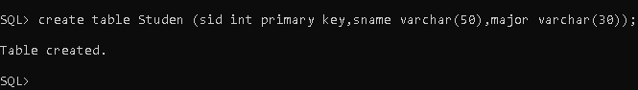

2NF: Enrollments table to remove partial dependency
Query:create table enrollments (studentid int,courseid int,enrollmentdate date,primary key(studentid, courseid));

3NF: Courses table with no transitive dependency
Query:create table courses (courseid int primary key,coursename varchar(50),credits int);

BCNF: Course_Instructors table
Query:create table course_instructors (courseid int,instructorid int,primary key(courseid, instructorid));

RESULT:
Tables were successfully created following normalization rules. Redundancy was reduced, and data integrity was maintained.

2a. AIM:To implement GRANT and REVOKE commands.
DESCRIPTION:
DCL commands control user access to database objects and maintain security.

Create a new user
Query:create user user1 identified by password123;
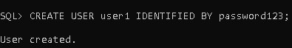

Grant privileges
Query:grant select, insert on students to user1;
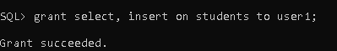

Revoke privileges
Query:revoke insert on students from user1;
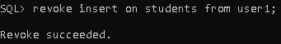

RESULT:
Privileges were successfully granted and revoked. Users accessed data according to assigned permissions.

2b.AIM:To implement COMMIT, SAVEPOINT, and ROLLBACK commands.
DESCRIPTION:
TCL ensures transactions follow ACID properties and allows safe data updates with rollback and commit options.

Insert new enrollment
Query: insert into enrollments(studentid, courseid, enrollmentdate)values (101, 101, to_date('2025-10-12', 'yyyy-mm-dd'));

Savepoint
Query:savepoint sp1;
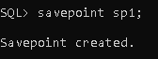

Another insert
Query:insert into enrollments(studentid, courseid,enrollmentdate)values (102, 'cse102', '2025-10-12');

Rollback to savepoint
Query:rollback to sp1;
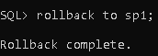

Commit changes
Query:commit;
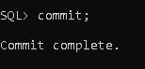

RESULT:
The first enrollment was inserted, the second was rolled back, and the transaction was committed successfully.

Unit-5
1. AIM:To create primary and secondary indexes on a table column to improve query performance.
DESCRIPTION:
Indexes speed up data retrieval by providing a quick lookup for rows based on column values.
1.Primary index is created automatically on the primary key.
2.Secondary index is created manually on non-primary key columns.

Create Students table:
Query: create table students (studentid int primary key,studentname varchar2(50),major varchar2(30));

Create Secondary Index on Major column
Query:create index idx_major on students(major);
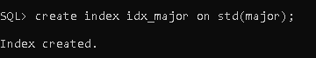

RESULT:
Primary index is automatically created on StudentID.
Secondary index idx_major was created successfully and can be used to retrieve data faster.

2.AIM:To retrieve data efficiently using indexes.
DESCRIPTION:
Indexes help in faster searching without scanning the entire table.

Retrieve all students with Major 'CSE'
Query:select * from students where major = 'cse';
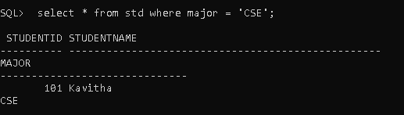
RESULT:
The query used the secondary index idx_major and retrieved data quickly.

3. AIM:To insert data into a table and observe how indexes are updated automatically.
DESCRIPTION:
When new rows are inserted, the primary and secondary indexes are updated to maintain fast access.

Insert new student records
Query:insert into students(studentid, studentname, major) values (103, 'kavitha', 'cse');
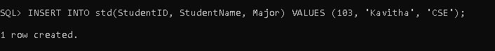

Query:insert into students(studentid, studentname, major) values (104, 'satya', 'ece');
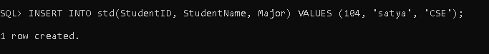

RESULT:
New rows were inserted successfully.Both primary and secondary indexes were updated automatically to include the new entries.

4. AIM:To delete data from a table and observe how indexes are maintained.
DESCRIPTION:
When rows are deleted, indexes are automatically adjusted to remove references to deleted data.

Delete a student record
Query:delete from studentswhere studentid = 102;
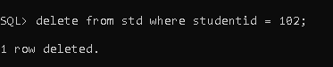

RESULT:
The row with StudentID = 102 was deleted successfully.Primary and secondary indexes were automatically updated to remove the deleted record.

