SALESFORCE

Performance Evaluation
and Improvement Plan
Week 6 Internship Task
Prepared by: Nidhrabingi Kavitha
Project: Salesforce Operations Performance Review
Deliverables: KPI analysis, dashboard mock-up, and actionable improvement roadmap

Executive Summary
This report presents a simulated evaluation of Salesforce operational performance and proposes a practical improvement plan for system responsiveness, user adoption, error reduction, workflow completion, and business efficiency. Because no live Salesforce organization telemetry or company dataset was provided, the report uses a clearly labeled illustrative six-week dataset rather than claiming to measure a real production environment. The selected KPIs include median page response time, weekly active-user adoption, recorded errors, and workflow completion within a target period. The dashboard visualizes trends across the six weeks and highlights the pattern that response time and error frequency rise while workflow completion declines, even as adoption improves. The analysis discusses potential causes that should be validated in a real environment, such as inefficient automation, overly complex page layouts, validation-rule friction, integration delays, poor data quality, training gaps, and unclear process ownership. The action plan separates immediate, short-term, and long-term activities. It recommends establishing a baseline, segmenting performance by user group and process, reviewing automation and integrations, simplifying high-traffic user journeys, improving training and data standards, monitoring error trends, and introducing a recurring governance review. Each recommendation includes an owner role, an indicative timeline, and a success measure so progress can be tracked. The report also explains limitations, measurement definitions, and a repeatable evaluation cycle. The included dashboard image is a mock-up generated from simulated data for demonstration and learning purposes; it is not a screenshot or export from a live Salesforce system. The report is intended as a structured starting point that can be adapted when authorized, real organization metrics become available.

1. Objective and Scope
The objective is to evaluate a representative set of Salesforce operations KPIs, identify possible workflow bottlenecks, and propose technical and process improvements. The scope covers response time, user adoption, recorded errors, and workflow completion. It does not claim to assess a real production org.

2. Data and Methodology
A six-week simulated dataset was created solely to demonstrate how an operations review can be conducted. Values are illustrative, not sourced from Salesforce telemetry or an external organization. In a real assessment, collect approved data from Salesforce reports, event monitoring or performance logs where available, support tickets, adoption analytics, and workflow timestamps. Confirm metric definitions and reporting periods before comparing teams.
Week | Median response (s) | Active adoption (%) | Errors (#) | Workflow on-time (%)
Wk 1 | 2.8 | 62% | 38 | 78%
Wk 2 | 3.1 | 65% | 42 | 77%
Wk 3 | 3.6 | 68% | 49 | 74%
Wk 4 | 4.2 | 69% | 57 | 71%
Wk 5 | 4.0 | 72% | 53 | 73%
Wk 6 | 4.6 | 74% | 61 | 70%
Metric definitions:
- Median page response time: illustrative median time for a user-facing page action, in seconds.
- Weekly active-user adoption: active users during the week divided by the eligible user population.
- Recorded errors: count of logged user-facing errors or support incidents in the reporting week.
- Workflow on-time completion: percentage of tracked workflow items completed within an agreed target.

3. KPI Dashboard Mock-up
The dashboard below is generated from the simulated data above. It demonstrates a compact view of four operational KPIs.
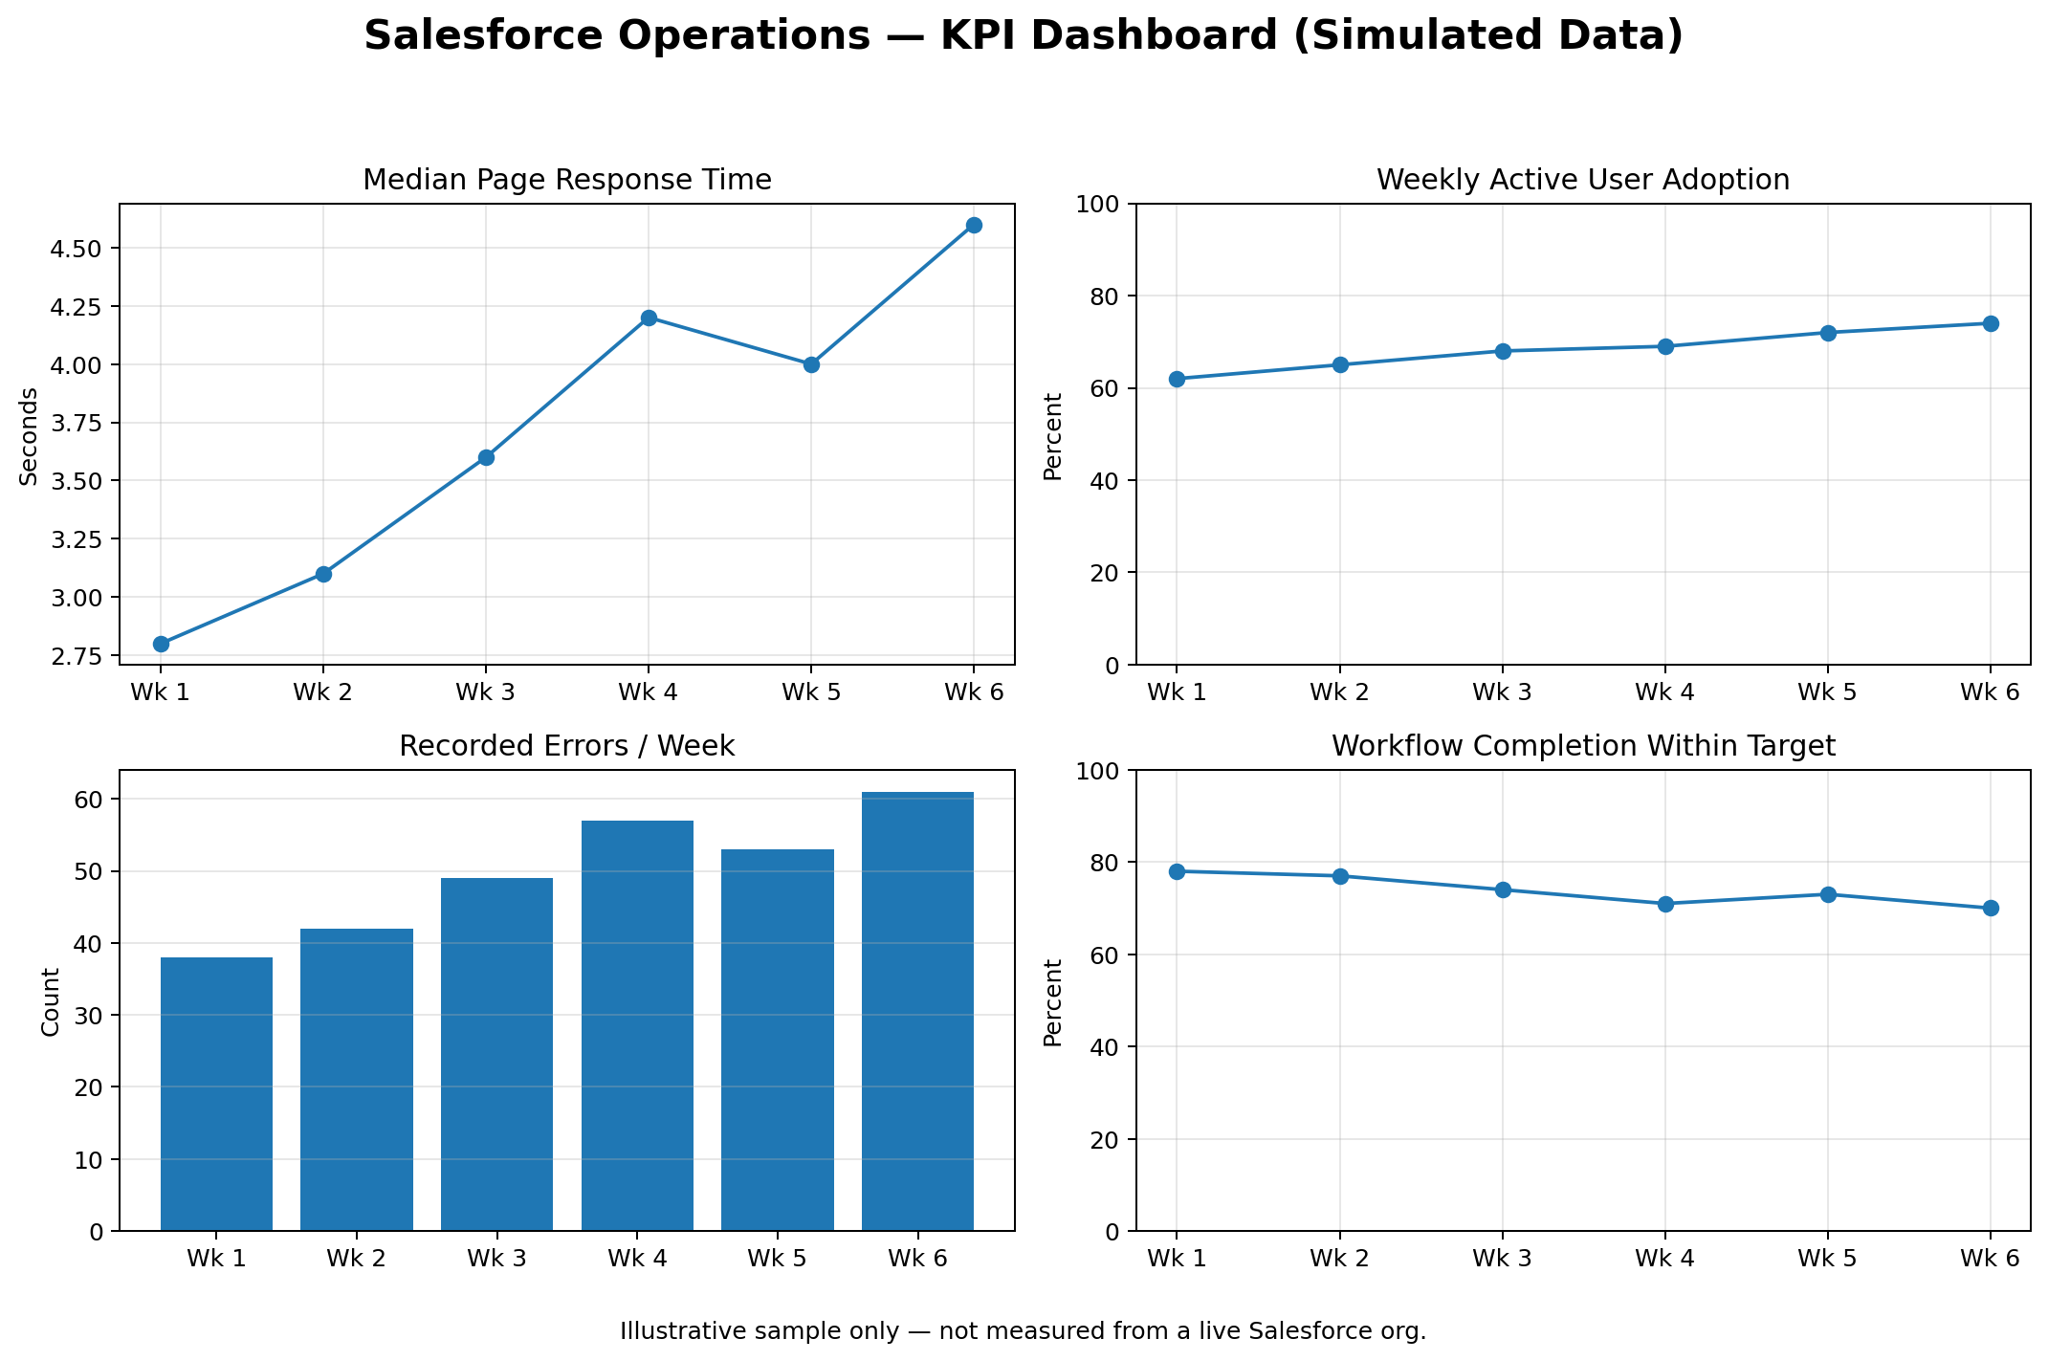
Figure 1. Illustrative KPI dashboard; not a live Salesforce dashboard or a real system measurement.

4. Findings and Interpretation

Response time increases
Median response time rises from 2.8 seconds in Week 1 to 4.6 seconds in Week 6. This may indicate heavier page loads, inefficient automation, integration latency, network effects, or data-volume changes. The dataset cannot identify the actual cause; diagnostics are required.

Adoption improves
Weekly active-user adoption increases from 62% to 74%. More users are engaging with the system, which is positive, but increased usage can expose usability or performance issues if workflows are not streamlined.

Errors trend upward
Recorded errors increase from 38 to 61 per week. Possible sources include validation failures, permissions, integration failures, duplicate or incomplete data, and user confusion. Error categories should be reviewed rather than treating all errors as equivalent.

On-time workflow completion declines
Completion within target drops from 78% to 70%. Combined with rising response time and errors, this suggests potential friction in the simulated process. A real review should segment by workflow, team, and complexity.

5. Potential Bottlenecks to Validate
- Automation overhead: flows, triggers, and validation rules may add unnecessary steps or run more often than needed.
- Page and interaction complexity: too many fields, related lists, or actions can slow users and increase mistakes.
- Integration delays: external services, API limits, or retries can affect record updates and user confidence.
- Data quality: duplicates, missing required values, and inconsistent naming create rework and failed automation.
- Training and process ambiguity: users may not understand ownership, required fields, or escalation paths.
- Reporting design: overly broad reports, unclear filters, or missing refresh expectations can lead to slow or misleading analysis.

6. Improvement Action Plan
Timeline | Actions | Owner role | Success measure
Immediate (0–2 weeks) | Establish a trusted baseline for each KPI; agree definitions and owners; categorize errors; identify the top three slow or failure-prone user journeys. | Salesforce admin + operations lead | Baseline approved; 90%+ of incidents categorized.
Short term (2–6 weeks) | Review high-traffic flows, validation rules, page layouts, and integrations; remove redundant steps only after testing; simplify high-use screens; publish quick-start guidance for frequent errors. | Admin/developer + process owners | Reduce repeat errors by 15% from measured baseline; improve task completion by 5 percentage points.
Medium term (6–12 weeks) | Pilot revised workflows with a representative user group; run user acceptance tests; create role-based training; monitor adoption and task completion weekly; use feedback to refine changes. | Product owner + training lead | Adoption reaches agreed target; positive pilot feedback; no critical regression.
Long term (3–6 months) | Introduce continuous performance monitoring, release/change governance, integration health checks, data-quality dashboards, and quarterly process reviews. | System owner + governance group | Sustained response-time improvement; fewer recurring incidents; quarterly KPI review completed.

7. Technical Recommendations
- Measure before optimizing: capture page-level timings and categorize slow transactions before changing configuration.
- Review automation for redundant operations, recursion, unnecessary queries, and unneeded synchronous work; test changes in a sandbox.
- Check integration logs, retry behavior, timeout patterns, and API consumption with the responsible technical owner.
- Simplify page layouts and reduce unnecessary fields or related lists on high-use pages, subject to user needs and governance.
- Use approved monitoring and Salesforce diagnostic capabilities available to the organization's edition and license.

8. Process and User Productivity Recommendations
- Map the current workflow from start to finish and remove duplicate approvals or re-entry where policy allows.
- Define field ownership, required information, naming conventions, and clear exception paths.
- Provide short role-based training and searchable quick-reference instructions.
- Create a feedback loop: users submit examples of friction, owners classify them, and improvements are prioritized by impact and effort.
- Use change management: document changes, test them with users, communicate releases, and keep rollback steps available.

9. Monitoring and Governance
Review the dashboard weekly during improvement work and monthly after stabilization. Segment metrics by workflow, user group, and severity when lawful and available. Record the baseline, target, actual value, owner, and explanation for each KPI. Set targets only after collecting real baseline data; example thresholds in this report are proposed planning goals, not universal Salesforce standards.

10. Risks, Limitations, and Assumptions
- All values are simulated and must not be represented as measurements from a real Salesforce environment.
- Potential causes are hypotheses that require verification with logs, users, configuration reviews, and process owners.
- The right response-time target depends on the transaction, architecture, network, and user context.
- Any configuration change must be authorized, tested, documented, and deployed through the organization's release process.
- Do not export or share sensitive customer data for analysis without proper approval.

11. Narrative Conclusion
The simulated results demonstrate how a combined KPI view can reveal patterns that a single metric might miss: adoption can rise while user experience and workflow completion worsen. The recommended response is to establish reliable measurements, classify errors, investigate the highest-impact journeys, simplify configuration and processes, and train users on consistent practices. A phased plan with named owners and measurable outcomes creates a repeatable improvement cycle. Once authorized real metrics are available, the simulated figures should be replaced with validated data and the recommendations prioritized based on evidence.

12. Public Resources
- Salesforce Help: https://help.salesforce.com/
- Salesforce Trailhead: https://trailhead.salesforce.com/
- Salesforce Architects: https://architect.salesforce.com/

Appendix A — Submission Description
This report presents a simulated evaluation of Salesforce operational performance and proposes a practical improvement plan for system responsiveness, user adoption, error reduction, workflow completion, and business efficiency. Because no live Salesforce organization telemetry or company dataset was provided, the report uses a clearly labeled illustrative six-week dataset rather than claiming to measure a real production environment. The selected KPIs include median page response time, weekly active-user adoption, recorded errors, and workflow completion within a target period. The dashboard visualizes trends across the six weeks and highlights the pattern that response time and error frequency rise while workflow completion declines, even as adoption improves. The analysis discusses potential causes that should be validated in a real environment, such as inefficient automation, overly complex page layouts, validation-rule friction, integration delays, poor data quality, training gaps, and unclear process ownership. The action plan separates immediate, short-term, and long-term activities. It recommends establishing a baseline, segmenting performance by user group and process, reviewing automation and integrations, simplifying high-traffic user journeys, improving training and data standards, monitoring error trends, and introducing a recurring governance review. Each recommendation includes an owner role, an indicative timeline, and a success measure so progress can be tracked. The report also explains limitations, measurement definitions, and a repeatable evaluation cycle. The included dashboard image is a mock-up generated from simulated data for demonstration and learning purposes; it is not a screenshot or export from a live Salesforce system. The report is intended as a structured starting point that can be adapted when authorized, real organization metrics become available.

