WEEK 4 TASK
Optimizing Salesforce Workflow Automation
Workflow Analysis • Automation Design • Implementation Plan • Sandbox Testing

Prepared for | Salesforce Internship — Week 4
Recommended platform | Salesforce Flow Builder
Included workflows | Lead assignment, case routing, lead follow-up task
Deliverables | Report, flow diagram, configuration blueprint, sandbox test plan

Prepared as a practical implementation blueprint. Live configuration must be completed and validated in an authorised Salesforce sandbox.

1. Executive Summary
This report identifies repetitive Salesforce tasks that can be automated to improve response time, consistency, and data quality. It recommends Salesforce Flow Builder for three practical use cases: automatic lead assignment, case routing, and follow-up task creation for qualified leads. The report defines entry conditions, decision logic, actions, error handling, implementation steps, and a sandbox test plan.
Scope note: This is a proposed design and implementation guide. It does not claim that flows have been installed in a live Salesforce org. Replace example queue names and custom field API names with values confirmed in the target sandbox.

2. Current-State Process Analysis
Process | Typical manual work | Risk / inefficiency | Automation opportunity
Lead management | Sales user reviews region and assigns each lead | Slow response; inconsistent ownership | Route eligible leads using region/product criteria
Case resolution | Support agent checks priority/type and forwards case | Delayed triage; cases may reach the wrong queue | Route new cases by priority and type
Lead follow-up | Sales user remembers to create a task | Missed follow-ups; duplicate tasks | Create a task when a lead qualifies; prevent duplicates
Monitoring | Admin discovers failures after a user report | Slow troubleshooting | Use fault paths, failed-flow monitoring, and test cases

3. Salesforce Automation Tool Selection
Tool | Assessment | Recommendation
Record-Triggered Flow | Supports decisions, record updates, related records, and fault paths | Recommended for all three proposed workflows
Workflow Rules | Legacy automation with narrower capabilities | Avoid for new builds; assess existing rules for migration
Process Builder | Legacy process automation | Use Flow for new automation
Approval Processes | Designed for formal review and approval steps | Use only where an approval process is required

Design principle: use a before-save record-triggered flow when only fields on the triggering record need updating. Use an after-save flow when creating a related Task, updating related records, or performing actions that require the saved record.

4. Proposed Automation Designs

Flow A — Lead Auto Assignment
- Object and trigger: Lead; when created, and optionally when routing-relevant fields change.
- Entry criteria: Lead is not converted, is eligible for routing, and has a usable region value.
- Decision: Branch by Region and, if required, Product Interest.
- Actions: Assign to the approved regional queue or user. If no outcome matches, assign to a default Leads queue and set Needs_Review__c = true.
- Controls: Avoid overwriting an intentional manual owner change; confirm that the queue supports Lead records and that the automation has the required access.

Flow B — Case Auto Routing
- Object and trigger: Case; on creation for new, unassigned cases.
- Decision order: High priority first, then Billing case type, otherwise General Support.
- Actions: Assign the Case Owner to the relevant queue and optionally set triage fields or a response target.
- Controls: Define a default route, review existing assignment rules, and test combinations so that a case cannot match conflicting branches.

Flow C — Qualified Lead Follow-Up Task
- Object and trigger: Lead; when created or updated to a qualifying state.
- Entry criteria: Rating = Hot or Status = Working, and Follow_Up_Created__c = false.
- Actions: Create a Task linked to the Lead, assign it to the Lead Owner, set a subject and due date, then set Follow_Up_Created__c = true.
- Controls: Use the flag to prevent duplicate tasks and confirm the task owner and due-date rules meet business policy.

5. Proposed Process Flow Diagram
The included PNG diagram presents the high-level design: a record event starts the automation, decision branches select the workflow, and actions assign records or create tasks. It is a conceptual diagram to guide creation of detailed element-level flows in Salesforce Flow Builder.
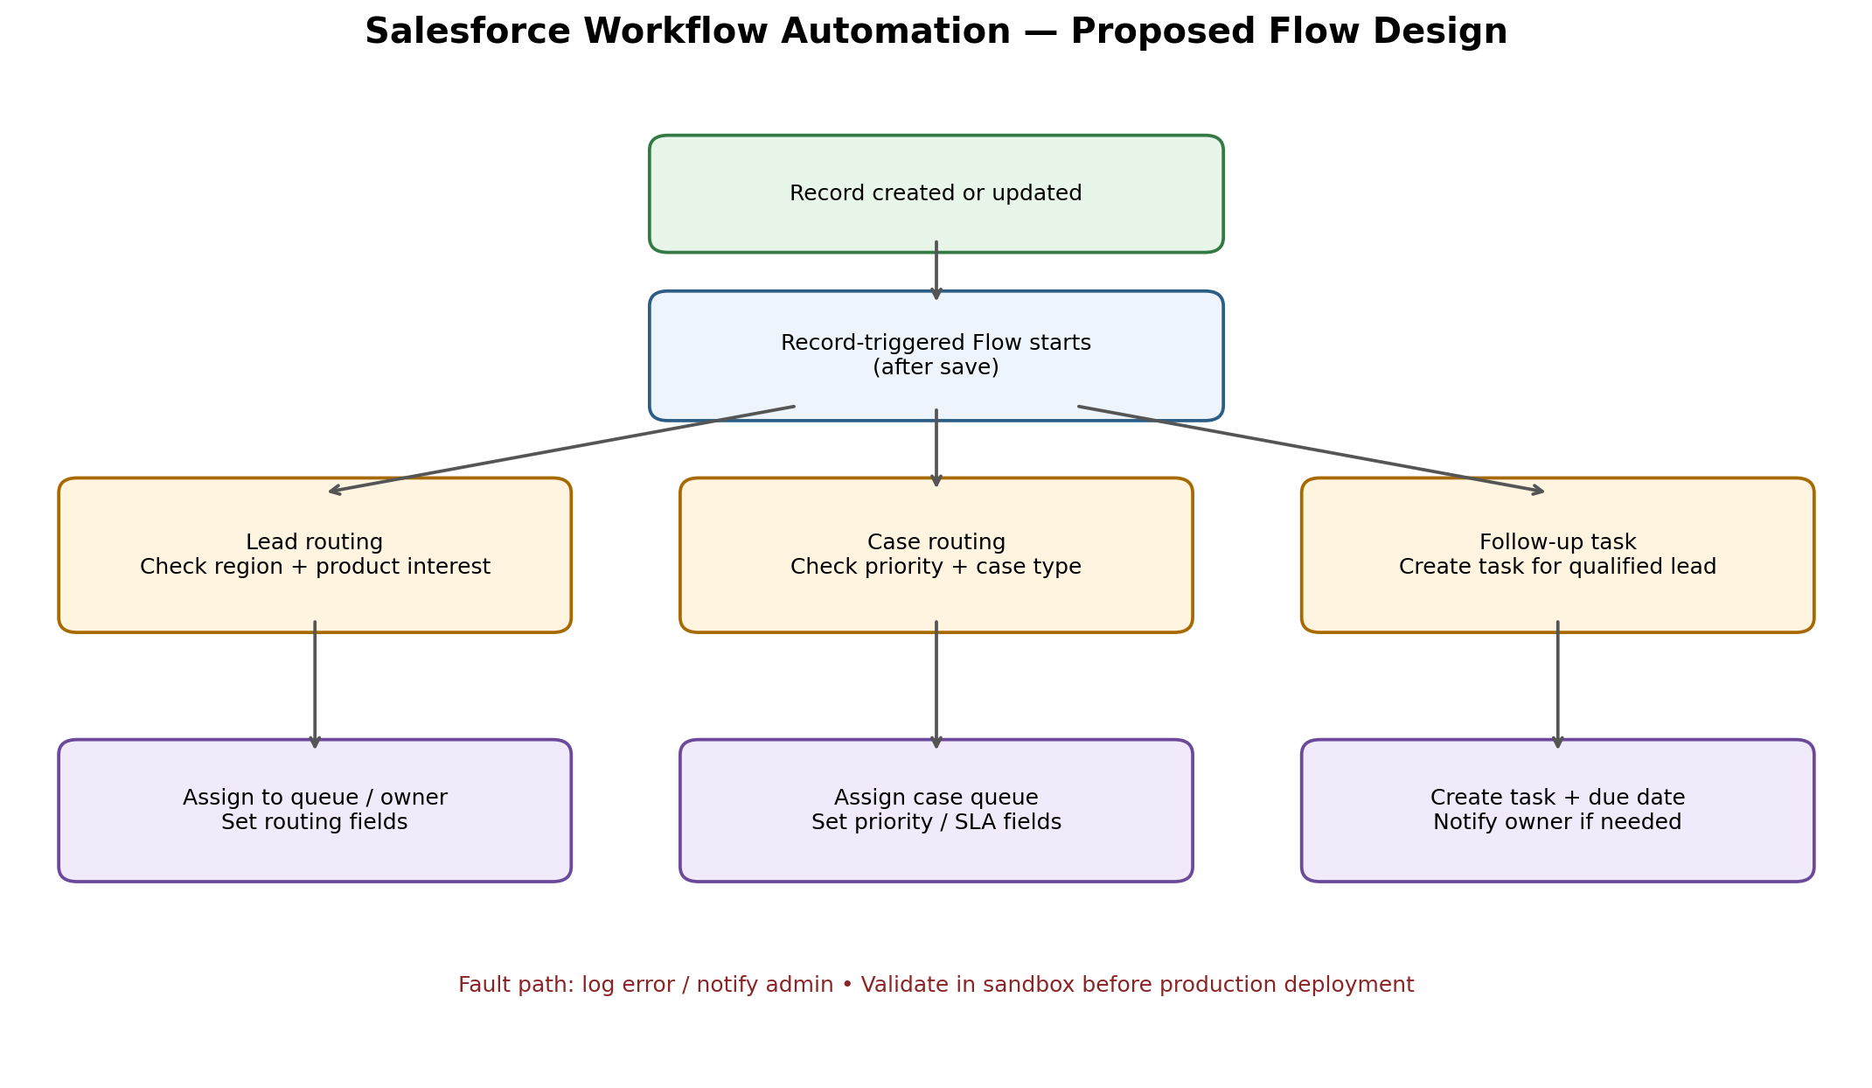

6. Step-by-Step Implementation Plan
Step 1 — Prepare sandbox — Use a sandbox or developer org. Confirm permissions for Flow Builder, the target objects, and queues. Do not test first in production.
Step 2 — Confirm data model — Check Lead fields such as Region, Rating, Status, and custom flags. Check Case Priority and Type values. Create custom checkbox fields only if needed and approved.
Step 3 — Prepare queues — Create or verify regional Lead queues and Case queues. Confirm supported objects, queue membership, and valid owner references.
Step 4 — Build Lead_Auto_Assignment — In Setup, open Flows and create a Record-Triggered Flow on Lead. Add entry conditions, Decision outcomes, assignment actions, a default route, and a review flag.
Step 5 — Build Case_Auto_Routing — Create a Case record-triggered flow. Set conditions for new/unassigned cases. Add ordered Decision outcomes for High priority, Billing, and default routing.
Step 6 — Build follow-up task flow — Create a Lead after-save flow. Add qualification conditions, create a Task linked to the Lead, assign it to the Lead Owner, and update the duplicate-prevention flag.
Step 7 — Add error handling — Where supported, connect action fault paths to an administrator notification or controlled logging process. Include the flow name, record ID, and safe error summary.
Step 8 — Debug and test — Use Flow Builder Debug and the accompanying CSV test plan. Run positive, negative, duplicate-prevention, and regression tests.
Step 9 — Review and activate — Have a reviewer inspect conditions, field mappings, access, and fault paths. Activate only after all critical tests pass.
Step 10 — Deploy and monitor — Use the organisation's approved change-set or DevOps Center process. Monitor failed flow interviews, user feedback, routing accuracy, and duplicate tasks after release.

7. Simulation and Configuration Settings
Setting | Lead assignment | Case routing | Follow-up task
Trigger | Lead created; relevant changes if needed | Case created | Lead created/updated to qualify
Entry criteria | Eligible, not converted, region present | New and unassigned | Hot rating or Working status; flag=false
Decision logic | Region / product interest | Priority, then case type | Qualification condition
Main action | Set OwnerId; optional review flag | Set OwnerId to queue | Create Task; set flag=true
Fallback | Default Leads queue | General Support queue | No action if not qualified
Failure path | Admin alert/log | Admin alert/log | Admin alert/log; check task permissions

8. Testing and Validation Plan
- Test each flow independently in a sandbox using representative synthetic records.
- Positive tests: matching region, high-priority case, billing case, and qualified lead.
- Negative tests: converted lead, unmatched region, non-qualifying lead, and already assigned case.
- Duplicate test: qualify a lead, confirm one task, update the record again, and verify no second task appears.
- Fault test: use a controlled invalid reference or permission scenario in sandbox to verify the fault path and administrator alert.
- Regression test: change an unrelated field and ensure no unintended reassignment, repeat notifications, or duplicate tasks occur.
- Record results in sandbox_test_plan.csv. Capture screenshots of Flow Builder elements, Debug output, and test records using synthetic data.

9. Error Handling, Security, and Risk Assessment
Risk | Impact | Mitigation
Incorrect routing criteria | Records sent to wrong team | Use explicit decision order, default queues, and test matrix
Missing queue/field | Flow failure or incomplete routing | Validate setup dependencies and API names before activation
Duplicate task creation | Extra work and user confusion | Use entry criteria and Follow_Up_Created__c; test re-entry
Overwriting manual ownership | Loss of business context | Limit trigger criteria and preserve deliberate manual assignments
Permission or automation conflict | Unexpected errors or competing updates | Review sharing, permissions, assignment rules, and active flows
Sensitive error notifications | Potential data exposure | Send minimal error context only to authorised administrators
Unmonitored failures | Issues remain unresolved | Review failed flow interviews and assign a monitoring owner

10. Success Measures
- Lead routing accuracy: percentage of eligible leads assigned to the intended owner or queue.
- Case triage time: elapsed time from case creation to assignment to the correct queue.
- Follow-up completion: percentage of qualified leads with a task created and completed within policy.
- Automation reliability: failed flow interviews compared with total flow executions.
- Data quality: number of unassigned records, records flagged for review, and duplicate follow-up tasks.

11. Conclusion
Salesforce Flow Builder is the recommended tool for new automation because it supports record-triggered logic, branching, record updates, related-record creation, and error handling in one declarative framework. The three proposed flows target common repetitive tasks while including fallback routes, duplicate prevention, and sandbox validation. The next step is to adapt the blueprint to the target org's actual fields and queues, execute the test plan, and capture genuine implementation screenshots before final submission.

Appendix — Supporting Files
- workflow_automation_diagram.png — conceptual process diagram.
- flow_configuration_blueprint.json — structured design blueprint; not deployable Salesforce metadata.
- sandbox_test_plan.csv — test cases and expected results.
- README_Implementation_Guide.txt — build steps and submission notes.

