Determining factors to reduce airplane bird strikes

Shashank Naik
New York University
New York, US
ssn292@nyu.edu
Shashank Singhal
New York University
New York, US
ss8746@nyu.edu
Kavitha Vishwanathan
New York University
New York, US
kv668@nyu.edu

Abstract—
In this paper we analyze the patterns in airplane and birds strikes with the help of historical bird strike data, bird migration data, along with bird population distribution across North America. With this analysis we investigate the factors that could help reduce bird strikes.
Keywords— bird strikes, flight, airplane, map reduce, analytics, Hadoop, Tableau

Introduction
Bird strikes are a significant threat to flight safety, and have caused a number of accidents with human casualties.^{[5]} Using Hadoop MapReduce based technologies we analyze the incidences of birds strikes utilizing historical bird strike data, bird migration data, along with bird population distribution across North America and thus investigating the factors that could help reduce bird strikes. We will be analyzing the frequency of bird strikes at a particular regions in a bird species migration route.
We have employed Pig Latin, Hive and MapReduce framework with HDFS for the purpose of our project. R is our Business Analytics tool of choice to generate analytics for the output of the MapReduce data.

Motivation
Most accidents occur when there is a collision involving a bird (or birds) and the windscreen or a bird (or birds) is sucked into the engines of mechanical air craft. These cause annual damages that have been estimated at $400 million^{[6]} within the United States of America alone and up to $1.2 billion to commercial aircraft worldwide.^{[8]} More than 200 people have been killed worldwide as a result of wildlife strikes since 1988.^{[7]} In addition to property damage, collisions between man-made structures, conveyances and birds is a contributing factor, among many others, to the world wide decline of many avian species.

Related Work
The data we are using for this paper is static and historic in nature with periodic refreshes. Keeping in mind the possibilities of ever increasing volume of data, we decided to future-proof our implementation by preparing for big data volume right from the offset. Sivaraman and Manickachezian in their paper on Intelligent Computing Applications^{[10]}, which speaks about how Hadoop enables users to store and process large volumes of data and analyze it in ways not previously possible with SQL-based approaches or less scalable solutions. They discuss the Big Data evolution and the future of Big Data based on Gartner’s Hype Cycle. In which they compared the different versions of hype cycle like in the 2012 version of the Hype Cycle for Emerging Technologies, Gartner predicted that it would take 2-5 years before big data would reach the plateau of productivity. In 2014 version edition Gartner adjusted that prediction to 5-10 years. Also, Hadoop’s MapReduce paradigm for distributing a task across multiple nodes in Hadoop is discussed with sample data sets. Keypoints of HDFS and MapReduce has been summarized which includes Load Balancing and Optimized Scheduling. Finally Sivaraman and Manickachezian^{[10]} conclude with a discussion on Big Data Hadoop sample use cases demonstrating how enterprises can gain a competitive advantage by being early adopters of big data analytics
One of the reference papers emphasizes heavily on the correct interpretation and analysis of data, continuing with the tone of equipping our solution with the ability to analyze large quantities of data, we decided to study the implications of an upcoming big data analytics technology on our paper. Present day data analysis environments, such as R, are constrained by the size of the main memory and cannot scale in many applications. It introduces Big R, a new platform enables accessing, manipulating, analyzing, and visualizing data residing on a Hadoop cluster from the R user interface^{[9]}. The current Big R implementation works on two main fronts: data exploration, which enables R as a query language for Hadoop and partitioned execution, allowing the execution of any R function on smaller pieces of a large dataset across the nodes in the cluster. Big R is a new platform for exploiting the best of both worlds: Hadoop and R. It extends a variety of R primitives, classes, operators, and functions to support big data, thereby making R scalable while exploiting the parallelization power inherent to Hadoop. It allows users to access, manipulate, visualize, and analyze data on HDFS (in flat files, Hive, or HBase) in a transparent manner. It is intended to work on three main fronts: data exploration, which enables R as a query language for Hadoop, partitioned execution, allowing the execution of any R function on smaller pieces of a large dataset across the nodes in the cluster, and large scale machine learning. Big R leverages the entire spectrum of R capabilities by partitioning the data in ‘R-able’ pieces and parallelizing the execution in multiple R instances running on a Hadoop cluster. Big R relies on Jaql, a scripting language for querying and manipulating large datasets on Hadoop, which internally translates a given query into MapReduce jobs in a transparent fashion. It enables the use of R as a query language for Hadoop, providing methods to filter, project, sort, join, and recode. Big R extends R primitives to seamlessly manipulate, visualize, and analyze big data.
Han Hui, Yonggang Wen, Tat-Seng Chua and Xuelong Li in their paper^{[11]} discuss the environment around big data and explore the plethora of options you have today to set up your own big data platform for big data analysis. It maps out the Big data technology chain and also gives a representation of the layered architecture of a big data system. They describe the Big data setup in a precise manner without getting much into details, but still covering the technical basics in order to explain the different aspects. Further, it discusses in detail the start to end process from data gathering to data processing and analysis. Their paper delves into detail and also discusses the challenges involved in all these steps. It discusses about Big data system challenges like redundancy and data compression, data life cycle management etc. For the data generation phase it discusses about the trends in data sources and difference in types of data attributes in data from different types of sources. In the data acquisition phase, it talks about the various sources like sensors, web crawlers etc. Data transmission technologies are then discussed in detail followed by data preprocessing. Next comes the data storage infrastructure, covering physical memory like RAM, HDD etc. Next comes data management framework where the software frameworks ranging from file systems and column oriented databases to document databases, it also discusses about NoSQL DBs. Programming models are also discussed covering technologies like Map reduce, dryad, pregel etc. This is followed by data analysis where the discussion gets application oriented. Lastly, they discuss the various cases handled using big data analytics and Hadoop framework and its applications.

Design
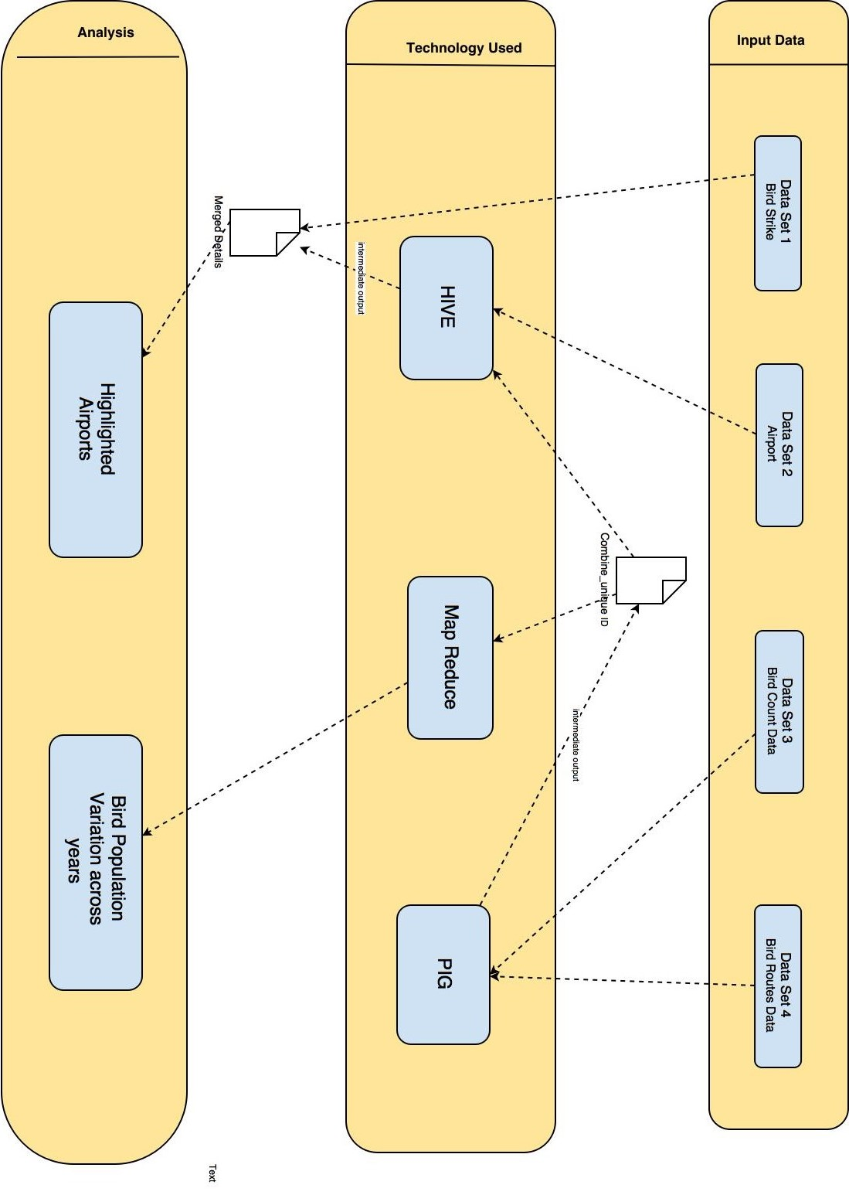

The design diagram describes the process we followed for the MapReduce computation. We used the cleansed data from four sources: FAA Wildlife Strike Data, Airports Database, North American Breeding Bird Survey - Bird Population Data and Bird Migration Routes data. The cleansing and data preparation was achieved through Hive and Pig Latin. The computations were performed on NYU’s HPC cluster. The data was loaded into HDFS and the bird counts were computed for locations close to airports using the latitudes and longitudes co-ordinates using Hive. We checked for airports in a specific square mile range around the spot for which we have the bird population data. MapReduce program was used to calculate analytics.

Results
We used New York University’s HPC cluster for processing the data due to that large data set size and high processing time required. We performed a join on the processed data which constituted of the NABBS bird population data and the USA airports data matching on locations within a latitude and longitude range of 0.2. This intensive operation generated the list of airports in the vicinity of the bird migration routes for which we had the population count. We used Tableau to analyze the data and mapped it using location geographical co-ordinate on the map. The size of the blue spots depicts the population count.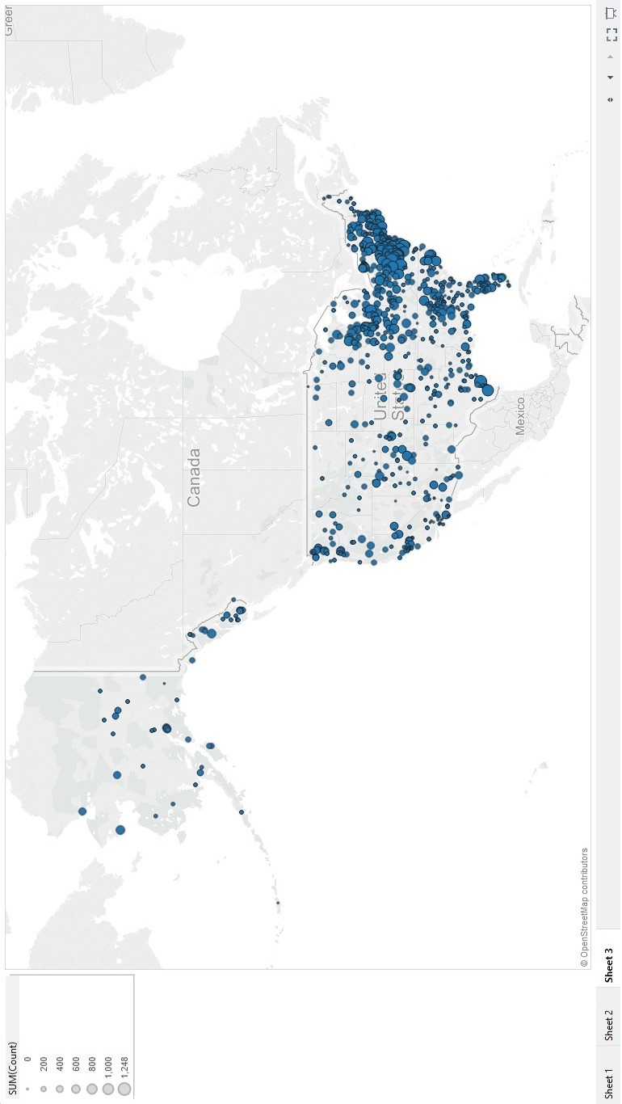
After this, we matched the names of the airports to the bird strike database using string matching in Pig Latin. This was to compare the incidences of bird strikes close to the airports with the largest bird populations and also to verify the species of birds that were reported to strike with the planes near those spots. The matching verified our hypothesis since the maximum incidences of bird strikes were in areas close to the airports around high migratory bird populations. As an additional analysis we visualized in Tableau the changes in bird populations in those areas year over year to investigate any drastic changes in bird counts.
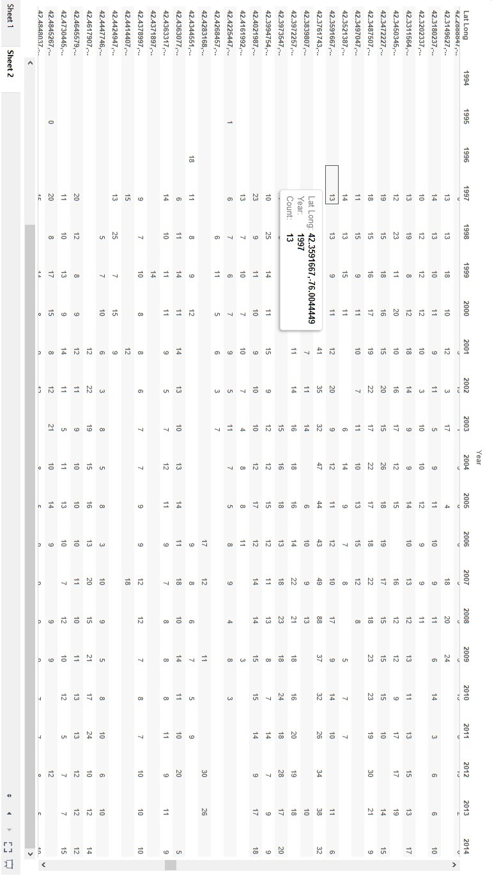
Unfortunately this analysis was speculative at best, there was no clear and significant impact of the bird strikes on bird population. In retrospect, considering the occurrences of bird strikes and the variances in bird species along with the sheer number of airports in the country, it is not surprising that bird populations are not severely affected by bird strikes.

Future Work
Considering the potential of the data, there is scope for more improvements and enhancements. In the future, we could consider airplane flight and bird migration paths instead of just discrete points. Also there is a requirement for more compatible data, with respect to geolocation formats or common address formats to reduce errors and aid programmatic computation. The data we acquired had geo-location coordinates only for the first stop on each bird migration route. This we felt was a major hurdle which could be looked into in future iterations.

Conclusion
As stated earlier about bird strikes being a significant threat to flight safety, we identified the airports that are around areas coinciding with a sizable bird population and thereby more prone to experiencing and reporting bird strikes. We proved this hypothesis by comparing our results with the actual bird strike data, with a considerable yet irrefutable amount of accuracy. Further, to strengthen the analysis we found the bird population variation across the years, thus suggesting the exploration of more precautionary measures that could be used by the airports list produced from our analytic to reduce bird strikes.

Acknowledgment
We would like to thank New York University for its High Performance cluster which we used for MapReduce computations. We are also grateful to the North American Breeding Bird Survey and Federal Aviation Administration for providing us with the bird migration and bird strike data.

References
- T. White. Hadoop: The Definitive Guide. O’Reilly Media Inc., Sebastopol, CA, May 2012.
- A. Gates. Programming Pig. O’Reilly Media Inc.,Sebastopol, CA, October 2011.
- J. Dean and S. Ghemawat. MapReduce: Simplified data processing on large clusters. In proceedings of 6th Symposium on Operating Systems Design and Implemenation, 2004.
- S. Ghemawat, H. Gobioff, S. T. Leung. The Google File System. In Proceedings of the nineteenth ACM Symposium on Operating Systems Principles – SOSP ‘03, 2003.

[5] https://en.wikipedia.org/wiki/Bird_strike
[6] Sodhi, Navjot S. "Competition in the air: birds versus aircraft.”, 2002
[7] Boeing: Strategies for Prevention of Bird Strike Events, 2011 http://www.boeing.com/commercial/aeromagazine/articles/2011_q3/4/
[8] Allan, John R.; Alex P. Orosz "The costs of birdstrikes to commercial aviation", August, 2001

[9] Lara Yejas; Weiqiang Zhuang; Pannu, A “Big R: Large-Scale Analytics on Hadoop Using R”. June, 2014
[10] E.Sivaraman, Dr.R.Manickachezian, “High Performance and Fault Tolerant Distributed File System for Big Data Storage and Processing using Hadoop”, 2014
[11] Han Hui, Yonggang Wen,, Tat-Seng Chua AND Xuelong LI, Toward Scalable Systems for Big Data Analytics: A Technology Tutorial, May 12, 2014

