Jenkins
Installation tutorial
https://www.jenkins.io/doc/book/installing/windows/
Troubleshooting Windows installation
Invalid service logon credentials
https://www.jenkins.io/doc/book/installing/windows/#invalid-service-logon-credentials
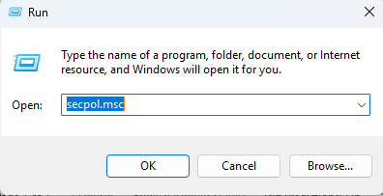

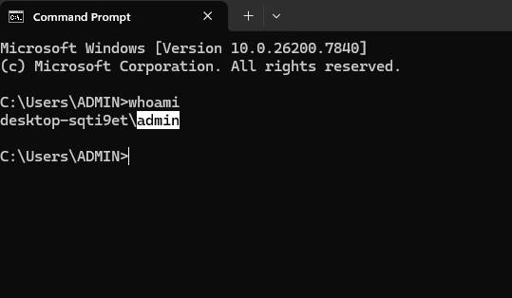

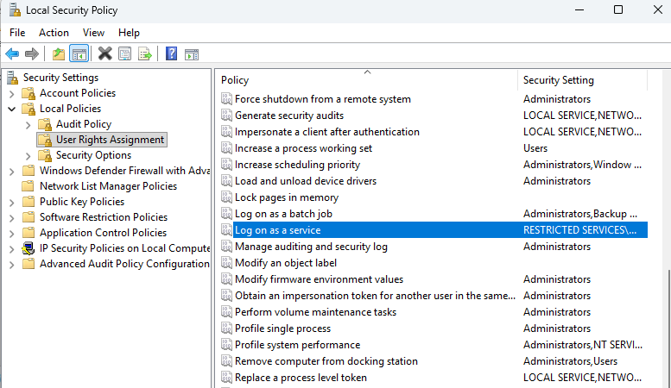

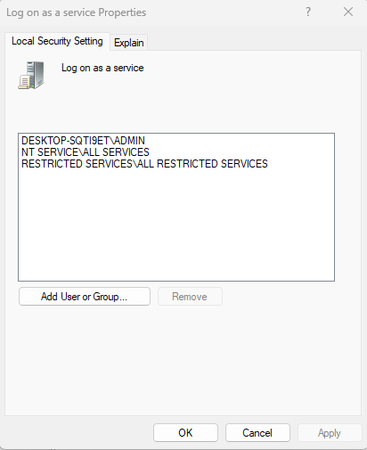

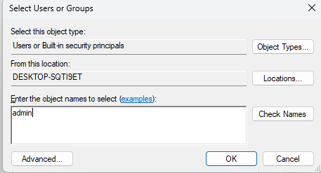
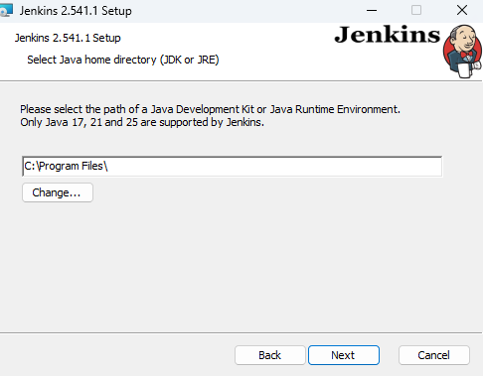
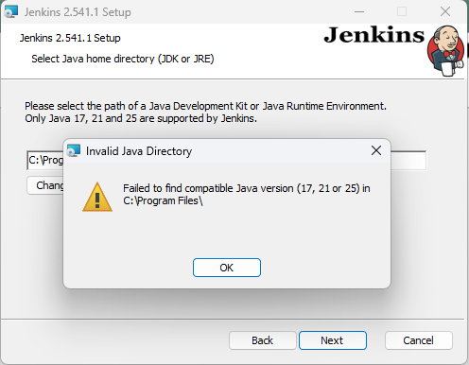

Quick direct download examples (Oracle script-friendly URLs)
https://download.oracle.com/java/25/latest/jdk-25_windows-x64_bin.exe

