***Assignment-9***

***By: Kaviya.C***

**Write a program add the two integer array of size 5 and store the result in the third array.**

**Ans:**

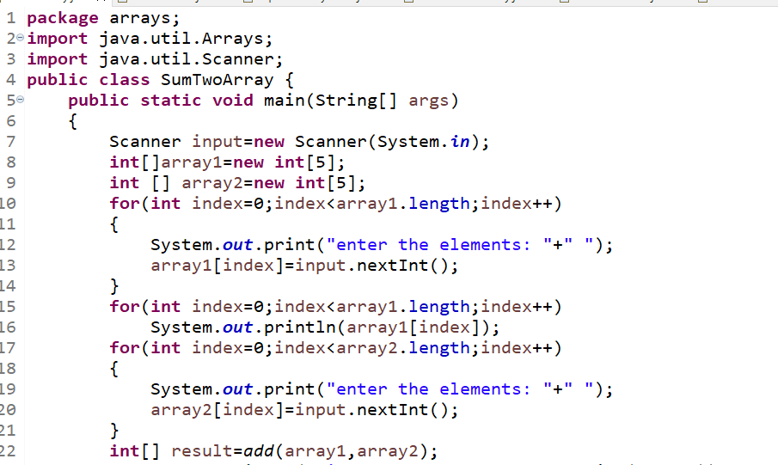

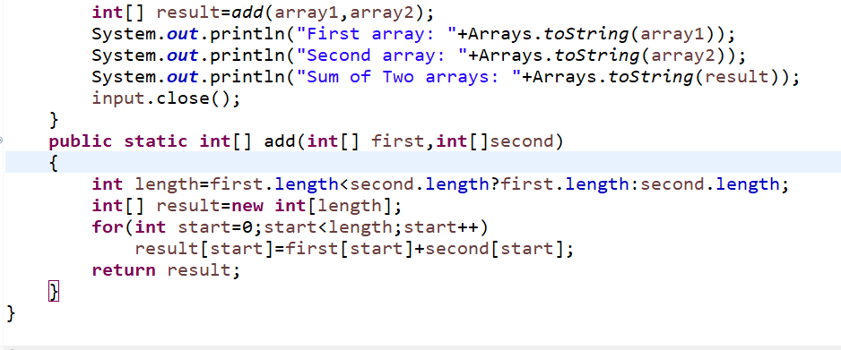

**OUTPUT:**

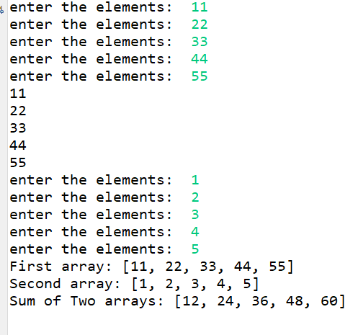

**write a program to find the sum of even number and odd number in the array of size 10.----🡪Ans:**

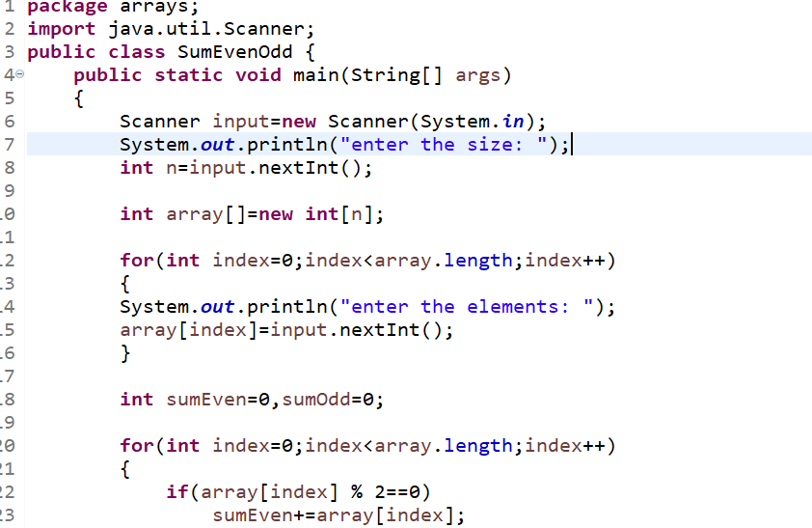

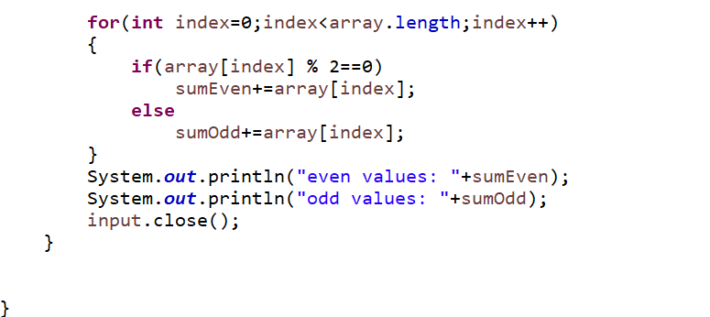

**OUTPUT:**

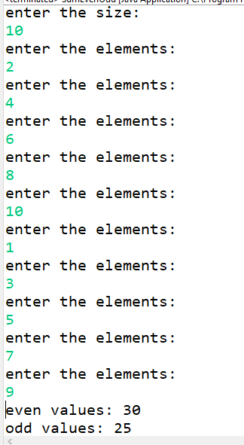

**Write a program to print lowercase letter from your name.**

**Ans:**

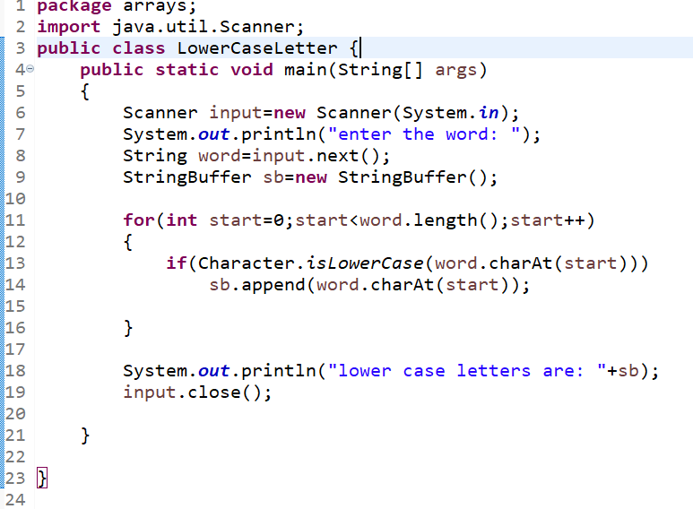

**OUTPUT:**

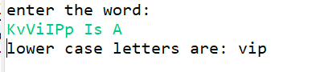

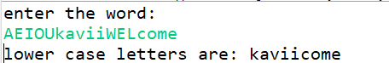

**write a program to count the number of vowels and consonents in the given message.**

**Ans:**

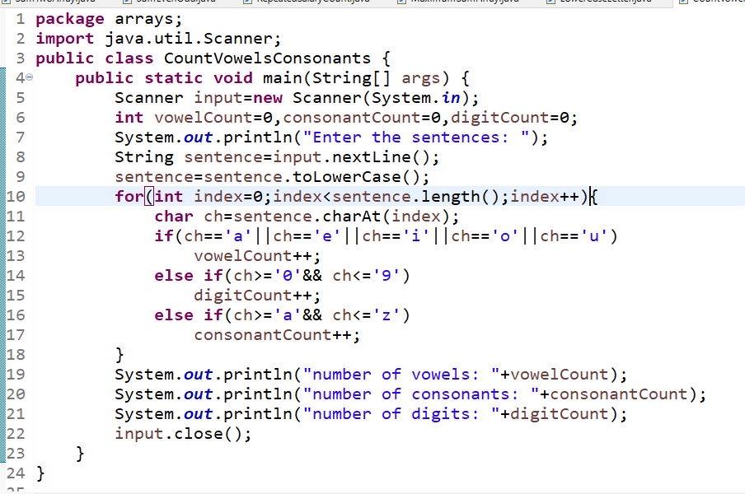

**OUTPUT:**

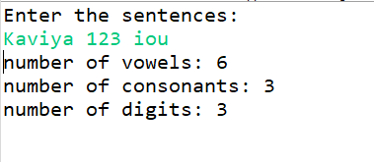

**Repeated Salary Count**

**John is working as a clerk in an organization where N number of people are working. His boss has asked him to get the count of employees who get same salary. Help him to get the count of repeated salary.**

**Include a function named countRepeaters that accepts 2 arguments and returns an int. The first argument is the input array and the second argument is an int that corresponds to the size of the array. The function returns an int that corresponds to the number of repeaters.**

**If the size of the array is negative or if any of the array elements are negative, print “Invalid Input” and terminate the program.**

**Input and Output Format:**

**Input consists of n+1 integers. The first integer corresponds to n, the number of elements in the array. The next 'n' integers correspond to the elements in the array.**

**Output consists of an integer that corresponds to the number of repeaters.**

**Assume that utmost one element in the array would repeat.**

**Assume that the maximum number of elements in the array is 20.**

**Sample Input 1:**

**5**

**1000**

**2000**

**3500**

**2000**

**5000**

**Sample Output 1:**

**2**

**Sample Input 2:**

**-5**

**Sample Output 2:**

**Invalid Input**

**Sample Input 3:**

**5**

**1000**

**-2000**

**Sample Output 3:**

**Invalid Input**

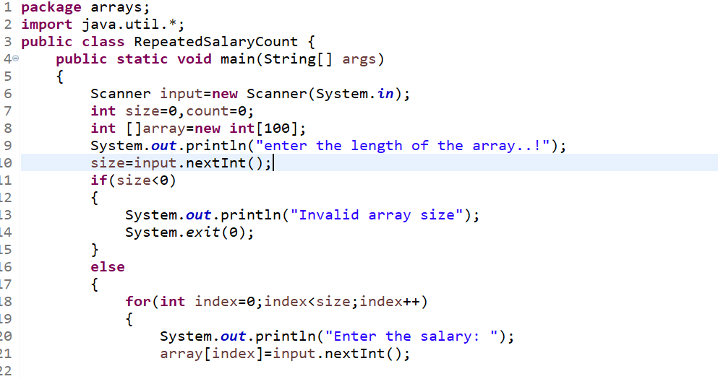

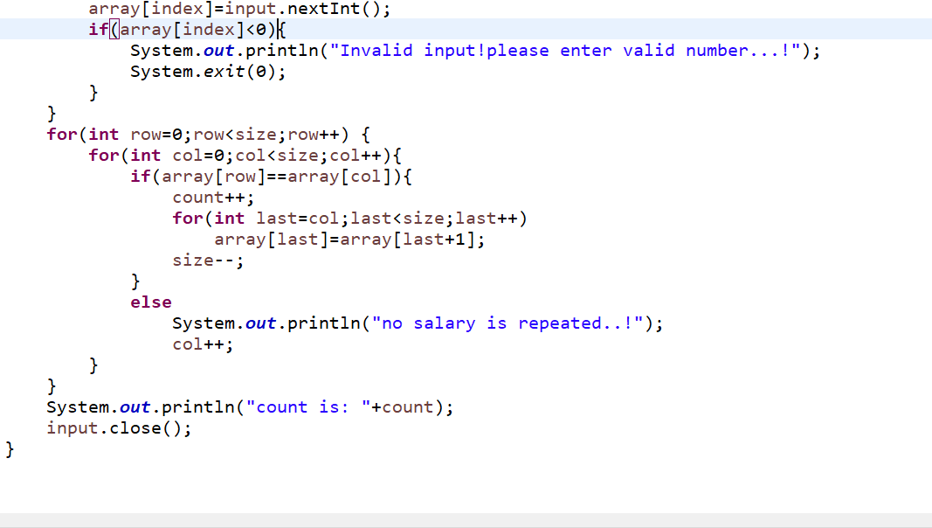

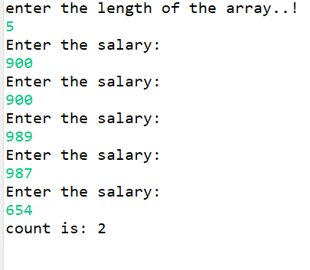

**3.maximumSum**

**Read the question carefully and follow the input and output format.**

**Given an Integer array, find out sum of Even and odd Numbers individually and find the maximum.**

**Input and Output Format :**

**First line of input consists of n, the number of elements. Next n lines correspond to the array elements. Output consist of maximum of odd and even sum.**

**1) Print "Invalid array size" when size of the array is a negative number and terminate the program.**

**2) Print "Invalid input" when there is any negative numbers available in the input array and terminate the program.**

**Include a function named maximumSum(int numbers[], int size) whose return type is an integer,.**

**Sample Input 1:**

**5**

**12**

**13**

**14**

**15**

**16**

**Sample Output 1:**

**42**

**Sample Input 2:**

**-13**

**Sample Output 2:**

**Invalid array size**

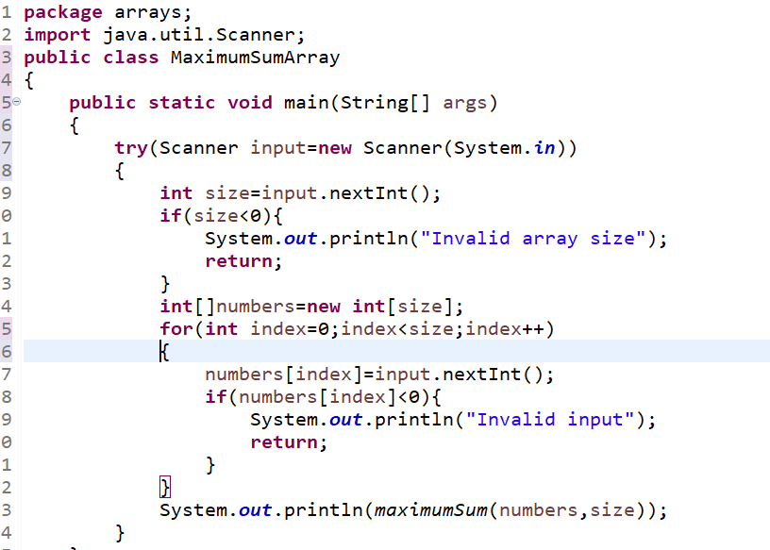

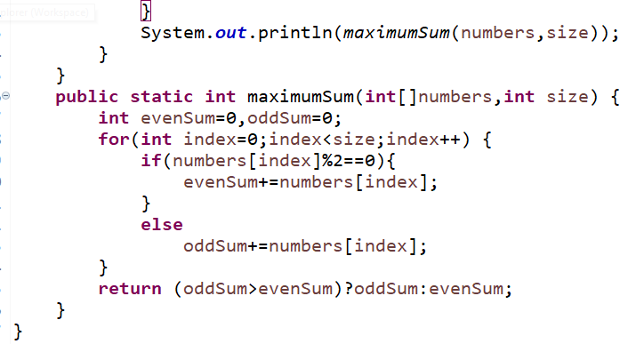

**OUTPUT:**

