1. Write a Java program to get the character at the given index within the String

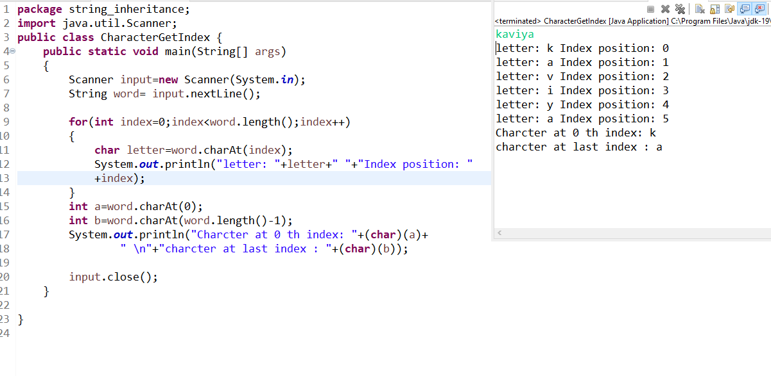

1. Write a Java program to get the character (Unicode code point) at the given index within the String

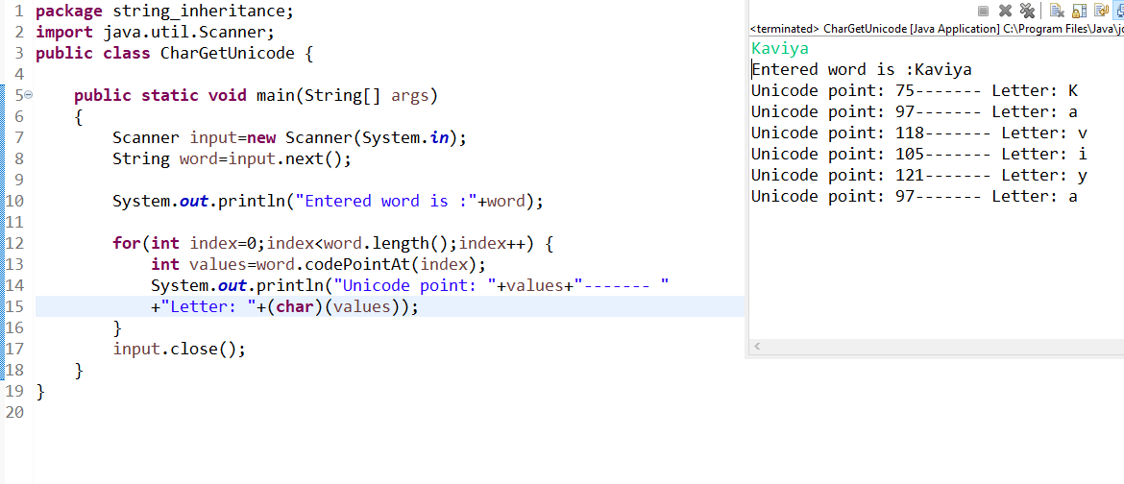

1. Write a Java program to compare two strings lexicographically. Two strings are lexicographically equal if they are the same length and contain the same characters in the same positions

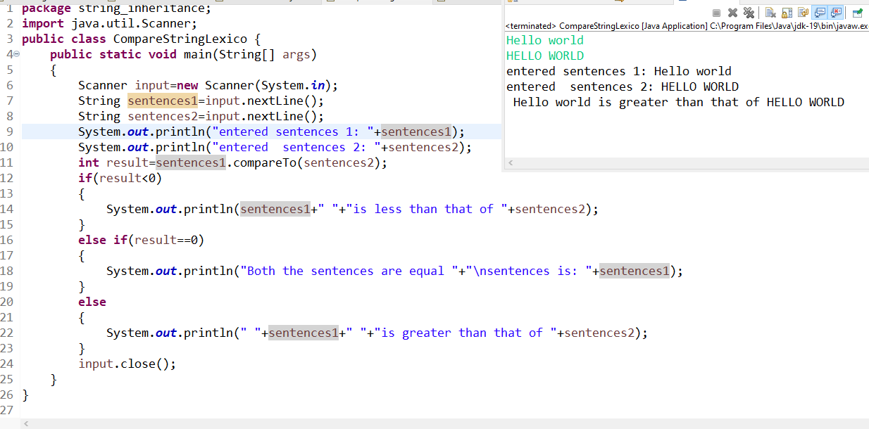

1. Write a Java program to counts occurrences of a certain character in a given string

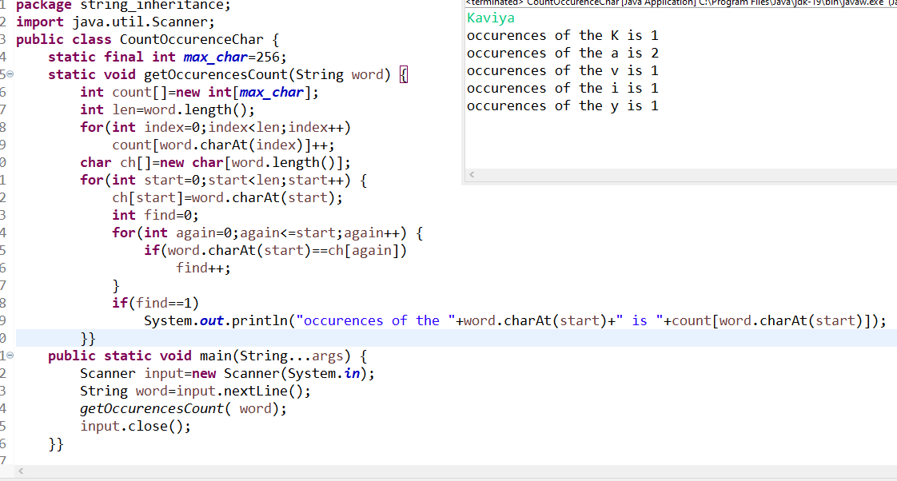

1. Write a Java program to concatenate a given string with itself of a given number of times.

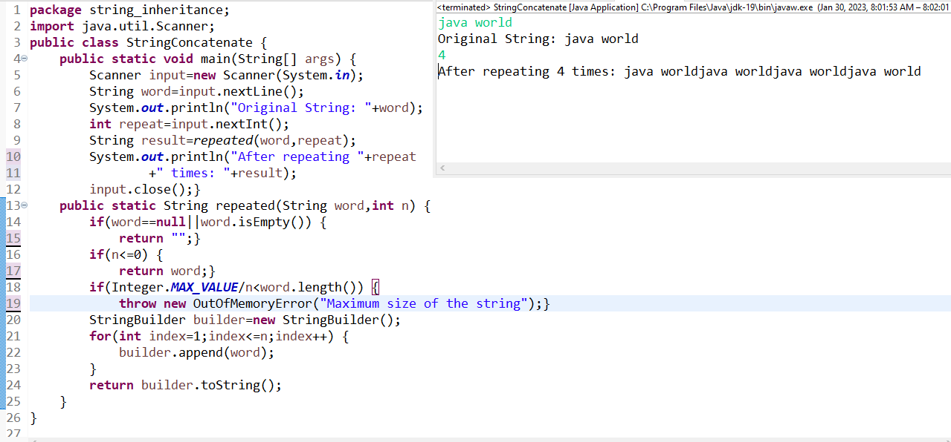

1. Write a Java program to sort in ascending and descending order by length of the given array of strings.

Sample Output:

Original unsorted colors: [Green, White, Black, Pink, Orange, Blue, Champagne, Indigo, Ivory]

Sorted color (descending order): [Champagne, Orange, Indigo, Green, White, Black, Ivory, Pink, Blue]

Sorted color (ascending order): [Pink, Blue, Green, White, Black, Ivory, Orange

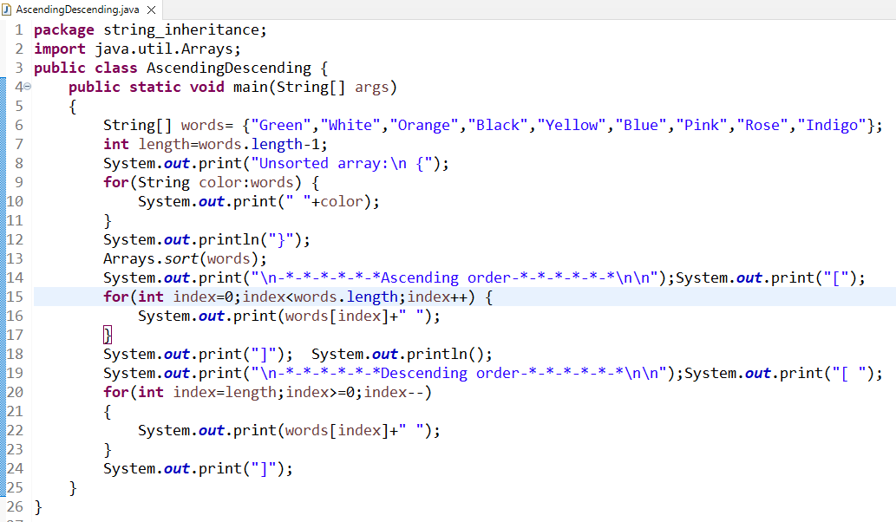

**OUTPUT**

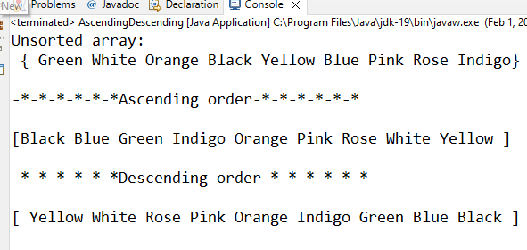

1. check the given string is panlidrome or not

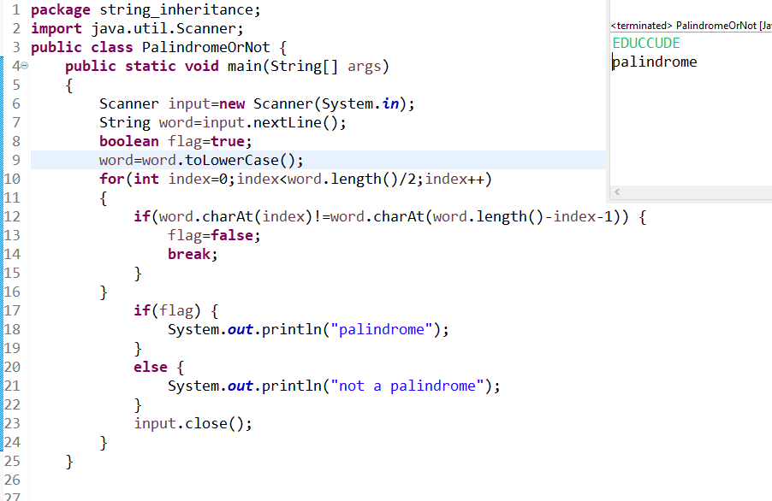

1. Java Program to prove that strings are immutable in java

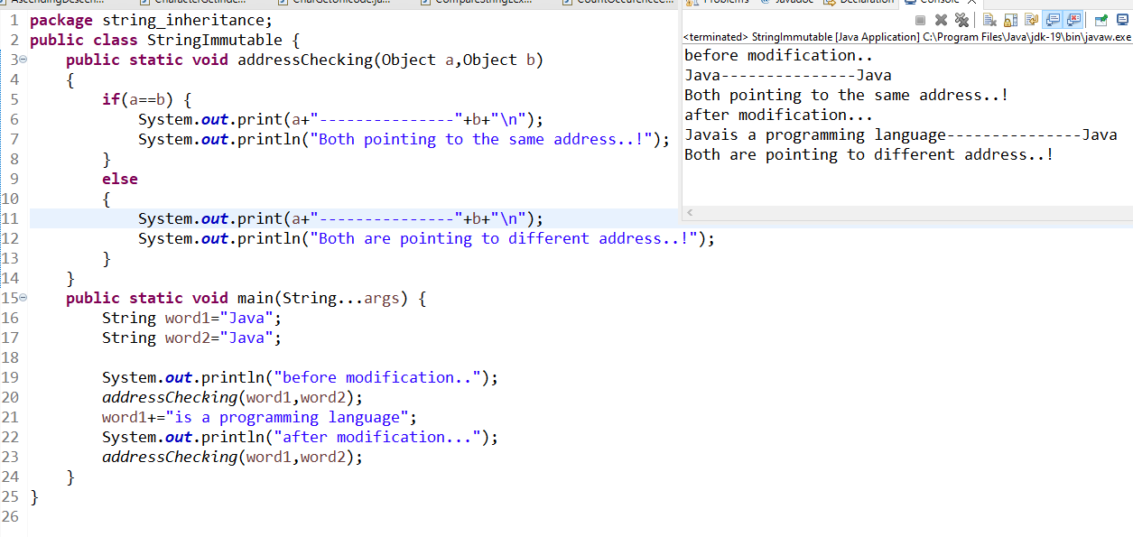

1. Java program to implement below classes using inheritance

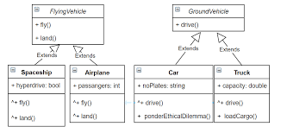

FlyingVechicle

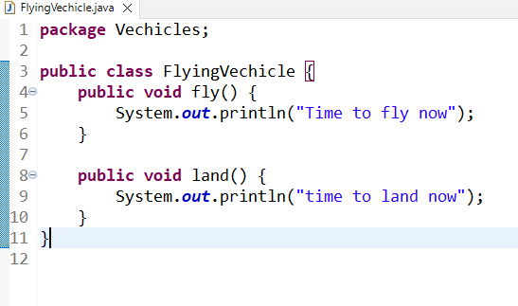

Ground Vechicle 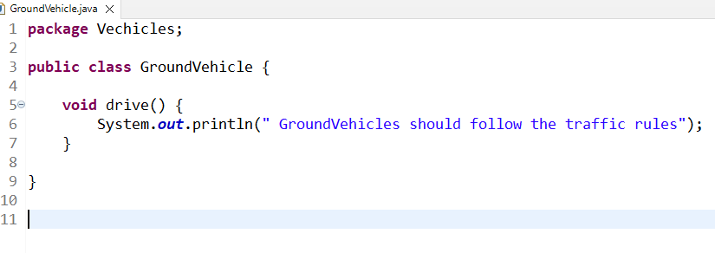

SpaceShip

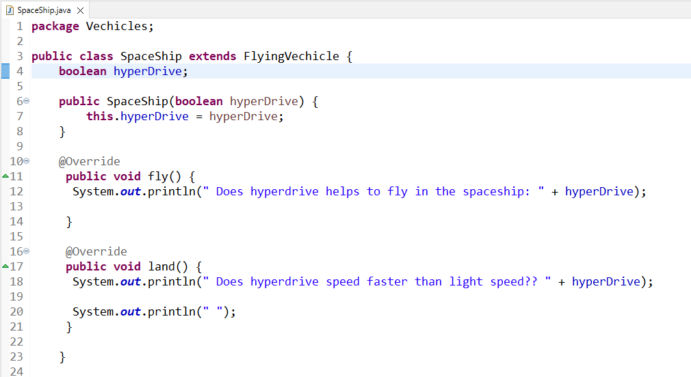

Airplane

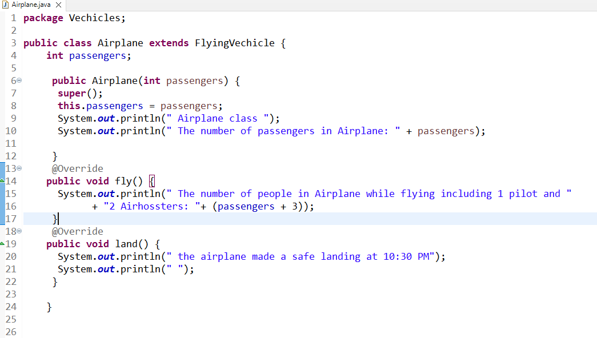

Car

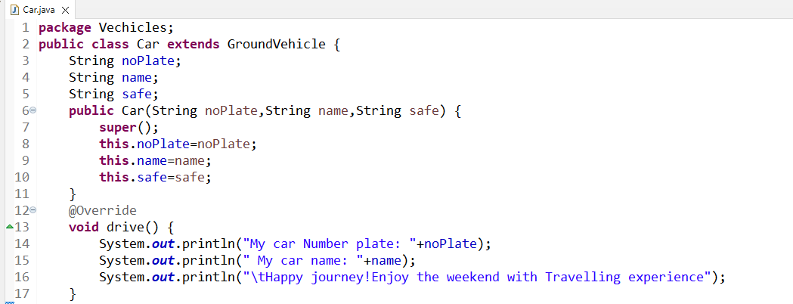

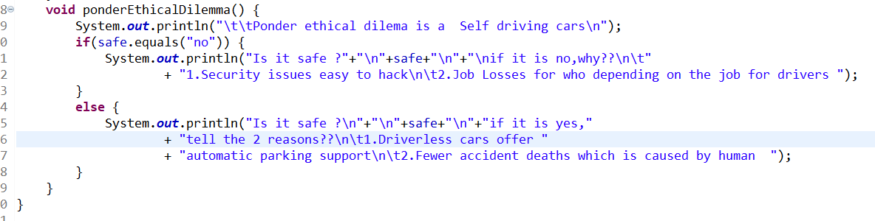

Truck

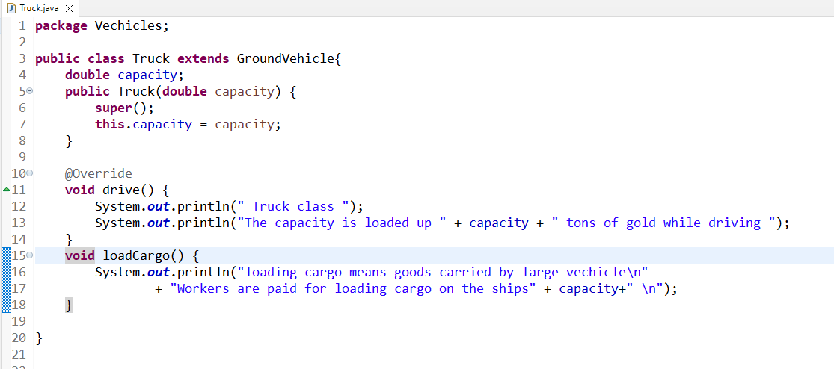

MainMethod or TestVechicles

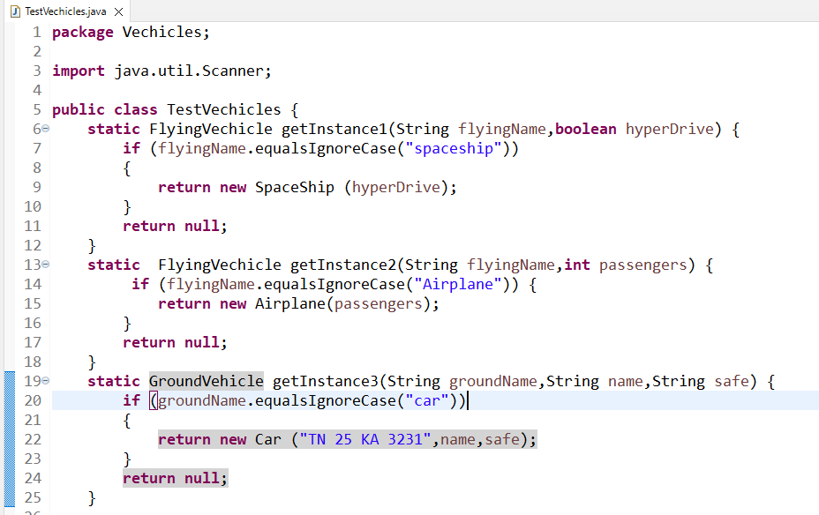

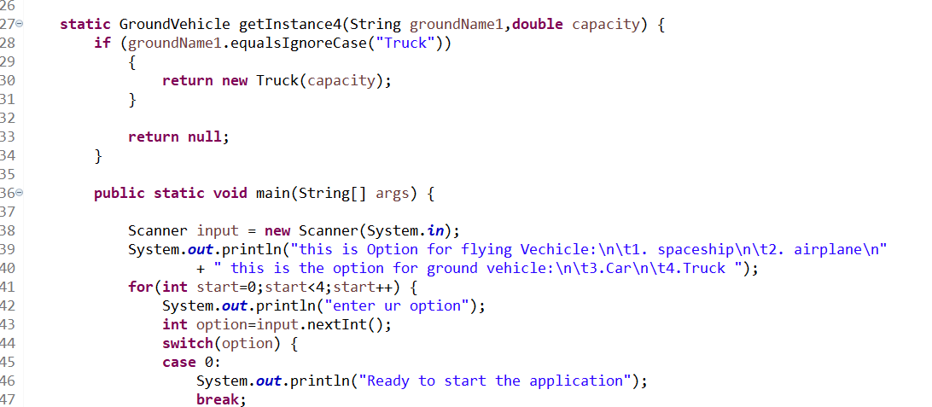

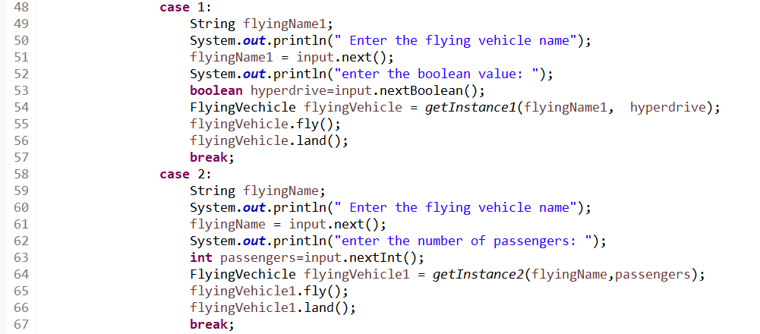

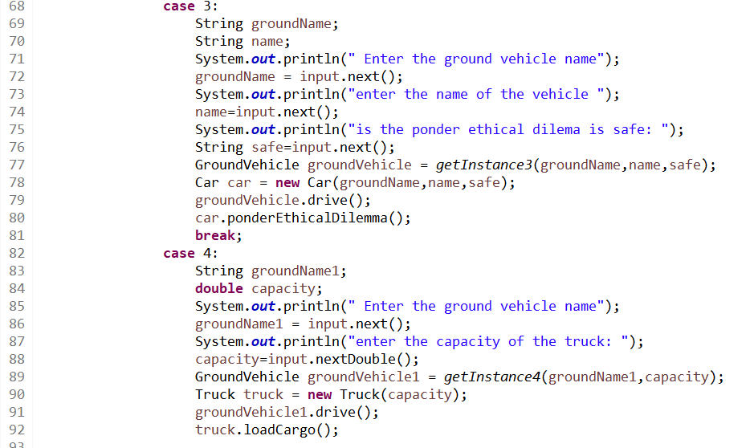

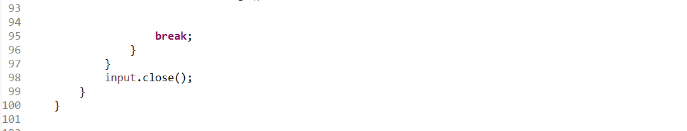

**OUTPUT:**

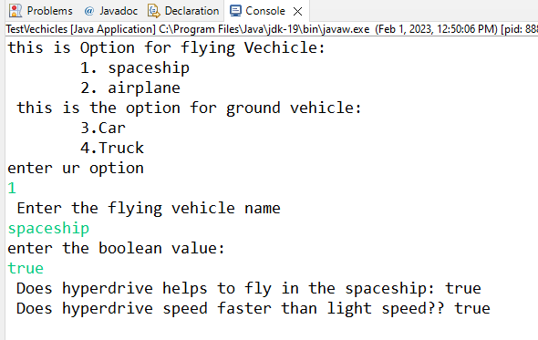

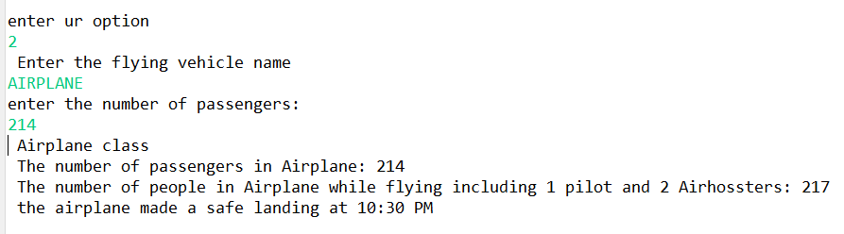

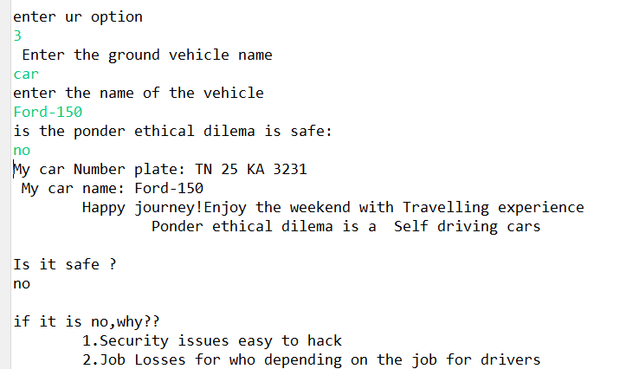

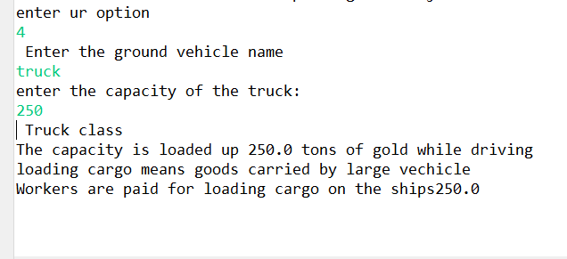

1. Write a java program to implement the below diagram

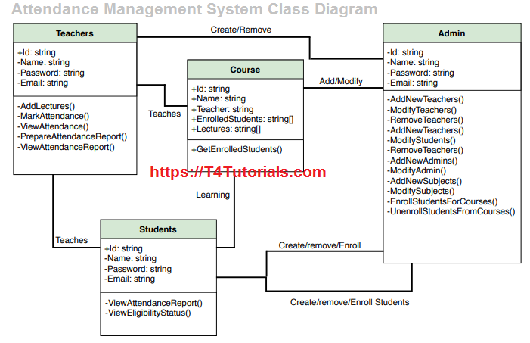

Zip File Added-----Below

**OUTPUT:**

**If I choose admin :**

**Below are the functions done by admin…….**

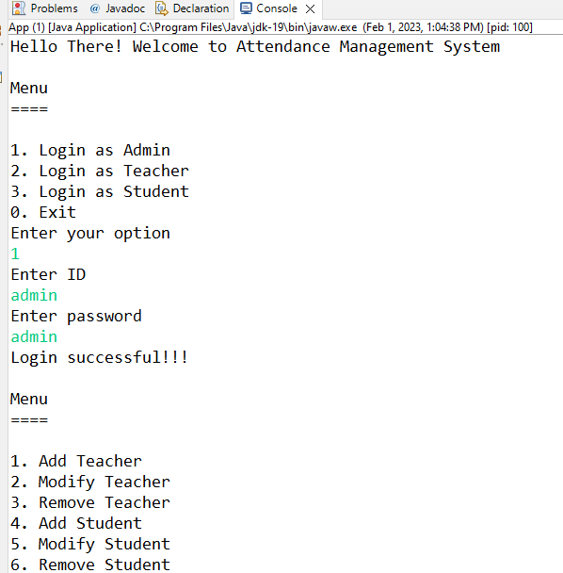

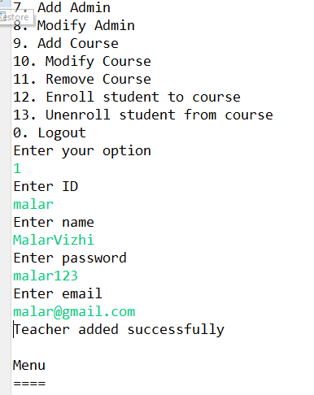

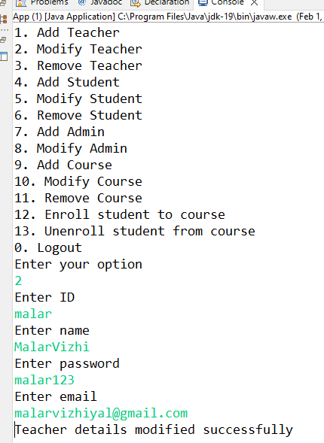

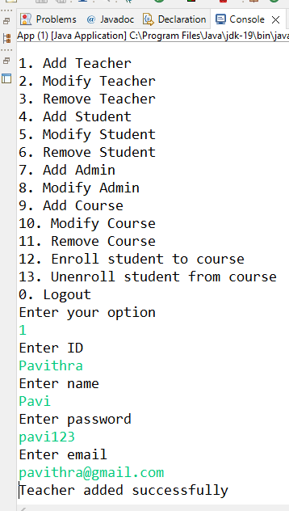

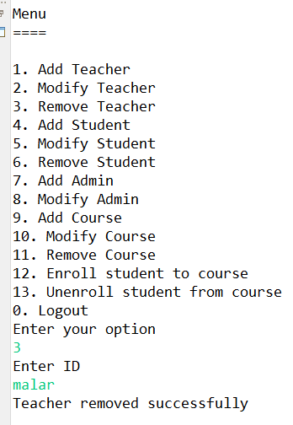

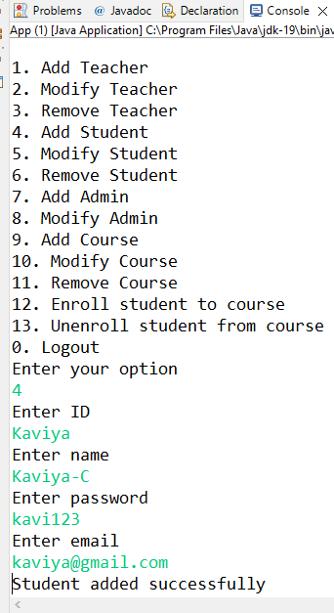

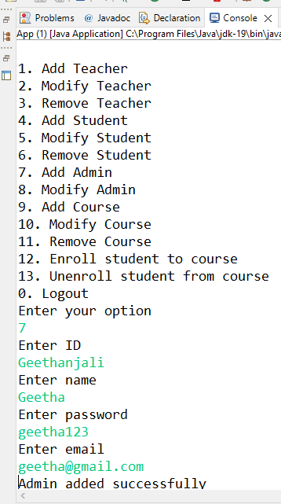

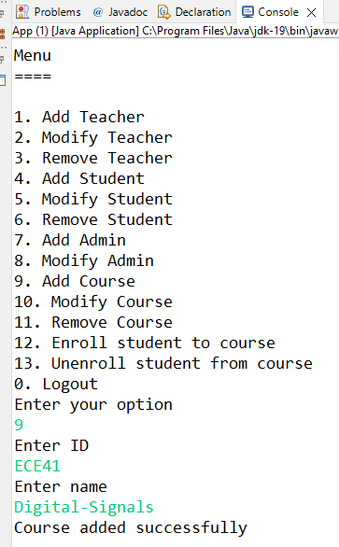

**If the course id is not same as before then it shows some message:**

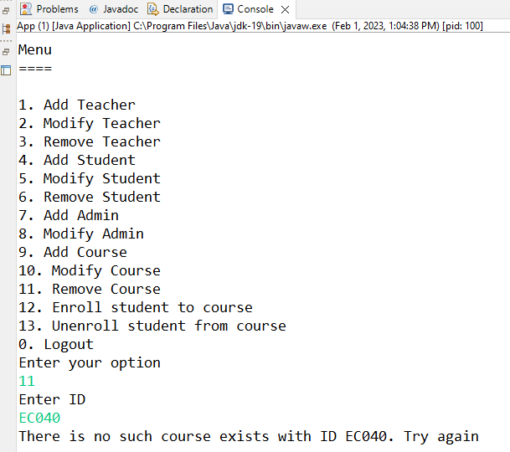

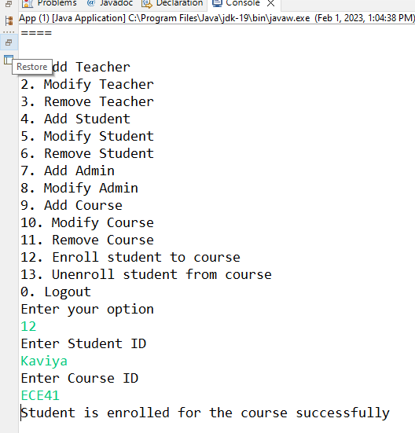

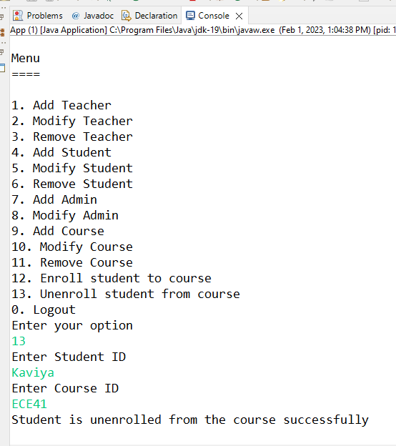

**Admin want to log out**

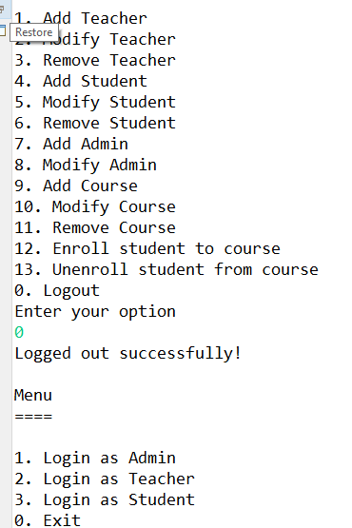

**Again:**

**I want to login as a student to perform the student functions**

**It throws error bcoz am setting the application first admin as a person to enter then others allowed**

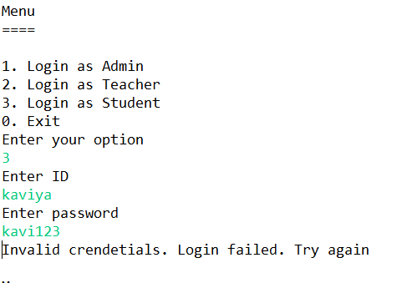

**If I want to login as a teacher then I need to enter the already mentioned the head of the details:**

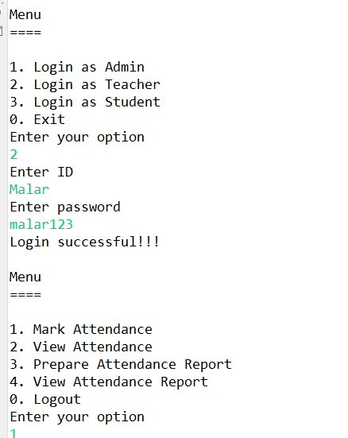

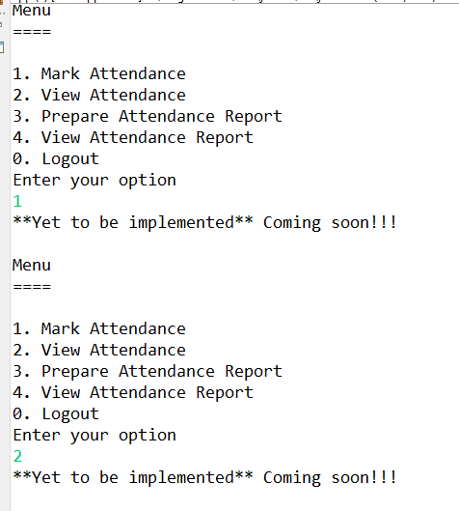

**If I want to login as a student then I already give my details of login credentials in code so I entered the same credential which I used in run time then only it will login successfully**

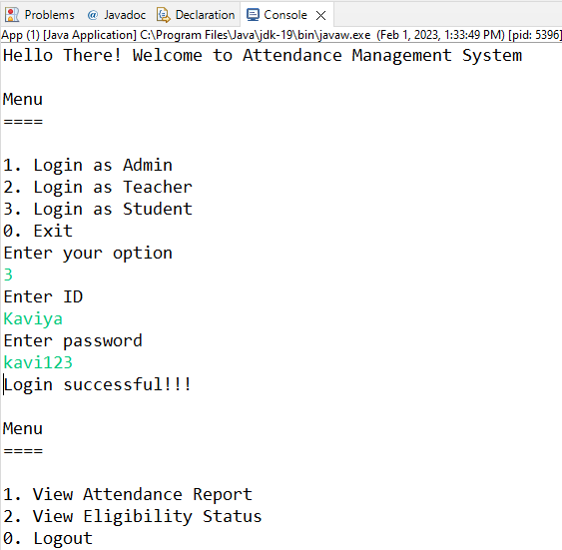

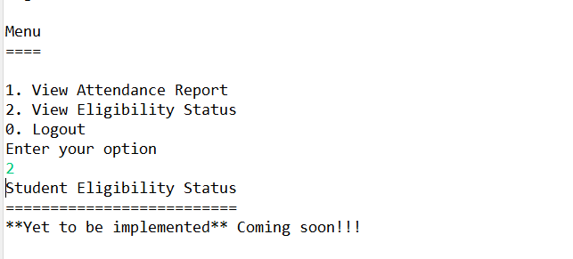

**Below program the red box of the execution still on if want to terminate completely then i give exit to terminate the program**

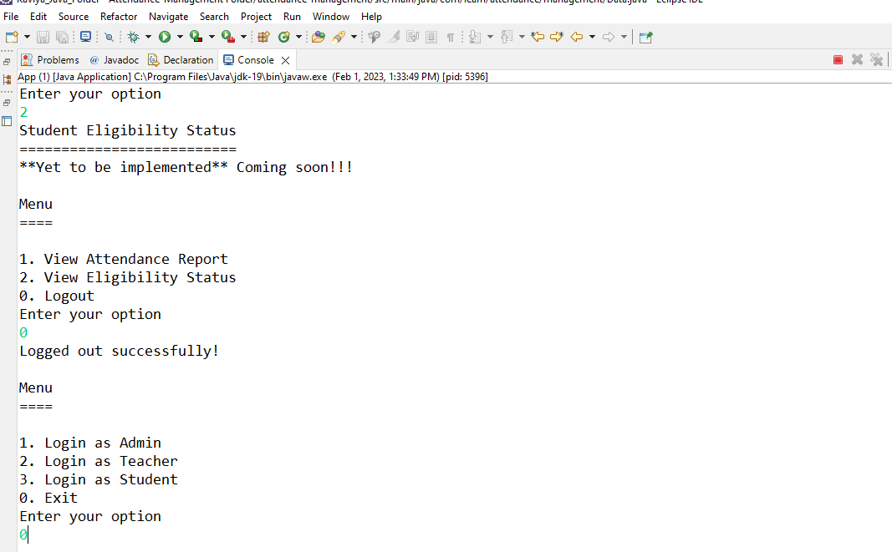

**If I give exit that red box will off…**

