***Assignment-12***

***Kaviya-C***

**All Vowels:**

**Write a Program to check if given word contains exactly five vowels and**

**the vowels are in alphabetical order. Return 1 if the condition is**

**satisfied else return -1. Assume there is no repetition of any vowel in**

**the given string and all letters are in lower case.**

**Include a class UserMainCode with a static method testOrderVowels which**

**accepts a string The return type is integer based on the condition stated**

**above.**

**Create a Class Main which would be used to accept two Input strings and**

**call the static method present in UserMainCode.**

**Input and Output Format:**

**Input consists of a string with maximum size of 100 characters.**

**Output consists of a single string.**

**Refer sample output for formatting specifications.**

**Sample Input 1:**

**acebisouzz**

**Sample Output 1:**

**valid**

**Sample Input 2:**

**alphabet**

**Sample Output 2:**

**invalid**

**Note: Need to implement this by using LinkedHashSet**

**Ans:**

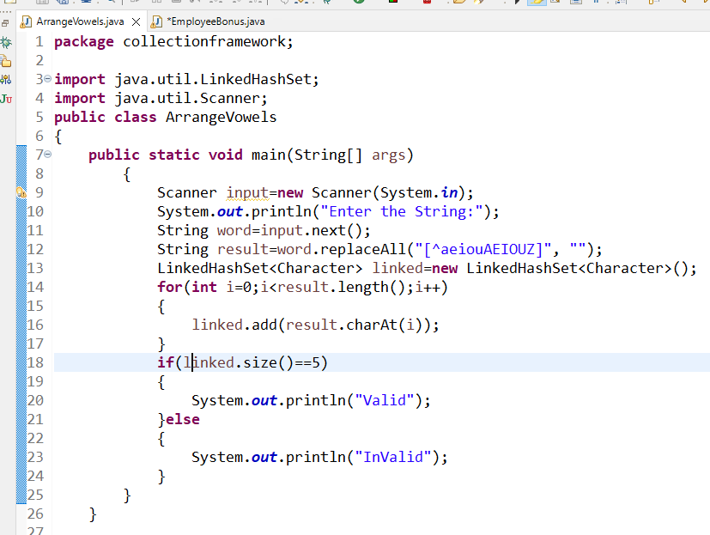

**Output:**

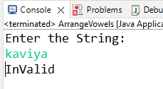

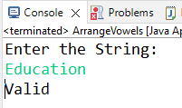

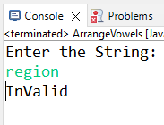

**Employee Bonus**

**A Company wants to give away bonus to its employees. You have been**

**assigned as the programmer to automate this process. You would like to**

**showcase your skills by creating a quick prototype. The prototype**

**consists of the following steps:**

**1.**

**Read Employee details from the User. The details would include id, DOB**

**(date of birth) and salary in the given order. The datatype for id is**

**integer, DOB is string and salary is integer.**

**2.**

**You decide to build two hashmaps. The first hashmap contains employee id**

**as key and DOB as value, and the second hashmap contains same employee**

**ids as key and salary as value.**

**3.**

**If the age of the employee in the range of 25 to 30 years (inclusive),**

**the employee should get bonus of 20% of his salary and in the range of 31**

**to 60 years (inclusive) should get 30% of his salary. store the result in**

**TreeMap in which Employee ID as key and revised salary as value. Assume**

**the age is caculated based on the date 01-09-2014. (Typecast the bonus to**

**integer).**

**4.**

**Other Rules:**

**a. If Salary is less than 5000 store -100.**

**b. If the age is less than 25 or greater than 60 store -200.**

**c. a takes more priority than b i.e both if a and b are true then store -**

**100.**

**5.**

**You decide to write a function calculateRevisedSalary which takes the**

**above hashmaps as input and returns the treemap as output. Include this**

**function in class UserMainCode.**

**Create a Class Main which would be used to read employee details in step**

**1 and build the two hashmaps. Call the static method present in**

**UserMainCode.**

**Input and Output Format:**

**Input consists of employee details. The first number indicates the size**

**of the employees. The next three values indicate the employee id,**

**employee DOB and employee salary. The Employee DOB format is “dd-mm-yyyy”**

**Output consists of a single string.**

**Refer sample output for formatting specifications.**

**Sample Input 1:**

**2**

**1010**

**20-12-1987**

**10000**

**2020**

**01-01-1985**

**14400**

**Sample Output 1:**

**1010**

**12000**

**2020**

**17280**

**Note: Need to use the HashMap and TreeMap**

**Ans:**

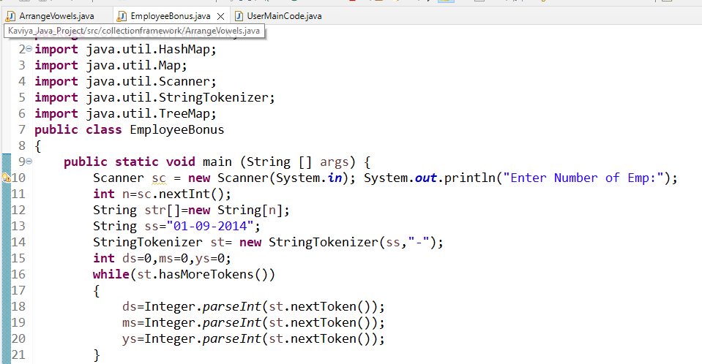

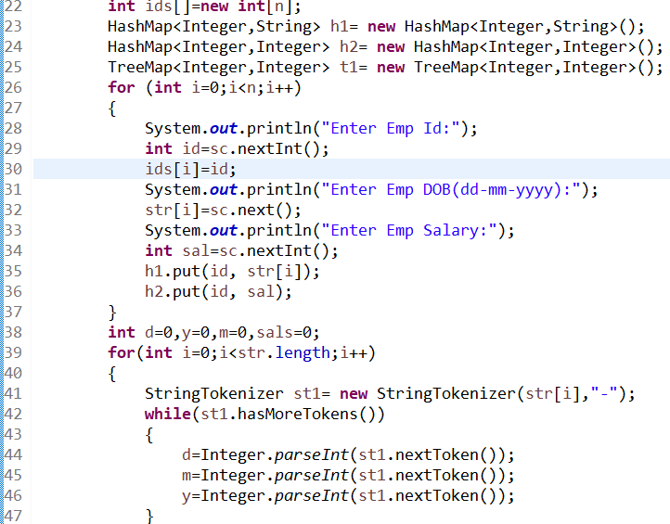

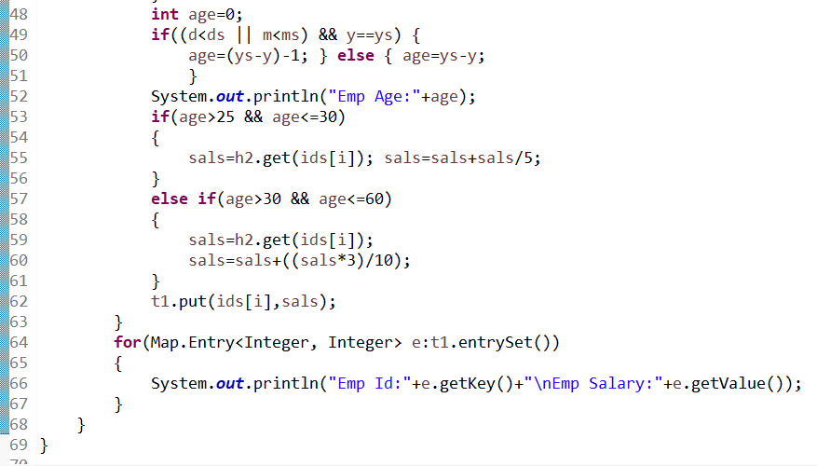

**Output:**

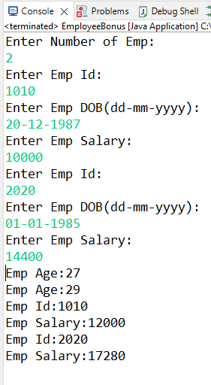

**Write a program that construts a hashmap and returns the value**

**corresponding to the largest key.**

**Include a class UserMainCode with a static method getMaxKeyValue which**

**accepts a string. The return type (String) should be the value**

**corresponding to the largest key.**

**Create a Class Main which would be used to accept Input string and call the static method present in UserMainCode.**

**Input and Output Format:**

**Input consists of 2n+1 values. The first value corresponds to size of the hashmap. The next n pair of numbers equals the integer key and value as string.**

**Output consists of a string which is the value of largest key.**

**Refer sample output for formatting specifications.**

**Sample Input 1:**

**3**

**12**

**amron**

**9**

**Exide**

**7**

**SF**

**Sample Output 1:**

**amron**

**Ans:**

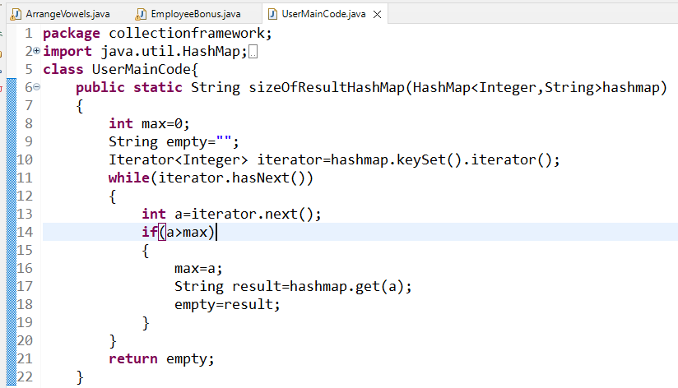

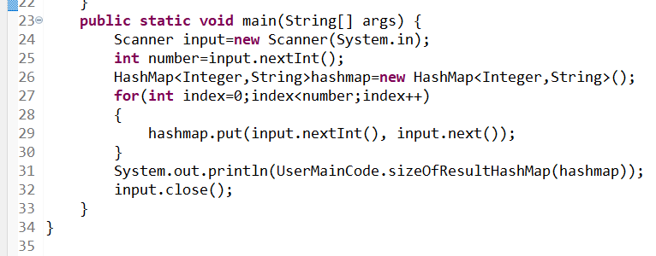

**Output:**

