***Assignment-16***

***Kaviya-C***

**Table creation, updation ,deletion, Insertion ,operation in maven folder and connect to the database:**

Ans:

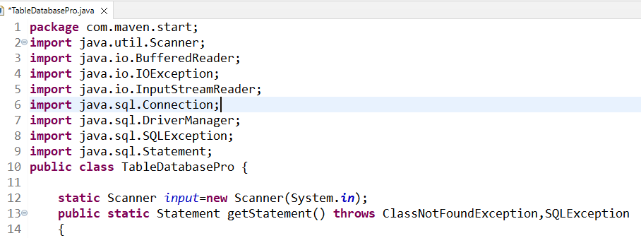

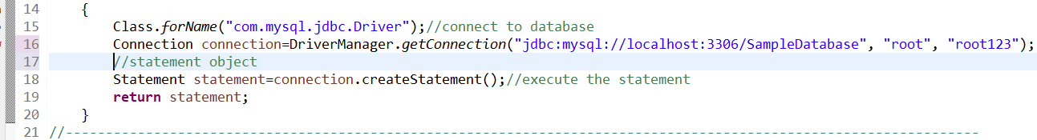

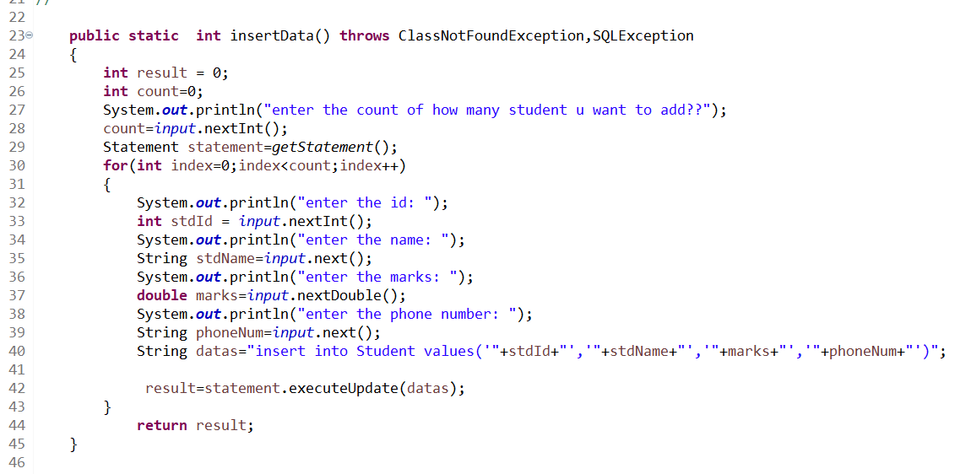

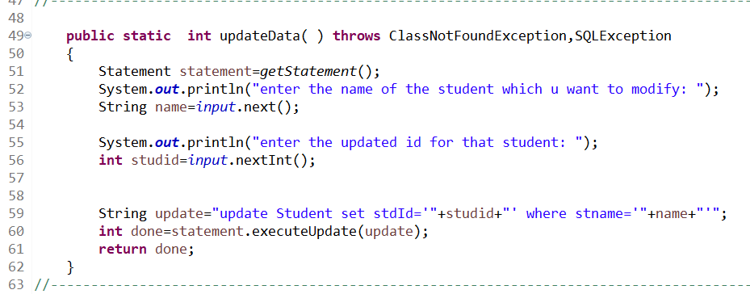

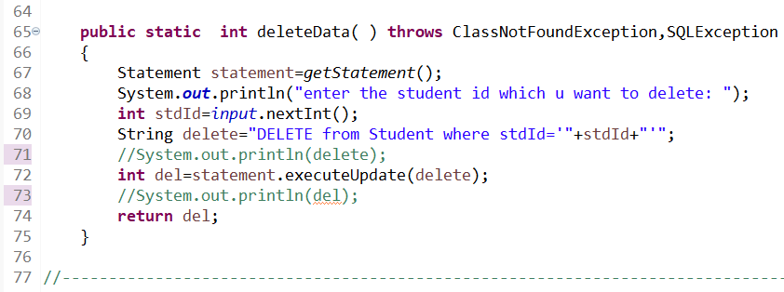

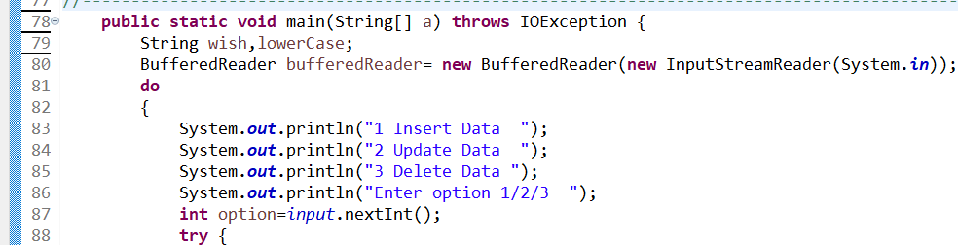

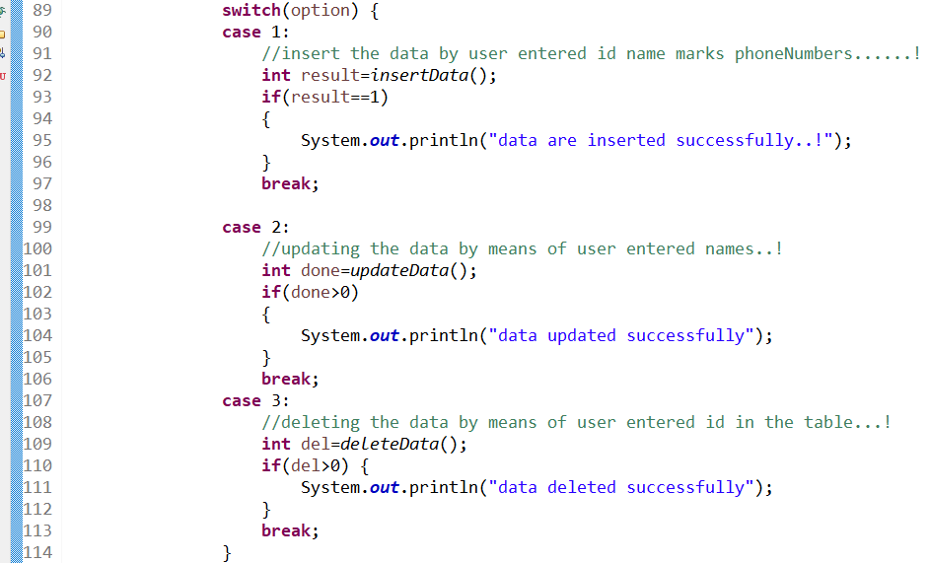

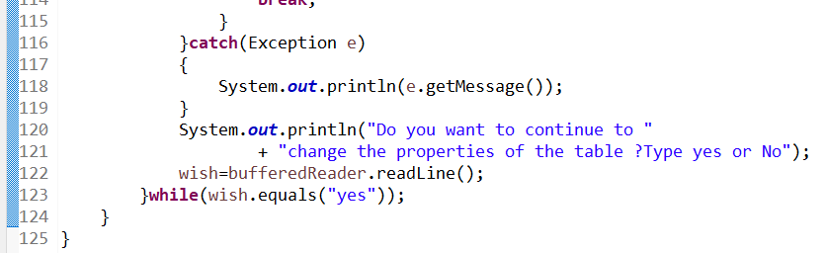

**OUTPUT:**

**No datas are added:**

**Only table and database created:**

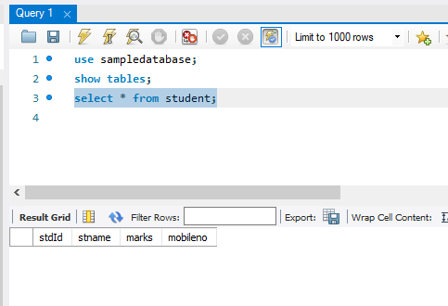

**From eclipse we insert the data to the table using statement interface:**

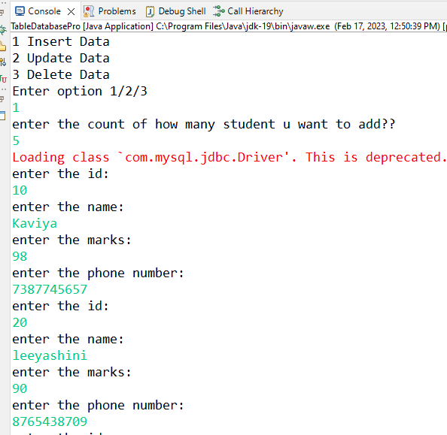

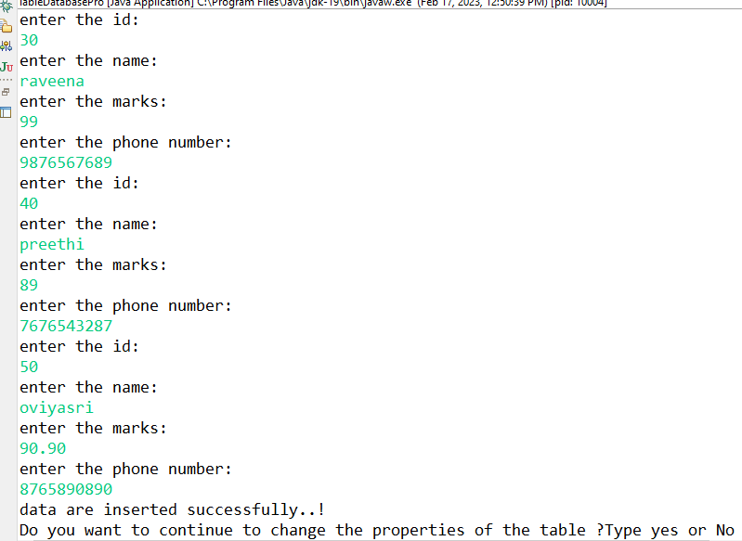

**This will reflect on mysql workbench**

**Below u can see:**

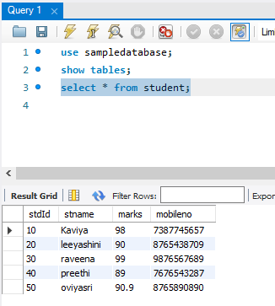

**Press yes for modifying or deleting or inserting the data: in eclipse as below:**

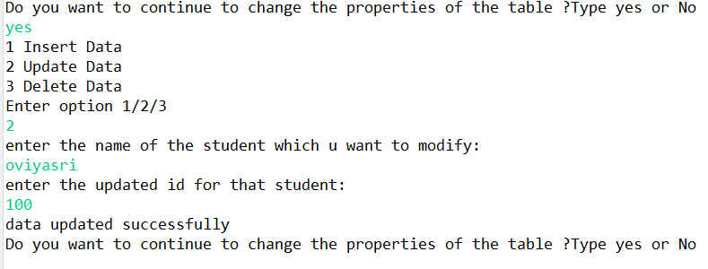

**Mysql Workbench the oviyasri id is changed:**

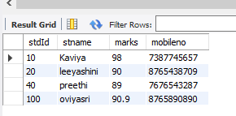

**For deleting the data :**

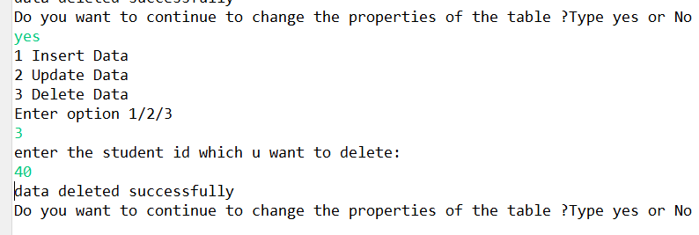

**MYsql that id is deleted:**

