1. Introduction

Project Title:

INSIGHT STREAM: Navigation and Landscape

Frontend Development with React.js

|  |  |
| --- | --- |
| TEAM LEADER | KAVIYA.N |

Team Members:

|  |  |  |
| --- | --- | --- |
| MEMBERS | NAMES | ROLES |
| MEMBER 1 | KAVIYA.N | CODE DEVELOPER |
| MEMBER 2 | KALAISELVI.J | DOCUMENTATION |
| MEMBER 3 | KAVIYA.M | CODE DEVELOPER |
| MEMBER 4 | KAVIYA.V | VOICE-DEMO VEDIO |

About the Project

In today’s world, people prefer to consume news and information through digital platforms instead of traditional methods like newspapers or television. Modern web applications provide news that is quick, personalized, and categorized for better understanding.

Our project Insight Stream is a frontend web application built with React.js. It focuses on delivering news in an organized and user-friendly manner. The project emphasizes simplicity, reusability of components, and scalability.

 Apart from building a working news application, this project also gives us hands-on learning in frontend development, state management, and routing with React.js.

2. Project Overview

Purpose:

The primary objective of Insight

Stream is to establish a user-friendly platform tailored for individuals who are passionate about staying informed, exploring diverse news topics, and accessing the latest updates.

Our key goals include:

User-Friendly Experience: Develop an interface that is intuitive and easy to navigate, ensuring users can effortlessly access, save, and share their preferred news articles.

Comprehensive News Management: Provide robust features for organizing and managing news content, incorporating advanced search options for a personalized news experience.

Technology Stack: Employ cutting-edge web development technologies, such as React.js, to ensure an efficient and enjoyable user interface.

Features of InsightStream:

News from API Sources: Access a vast library of global news spanning various categories and interests, ensuring a well-rounded coverage of current affairs.

Visual News Exploration: Discover breaking stories and explore different news categories through curated image galleries, enhancing the visual appeal of news discovery.

Intuitive Design: Navigate the application seamlessly with a clean, modern interface designed for optimal user experience and clarity in information presentation.

3. Architecture

3.1 Component Structure:

Dashboard → Real-time insights and key metrics

Streams → Access live data streams

Analytics → Tools for queries, visualizations, and reports

Reports → Saved and scheduled reports

Collaboration → Shared dashboards, comments, team workspaces

Settings → Preferences, integrations, and security controls

3.2 State Management:

Global state: Dashboards, streams, reports, authentication

Local state: Filters, export options, visualization settings

3.3 Routing:

Primary Navigation: Dashboard, Streams, Analytics, Reports, Collaboration, Settings

Secondary Navigation: Contextual menus inside modules

1. Setup Instructions
   1. Prerequisites:

Here are the key prerequisites for developing a frontend application using React.js:

Node.js and npm: Node.js is a powerful JavaScript runtime environment that allows you to run JavaScript code on the local environment. It provides a scalable and efficient platform for building network applications.

Install Node.js and npm on your development machine, as they are required to run JavaScript on the server-side.

Download: https://nodejs.org/en/download/

Installation instructions: https://nodejs.org/en/download/package-manager/

React.js: React.js is a popular JavaScript library for building user interfaces. It enables developers to create interactive and reusable UI components, making it easier to build dynamic and responsive web applications.

Install React.js, a JavaScript library for building user interfaces.

Create a new React app:

npx create-react-app my-react-app

Replace my-react-app with your preferred project name.

Navigate to the project directory:

cd my-react-app

Running the React App:

With the React app created, you can now start the development server and see your React application in action.

Start the development server:

npm start

This command launches the development server, and you can access your React app at http://local host:3000 in your web browser.

HTML, CSS, and JavaScript: Basic knowledge of HTML for creating the structure of your app, CSS for styling, and JavaScript for client-side interactivity is essential.

Version Control: Use Git for version control, enabling collaboration and tracking changes throughout the development process. Platforms like GitHub or Bit bucket can host your repository.

Git: Download and installation instructions can be found at: HTTP://git-cm.com/downloads

Development Environment: Choose a code editor or Integrated Development Environment (IDE) that suits your preferences, such as Visual Studio Code, Sublime Text, or Web Storm.

Visual Studio Code: Download from https://code.visualstudio.com/download

Sublime Text: Download from https://www.sublimetext.com/download

WebStorm: Download from https://www.jetbrains.com/webstorm/

To clone and run the Application project from GitHub:

Follow below steps

Install Dependencies:

Navigate into the cloned repository directory and install libraries:

cd news

npm install

Start the Development Server:

To start the development server, execute the following command:

npm start

Access the App: Open your web browser and navigate to HTTP://local-host:3000.

You have

1. Folder Structure

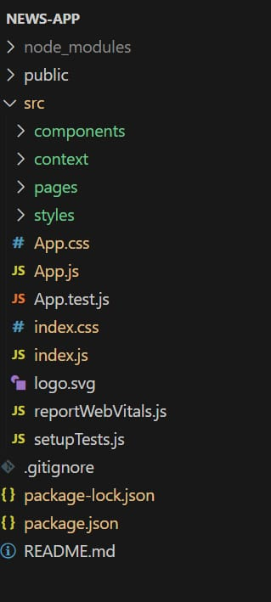 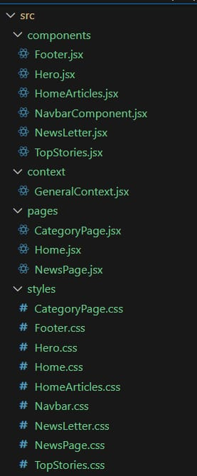

In this project, we’ve split the files into 4 major folders, Components, Context, Pages and Styles. In the pages folder, we store the files that acts as pages at different URLs in the application. The components folder stores all the files, that returns the small components in the application. The context API will be coded in the context folder. All the styling css files will be stored in the styles folder.

1. Running the Application

npm start

The app runs locally at:

👉 http://localhost:3000

7.Component Documentation

7.1 Key Components:

Dashboard → Real-time insights

Streams → Monitor live data

Analytics → Visualizations and reporting tools

Reports → Saved/scheduled reports

Collaboration → Team discussions, shared dashboards

Settings → Preferences, integrations

7.2 Reusable Components:

Navigation bar

The navigation bar (navbar) is the main control panel of a web app. It allows users to move between sections like Dashboard, Streams, Analytics, and Reports. In React, navbars are often reusable components with links or buttons that use React Router for navigation.

Search filters

Search filters allow users to narrow down results based on certain conditions. They make large datasets manageable by letting users choose categories, keywords, time ranges, or tags.

Charts & graphs

Charts and graphs visually represent data insights. Instead of raw numbers, they make trends, comparisons, and anomalies easier to understand. React apps often use libraries like Recharts, Chart.js, or D3.js.

Notification popups

Notification popups (toast messages, alerts) provide real-time feedback to users. They can notify about new updates, warnings, errors, or success confirmations.

8.State Management

Global State:

User authentication, active streams, notifications, dashboards.

Local State:

Component-level filters, inputs, visualization parameters.

9.User Interface

Responsive (desktop, tablet, mobile)

Consistent icons and menus

Contextual navigation for quick tasks

Role-based UI (Admins, Analysts, Viewers, Partners)

10. Styling

1. Global Styling Approach

CSS Modules / Styled Components: Prevent class name conflicts and enable modular styling.

Theme Management: Light/Dark theme toggle with centralized color palette (Tailwind/Material UI).

Typography System: Define font sizes, weights, and line heights consistently across the app.

2. Responsive Design

Use flexbox and CSS grid for layouts.

Media queries for different breakpoints (mobile-first approach).

Test responsiveness on Chrome DevTools device toolbar.

3. Best Practices

Use utility classes (Tailwind CSS) for faster styling.

Keep colors, spacing, and font sizes in variables/tokens.

Reuse styled components for buttons, inputs, and cards.

4. Accessibility

High-contrast themes.

Semantic HTML (nav, main, section, footer).

ARIA attributes for screen readers.

11.Testing

1. Unit Testing (Jest)

Test pure functions (data processing, utility methods).

Example: Checking if a search filter function returns correct results.

2. Component Testing (React Testing Library)

Verify rendering of components (navbar, cards, charts).

Simulate user interactions (click, input, navigation).

Snapshot testing for UI consistency.

3. Integration Testing

Ensure multiple components work together.

Example: Search bar + API call + display results.

4. End-to-End (E2E) Testing

Tools: Cypress / Playwright.

Test complete user journeys (Login → Navigate Dashboard → View Reports).

Validate performance and API integration.

5. Test Coverage

Generate coverage reports with Jest (--coverage).

Aim for 80–90% coverage across components.

6. Continuous Integration (CI)

Run test suites automatically in GitHub Actions / GitLab CI.

Block merging if critical tests fail.

12. Screenshots or Demo

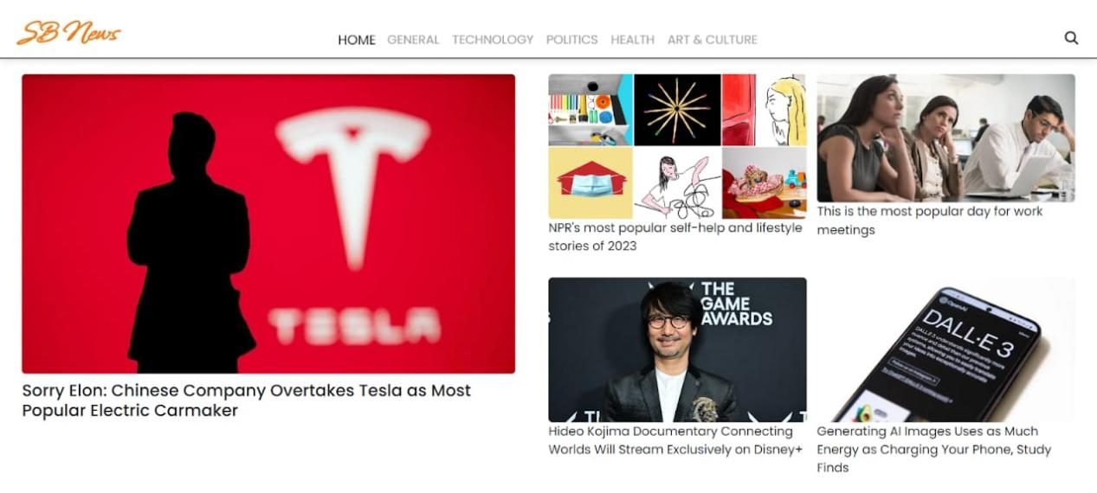

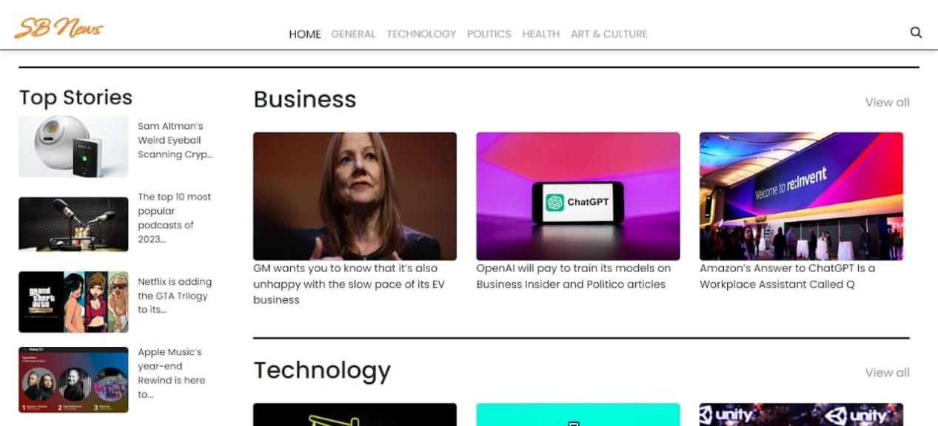

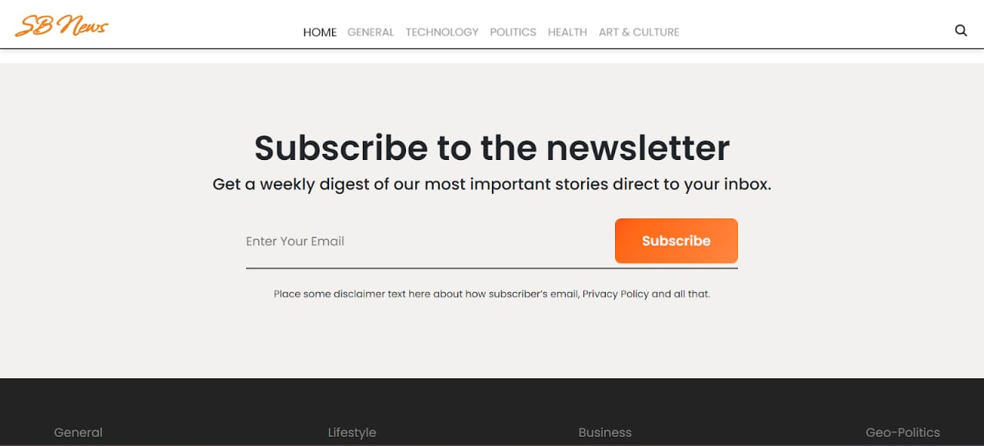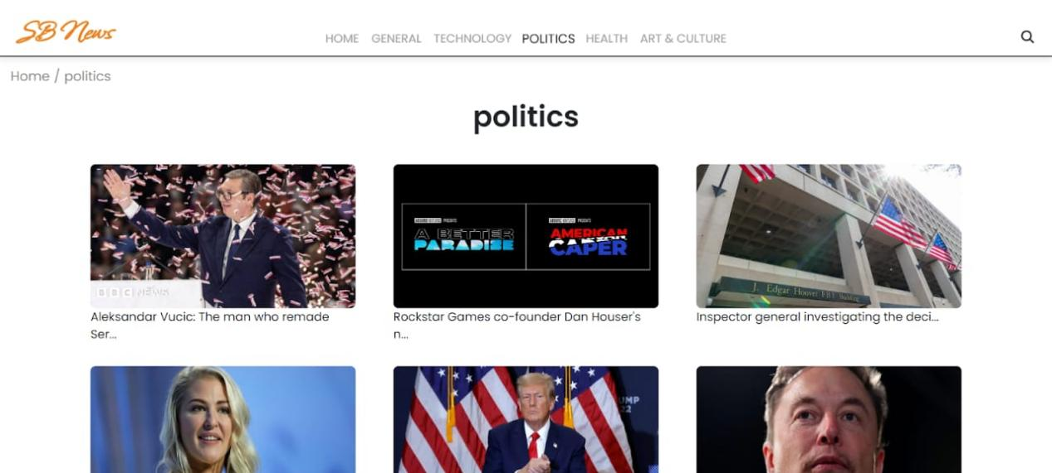

13. Known Issues

Optimization needed for large-scale streaming

Performance tuning for heavy analytics dashboard.

1. Future Enhancements

Advanced theming & customization

More interactive visualizations

AI-driven insights & recommendations

Offline mode with cached data

15.Conclusion

The Insight Stream project gave us valuable learning in frontend development.

We learned how to install Node.js and set up a React.js application.

We understood the importance of reusable components and state management.

We practiced routing and navigation using React Router.

We improved our problem-solving and teamwork skills during development.

We are now prepared to extend this project with future enhancements and real-world applications.

We have learned how to:

Install Node.js and set up a React application.

Build and use reusable components.

Manage data using state and props.

Implement routing for seamless navigation.

This project not only improved our technical knowledge but also prepared us for future internships, academic projects, and industry-level applications.