Bus Tracker with ETA
A Major Project Report Submitted to the Bharathiar University in Partial Fulfilment of the Requirements for the Award of the Degree of

MASTER OF COMPUTER APPLICATIONS

Submitted by
KAVIYA R
(Reg. No: 23CSEA15)
Under the guidance of

Dr. J. SATHEESHKUMAR, M.C.A., Ph.D.,
Professor,
Department of Computer Application.



DEPARTMENT OF COMPUTER APPLICATIONS BHARATHIAR UNIVERSITY
COIMBATORE-641046.

APRIL- 2025

CERTIFICATE
This is to certify that, this Major project work entitled “BUS TRACKER WITH ETA” was submitted to the Department of Computer Applications, Bharathiar University in partial fulfilment of the requirements for the award of the degree of MASTER OF COMPUTER APPLICATIONS, is a record of original work done by KAVIYA R (23CSEA15) during his period of study in the Department of Computer Applications, Bharathiar University, Coimbatore, under my supervision and guidance, and this project work has not formed the basis for the award of any Degree/ Diploma /Associateship/ Fellowship or similar title to any candidate of any University.

Place: Coimbatore Date:

Project Guide Head of the Department

Submitted for the University Viva-Voce Examination held on

Internal Examiner External Examiner

DECLARATION

DECLARATION
I hereby declare that this Major project work titled, “BUS TRACKER WITH ETA” submitted to Department of Computer Applications, Bharathiar University, is a record of original work done by KAVIYA R (23CSEA15), under the supervision and guidance of Dr. J. SATHEESHKUMAR, M.C.A., Ph.D., Professor, Department of Computer Application, Bharathiar University, and that this project work has not formed the basis for the award of any Degree/ Diploma/ Associateship/ Fellowship or similar title to any candidate of any University.

Place: Coimbatore Signature of the Candidate Date: (KAVIYA R)

COUNTERSIGNED BY

INTERNSHIP CERTIFICATE



ACKNOWLEDGEMENT

ACKNOWLEDGEMENT
I have taken efforts in this project. However, it would not have been possible without the kind support and help of many individuals and organizations. I would like to extend my sincere thanks to all of them. I express my sincere gratitude to our Professor& Head of the Department Dr. M. PUNITHAVALLI, M.Sc., M.Phil., Ph.D., Department of Computer Application, Bharathiar University, Coimbatore, thanks to department faculty members and guest faculties supported to acquire knowledge from various inputs. I am forever indebted to this Major project guide Dr. J. SATHEESHKUMAR, M.C.A., Ph.D., Professor, Department of Computer Applications, Bharathiar University for providing valuable suggestions and always been enthusiastically guiding us throughout the project.
Finally, I also extend my special thanks to my family, friends, who have kindly provided the necessary support for the successful completion of the project and their moral support.

ABSTRACT

ABSTRACT
The Bus Tracker with ETA is a real-time tracking system designed to provide commuters with updated information on bus routes, schedules, and estimated arrival times (ETA). Users can search for bus routes by entering a bus number or specifying their starting and destination locations.
This project integrates Firebase Realtime Database for efficient data management, React.js for the frontend, and Node.js with Express.js for backend operations. The Google Maps API suite, including Maps JavaScript API, Places API, Directions API, Distance Matrix API, Geocoding API, Geolocation API, Route Optimization API, and Routes API, is utilized for interactive mapping, real-time location tracking, and ETA predictions.
Additionally, the system retrieves live GPS data from buses and stores it in Firebase Realtime Database, ensuring high accuracy in estimated arrival times. This integration significantly enhances public transportation accessibility by reducing uncertainty, improving route planning, and enhancing the overall commuting experience.
Future enhancements may include advanced GPS integration for live bus tracking, AI-driven ETA predictions, and real-time user notifications for arrival alerts, ensuring greater efficiency and reliability for public transport users.

TABLE OF CONTENT

CONTENT

S.NO | PARTICULARS | PAGE NO
I | INTRODUCTION | 1
II | SYSTEM ANALYSIS | 2
II | 2.1 Existing System | 2
II | 2.2 Proposed System | 3
III | SYSTEM SPECIFICATION | 4
III | 3.1 Hardware Specification | 4
III | 3.2 Software Specification | 4
IV | SYSTEM OVERVIEW | 5
IV | 4.1 Module Description | 5
IV | 4.2 Software Description | 7
V | SYSTEM DESIGN | 11
V | 5.1 Primary and Secondary Design | 11
V | 5.2 User interface Design | 11
V | 5.3 Data flow Diagram | 12
V | 5.4 User Flow Chart | 14
V | 5.5 ER Diagram | 15
VI | SYSTEM TESTING AND IMPLEMENTATION | 20
VII | CONCLUSION | 22
VIII | FUTURE ENHANCEMENT | 23

- INTRODUCTION
The digital era is reshaping urban mobility, with public transportation playing a vital role in daily commuting. However, many commuters struggle with unreliable bus schedules and a lack of real-time information. The Bus Tracker with ETA aims to address these issues by providing a smart, web-based solution that delivers real-time bus tracking and accurate arrival time predictions.
Users can search for buses by entering a route number or specifying their starting and destination locations. The system fetches live data from Firebase, processes GPS-based bus locations, calculates estimated arrival times, and displays the information on an interactive Google Maps API-powered interface. This project ensures that commuters can plan their trips efficiently, reducing waiting times and enhancing travel convenience.

SYSTEM ANALYSIS
  - EXISTING SYSTEM
Traditional bus tracking and Estimated Time of Arrival (ETA) prediction systems primarily depend on static schedules, manual lookups, or third-party applications that often lack accuracy. These methods do not provide real-time location tracking, making it difficult for commuters to plan their journeys efficiently. Without live GPS data, users experience uncertainty regarding bus arrival times and route changes
    - DRAWBACKS OF EXISTING SYSTEM:
      - Reliance on static schedules leads to inaccurate ETA predictions.
      - Absence of real-time GPS tracking causes uncertainty in bus arrival times.
      - Limited integration with modern mapping technologies reduces accuracy.
      - Outdated user interfaces result in poor engagement and usability.
      - Inability to handle dynamic commuter demands efficiently.
      - No real-time notifications for users regarding delays or route changes.

  - PROPOSED SYSTEM
The proposed system overcomes the limitations of traditional bus tracking methods by providing a real-time, GPS-based bus tracking and ETA prediction platform. It leverages Firebase Realtime Database for storing and updating live GPS locations of buses, ensuring accurate data retrieval. The integration of Google Maps API, including Maps JavaScript API, Places API, Directions API, Distance Matrix API, Geocoding API, Geolocation API, Route Optimization API, and Routes API, enhances the accuracy of bus routes, estimated arrival times, and navigation. The user-friendly React-based interface allows seamless route searches, improving commuter convenience and travel planning

2.2.1 ADVANTAGES
      - Allows users to search for bus routes using a bus number or specifying start and destination points.
      - Provides real-time GPS tracking and highly accurate ETA predictions.
      - Integrates multiple Google Maps APIs for precise location tracking and route optimization.
      - Enhances commuter experience with an intuitive interface and interactive maps.
      - Reduces waiting time by offering up-to-date arrival estimates.
      - Scalable system capable of handling increasing commuter demands.
      - Future-ready for additional features like live user notifications and optimized route suggestions.

SYSTEM SPECIFICATION
  - HARDWARE SPECIFICATION
Processor : Multi-Core Processor
RAM : Sufficient RAM (16GB or more)
Hard disk : 1TB
System type : x64-based processor

3.2 SOFTWARE SPECIFICATION

Operating system : Windows 11
User Interface : React.js,CSS
Server & Processing : Node.js with Express.js
Database : Firebase Realtime Database
IDE : VSCode(Visual Studio Code )
APIs Used : Google Maps API

3.2.1 VS Code (Visual Studio Code)
Visual Studio Code (VS Code) is the primary Integrated Development Environment (IDE) used for writing, testing, and debugging code. It offers useful extensions, built-in Git integration, and a seamless development experience.
3.2.2 User Interface (UI) - React.js, CSS
The frontend of the application is built using React.js, a powerful JavaScript library for building dynamic and responsive user interfaces. CSS is used for styling, ensuring a visually appealing and user-friendly experience.
3.2.3 Server & Processing - Node.js with Express.js
The backend is developed using Node.js, a fast and scalable JavaScript runtime. Express.js, a lightweight framework for Node.js, is used to handle API requests, process data, and communicate with the database efficiently.

3.2.4 Database - Firebase Realtime Database
The application uses Firebase Realtime Database, a cloud-hosted NoSQL database, to store and manage live bus tracking data. It enables real-time synchronization of GPS locations, ensuring up-to-date information for users.
3.2.5 APIs Used - Google Maps API
The system integrates various Google Maps APIs to enhance location-based functionalities:
- Maps JavaScript API – Displays interactive maps on the application.
- Places API – Helps users search and autocomplete locations.
- Directions API – Calculates and displays the best possible routes.
- Distance Matrix API – Estimates travel time between locations.
- Geocoding API – Converts addresses into geographical coordinates.
- Geolocation API – Retrieves the user’s real-time location.
- Routes API – Optimizes routes for efficient navigation.

IV.SYSTEM DESIGN & PLANNING

4.1 Methodology
The development of the Bus Tracker with ETA system follows a structured methodology to ensure efficient implementation, accuracy in tracking, and real-time data updates. The methodology focuses on modular development, integration of advanced technologies, and continuous improvements based on testing and user feedback.

4.1.1 Agile Development Approach

The project adopts the Agile methodology, which emphasizes iterative development and flexibility. By breaking the development process into smaller cycles, each module is developed, tested, and refined separately. This approach allows for continuous integration of new features and improvements based on real-world performance and user feedback.

4.1.2 Requirement Analysis

The system requirements are analyzed to determine the necessary functionalities, including real-time GPS tracking, estimated arrival time (ETA) calculations, and interactive route visualization. The choice of Firebase Realtime Database ensures seamless data storage and retrieval, while the integration of Google Maps API allows accurate route tracking. The system also considers factors such as server load, data consistency, and minimal latency in live tracking.

4.1.3 Modular System Design

The system is designed using a modular approach to ensure efficiency and scalability. Each module is responsible for specific functionalities:
- Landing Page Module: Provides an overview of the system and allows users to access bus tracking features easily. It serves as the entry point for users to search for bus routes and track live locations.
- Bus Route Search Module: Enables users to find bus routes by entering a bus number or specifying starting and destination locations. The system fetches route details from Firebase and displays available buses, schedules, and stops.
- Real-Time Bus Tracking Module: Retrieves GPS data from buses and updates Firebase in real-time. Users can track buses dynamically on an interactive map, reducing uncertainty about arrival times.
- Interactive Map Module: Uses Google Maps API to display live bus locations, routes, and stops visually. It ensures clear navigation and helps users make informed travel decisions.
- Estimated Arrival Time (ETA) Module: Processes live GPS data and predicts arrival times based on bus speed, distance, and real-time traffic conditions. This helps users plan their commutes efficiently.
- Bus Stops & Route Management Module: Manages and displays bus stops along each route, showing estimated arrival times for better trip planning. Users can view stop sequences and track buses more effectively.
- Error Calculation Module: Ensures tracking accuracy by comparing predicted and actual arrival times. It continuously refines calculations to improve the precision of ETA predictions and real-time tracking.

4.1.4 Integration of Technologies

To ensure seamless real-time tracking and data accuracy, the system integrates key technologies:
- GPS Tracking: Fetches live location data from buses and updates Firebase in real-time.
- Firebase Realtime Database: Stores and synchronizes location, route, and ETA data efficiently.
- Google Maps API: Provides interactive route visualization and stop locations for enhanced navigation.
4.1.5 Iterative Testing and Refinement
Each module undergoes continuous testing to ensure accurate tracking and efficient ETA calculations. The error module refines predictions by comparing estimated and actual times, while user feedback enhances usability and performance.

4.1.6 Deployment and Maintenance

Once all modules are successfully tested and integrated, the system is deployed for real-world usage. Continuous monitoring ensures smooth operation, and necessary updates are implemented to optimize tracking accuracy and user experience. Regular maintenance keeps the system reliable and adaptable to evolving transportation needs.

4.2 WORKING PRINCIPLE

The Bus Tracker with ETA system continuously tracks bus locations and provides estimated arrival times. It integrates real-time location updates, cloud-based storage, and predictive analysis to ensure accurate

4.2.1 Bus Location Acquisition

The system continuously collects location data from moving buses using tracking technology. These updates are frequently refreshed to ensure real-time tracking.

4.2.2 Data Transmission and Storage

The live bus location data is sent to Firebase Realtime Database, where it is processed and stored. Firebase enables instant synchronization, allowing users to receive up-to-date bus information across multiple devices.

4.2.3 Route and Map Visualization

The system integrates with Google Maps API to provide an interactive map interface. Users can search for bus routes, view live locations, and check upcoming stops on a dynamic map.

4.2.4 Estimated Arrival Time (ETA) Calculation

The ETA is calculated using the current location of the bus, speed, and distance to the next stop. The system continuously updates the ETA based on live tracking data to improve prediction accuracy.

4.2.5 Error Calculation for Accuracy Enhancement

To ensure precise arrival estimates, the Error Calculation Module compares estimated times with actual arrival times. This module refines predictions by adjusting calculations based on observed deviations.

4.2.6. User Interaction and Real-Time Updates

Passengers access the system via a web-based interface, where they can search for buses, track locations, and view estimated arrival times. The system ensures that users receive real-time updates, enabling better trip planning.

4.3 FLOW CHART
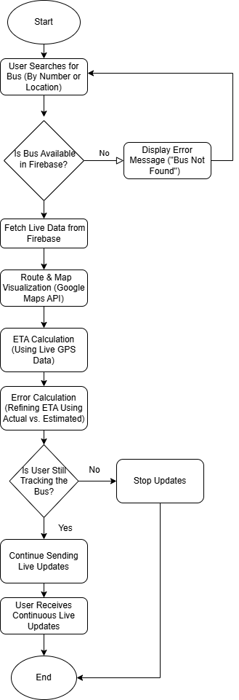
Fig 4.3.1 Flow Chart

4.4 Software Development Life Cycle Model
The Bus Tracker with ETA system is developed following the Software Development Life Cycle (SDLC) to ensure a structured and efficient development process. The system aims to provide real-time bus tracking, accurate estimated arrival times (ETA), and interactive route visualization.

4.4.1 Planning Phase

In this phase, the system’s objectives and feasibility are determined. The primary goal is to enable real-time tracking and reduce wait times for commuters. Key technologies such as GPS tracking, Firebase Realtime Database, and Google Maps API are evaluated for integration. Risks, including GPS signal loss and performance issues, are assessed, and a development timeline is established.

4.4.2 Requirement Analysis Phase

User needs are analyzed to define the system's core features, including real-time tracking, ETA calculation, and route visualization. Firebase Realtime Database is chosen for data storage to handle continuous updates efficiently. Scalability, security, and accuracy requirements are also considered to ensure the system's effectiveness in real-world conditions.

4.4.3 System Design Phase

The system architecture is outlined, focusing on modular design for efficiency. Firebase Realtime Database stores live bus locations, routes, and user queries. The tracking module retrieves GPS data, while the ETA calculation module estimates arrival times based on bus speed and distance. The interactive map module integrates Google Maps API for real-time route visualization. The error calculation module ensures ETA accuracy by refining predictions based on actual arrival times.

4.4.4 Development Phase
This phase involves coding and integration, with GPS updating bus locations in Firebase, Google Maps enabling route visualization, and the ETA algorithm refining arrival predictions through real-time data and error analysis.

4.4.5 Testing Phase

The system undergoes rigorous testing to validate tracking accuracy, ETA predictions, and system performance. Each module is tested individually before integration. The error calculation module is fine-tuned using real-time data. User feedback is collected to identify potential improvements before final deployment.

4.4.6 Deployment Phase

After successful testing, the system is deployed for real-world use. The database is optimized for fast updates, and security measures are implemented. The system is made accessible to users, and live tracking is monitored to ensure smooth operation.

4.4.7 Maintenance and Updates

Post-deployment, the system is continuously monitored to improve accuracy and reliability. The error calculation module is refined, and security updates are applied. User feedback is incorporated into system enhancements, ensuring seamless performance over time.
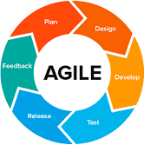

Fig 4.4 Software Development Life Cycle (SDLC) Model

4.5 MODULE DESCRIPTION

4.5.1 Landing Page Module

The Landing Page Module provides a user-friendly interface where commuters can access real-time bus tracking information. It highlights key features such as live tracking, ETA, and seat availability. The page also includes a simple step-by-step guide on how to use the system, making it easy for first-time users. With a visually appealing design, it ensures seamless navigation and quick access to bus tracking features.

4.5.2 Bus Route Search Module

This module allows users to find bus routes by entering a bus number or specifying their starting and destination locations. The system fetches route details from Firebase and displays available buses, schedules, and stops. This ensures users can quickly identify the best routes and plan their trips effectively.

4.5.3 Real-Time Bus Tracking Module

The system retrieves live GPS data from buses and updates their locations in Firebase, providing real-time tracking. Users can view bus positions on an interactive Google Map, allowing them to track buses live and reduce waiting times. This feature improves commuting

Efficiency by offering accurate location updates .

4.5.4 Interactive Map Module

Using Google Maps API, this module provides a real-time visual representation of bus routes, stops, and live bus locations. It updates dynamically and displays estimated arrival times, enabling users to track their buses easily. The system also considers historical traffic data to improve accuracy.

4.5.5 Estimated Arrival Time (ETA) Module

This module calculates the estimated arrival time based on live GPS data, bus speed, and distance from stops. It dynamically updates to reflect traffic conditions and delays, ensuring users receive accurate arrival predictions. This helps passengers plan their journeys more efficiently without unnecessary waiting.

4.5.6 Bus Stops & Route Module

This module manages and displays the list of bus stops along each route, along with their estimated arrival times. Users can view stops in sequence, track buses along the route, and check ETAs, making their commute more predictable and efficient.

4.5.7 Error Calculation Module

The Error Calculation Module ensures tracking accuracy by comparing predicted and actual arrival times. It identifies discrepancies and refines the system for better reliability. By continuously improving calculations, it enhances the precision of bus tracking and ETA predictions.

4.6 DATABASE DESIGN

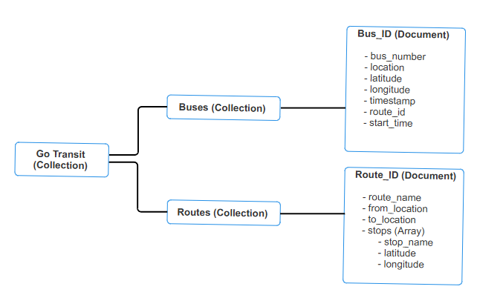

Fig 4.6.1 Firebase Realtime Database

V. SYSTEM TESTING

5.1 TESTING METHODOLOGIES
5.1.1 UNIT TESTING
Unit testing ensures that individual modules, such as bus location retrieval, ETA calculation, and data updates, function correctly. Each function and API call is tested in isolation to detect errors early.
5.1.2 Integration Testing
Integration testing verifies data flow between different components, such as GPS data transmission, database updates, and map integration. It ensures that modules communicate effectively and that real-time tracking is accurate.
5.1.3 Functional Testing
Functional testing validates core features, ensuring they meet system requirements. Key test cases include:
- Bus route search: Users should be able to search for a bus by number or route.
- Real-time tracking: Bus location should update dynamically on the map.
- ETA calculation: Arrival times should be estimated accurately based on live data.
- User interface navigation: Buttons, forms, and maps should function properly.
5.1.4 System Testing
System testing evaluates the entire Bus Tracker with ETA System, ensuring front-end, back-end, and database integration. It verifies overall system stability, real-time tracking accuracy, and performance under different traffic conditions.
5.1.5 Performance Testing
Performance testing analyzes the system’s ability to handle multiple user requests and large-scale GPS updates. It tests:
- Response time for location updates.
- System load handling with multiple buses tracking simultaneously.
- Database performance under high read/write conditions.
5.1.6 Usability Testing
Usability testing ensures that users can easily navigate the system. It evaluates:
- User-friendliness of the landing page and interactive map.
- Clarity of bus routes and arrival time information.
- Ease of access on mobile devices.
5.1.7 Compatibility Testing
Compatibility testing verifies that the system functions correctly across different browsers, devices, and screen sizes. It ensures that:
- The system is responsive on desktop, tablets, and mobile devices.
- It works seamlessly on different web browsers.
5.1.8 User Acceptance Testing (UAT)
Real-world users test the system to validate its functionality, reliability, and ease of use. The testing process includes:
- Live tracking verification by passengers and drivers.
- Accuracy of ETA predictions under real-world conditions.
- Feedback collection to refine the system before deployment.

5.2 TEST CASE
Test Case ID | Test Scenario | Test Steps | Expected Result | Actual Result | Status
TC-1 | using bus number or from-to location | 1. Open the Bus Tracker system.  2. Enter a valid bus number or starting and destination locations.  3. Click the search button. | The system should display the correct bus routes, schedules, and stops. | As expected | Pass
TC-2 | Invalid Searching Bus Route Search | 1. Open the Bus Tracker system.  2. Enter an invalid or non-existent bus number.  3. Click the search button. | The system should display an appropriate error message. | As expected | Pass
TC-3 | Real-Time Bus Tracking | 1. Open the Bus Tracker system.  2. Search for a bus and view its real-time location. | The bus should be displayed on the map with live tracking updates. | As expected | Pass
TC-4 | ETA Calculation Accuracy | 1. Search for a bus.  2. Check the estimated arrival time at a specific stop.  3. Compare with actual arrival time. | The ETA should be accurate within a reasonable margin of error. | As expected | Pass
TC-5 | Live Location Synchronization | 1. Move the bus in real-time.  2. Check if the system updates the bus location instantly. | The system should update the location in real-time with minimal delay. | As expected | Pass
TC-6 | Interactive Map Navigation | 1. Open the interactive map.  2. Zoom in, zoom out, and pan across the map.  3. Click on bus stops for information. | The map should function smoothly, displaying bus routes and stops. | As expected | Pass
TC-7 | Data Consistency in Firebase | 1. Search for a bus.  2. Open Firebase Database and check if bus location data is updated correctly. | The data should be correctly stored and synchronized in Firebase. | As expected | Pass
TC-8 | ETA Error Calculation | 1. Check ETA predictions.  2. Compare estimated and actual arrival times. | The system should refine ETA predictions based on errors. | As expected | Pass
TC-9 | Mobile Responsiveness | 1. Open on a mobile browser.  2.Verify smooth functionality and proper display. | Fully responsive and functional on mobile. | As expected | Pass
VI.APPENDIX

6.1 SOURCECODE
const express = require("express");

const cors = require("cors");

const admin = require("firebase-admin");

const path = require("path");

// Initialize Firebase

admin.initializeApp({

credential: admin.credential.cert(require(path.join(__dirname, "serviceAccountKey.json"))),

databaseURL: "https://go-transit-48399-default-rtdb.asia-southeast1.firebasedatabase.app/",

});

const app = express();

app.use(cors());

app.use(express.json());

const db = admin.database();

const port = 5000;

// ✅ Test Route

app.get("/", (req, res) => res.send("✅ Backend is running!"));

// ✅ Fetch Bus Route Data

app.get("/search", async (req, res) => {

const { from, to, busNumber } = req.query;

try {

if (busNumber) {

const busRef = db.ref("routes/buses");

const snapshot = await busRef.orderByChild("bus_number").equalTo(Number(busNumber)).once("value");

if (!snapshot.exists()) return res.status(404).json({ message: "Bus not found" });

const busData = Object.values(snapshot.val())[0];

const routeSnapshot = await db.ref(`routes/${busData.route_id}`).once("value");

res.json({

message: "✅ Route found",

busNumber: busData.bus_number,

startTime: busData.start_time || "Not Available",

routeDetails: routeSnapshot.exists() ? routeSnapshot.val() : {},

});

} else if (from && to) {

const routesSnapshot = await db.ref("routes").once("value");

if (!routesSnapshot.exists()) return res.status(404).json({ message: "No routes found" });

const routes = routesSnapshot.val();

const foundRoutes = Object.values(routes).filter(route =>

route.stops && route.stops.some(stop => stop.name.toLowerCase() === from.toLowerCase()) &&

route.stops.some(stop => stop.name.toLowerCase() === to.toLowerCase())

);

res.json(foundRoutes.length ? { routes: foundRoutes } : { message: "No matching routes" });

} else {

res.status(400).json({ message: "Provide a bus number or both 'from' and 'to' locations" });

}

} catch (error) {

res.status(500).json({ message: "Error fetching data", error: error.message });

}

});

// ✅ Update Bus Location

app.post("/update-location", async (req, res) => {

const { busNumber, latitude, longitude } = req.body;

if (!busNumber || isNaN(latitude) || isNaN(longitude)) return res.status(400).json({ error: "Invalid input" });

try {

await db.ref(`routes/buses/${busNumber}/location`).set({ latitude, longitude, timestamp: new Date().toISOString() });

res.json({ message: "✅ Location updated" });

} catch (error) {

res.status(500).json({ error: "Failed to update location" });

}

});

// ✅ Start Server

app.listen(port, () => console.log(`✅ Server running on http://localhost:${port}`));

SCREENSHOT

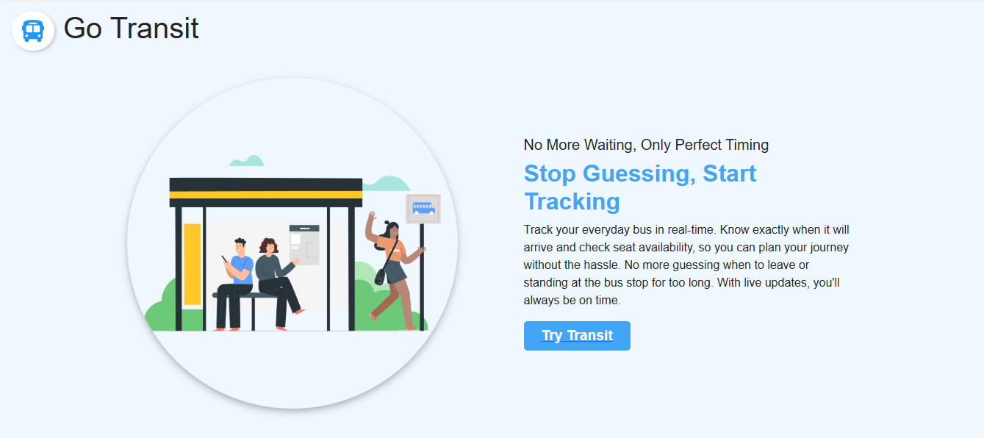

Figure 6.2.1 Landing Page

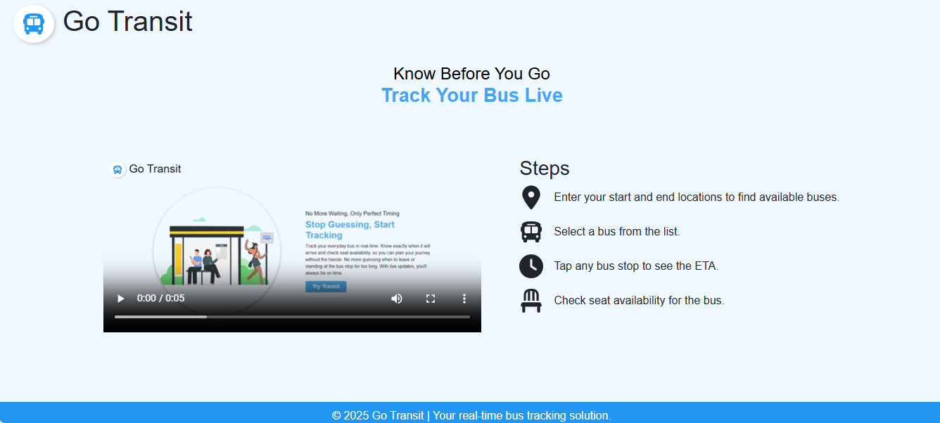

Figure 6.2.2 Landing Page
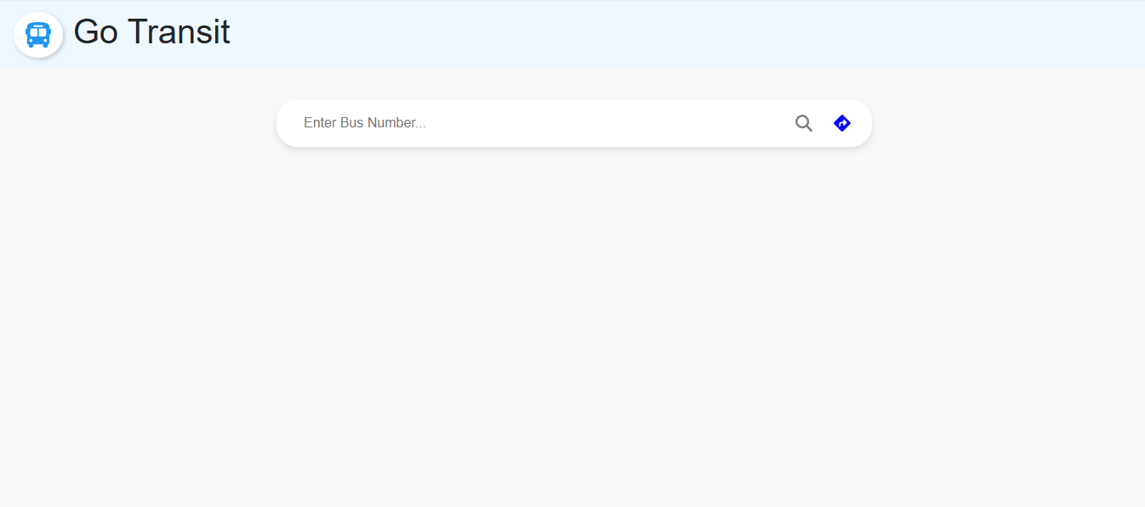

Figure 6.2.3 Bus Number-Based Search Interface

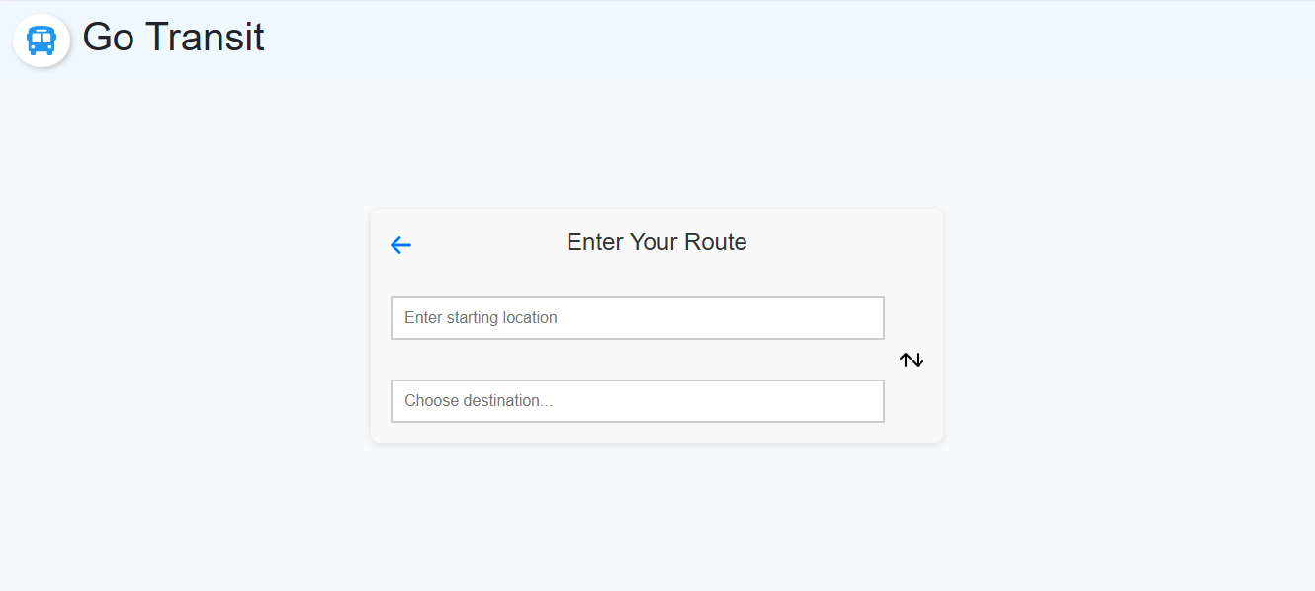

Figure 6.2.4 Route-Based Search Interface
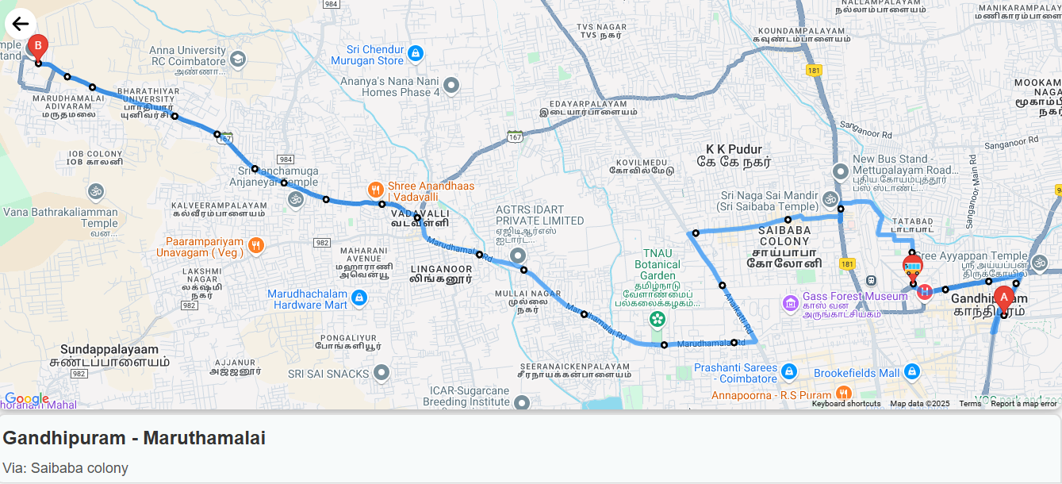

Figure 6.2.5 Map Display - Route & Live Bus Tracking

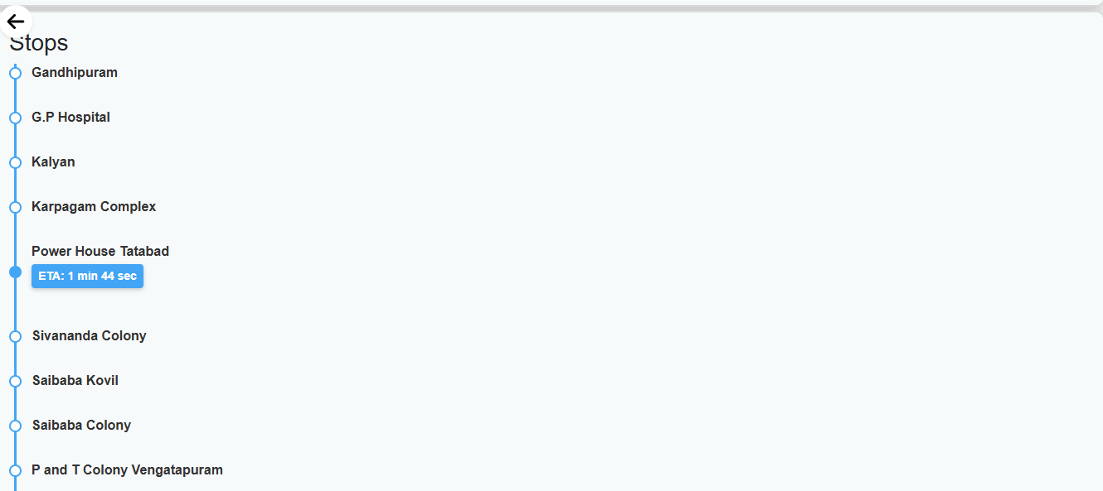

Figure 6.2.6 Bus Stops & Estimated Time of Arrival (ETA)
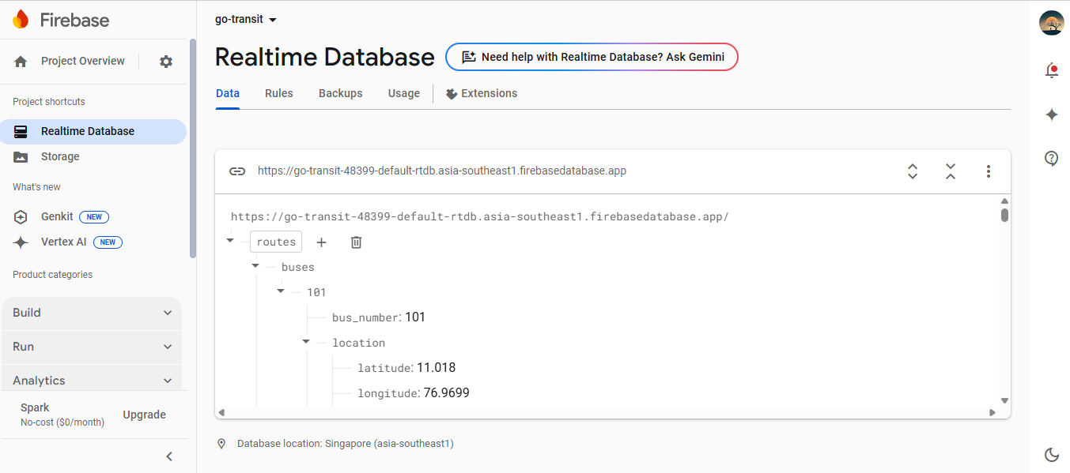

Figure 6.2.7 Firebase Realtime Database

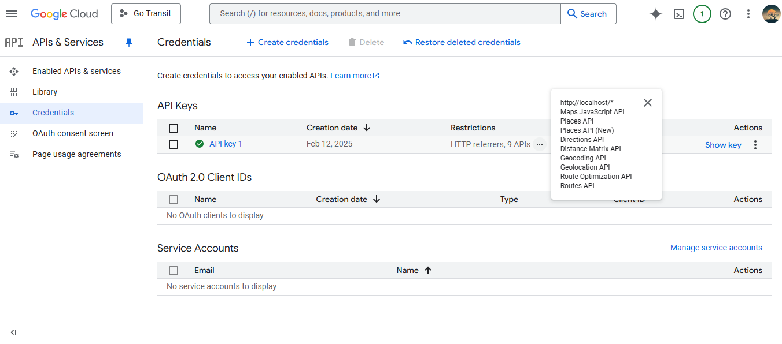

Figure 6.2.8 Google Maps API & Credential
VII. CONCLUSION
The Bus Tracker with ETA system provides a reliable and efficient solution for real-time bus tracking and estimated arrival time predictions. By integrating GPS tracking, Firebase Realtime Database, and Google Maps API, the system ensures accurate and up-to-date information for commuters. The modular approach allows for scalability, while Agile methodology ensures continuous improvements based on user feedback. Through rigorous testing, the system guarantees high accuracy in tracking and ETA calculations, improving the commuting experience by reducing uncertainty and wait times.

VIII. FUTURE ENHANCEMENTS
- AI-Based ETA Prediction: Implementing machine learning models to improve ETA accuracy by analyzing historical traffic patterns and real-time road conditions.
- Multimodal Transportation Integration: Expanding the system to include other public transportation modes, such as trains and metro services, for a seamless travel experience.
- Mobile App Development: Creating a dedicated mobile application to enhance accessibility and user experience with features like push notifications for bus arrivals and route changes.
- Voice Assistant Integration: Adding voice-enabled features to assist visually impaired users in navigating the system effortlessly.
- Offline Mode Support: Enabling offline access to previously searched routes and estimated arrival times for users with limited internet connectivity.
- Advanced Analytics Dashboard: Introducing a dashboard for transit authorities to monitor fleet efficiency, passenger trends, and route optimization.
- Crowdsourced Data Integration: Allowing users to report delays, congestion, or route changes to enhance real-time data accuracy.

IX.BIBLIOGRAPHY

9.1 REFERENCE:

9.1.1 BOOKS
- Bin Ran, David E. Boyce – Dynamic Urban Transportation Network Models: Theory and Implications for Intelligent Vehicle-Highway Systems, Springer, 1996.
- Jean-Paul Rodrigue – The Geography of Transport Systems, Routledge, 2020.
- Nigel H. M. Wilson, Agostino Nuzzolo – Schedule-Based Dynamic Transit Modeling: Theory and Applications, Springer, 2016.
- Mashrur Chowdhury, Adel Sadek, Pushkin Kachroo – Intelligent Transportation Systems: Smart and Green Infrastructure Design, CRC Press, 2017.
- Xiao-Yun Lu, Steven E. Shladover – Connected and Automated Vehicles: Smart Mobility and Transportation, Springer, 2021.

9.1.2 JOURNAL ARTICLES
- Zhang, J., Shen, L., & Li, H. (2020). "Machine Learning-Based Traffic Flow Prediction in Intelligent Transportation Systems." IEEE Transactions on Intelligent Transportation Systems
- Ma, X., & Liu, C. (2019). "Real-Time Bus Arrival Prediction Using IoT and Big Data Analytics." Transportation Research Part C: Emerging Technologies.
- Wang, H., & Chen, X. (2021). "Autonomous Vehicles and Urban Mobility: A Review on Smart Transportation." Journal of Transport Geography.
- Gkiotsalitis, K., & Cats, O. (2020). "Public Transport Planning Adapting to the COVID-19 Pandemic." Transportation Research Part A: Policy and Practice.
- Zhao, J., & Zhang, Y. (2022). "Integrating AI and IoT for Smart Traffic Management." IEEE Internet of Things Journal.

