CSS
CSS Position
The position property controls how elements are placed on a webpage.
The position property in CSS is used to control where an element appears on a webpage.
It helps move elements:
- up
- down
- left
- right
without changing other content too much.
Problem | Solution
Keep navbar always visible | fixed
Place text on image | absolute
Move element slightly | relative
Sticky menu on scroll | Sticky
Exact element placement | Absolute

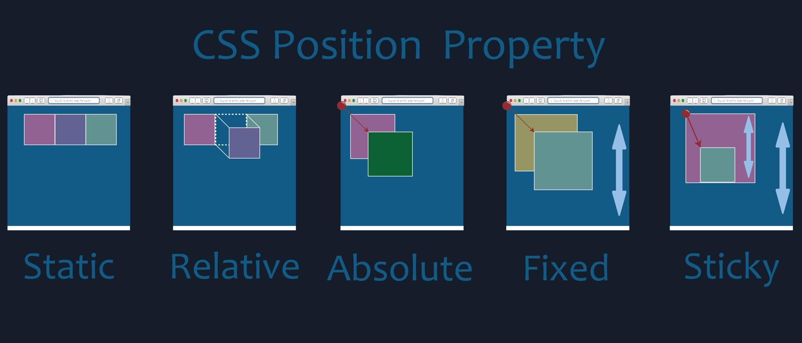
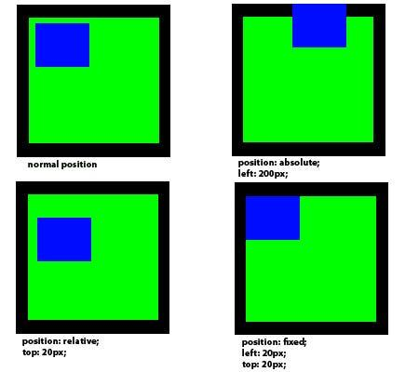
Types of Position
1. Static (Default)
.box{
position:static;
}

2. Relative
Moves relative to its normal position.
.box{
position:relative;
left:50px;
top:20px;
}

3. Absolute
Moves relative to parent element.
.parent{
position:relative;
}
.child{
position:absolute;
top:20px;
right:20px;
}

4. Fixed
Stays fixed on screen.
.box{
position:fixed;
bottom:0;
right:0;
}

5. Sticky
Sticks while scrolling.
.box{
position:sticky;
top:0;
}

CSS Display
The display property controls how HTML elements appear on a webpage.
It decides:
- whether an element starts on a new line
- how much width it takes
- whether elements stay side-by-side
- whether an element is visible

Controls how elements appear.
Block
Takes full width.
div{
display:block;
}

Inline
Takes only needed width.
span{
display:inline;
}

Inline-Block
Inline but allows width/height.
.box{
display:inline-block;
width:100px;
}

None
Hides element.
.box{
display:none;
}

CSS Float
Used to place elements left or right.
Float Left
img{
float:left;
}

Float Right
img{
float:right;
}

Clear Float
.clear{
clear:both;
}

CSS Overflow
Controls content overflow.
Hidden
.box{
overflow:hidden;
}

Scroll
.box{
overflow:scroll;
}

Auto
.box{
overflow:auto;
}

