**PROJECT INNOVATION**

Waste Management System

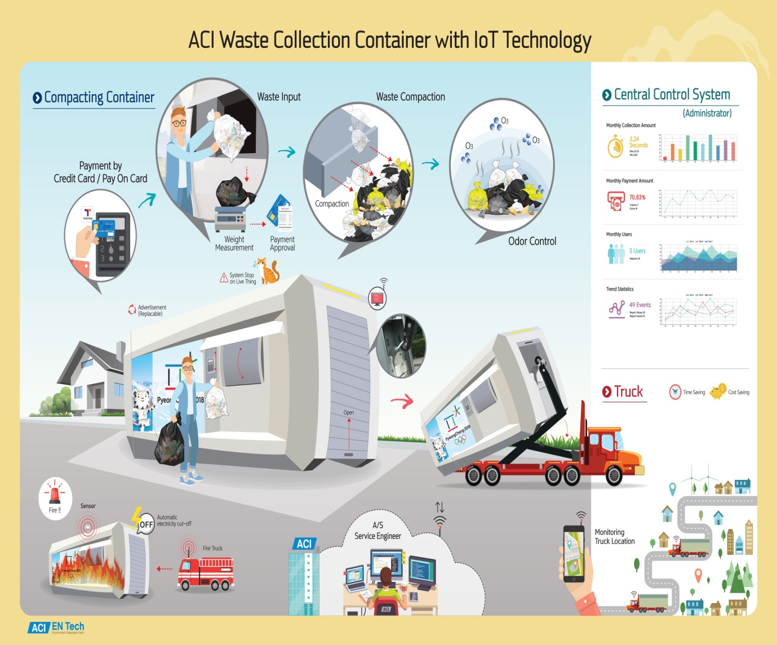

TEAM DETAILS

|  |  |
| --- | --- |
| Mentor | Mrs.M.Maheswari |
| Leader | R.Abinaya |
| Members | K.Aruna  A.James Soosanna  J.Kaviya  K.Keerthana |
| Project Innovation | The Internet of Things (IoT) is a concept in which surrounding objects are connected through wired and wireless networks without user intervention. In the field of IoT, the objects communicate and exchange information to provide advanced intelligent services for users.  This project deals with the problem of waste management in smart cities, where the garbage collection system is not optimized. This project enables the organizations to meet their needs of smart garbage management systems. This system allows the user to know the fill level of each garbage bin in a locality or city at all times, to give a cost-effective and time-saving route to the truck drivers. |

ABSTRACT

The paper is based on the concept of Automation used in waste management system under the domain of Cleanliness and Hygiene. Dumping garbage onto the streets and in public areas is a common synopsis found in all developing countries and this mainly end up affecting the environment and creating several unhygienic conditions. In order to deal with these problems Smart netbin is an ideology put forward which is a combination of hardware and software technologies i.e. connecting Wi-Fi system to the normal dustbin in order to provide free internet facilities to the user for a particular period of time. The technology awards the user for keeping the surrounding clean and thus work hand in hand for the proper waste management in a locality. Smart netbin uses multiple technologies firstly the technology for measuring the amount of trash dumped secondly the movement of the waste and lastly sending necessary signals and connecting the user to the Wi-Fi system. The proposed system will function on client server model, a cause that will assure clean environment, good health, and pollution free society.

COMPONENTS REQUIRED

* Arduino UNO
* NODEMCU
* Ultrasonic Sensor
* Servo Motor
* Arduino IDE
* Blynk App

DESCRIPTION OF COMPONENTS

ARDUINO UNO

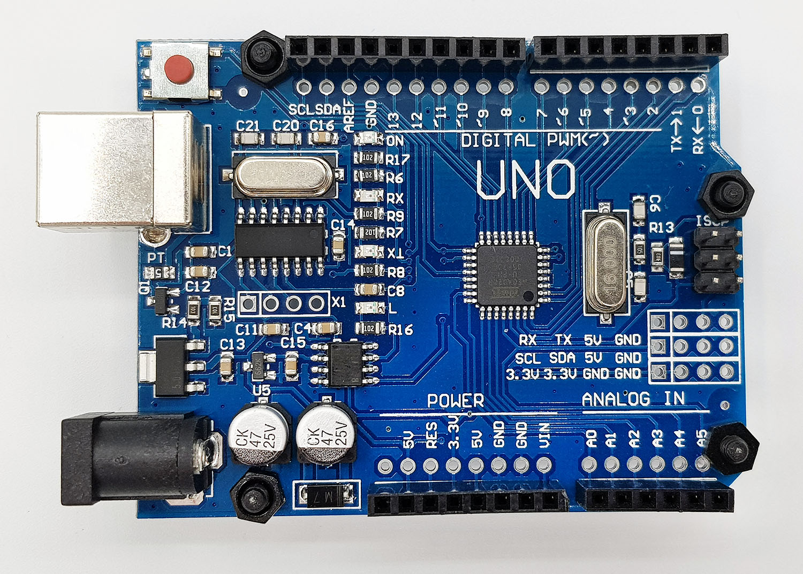

* The Arduino UNO is a microcontroller board which has fourteen digital input/output pins, six analog inputs, USB connection, power jack, 16MHz quartz crystal, ICSP header, and a reset button.
* The components such as Servo Motor and Ultrasonic Sensor are connected to this board and the first part code is dumped into this board. After the dumping of the code, the sensors start working according to the code written.
* When the sensors do not work as expected then the reset button should be pressed so that the code and the microcontroller restart and the sensors start working.
* This UNO board and 1.0 version of Arduino IDE are the reference versions of Arduino. UNO means one in Italian which denotes the version of the device.

NODE MCU

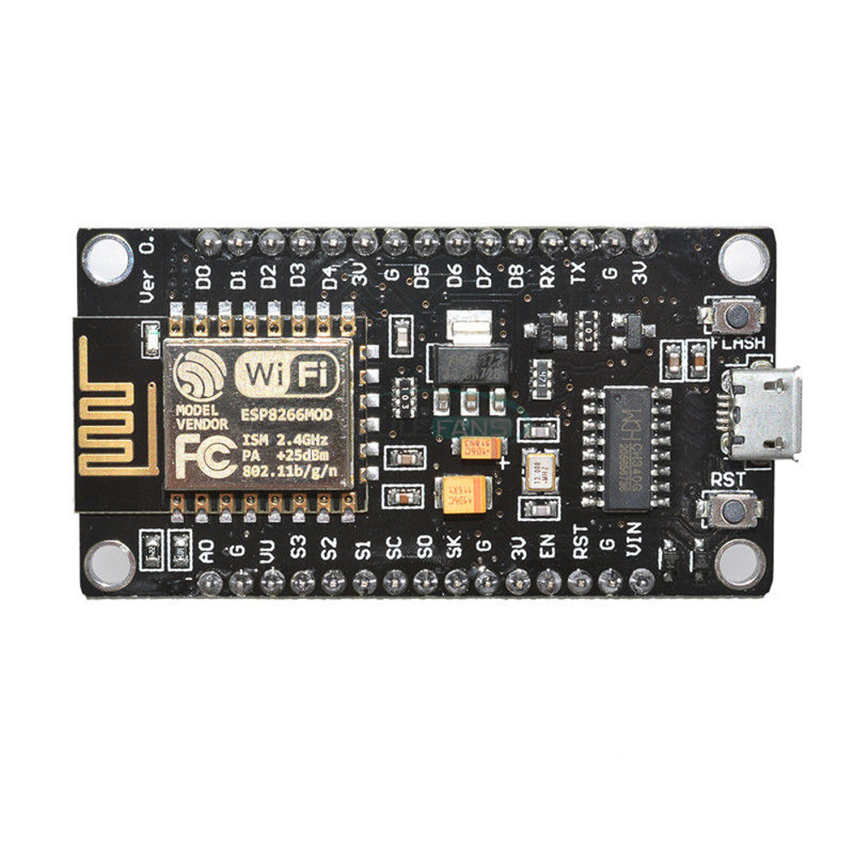

* NodeMCU is an open source IoT platform. This is used for making the things work using Wi-Fi.
* This board includes firmware which runs on ESP8266 Wi-Fi SoC Express Systems and the hardware is based on ESP-12 module.
* The second ultrasonic sensor is connected to this board and the second part code is dumped into this board.
* Before dumping the code, in the Arduino IDE the correct board should be selected. This uses many open source projects such as lua-cjson and SPIFFS.

ULTRA SONIC SENSOR 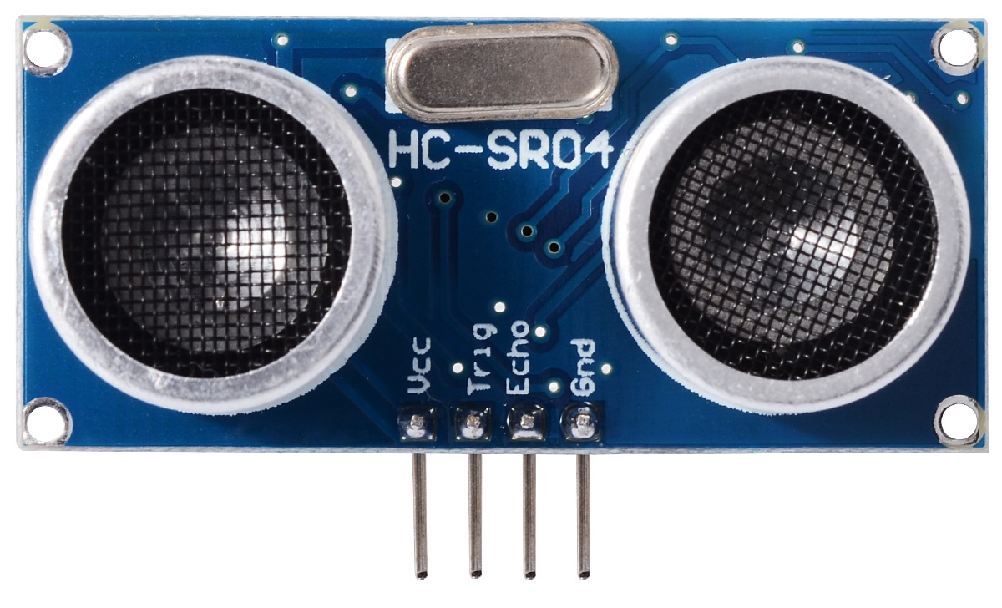

* Ultrasonic Sensor is an instrument which measures the distance to the waste using ultrasonic sound waves.
* It has a transducer that helps to send and receive ultrasonic pulses based on the object’s proximity. It detects the objects and the waste materials.
* There are mainly two essential elements which are the transmitter and receiver. Using the piezoelectric crystals, the transmitter generates sound, and from there it travels to the target and gets back to the receiver component.
* **Ultrasonic sensor working principle** is either similar to sonar or radar which evaluates the target/object attributes by understanding the received echoes from sound/radio waves correspondingly.
* These sensors produce high-frequency sound waves and analyze the echo which is received from the sensor.
* The sensors measure the time interval between transmitted and received echoes so that the distance to the target is known.

SERVO MOTOR

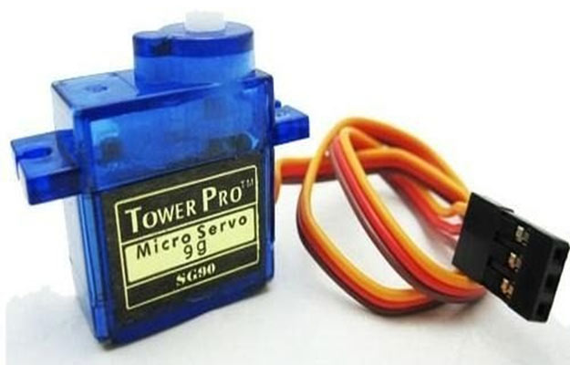

* Servo Motor helps in opening the lid of the dustbin.
* The Arduino is programmed in such a way that after detecting the waste using ultrasonic sensor the lid should open automatically and this is done using this servo motor.
* A Motor: This can be either a [DC motor](https://www.electrical4u.com/dc-motor-or-direct-current-motor/) or an AC motor depending on the power source and the application requirements. The motor provides the mechanical power to rotate or move the output shaft.
* A Sensor: This can be either a [potentiometer](https://www.electrical4u.com/potentiometer/), an encoder, a resolver, or another device that measures the position, speed, or torque of the output shaft and sends feedback signals to the controller.
* A Controller:  This can be either an analog or a digital circuit that compares the feedback signals from the sensor with the desired setpoint signals from an external source (such
* computer or a joystick) and generates control signals to adjust the motor’s [voltage](https://www.electrical4u.com/voltage-or-electric-potential-difference/) or [current](https://www.electrical4u.com/electric-current-and-theory-of-electricity/) accordingly.

ARDUINO IDE

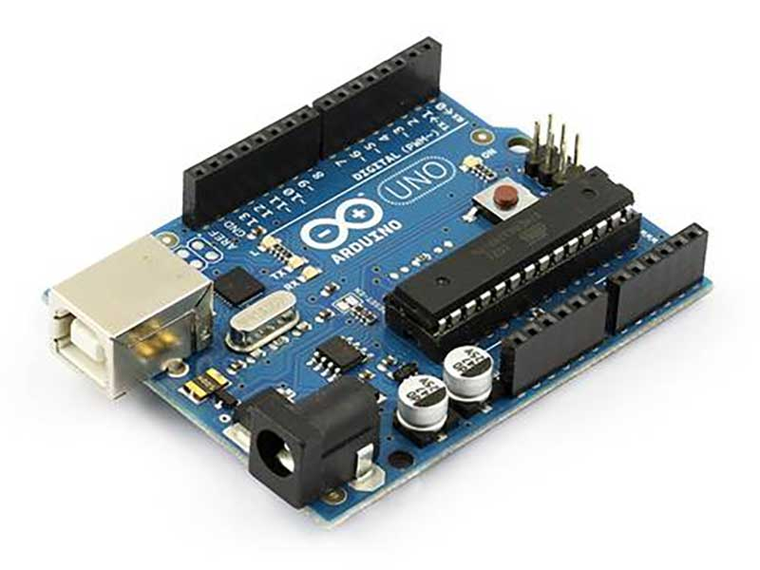

* The Arduino Integrated Development Environment is a cross platform application that is used to upload programs into Arduino Compatible boards.
* The Arduino IDE supports C and C++ using special rules of code structuring. The Arduino IDE employs the program AVRDUDE to convert the executable code into a text file in hexadecimal encoding that is loaded into the Arduino Board by a loader program in the board’s firmware.
* This IDE when selected opens a default sketch file where the part of the code is divided into two parts the void setup ( ) and the void loop ( ).
* Above these two statements the header files and the variable declarations should be done so that the actual code logic and be mentioned in those methods.
* The setup method has the different variables that are needed to perform the specific operation and the loop method consists the actual logic code.
* After the code has been written it should be verified and should be compatible to the board that the code needs to be uploaded.

BLYNK APP



* Blynk is a Platform with IOS and Android apps to control Arduino, Raspberry Pi and the likes over the Internet.
* It’s a digital dashboard where you can build a graphic interface for your project by simply dragging and dropping widgets.

PROTOCOLS

The prototype is constructed as follows:

* Taking a plastic container or a dustbin, placing an ultrasonic sensor at the front part of the dustbin. The lid of the dustbin is taken as a cardboard and a servo motor is placed on the lid. Another ultrasonic sensor is placed inside the dustbin.
* The code of this project is divided into two parts. The first part code indicates the working of the dustbin i.e. mainly opening the lid of the dustbin.
* The second part code indicates the notification part which is received on the mobile using the Blynk app.
* The first part is constructed as follows: The ultrasonic sensor placed at the front part has four pins named Vcc, GND, ECHO and TRIG.
* The pin TRIG, pin ECHO is connected to digital pin numbers two and three on the Arduino Board. The servo motor has three pins named Vcc, GND, and servo pin. The servo pin of Servo motor is connected to digital pin number nine on the Arduino board.
* The Vcc of ultrasonic sensor is connected to 5V of Arduino board and the Vcc of servo motor is connected to 3.3V of Arduino board. The GND pins are connected to ground on the Arduino board.
* After the connections are made, the Arduino is connected to the system and using the Arduino IDE the code is dumped inside the Arduino. This ends the connection and code dump for the first part.
* The second part is constructed as follows: The ultrasonic sensor which is placed inside the dustbin also has the same four pins named Vcc, GND, ECHO and TRIG.
* In the Arduino IDE the board has to be changed from Arduino UNO to NodeMCU, if the board is not available in the list then we need to install the board from the Boards Manager.
* In this part the TRIG and ECHO pins of ultrasonic sensor is connected to digital pins D5 and D6 of NodeMCU. The Vcc is connected to Vin of NodeMCU and GND to ground of NodeMCU.
* This is the connection that is required and now the code should be dumped into NodeMCU. This ends the connection and code dump for the second part.

FEATURES OF WASTE MANAGEMENT SYSTEM

The key research objectives are as follows:

• The proposed system would be able to automate the solid waste monitoring process and management of the overall collection process using IOT (Internet of Things).

• The Proposed system consists of main subsystems namely Smart Trash System(STS) and Smart Monitoring and Controlling Hut(SMCH).

• In the proposed system, whenever the waste bin gets filled this is acknowledged by placing the circuit at the waste bin, which transmits it to the receiver at the desired place in the area or spot.

• In the proposed system, the received signal indicates the waste bin status at the monitoring and controlling system.

**SUMMARY**

* The smart dustbin uses an Ultrasonic sensor HC-SR04 to detect objects in front.
* It then sends the signals to Arduino Uno.
* The Arduino understands the signal and sends a signal to the Servomotor which opens the flap on top of the dustbin.