PROJECT OVERVIEW AND DESIGN

**SMART WASTE MANAGEMENT**

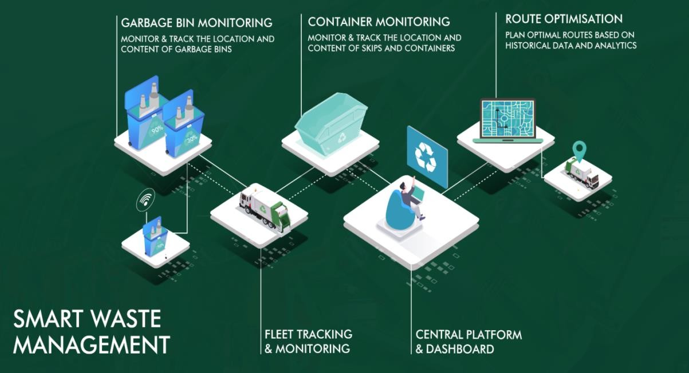

Waste collection is an essential [city service](https://www.iotforall.com/what-makes-smart-city-2019/), yet existing waste management systems are resource-intensive, inefficient, and outdated. The Internet of Things (IoT) has the potential to greatly optimize collection services and reduce operational costs for cities.

All humans produce municipal solid waste, commonly known as trash or garbage, on a daily basis, yet essential waste collection systems in cities are often taken for granted by residents until a garbage bin overflows. Due to recent population growth and urbanization, waste production in cities has increased, and municipal waste collection operations need to adapt to be able [to ensure](https://www.iotforall.com/smart-city-approaches-real-world/) [clean cities.](https://www.iotforall.com/smart-city-approaches-real-world/)

**TEAM DETAILS**

|  |  |
| --- | --- |
| Mentor: | Mrs.M.Maheswari |
| Leader: | Abinaya.R |
| Members: | Aruna.K  James Soosanna.A Kaviya.J  Keerthana.K |
| Problem Description: | Efficient way of waste disposal and collection of disposed garbage is essential for a sustainable and clean India. This paper presents smart waste management using IoT based waste bin for collection and monitoring the level of waste inside bin. The system is implemented using two ultrasonic sensors which is being controlled by Node MCU. |
| Phase: | Phase 1:Problem definition and Design thinking. |

**PROJECT DETAILS ON PROBLEMS AND SOLUTIONS**

**OBJECTIVE**

Smart waste management solutions use sensors placed in waste receptacles to measure fill levels and to notify city collection services when bins are ready to be emptied.

Over time, historical data collected by sensors can be used to identify fill patterns, optimize driver routes and schedules, and reduce operational costs.

The cost of these sensors is steadily decreasing, making IoT waste bins more feasible to implement and more attractive to city leaders.

**INTRODUCTION**

Dustbin is the storage container used for disposing waste by each and every person in the world. The main thing they look in their surroundings for disposing waste is the Dustbin.

Smart Dustbin is just a normal bin where everyone can disposewaste but integration of some hardware components is done for more efficient use of it. Smart Dustbin is integrated with some hardware components such as Arduino, NODEMCU, Servo Motor, Ultrasonic sensors.

These components help in opening the lid, on detection of human hand and waste and also sending the notification in the form of LED. The code required to perform the above- mentioned operation is dumped in Arduino and NODEMCU.

**ABSTRACT**

Every person in this world throws waste in the form of plastics, wet waste, dry waste and etc. Also, every person looks for a place or a plastic container to dispose that waste, that plastic container is the Dustbin which they look for.

Dustbin is a plastic container where everyone can dispose their waste. Dustbin is used as a storage place to dispose waste, but we cannot estimate the exact amount of waste disposed by a society, and the dustbin cannot take more waste as the space should be available in it to take more. We need to know the level of waste in the dustbin and based on that we can intimate people to use the dustbin or not. In this Smart Dustbin project, we have designed a prototype where the lid of the dustbin is opened, on detection of human hand and waste, and the level of waste available inside the dustbin is sent as notification in the form of LED. The main components we used in making this prototype are Arduino, NODEMCU, Servo Motor and Ultrasonic Sensors. The software component is the application named as Blynk which is used to get notification. This dustbin can be a start to Smart Waste Management System where the officials can clean or empty the dustbin which depends on the notification received by them and not waiting for a call from a person of a society who informs the garbage trucks to come and take the waste from them.

**PROJECT DETAILS**

|  |  |
| --- | --- |
| Proposed Method: | IoT-Based Smart Waste Management Systems |
| Hardware: | The hardware components used in this method are Arduino UNO, NODEMCU, Ultrasonic sensor, Servo Motor.  Arduino UNO: It is a microcontroller board which has fourteen digital input/output pins, six analog inputs, USB connection, power jack, 16MHz quartz crystal, ICSP header,  and a reset button.  NodeMCU is an open source IoT platform. This is used for making the things work using Wi-Fi. This board includes firmware which runs on ESP8266 Wi-Fi SoC Express Systems  and the hardware is based on ESP-12 module.  Ultrasonic Sensor is an instrument which measures the distance to the waste using ultrasonic sound waves. It has a transducer that helps to send and receive ultrasonic pulses waste materials.  Servo Motor helps in opening the lid of the dustbin. The  Arduino is programmed in such a way that after detecting the |

|  |  |
| --- | --- |
|  | waste using ultrasonic sensor the lid should open automatically and this is done using this servo motor |
| Software: | The software requirements for this project are Arduino IDE and Blynk app. Arduino IDE: The Arduino Integrated Development Environment is a cross platform application that is used to upload programs into Arduino Compatible boards Blynk App: Blynk is a Platform with IOS and Android apps to control Arduino, Raspberry Pi and the likes over the Internet. for your project by simply dragging and dropping widgets. |

**BLOCK DIAGRAM**

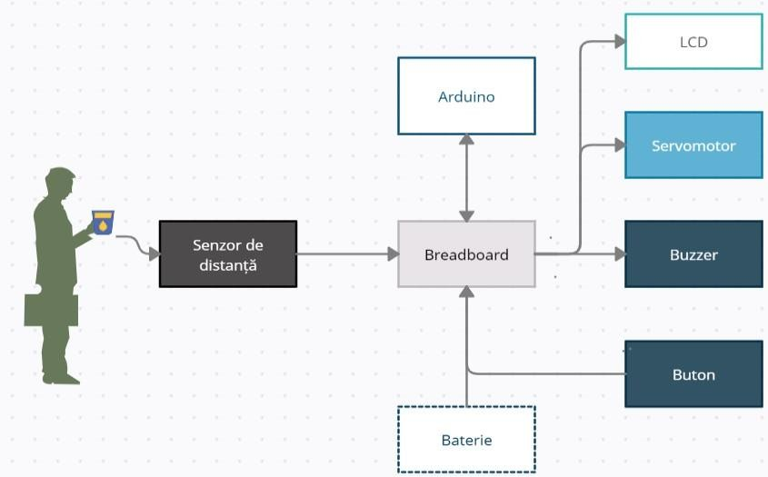

**CONCLUSION**

IOT based Dustbins help the people to manage the waste easily and help them reduce the work of calling or waiting for the specific person to make the area clean and makes a diseases and the people will be fit and are not prone to diseases caused by these waste materials. The mission Swachh Bharat can also be implemented easily. This system assures the cleaning of dustbins soon when the garbage level reaches its maximum. It will take power supply with the help of Battery. If the dustbin is not cleaned in specific time, then the record is sent to the Sweeper or higher authority who can take appropriate action against the concerned contractor. It

ultimately helps in keeping the surrounding clean and the waste management can be much easier.