**SMART WASTE MANAGEMENT**

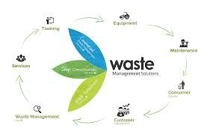

**TEAM DETAILS**

|  |  |
| --- | --- |
| **Mentor:** | Mrs.M.Maheswari |
| **Leader:** | R.Abinaya |
| **Members:** | K.Aruna  A.James Soosanna  J.Kaviya  K.Keerthana |
| **Problem Description:** | In this project we are going to use different sensors to manage the waste.All the datas from the sensors will be sent to blynk app using iot technology. |
| **Phase:** | Phase 3:Design the innovation to solve the problem. |

**SIMULATION STEPS**

**STEP1:**In this step add Arduino UNO and Ultrasonic sensor

First make the following connections:

TX pin of ESP → TX pin of Arduino

RX pin of ESP → RX pin of Arduino

Vcc pin of ESP → 3.3V pin of Arduino

Enable pin of ESP → 3.3V pin of Arduino

GND pin of ESP → GND pin of Arduino

Reset pin of Arduino → GND pin of Arduino

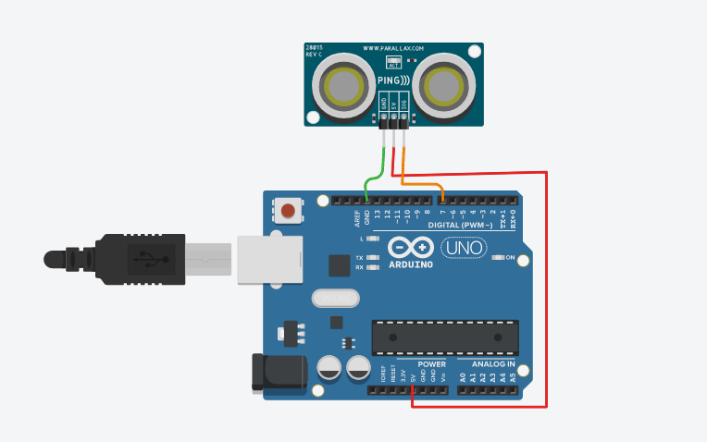

Step 2:Now add ESP32 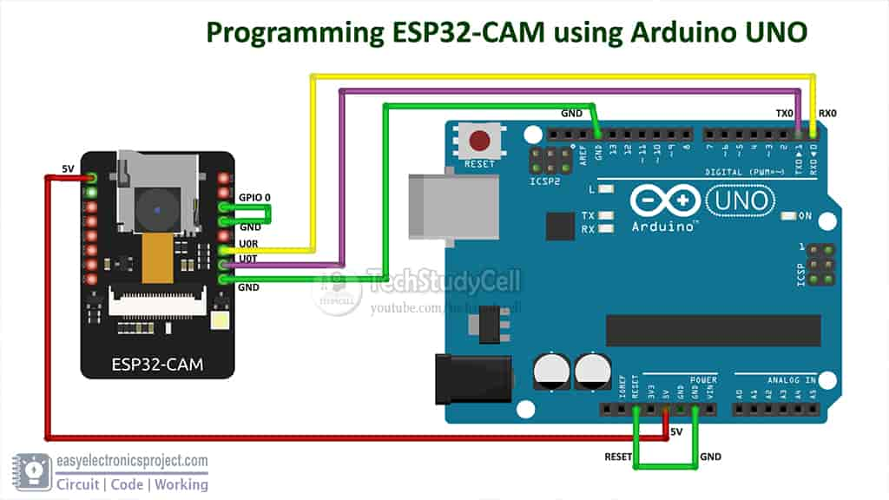

**Step 3:** VCC and EN pin of ESP → 3.3V pin of Arduino

• GND pin of ESP → GND pin of Arduino

• TX pin of ESP → RX pin of Arduino

• RX pin of ESP → TX pin of Arduino

• VCC pin of Ultrasonic Sensor → 5V pin of Arduino

• GND pin of Ultrasonic Sensor → GND pin of Arduino

• Trigger pin of Ultrasonic Sensor → D9 pin of Arduino

• Echo pin of Ultrasonic Sensor → D10 pin of Arduino

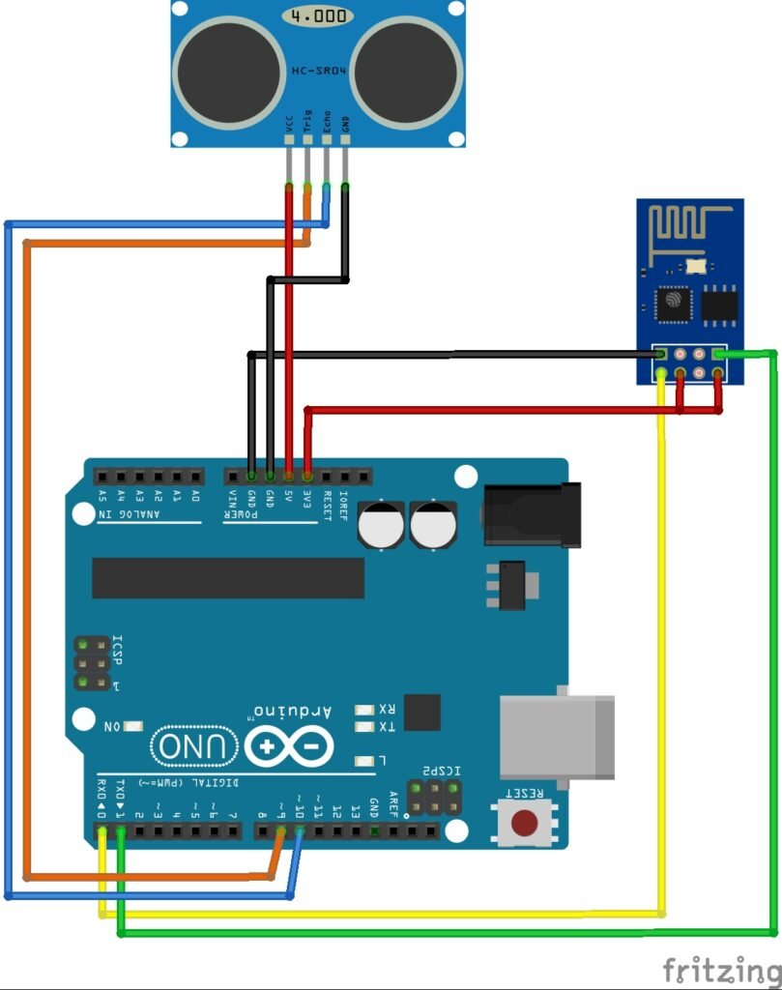

**CODING FOR THE ABOVE SIMULATION:**

#define BLYNK_PRINT Serial

#include <ESP8266WiFi.h>

#include <BlynkSimpleEsp8266.h>

const int trigger = 9;

const int echo = 10;

float duration;

int distance, percentage;

const int upper_limit = 5;

const int bottom_limit = 80;

// You should get Auth Token in the Blynk App.

// Go to the Project Settings (nut icon).

char auth[] = "YourAuthToken";

// Your WiFi credentials.

// Set password to "" for open networks.

char ssid[] = "Your SSID ";

char pass[] = "Your PASSWORD";

void setup()

{

Serial.begin(9600);

pinMode(trigger, OUTPUT);

pinMode(echo, INPUT);

digitalWrite(trigger, LOW);

Blynk.begin(auth, ssid, pass);

}

void sensor()

{

digitalWrite(trigger, HIGH);

delayMicroseconds(10);

digitalWrite(trigger, LOW);

duration = pulseIn(echo, HIGH);

distance = duration * 0.017;

percentage= ((bottom_limit - distance)/(bottom_limit - upper_limit))*100;

//Actually percentage = (((bottom_limit - upper_limit)- (distance - upper_limit))/(bottom_limit - upper_limit)))*100;

}

BLYNK_READ(V5){

Blynk.virtualWrite(V5, percentage);

}

void loop()

{

sensor();

Blynk.run();

BLYNK_READ(V5);

}