REAL-WORLD RETAIL DATA ANALYSIS USING THE SUPERSTORE DATASET

INTERNSHIP PROJECT REPORT

SUBMITTED BY:
Kaviya M
COURSE:
M.Sc. Mathematics
ORGANIZATION:
Thiranex
PROJECT TITLE:
Real-World RETAIL DATA ANALYSIS USING THE SUPERSTORE DATASET
TOOLS USED:
- Python
- Pandas
- NumPy
- Matplotlib
- Scikit-learn
SUBMISSION DATE:
28 June 2026

INTRODUCTION
Retail businesses generate a large amount of sales data every day. Analyzing this data helps organizations understand customer purchasing behavior, identify profitable products, and make informed business decisions.
In this project, the Superstore Retail dataset was analyzed using Python. The dataset was cleaned, explored, and visualized to identify important sales and profit trends. A Linear Regression model was also developed to demonstrate a basic machine learning approach for predicting sales.
This project demonstrates the practical application of data analysis and machine learning techniques using real-world retail data.
OBJECTIVE
The main objectives of this project are:
- To analyze the Superstore Retail dataset using Python.
- To clean the dataset by checking for missing values and duplicate records.
- To perform Exploratory Data Analysis (EDA) to understand sales and profit trends.
- To create meaningful visualizations for better business insights.
- To build a Linear Regression model for sales prediction.
- To evaluate the performance of the machine learning model using MAE, MSE, and R² Score.
DATASET DESCRIPTION
The dataset used in this project is the Superstore Retail Dataset, which contains information about customer orders, products, sales, discounts, profits, and shipping details.
The dataset includes the following important columns:
- Row ID
- Order ID
- Order Date
- Ship Date
- Ship Mode
- Customer ID
- Customer Name
- Segment
- Country
- City
- State
- Postal Code
- Region
- Product ID
- Category
- Sub-Category
- Product Name
- Sales
- Quantity
- Discount
- Profit
This dataset was used to analyze sales performance, identify profit trends, and build a simple machine learning model for sales prediction.
DATA CLEANING
Data cleaning is an important step in data analysis to ensure the dataset is accurate and suitable for analysis.
The following data cleaning steps were performed:
- Imported the Superstore Retail dataset into Python using Pandas.
- Checked for missing values using the "isnull().sum()" function.
- No missing values were found in the dataset.
- Checked for duplicate records using the "duplicated().sum()" function.
- One duplicate record was found and removed using the "drop_duplicates()" function.
- Verified the data types of all columns.
- The cleaned dataset was then used for further analysis and visualization.
EXPLORATORY DATA ANALYSIS (EDA)
Exploratory Data Analysis (EDA) was performed to understand the characteristics of the Superstore Retail dataset.
The following analyses were carried out:
- Examined the dataset structure, including rows, columns, and data types.
- Calculated summary statistics for numerical columns.
- Analyzed total sales by product category.
- Compared sales across different regions.
- Analyzed profit by category.
- Visualized monthly sales trends to identify changes over time.
- Identified the top 10 products based on total sales.
The visualizations provided useful insights into sales performance, product categories, and regional trends, helping to better understand the retail business data.
VISUALIZATIONS
Several visualizations were created to better understand the Superstore Retail dataset.
1. SALES BY CATEGORY
A bar chart was created to compare total sales across different product categories. It showed which category generated the highest sales.
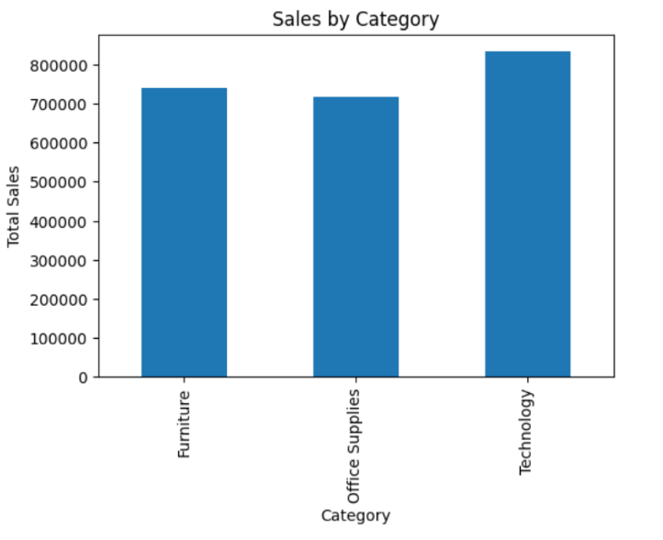
SALES BY CATEGORY – INTERPRETATION
- The bar cha3rt illustrates the total sales generated across three product categories: Furniture, Office Supplies, and Technology.
- The analysis shows that Technology achieved the highest total sales, with approximately 836,000. This indicates that technology products are the most popular among customers and contribute the largest share of the company's revenue.
- The Furniture category recorded the second-highest sales, with approximately 742,000. This suggests that furniture products have strong customer demand and make a significant contribution to overall sales.
- The Office Supplies category generated total sales of approximately 719,000, making it the lowest-selling category among the three. However, the difference in sales between Furniture and Office Supplies is relatively small, indicating that both categories maintain consistent sales performance.
- Overall, the analysis reveals that all three categories contribute substantially to total sales, with Technology leading in revenue generation. Although Furniture has higher sales than Office Supplies, its profit is comparatively lower, suggesting that higher costs or lower profit margins may affect its overall profitability.
BUSINESS RECOMMENDATION:
- Continue promoting Technology products, as they generate the highest sales and profit.
- Maintain effective sales strategies for Furniture while reducing costs and improving profit margins.
- Strengthen marketing and product offerings for Office Supplies to increase sales and maintain steady growth.
2.PROFIT BY CATEGORY
A bar chart was created to analyze the total profit earned by each product category.
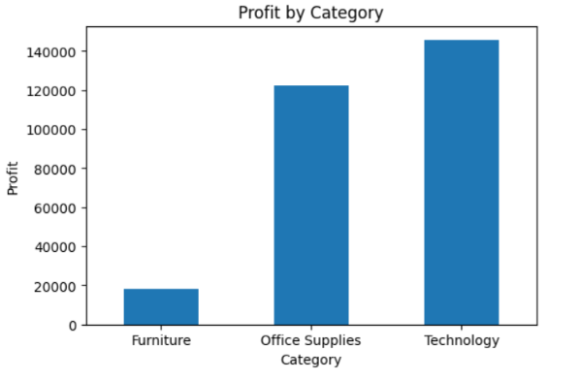
Profit by Category – Interpretation
- The bar chart presents the total profit generated by three product categories: Furniture, Office Supplies, and Technology.
- From the analysis, Technology is the highest-profit category, generating approximately 145,000 in profit. This indicates that technology products contribute the most to the organization's overall profitability and have strong market demand.
- The Office Supplies category ranks second, with a profit of approximately 122,000. This category also performs well and makes a significant contribution to the company's total profit, indicating stable and consistent sales performance.
- In contrast, Furniture records the lowest profit, at approximately 18,000. The substantial difference between Furniture and the other categories suggests that this category may be affected by lower profit margins, higher discounts, increased shipping costs, or lower customer demand.
- Overall, the analysis reveals that Technology and Office Supplies are the major contributors to the company's profit, while Furniture requires further investigation and strategic improvements to enhance its profitability.
Business Recommendation:
- Continue investing in the Technology category to maximize profits.
- Maintain strong performance in Office Supplies through effective inventory and sales strategies.
- Analyze the Furniture category by reviewing pricing, discounts, and operational costs to improve its profit contribution.
3. MONTHLY SALES TREND
A line chart was used to visualize monthly sales over time, making it easier to observe trends and seasonal changes.
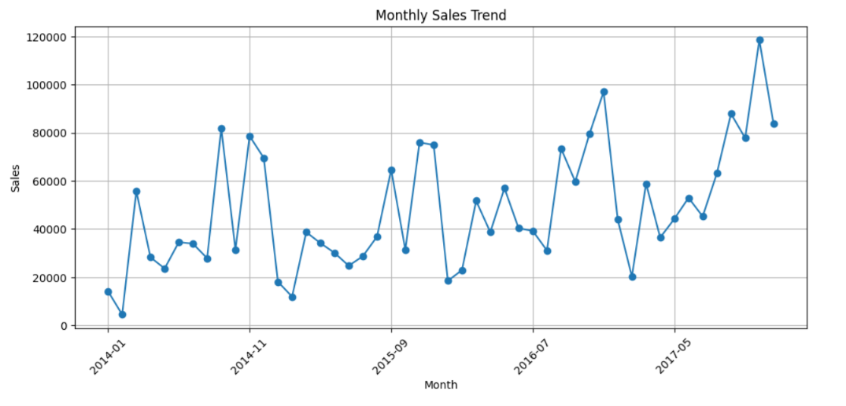
Monthly Sales Trend – Interpretation
- The line chart illustrates the monthly sales performance from January 2014 to December 2017. It shows fluctuations in sales over time, indicating periods of both growth and decline.
- The analysis reveals that sales were relatively low at the beginning of 2014 but gradually increased with several peaks throughout the study period.
- A noticeable upward trend is observed during 2016 and 2017, where monthly sales consistently remained higher than in previous years.
- The highest sales were recorded towards the end of 2017, reaching approximately 119,000, indicating a significant improvement in business performance.
- Although a few months experienced temporary declines, the overall sales trend remained positive. These fluctuations may be attributed to seasonal demand, promotional campaigns, customer purchasing behavior, or market conditions.
- Overall, the chart indicates that the company experienced steady business growth over the four-year period, with increasing monthly sales and stronger revenue generation in the later years.
Business Recommendation:
- Continue the sales and marketing strategies that contributed to the strong growth observed during 2017.
- Analyze the factors responsible for peak sales months and apply similar strategies in other months.
- Investigate the causes of lower sales periods and implement promotional campaigns or inventory planning to minimize seasonal declines.
- Use monthly sales trend analysis for accurate sales forecasting and strategic business planning.
4. Top 10 Products by Sales
A bar chart displayed the ten products with the highest total sales, highlighting the best-selling products
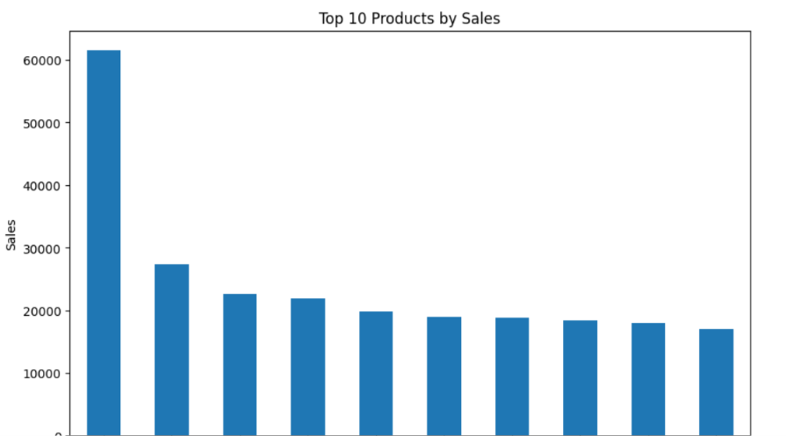
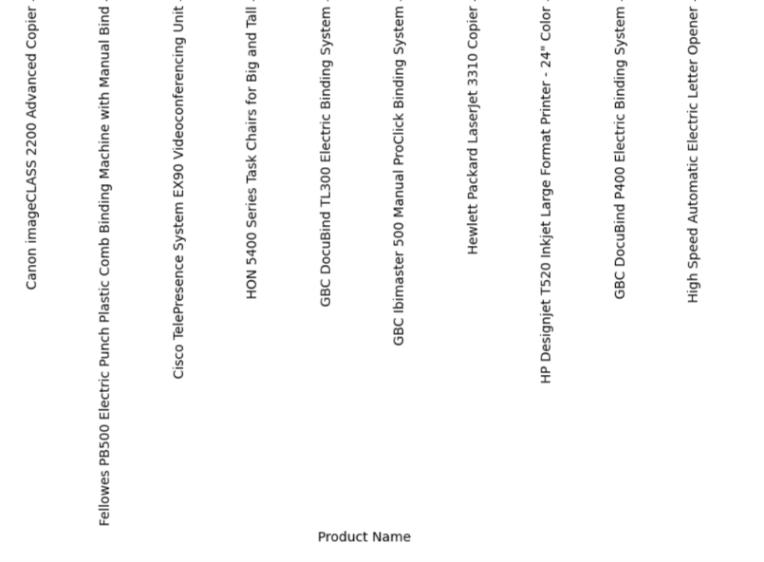
MACHINE LEARNING MODEL
A Linear Regression model was developed to predict sales using selected features from the dataset.
The following steps were performed:
- Selected Quantity, Discount, and Profit as input features.
- Selected Sales as the target variable.
- Split the dataset into training and testing sets.
- Trained the Linear Regression model using the training data.
- Predicted sales values for the test dataset.
- Evaluated the model using Mean Absolute Error (MAE), Mean Squared Error (MSE), and R² Score.
The model demonstrated the basic process of applying machine learning to retail data analysis.

RESULTS
The project successfully analyzed the Superstore Retail dataset and generated useful business insights.
Model Evaluation Results:
- Mean Absolute Error (MAE): 245.08
- Mean Squared Error (MSE): 680377.46
- R² Score: -0.152
The negative R² score indicates that the selected features (Quantity, Discount, and Profit) were not sufficient to accurately predict Sales. Using additional features such as Category, Region, and Customer Segment may improve the model's performance.
CONCLUSION
- This project successfully demonstrated the process of retail data analysis using the Superstore Retail dataset.
- The dataset was cleaned, explored, and visualized to identify important sales and profit trends.
- A Linear Regression model was also developed to demonstrate a basic machine learning workflow.
- The project highlights the importance of data analysis in understanding business performance and supports data-driven decision-making.
- Future improvements can be made by using additional features and more advanced machine learning algorithms to improve prediction accuracy.

