**TITANIC Dataset**

**Pair Plot:**

**Observations:**

* Which features separate survivors/non-survivors.
* Cluster patterns by survival status (especially Fare, Pclass, Age).
* Identify strongly overlapping or non-overlapping groups.

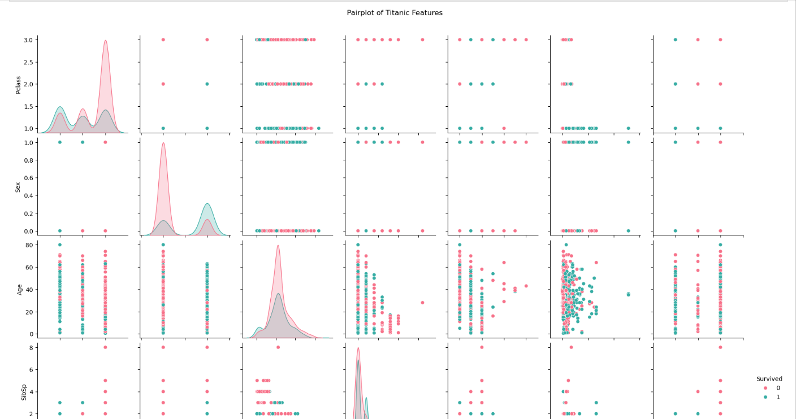

**Heatmap:**

**Observation:**

* Features with high positive/negative correlation.
* For example, Pclass might be negatively correlated with Fare, Survived.

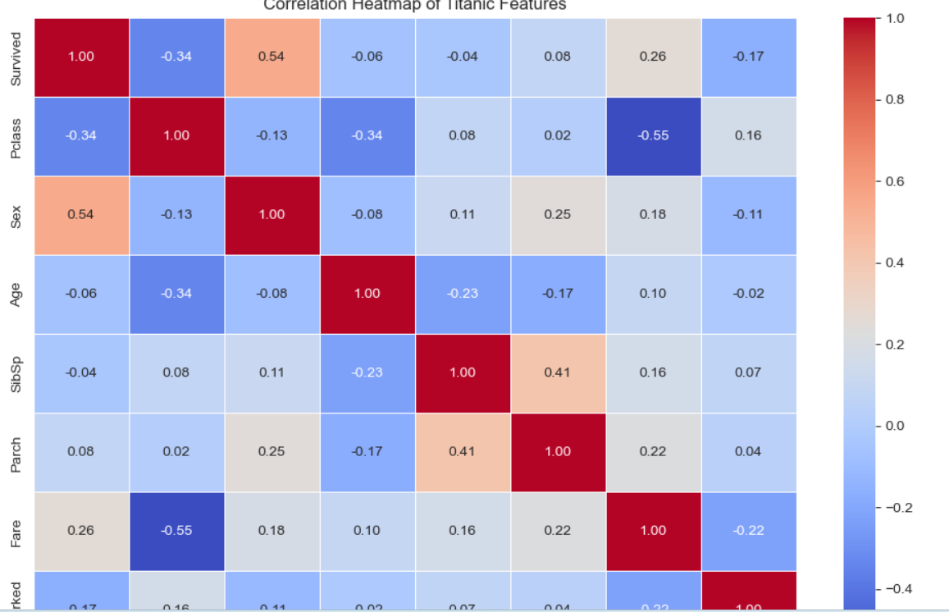

**Hist Plot:**

**Observations:**

* Check the skewness (Age, Fare).
* See frequency of different classes (Pclass, SibSp, etc.).

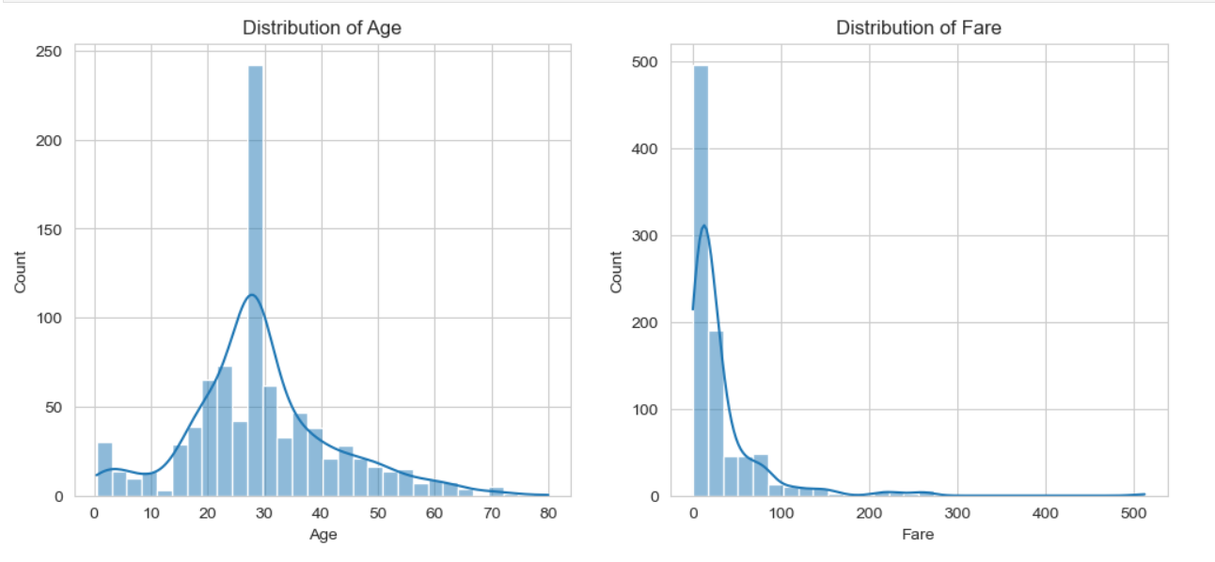

**Box Plot:**

**Observation:**

1.Fare has many extreme outliers (very expensive tickets).

2.Age shows some old-age outliers (80+).

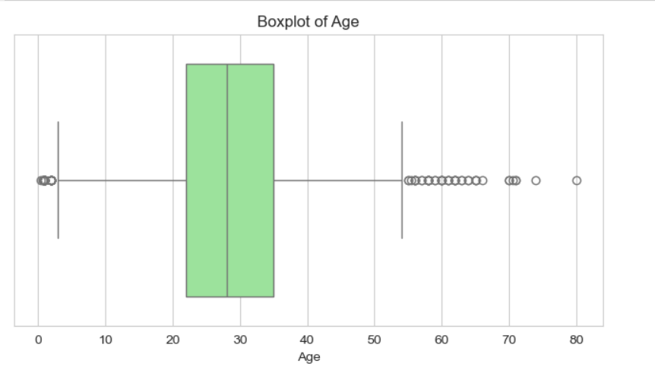

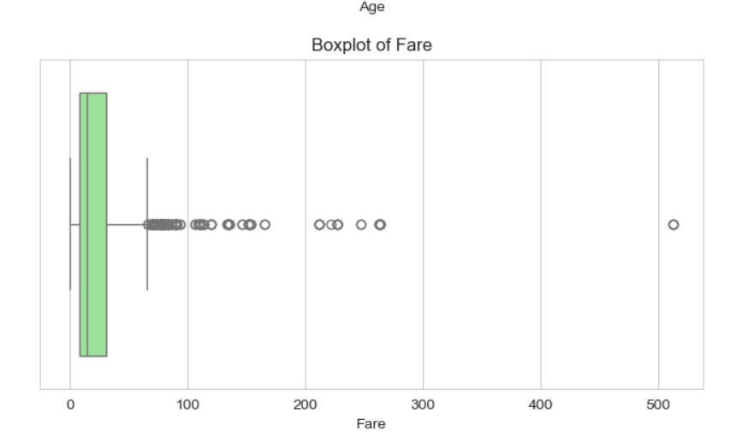

**Scatterplot:**

**Observation:**

**1:** Fare vs Age (Colored by Survival)

* + - Higher fares were often associated with survivors.
    - Survivors are more concentrated at younger ages too.

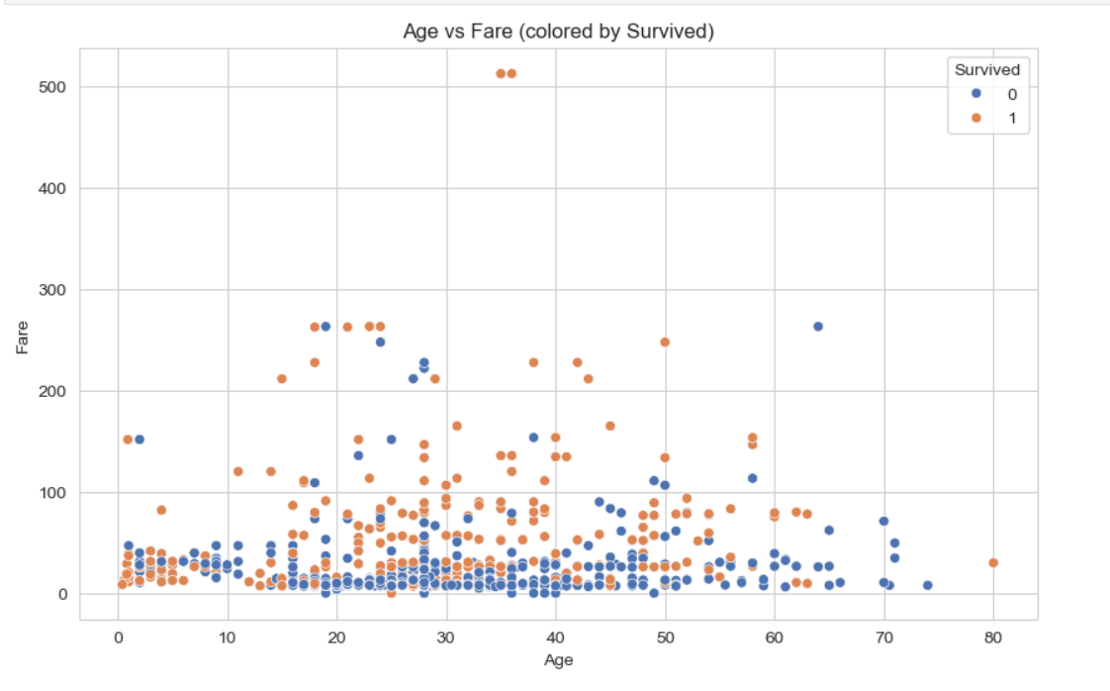

**2.** SibSp vs Parch (Family Size Influence)

**Observation:**

Travelers with moderate family size (1-2) had better survival chances.

