**KINGSTON ENGINEERING COLLEGE –5113**

DATA ANALYTICS WITH COGNOS

PRODUCT SALES ANALYSIS-PROJECT 5

**TEAM MEMBERS:**

S.PON LAVANYA-au511321205021

S. POORNIMA-au511321205022

J. KAVIYA-au511321205014

S. SRINIDHI-au511321205039

# INTRODUCTION:

In today's rapidly evolving business landscape, data-driven decision-making is the key to success. As we navigate the intricacies of the market, understanding our product sales performance becomes not only essential but transformative. This Product Sales Analysis Project aims to delve deep into the data, uncover insights, and empower our organization to make informed strategies.

In this project, we will comprehensively analyse the sales performance of our product(s) over a specified time period. This analysis will encompass various facets of our sales data, including but not limited to:

* **Revenue**: Examining the total revenue generated by our product(s) and assessing its growth or decline trends.
* **Sales Volume**: Investigating the quantity of units sold and identifying patterns in sales volume.
* **Profit Margins**: Assessing the profitability of our product(s) by examining profit margins.
* **Market Share**: Understanding our product's market share relative to competitors.
* **Customer Insights**: Gaining a deeper understanding of customer behaviour, preferences, and demographics.
* **Sales Channels**: Analysing the effectiveness of different sales channels and distribution methods.
* **Marketing Effectiveness**: Evaluating the impact of marketing campaigns and promotions on sales.
* **Inventory Management**: Optimizing inventory levels for cost-efficiency.

As we embark on this Product Sales Analysis Project, our goal is to equip our organization with the knowledge and insights necessary to thrive in a competitive marketplace. By examining our product sales data from multiple angles, we aim to make strategic decisions that will lead to increased revenue, improved customer satisfaction, and sustained growth.

# ABOUT DATASET:

Where did we get the dataset?

**Kaggle:**

**.** we got our ‘Product sales Analysis’ dataset from Kaggle.

[**https://www.kaggle.com**](https://www.kaggle.com/)

**.** Kaggle is a popular platform for sharing datasets and hosting data science competitions.

# DETAILS:

# A product sales analysis involves a detailed examination of various aspects related to the performance of a product or group of products in the market. To conduct a comprehensive product sales analysis, you'll need to gather, process, and analyse a wide range of data and information. Here are the key details and steps involved in conducting a product sales analysis:

Q1- Total unit sales of product 1  
 Q2- Total unit sales of product 2  
 Q3- Total unit sales of product 3  
 Q4- Total unit sales of product 4  
 S1- Total revenue from product 1  
 S2- Total revenue from product 2  
 S3- Total revenue from product 3  
 S4- Total revenue from product 4

The dataset contains the following example of details:

On 13-06-2010, product 1 had been brought by 5422 people and INR 17187.74 had been generated in revenue from product

REC corporate needs you to solve the following questions:

1) Is there any trend in the sales of all four products during certain months?  
2) Out of all four products which product has seen the highest sales in all the given years?  
3) The company has all its retail centres closed on the 31st of December every year. Mr: Hariharan the CEO would love to get an estimate on no: of units of each product that could be sold on 31st of Dec every year, if all their retail centers were kept open.  
4) The CEO is considering an idea to drop the production of any one of the products. He wants you to analyse this data and suggest whether his idea would result in a massive setback for the company.  
5) The CEO would also like to predict the sales and revenues for the year 2024. He wants you to give a yearly estimate with the best possible accuracy.

# LIBRARIES USED:

* Matplotlib- used for plotting graph
* NumPy-used for mathematical operations of array.
* Pandas-used for working with data visualization for cleaning, analysing and exploring.
* Sklearn-used to build machine learning models.

Seaborn-used to predict statistical graphs.

INSTALLATION:

Pip install pandas seaborn matplotlib

PROGRAM:

import pandas as pd  
import matplotlib.pyplot as plt  
  
# Data  
data = {  
 'Date': ['13-06-2010', '14-06-2010', '15-06-2010', '16-06-2010', '17-06-2010', '18-06-2010',  
 '19-06-2010', '20-06-2010', '21-06-2010', '22-06-2010', '23-06-2010', '24-06-2010',  
 '25-06-2010', '26-06-2010', '27-06-2010', '28-06-2010', '29-06-2010', '30-06-2010',  
 '01-07-2010', '02-07-2010', '03-07-2010', '04-07-2010', '05-07-2010', '06-07-2010',  
 '07-07-2010', '08-07-2010', '09-07-2010', '10-07-2010', '11-07-2010', '12-07-2010',  
 '13-07-2010', '14-07-2010', '15-07-2010', '16-07-2010', '17-07-2010', '18-07-2010',  
 '19-07-2010', '20-07-2010', '21-07-2010', '22-07-2010', '23-07-2010'],  
 'Q-P1': [5422, 7047, 1572, 5657, 3668, 2898, 6912, 5209, 6322, 6865, 1287, 2197, 7910, 3855,  
 5988, 2653, 3664, 7077, 3509, 3716, 7746, 7006, 5223, 4753, 3369, 6805, 7826, 7450,  
 5868, 5273, 1562, 378, 3180, 2508, 7257, 2527, 2581, 7694, 3935, 2898, 7734],  
 'Q-P2': [3725, 779, 2082, 2399, 3207, 2539, 1470, 2550, 852, 414, 3955, 1429, 1622, 1015,  
 3288, 1544, 2294, 2297, 700, 3175, 2883, 2833, 1923, 3125, 752, 758, 2872, 273,  
 1690, 1888, 1851, 581, 438, 1197, 302, 1347, 2489, 2975, 2972, 532, 1994],  
 'Q-P3': [576, 3578, 595, 3140, 2184, 311, 1576, 3415, 3646, 3902, 2710, 2754, 5574, 1746,  
 916, 3867, 3244, 5376, 1175, 651, 671, 758, 1583, 2787, 5913, 4499, 3592, 4511,  
 1461, 5949, 3289, 2531, 1327, 1556, 4973, 1626, 2607, 1278, 5299, 4664, 2772],  
 'Q-P4': [907, 1574, 1145, 1672, 708, 1513, 1608, 842, 1377, 562, 1804, 1299, 306, 608, 1530,  
 652, 897, 1130, 1205, 1263, 728, 1005, 1877, 583, 358, 1740, 328, 505, 391, 1677,  
 1740, 446, 532, 1946, 1686, 1724, 1692, 558, 1253, 1667, 271]  
}  
  
# Create DataFrame  
df = pd.DataFrame(data)  
  
# Set the Date column as the index  
df.set_index('Date', inplace=True)  
  
# Plotting  
df.plot(kind='bar', figsize=(15, 8))  
plt.title('Bar Graph of Data')  
plt.xlabel('Date')  
plt.ylabel('Values')  
plt.show()

**OUTPUT:**

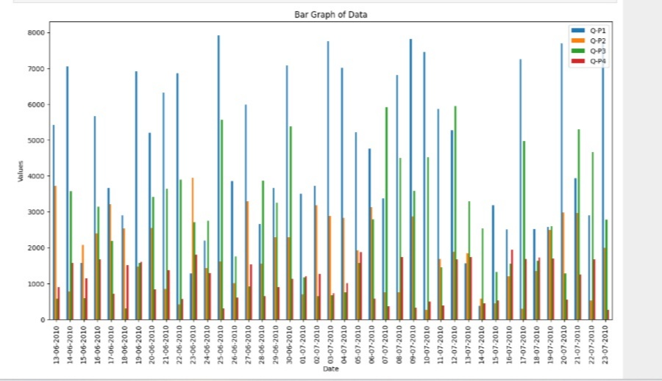  
  
  
**LIBRARIES USED:**

**Importing Libraries:**

**import pandas as pd**:

the Pandas library and aliases it as "pd" easier usage.

* **import matplotlib.pyplot as plt** :Imports the Matplotlib library's plotting module and aliases it as "plt".

**Data:**

* A dictionary named data is defined, containing four key-value pairs. Each key represents a column, and the associated values are lists of data. The columns are 'Date,' 'Q-P1,' 'Q-P2,' 'Q-P3,' and 'Q-P4.' The 'Date' column contains date strings, and the others contain numerical data.

**Creating a Data Frame:**

* A Data Frame named **df** is created using Pandas by passing the **data** dictionary to the **pd.Data Frame()** constructor. This Data Frame organizes the data into a tabular format, making it easier to work with and visualize.
* Setting the Date Column as the Index:
* The 'Date' column is set as the index of the Data Frame using the **set index ()** method. This change is made in place with **in place=True**, meaning it modifies the Data Frame directly.
* Plotting:
* The code uses Matplotlib to create a bar graph using the **plot ()** method on the Data Frame **df**. The following parameters are provided:
* **kind='bar'**: Specifies that a bar graph should be created.
* **figsize=(15, 8)**: Sets the figure size to 15 inches in width and 8 inches in height.
* The **plt.title()**, **plt.xlabel()**, and **plt.ylabel()** functions are used to set the graph's title, x-axis label, and y-axis label.
* Finally, **plt.show()** is called to display the bar graph.

The resulting bar graph will have the 'Date' column on the x-axis and the values from columns 'Q-P1,' 'Q-P2,' 'Q-P3,' and 'Q-P4' on the y-axis. Each date will have a set of bars representing the values from the corresponding columns, making it easy to compare the values over time.

**CONCLUSION:**

- The product sales analysis code is a valuable tool for businesses to analyse their sales data and gain insights into their performance.  
- By analysing sales data, businesses can identify trends and patterns, enabling them to make informed decisions and improve their sales strategies.  
- The code allows for efficient and accurate analysis of sales data, helping businesses identify their best-selling products, understand customer preferences, and optimize their product offerings**.**

**THANK YOU**