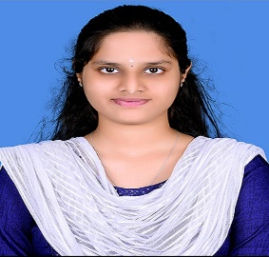**Kaviya Manikandan**

**Profile of Kaviya Manikandan**

III-year B. Tech, Computer Science and Business systems,

PSNA College of Engineering and Technology (Autonomous)

Dindigul – 624 622, Tamil Nadu, India.

**Mobile:** +91 9150713579

**Email:** [kaviyamanikandan32@gmail.com](mailto:kaviyamanikandan32@gmail.com)

|  |
| --- |
| **Career Ambition**  To excel in the field of Computer science and business systems. Have thirst to learn new things and to be a good team player to begin with, in projects in good organizations. In my career, gaining rich experience and expertise, I want to be in the top brass of world class organizations |

1. Name : Kaviya Manikandan
2. Father’s Name : Manikandan. R
3. Date of Birth : 03rd February 2005
4. Gender : Female
5. Address : # 631, Main Road, Kanjamanathan Pettai,

Virupatchi Post, Kurinjipadi – 607 302

**Education**

|  |  |  |  |
| --- | --- | --- | --- |
| **Class/**  **Degree** | **Institution/University** | **Month and year of Passing** | **Percentage/ CGPA** |
| **X Std** | St. Paul Matric H.S. School,  Kurinjipadi – Cuddalore Dt. | March 2020 | **71.6** |
| **XII Std** | St. Paul Matric H.S. School,  Kurinjipadi – Cuddalore Dt. | May 2022 | **85%** |
| **B.Tech**  **CSBS**  **(Studying)** | PSNA College of Engineering and Technology, Dindigul – 624 622,  An Autonomous Institution Affiliated to Anna University, Chennai. | IV semester completed | CGPA **8.3**  up to III semester |

**Proficiency in Computer Science**

1. Languages : Python, Java,
2. Qualification: Google cloud member, Currently Intern at the IITM Research Park

Certified that the information given above are true and correct to the best of my knowledge.

Date: 24-01-2024