Building a Smarter AI-Powered Spam Classifier

**Phase 3: Development Part 1**

In this part, you will begin building your project by loading and preprocessing the dataset.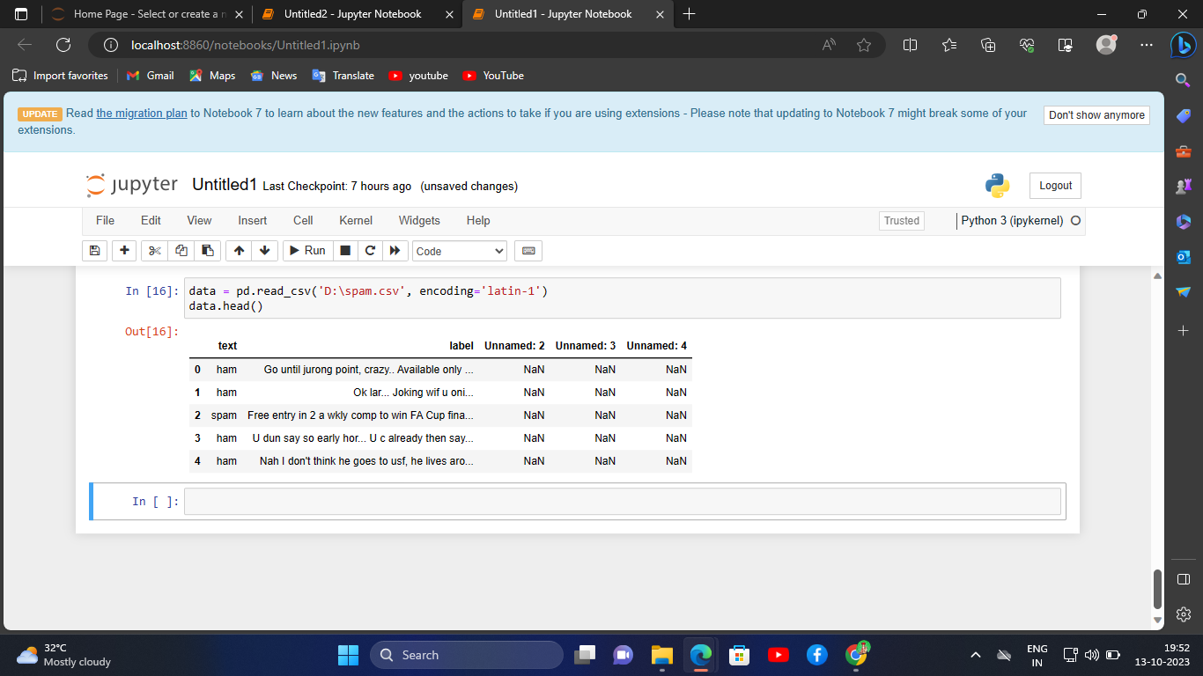

In this phase, start building the core components of our spam classifier. Use the Kaggle dataset which contains a collection of SMS messages labelled as spam or non-spam.

Hence, We import the dataset into the program and Get the data from the dataset.

So, The Data Preprocessing is Successfully Executed.