ParkSmart: Revolutionizing Parking with AI-Powered Multi-Storey Automation

S. Kaviyarasu
Coimbatore Institute of Technology
Coimbatore, India

Abstract—The automatic parking system prototype is a groundbreaking solution aimed at addressing the challenges associated with conventional parking systems. This report provides a comprehensive overview of the prototype, highlighting its design, functionality, and potential benefits.
Keywords—automatic parking system, prototype, design, functionality, benefits (key words)

Introduction
The automatic parking system prototype is a groundbreaking solution aimed at addressing the challenges associated with conventional parking systems. In today's urban environments, the scarcity of parking spaces and the inefficiencies in manual parking processes have led to frustration and wasted time for drivers. The purpose of this report is to provide a comprehensive overview of the automatic parking system prototype, highlighting its design, functionality, and potential benefits.

System Overview
The automatic parking system comprises several key components that work together seamlessly to streamline the parking process. The hydraulic base serves as the core mechanism responsible for lifting and transporting vehicles. The RFID card system allows for secure and convenient identification and retrieval of parked cars. The receiver and transmitter systems are strategically placed in each parking slot to monitor occupancy. A central control unit coordinates the actions of these components, ensuring smooth communication and efficient parking operations.

Car Entry Process
Upon entering the parking facility, drivers are issued RFID cards that serve as their identification throughout the parking process. The RFID card contains unique information associated with the driver and the vehicle. To check for available parking slots, the driver taps the RFID card on the entry RFID reader. The receiver and transmitter systems

assess the occupancy status of each slot and update the RFID card with the assigned slot number if an available space is found.

Car Parking Process
Once the RFID card is updated with the assigned slot number, the hydraulic base comes into action. The hydraulic base is equipped with advanced lifting mechanisms and sensors to ensure precise placement of the vehicle. It smoothly elevates the car and transports it to the assigned slot. The hydraulic base's design incorporates safety features, such as anti-collision sensors and fail-safe mechanisms, to prevent accidents and ensure the security of the parked vehicle.

Car Retrieval Process
When the driver wishes to retrieve their car, they tap the RFID card on the exit RFID reader. The reader reads the assigned slot number from the RFID card and communicates this information to the central control unit. The hydraulic base receives instructions from the control unit and navigates to the designated slot using the receiver and transmitter systems. Once the car is located, the hydraulic base lifts it and returns it to the driver, ready for exit from the parking facility.

AI & ML Model
Object Detection: Object detection algorithms, such as YOLO (You Only Look Once) has been employed to detect and locate cars or other objects in real-time. These algorithms use deep learning techniques to identify and classify objects within a given image or video stream.

Path Planning: Path planning algorithms determine the optimal path for the car to navigate and park in the designated parking spot. These algorithms take into account various factors such as the available space, obstacles, and safety considerations. Techniques like A* (A-star)are applied to generate efficient and collision-free paths.

Benefits and Advantages
The automatic parking system prototype offers numerous benefits and advantages. The dynamic parking feature optimizes space utilization by efficiently allocating available slots in real-time. This reduces the time spent searching for parking spaces and increases overall parking capacity. The RFID-based card system enhances security, allowing only authorized individuals to retrieve their vehicles. Additionally, the automated nature of the system minimizes human errors and reduces the risk of parking-related accidents, resulting in a safer and more efficient parking experience.

Challenges and Future Development
The development of the automatic parking system prototype presented several challenges. Integrating multiple systems and ensuring robust communication among them required meticulous planning and testing. Scalability is another consideration for future development, as expanding the prototype to accommodate larger parking lots or multi-level facilities may pose additional technical and logistical challenges. Furthermore, exploring the integration of emerging technologies such as artificial intelligence and machine learning can further optimize parking processes and enhance the system's overall efficiency.

Working Model
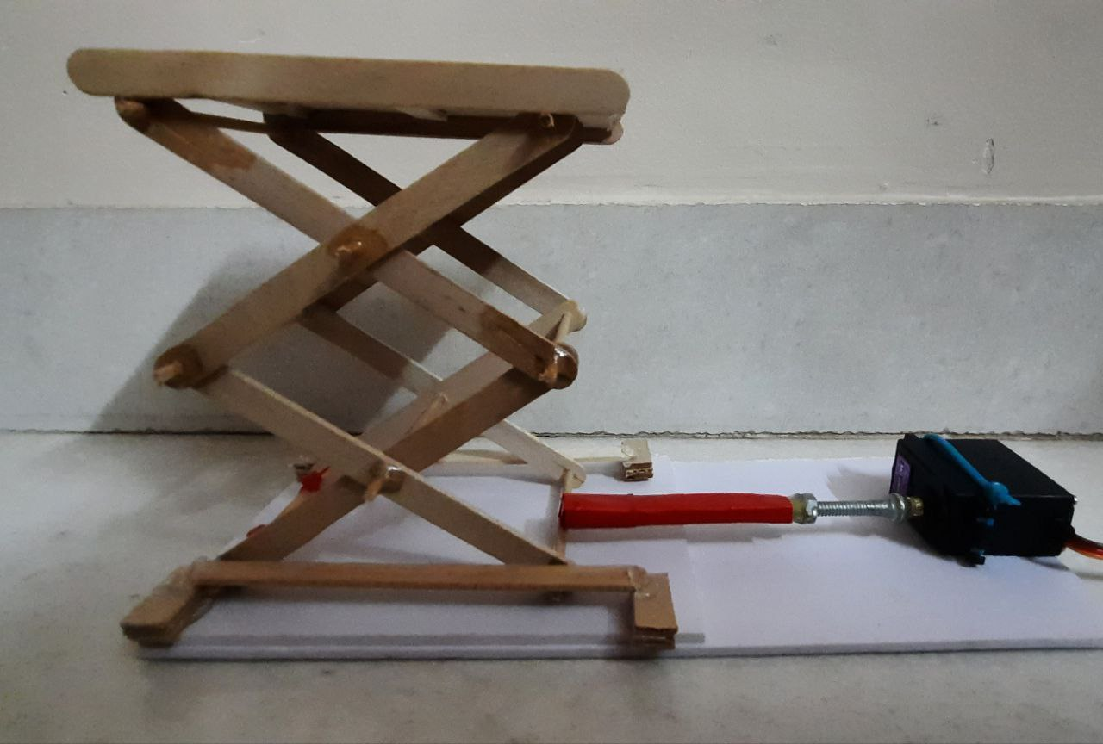

Conclusion
In conclusion, the automatic parking system prototype represents a significant advancement in parking technology. By leveraging the hydraulic base, RFID card system, receiver and transmitter systems, and a central control unit, the prototype demonstrates the potential for revolutionizing the parking experience. The seamless integration of these components streamlines the parking process, reduces search time, enhances security, and minimizes the risk of accidents. The success of this prototype paves the way for further research, development, and implementation of automatic parking systems to address the ongoing parking challenges faced in urban environments.

Acknowledgment
We would like to express our sincere gratitude to the individuals and organizations who contributed to the development and preparation of this report on the automatic parking system prototype. Their valuable support, insights, and assistance were instrumental in creating a comprehensive overview of the system's design, functionality, and potential benefits.
We extend our heartfelt appreciation to Dr. Valliappan Raman, Professor & HOD (Artificial Intelligence and Data Science), and Dr.R.Prabhakar Secretary, Coimbatore Institute of Technology, Coimbatore for providing the necessary resources and environment for carrying out this project.
We are indebted to everyone who has contributed their time, knowledge, and efforts to make this report a reality. Without their dedication and commitment, this work would not have been possible.
Thank you for your invaluable contributions and unwavering support throughout this endeavor.

