Assignment 2: Course 2 - AI and ML Algorithms and Techniques
NAME:KAVIYA SREE RS
ROLL NUMBER:23BIT042

Graded quiz: Feature selection techniques:
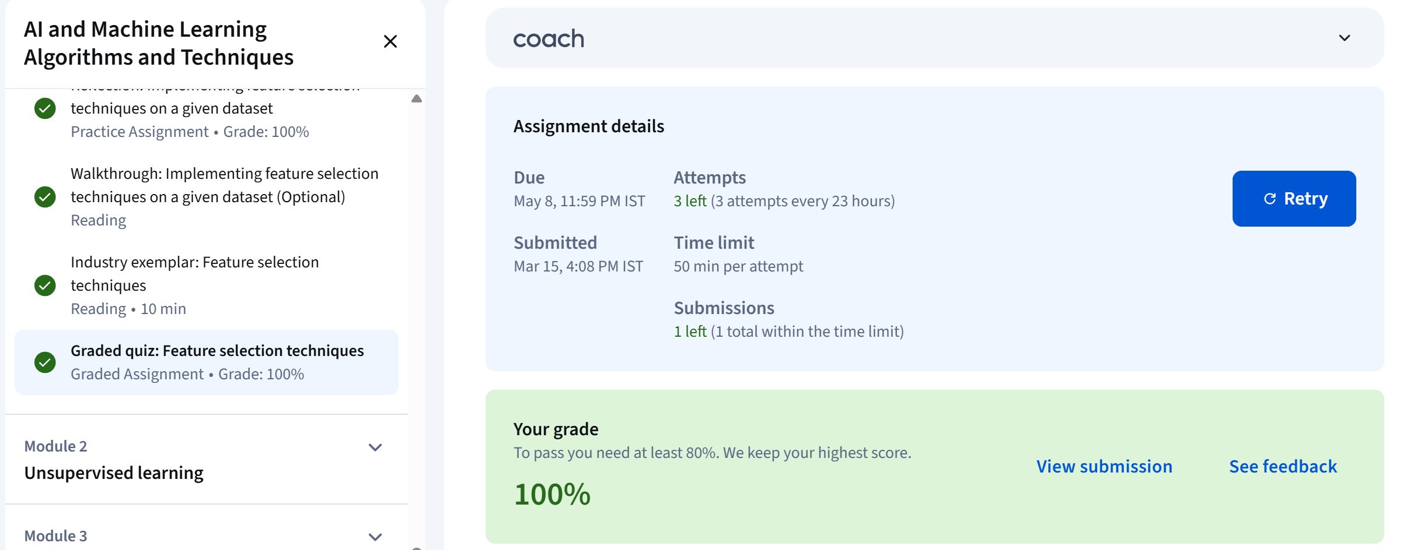

Graded quiz: Unsupervised learning
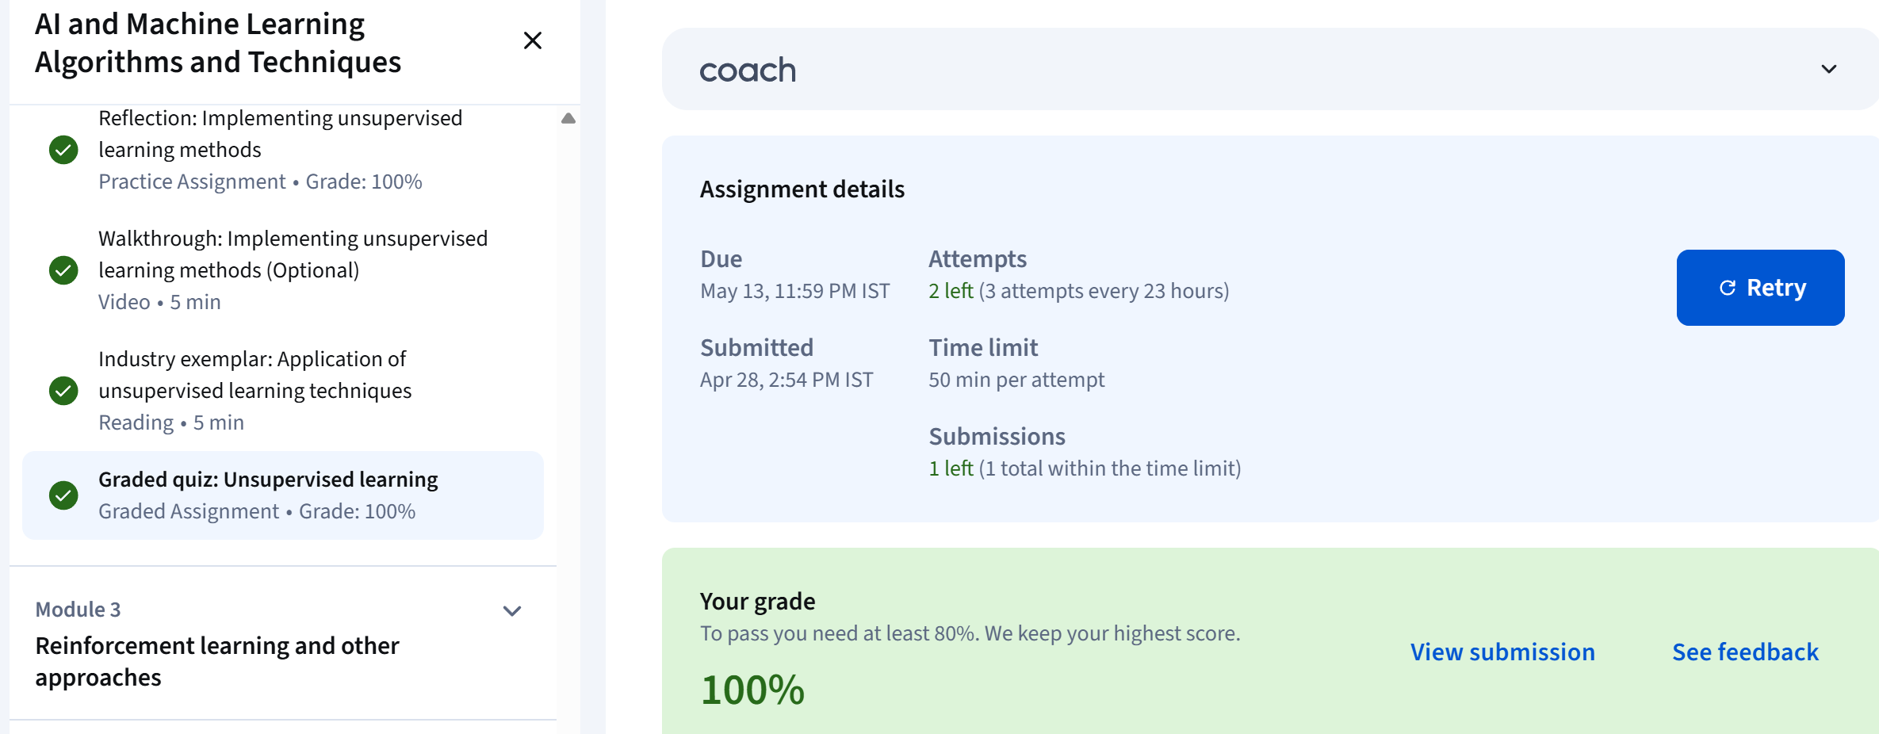

Graded quiz: Reinforcement learning and other approaches
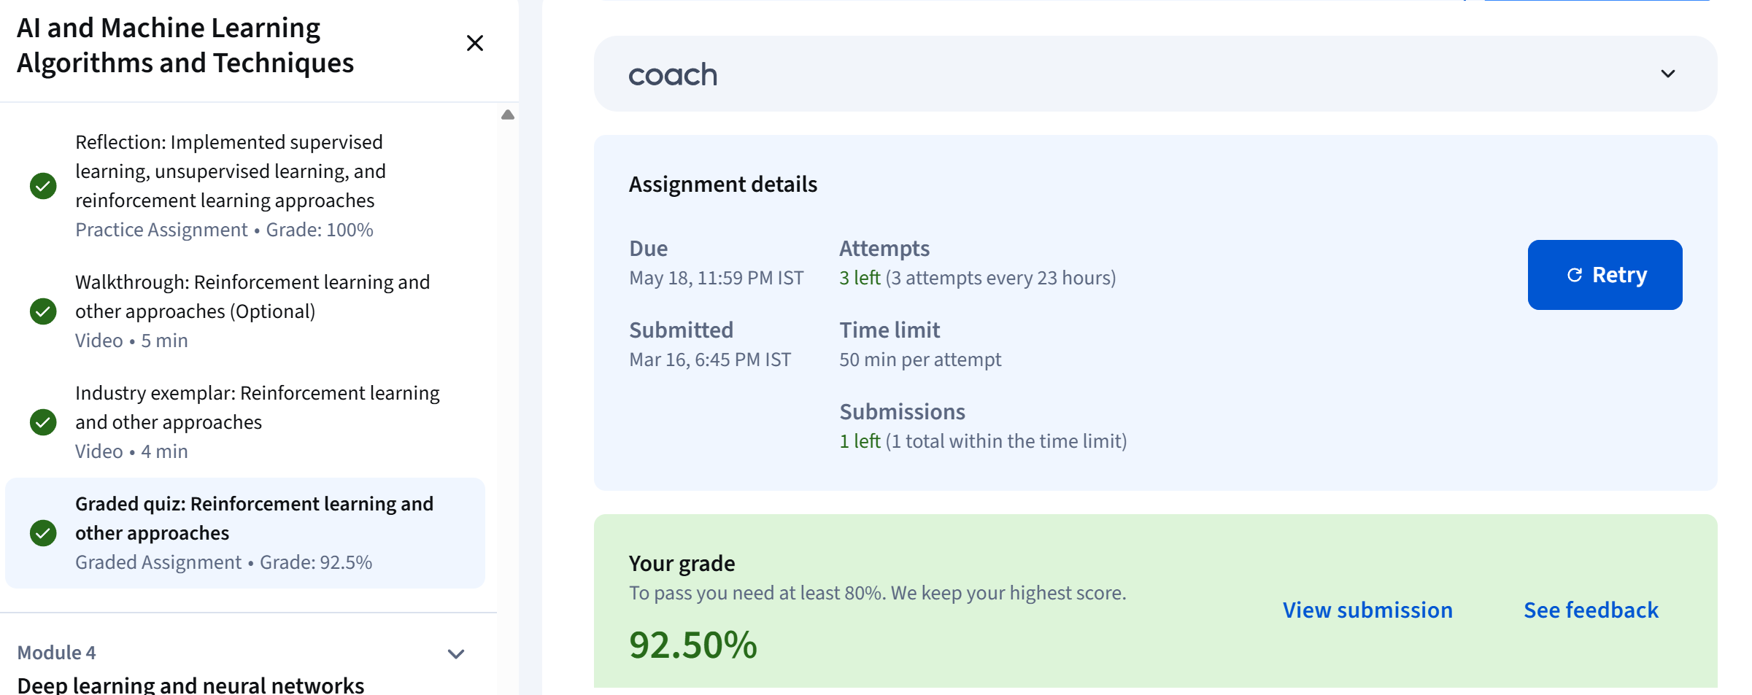

Graded quiz: Deep learning and neural networks
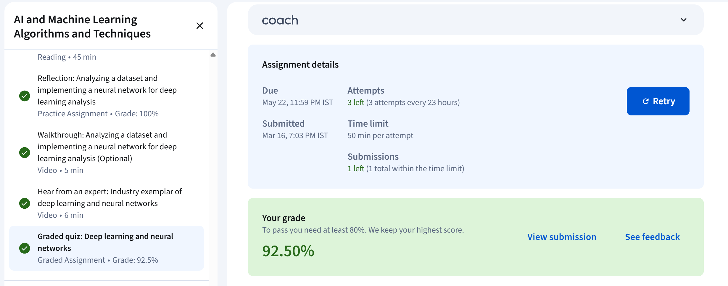

Graded quiz: AI/ML engineering and working with models


