Competition Project Proposal
AI-Powered National Internet Coverage Mapping Platform
English version — translated from the Lao original

1. The Problem
Many areas across Laos still do not receive adequate internet coverage, which delays access to technology for the communities living there.
Schools are affected most visibly: many are unable to integrate technology into their teaching, leaving students in rural districts to adapt to the digital world far more slowly than they should.
Beyond this, the root problem is that no reliable evidence exists about which areas lack coverage, or by how much. Network expansion is therefore planned largely on estimates rather than on real measurement.

2. Proposed Solution

2.1 Overall Concept
We will develop a mobile application together with a backend system that uses artificial intelligence to build a national internet coverage quality map.
What makes this approach different is that the primary data does not come from operator estimates or marketing coverage maps. It comes from real field measurements collected through users’ phones across the country (crowdsourced measurement) — the only method that reflects what rural communities actually experience.

2.2 How Data Is Collected
The app collects technical data automatically through the Android telephony API:
Data collected | Detail
Signal strength | RSRP, RSRQ, SINR
Network type | 2G / 3G / 4G / 5G
Operator | The network currently connected
Service quality | Download / upload speed and latency
Position and time | GPS coordinates and measurement timestamp

Technical note: the first phase targets Android only, because iOS severely restricts access to signal-strength data.

2.3 Operating Where There Is No Coverage (Store-and-Forward)
This is the core of the design. In an area with no internet, the app cannot upload to the server immediately. It therefore:
- Records each measurement locally with its coordinates and timestamp
- Uploads automatically once the user returns to an area with coverage
With this approach, the places with "no signal at all" become the most valuable data in the system, rather than blank gaps on the map.

Why measurement is possible without internet
The key principle is that measuring the signal and using the internet are two separate things. The phone’s modem scans for base stations continuously, whether or not any data is being transmitted. Even where the internet is unusable, the app can still read the radio state through Android’s ServiceState and getAllCellInfo().
Likewise, GPS works without any network, because it receives one-way signals from satellites. A-GPS only speeds up the initial position fix.
For this reason the system distinguishes five states rather than a simple "signal / no signal":
Radio state | Meaning | Map colour
No cell detected at all | No network reaches this area — a new tower is required | Red
Cells visible but registration fails | Signal exists but is too weak to use (emergency calls only) | Red-orange
Registered on 2G/3G only | Calls and SMS work, data does not | Orange
4G/LTE with weak signal | Data works but is slow (RSRP below –110 dBm) | Yellow
4G/LTE with good signal | Normal usable service | Green

This distinction carries real policy weight: an area no tower reaches at all requires investment in a new site, whereas an area that has a tower but a weak signal may be solved by equipment upgrades or a repeater, at far lower cost.

Two levels of measurement
- Passive measurement: RSRP, RSRQ, SINR, cell IDs and network type — collectable anywhere, even with no internet, and cheap on battery
- Active testing: download speed and latency — possible only where the internet is usable
Points carrying both levels are used to train a model of the relationship between RSRP and real throughput; that relationship is then applied to estimate speed at the radio-only points.
Technically, Android’s WorkManager with a NetworkType.CONNECTED constraint handles deferred uploads. A sampling rule (one record per 100 m or per 60 seconds) and a queue cap prevent excessive use of device storage.

A limitation we accept openly
The system only learns about places people actually travel to. A village with no traffic produces no data. Partnering with regular collectors — bus drivers, health workers on field visits, provincial staff and teachers — therefore matters more to map coverage than the app’s own features do.

2.4 Map Presentation
All data is aggregated into a hexagonal grid (H3) rather than displayed as individual points, both to protect user privacy and to keep the map readable:
- Green: fast and stable internet access
- Yellow: signal present but slow or unstable
- Red: no internet access
- Grey: not yet measured (to be estimated by the AI model described in 2.5)

2.5 The Role of Artificial Intelligence

(1) Coverage Prediction
In practice, measurements will only exist along routes people travel. AI fills the gaps by training a model on:
- The real measurement points collected
- Terrain elevation data (SRTM Digital Elevation Model)
- Land cover and population density
- Distance from known tower sites (OpenCelliD)
This is combined with a radio propagation model (Longley-Rice / Okumura-Hata) as a physical baseline, so that predictions remain credible.

(2) Satellite Image Analysis (Computer Vision)
Satellite imagery and nighttime lights data are used to:
- Detect the location and extent of villages and settlements
- Estimate population where census data is out of date
- Assess electrification, a prerequisite for installing a tower

(3) Tower Site Ranking (Site Optimization)
This is a facility location problem: the system computes the sites that cover the largest population per tower and presents them to operators as a prioritised list.

(4) Outage Detection (Anomaly Detection)
Time-series analysis alerts operators when signal quality in an area degrades abnormally or disappears.

2.6 The User’s Side
- Report a problem: users can report slow or unusable internet, which is forwarded to the service provider
- Check before travelling: users can view the map in advance to see whether their destination has coverage
- Privacy protection: location data is anonymised and aggregated into grid tiles before any display

2.7 How the Data Is Used
Channel 1 — Government and operators: providing real evidence to the Ministry of Technology and Communications and to domestic network operators, so that tower expansion is planned where it is genuinely needed and delivers value for the investment.
Channel 2 — Citizens and travellers: giving the public, students and travellers a tool to plan journeys and remote work in advance.

2.8 Pilot Scope
So that the project can demonstrate concrete results, the first phase will:
- Build the Android collection app and the backend (FastAPI + PostGIS)
- Collect real measurements along the main routes of one target province
- Train an AI model to predict coverage for the unmeasured areas
- Present the map and a ranked list of tower sites worth funding first

3. System Architecture
This section presents the system at two levels: an overall view for general understanding, and a five-layer technical architecture with clearly separated responsibilities, so each part can be developed, tested and scaled independently.

3.1 System Overview
Figure 1 shows how the system works end to end — from the input data sources, through central processing, to the people who use the results and the social impact that follows.
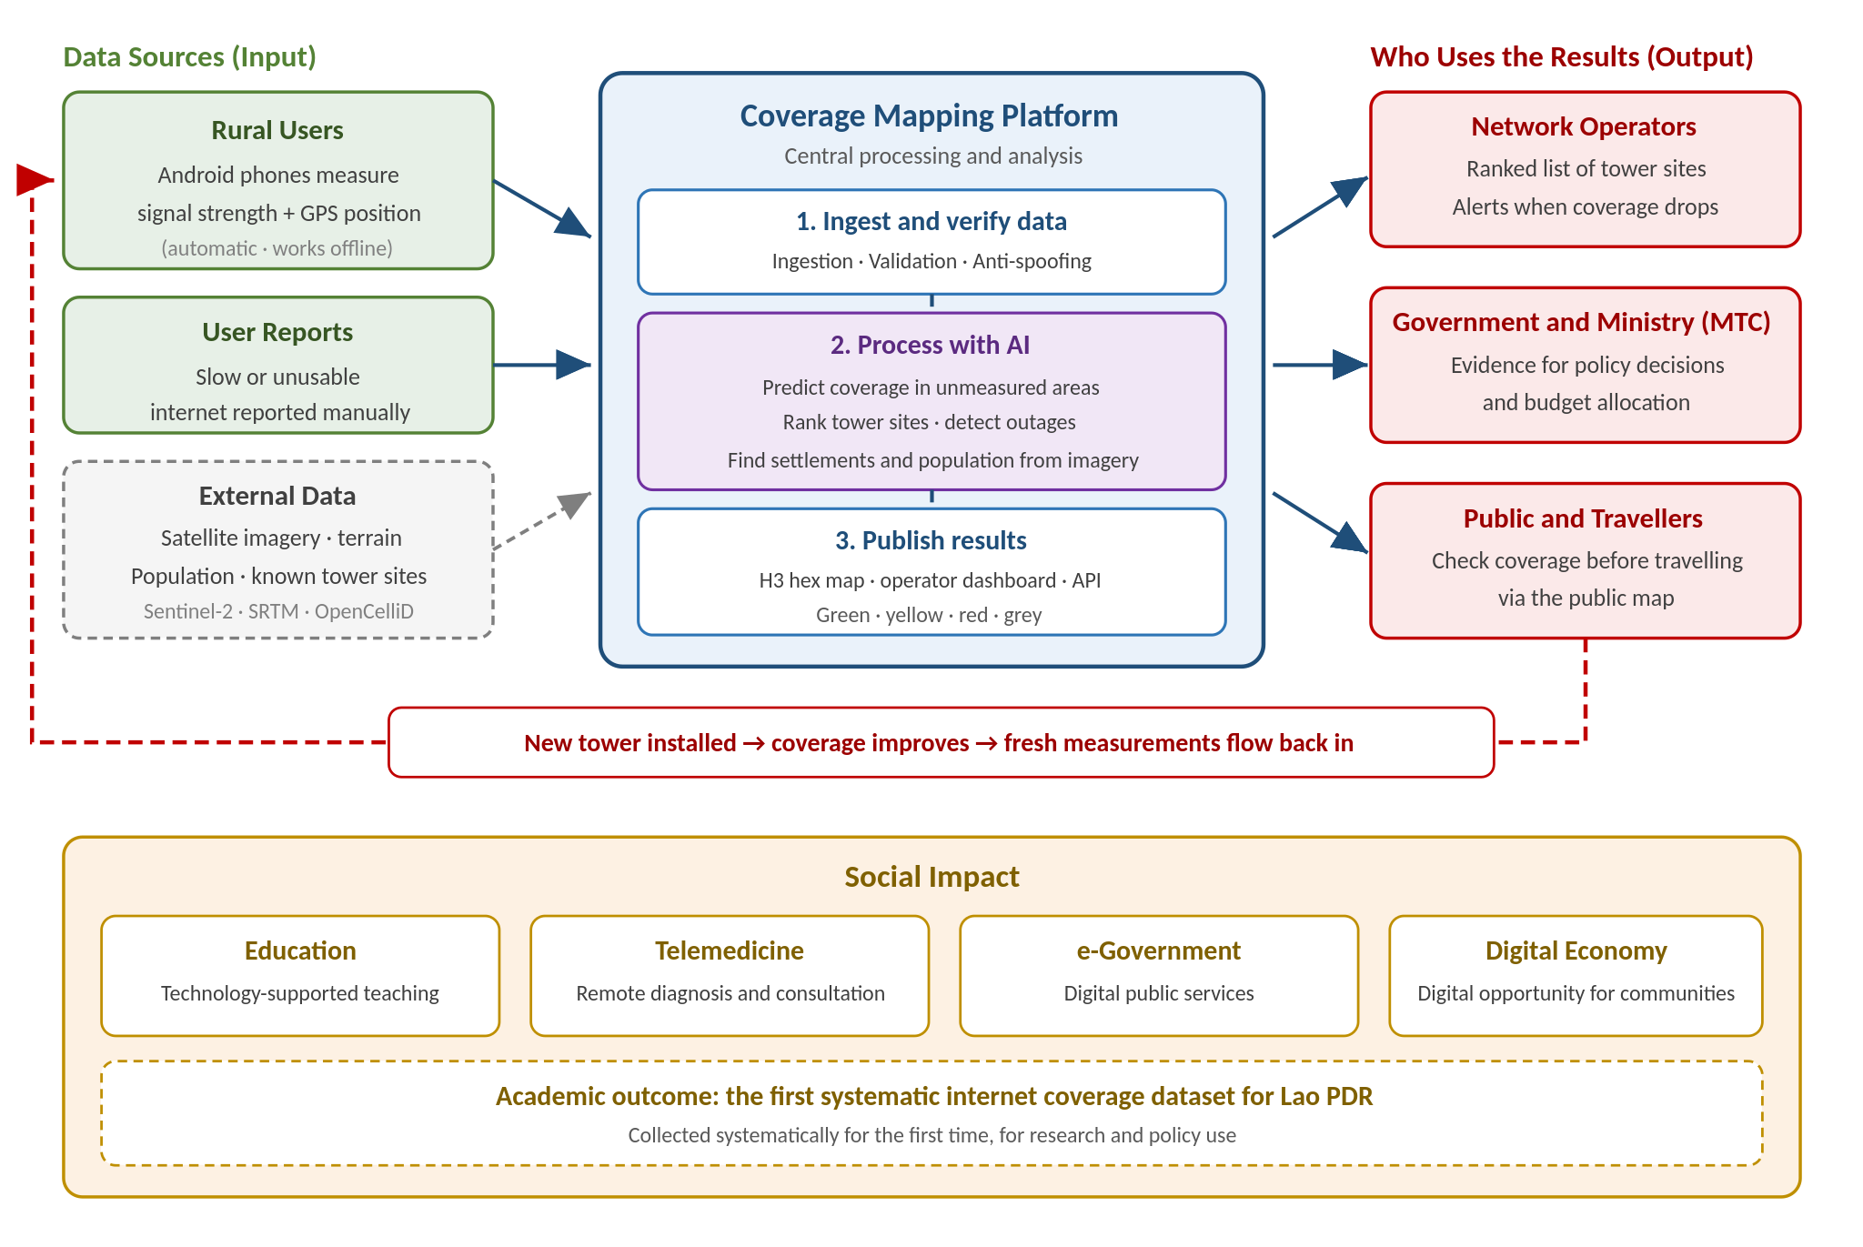
Figure 1: System overview
The critical element is the feedback loop shown as the red dashed line: once an operator acts on the data and installs a tower, coverage in that area improves, and fresh measurements flow back into the system. The map stays current, and the investment is demonstrably proven to have worked.

3.2 Technical Architecture
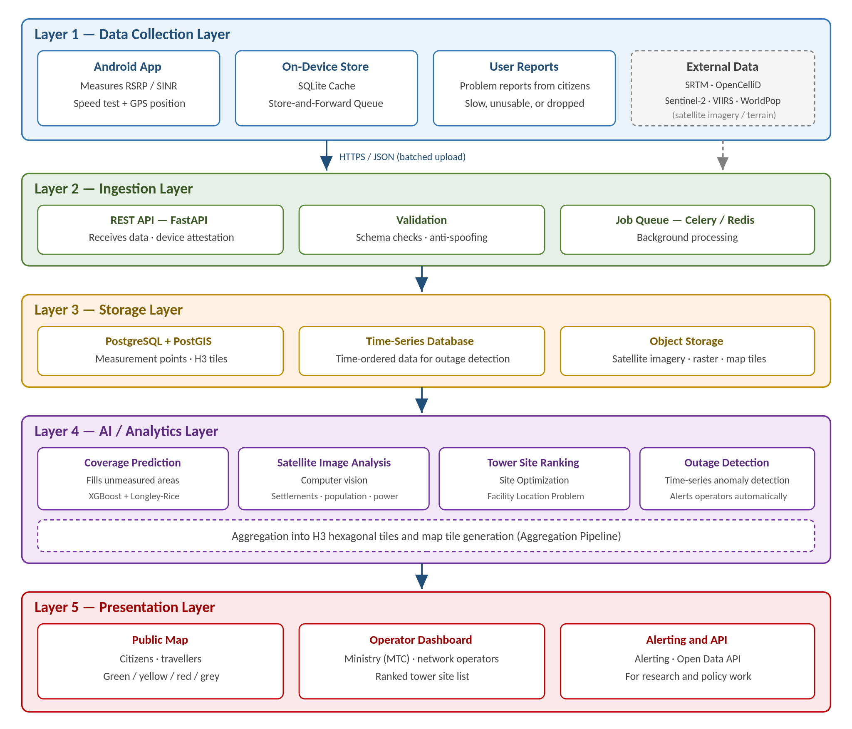
Figure 2: Five-layer technical architecture

3.3 Responsibilities by Layer
Layer | Main responsibility | Technology used
Layer 1  Data Collection | Measure signal from real devices, receive user reports, and import external datasets | Android (Kotlin), SQLite, SRTM, OpenCelliD, Sentinel-2
Layer 2  Ingestion | Receive data, verify device identity, validate records and queue processing jobs | FastAPI, Pydantic, Celery, Redis
Layer 3  Storage | Store measurement points, H3 tiles, time-series data and satellite imagery | PostgreSQL + PostGIS, TimescaleDB, MinIO / S3
Layer 4  AI / Analytics | Predict coverage, analyse satellite imagery, rank tower sites and detect outages | Python, XGBoost, PyTorch, H3, SPLAT! / Longley-Rice
Layer 5  Presentation | Serve the public map, the operator dashboard and the alerting system | MapLibre GL, React, REST / Open Data API

3.4 Data Flow
- The app measures signal quality and records it locally with coordinates and time
- On returning to coverage, records are uploaded in batches over HTTPS
- The system validates records and rejects spoofed data before writing to PostGIS
- Background jobs aggregate data into H3 tiles and retrain the AI models
- Results are rendered as map tiles and a ranked list of candidate tower sites
- The public views the map; operators and government access the dashboard or API

3.5 Security and Data Protection
- All data transmission is encrypted with TLS/HTTPS
- Device attestation and rate limiting guard against fabricated submissions
- Location data is anonymised and aggregated into tiles before any display
- Access is separated between the public, operators and government (role-based access control)

Verifying the trustworthiness of delayed data
Because data from uncovered areas is uploaded hours after capture, it is inherently easier to forge. The system applies three measures:
- Sign at capture time: each record is signed with a device key the moment it is measured, not at upload
- Record visible cell IDs: these are hard to fabricate plausibly, so they can be cross-checked against the reported position
- Check trajectory plausibility: the system verifies that travel from the measurement point to the upload point is physically possible
These measures are necessary because, without them, anyone could submit false data to make their own area appear underserved and jump the investment queue.

4. Expected Outcomes
Operators and government will receive real evidence of rural communities’ demand for internet access, so that every rural area can achieve coverage and move into the digital era together.
The platform also underpins the following:
- Education: supporting technology-integrated teaching in rural schools
- Telemedicine: enabling remote diagnosis and consultation in isolated areas
- e-Government: extending digital public services to the grassroots
- Digital economy: opening digital economic opportunity to communities
Academically, a further outcome is the first systematically collected internet coverage quality dataset for Lao PDR, which can support research and policy-making well beyond the life of this project.

