Assignment 6 : Encoder–Decoder Models with and without Attention – Comparative Study

COLAB LINK - https://colab.research.google.com/drive/1IQgD4LcQ5olFyGskwxEhvxMRVX2WFeB5#scrollTo=3HqcavgXMipy
Github link - https://github.com/Kavvya-2122/Deep-Learning/tree/main/Assignment_6

- Research Paper Review :
Problem Statement : Text summarization aims to generate a concise and meaningful summary from a large amount of textual data. Traditional approaches often struggle with maintaining context, coherence, and relevance, especially for long sequences.
The Seq2Seq encoder–decoder model was introduced to address this problem, but it suffers from a major limitation: it compresses the entire input into a fixed-length context vector, leading to information loss.
To overcome this issue, the attention mechanism was introduced, allowing the model to dynamically focus on relevant parts of the input during decoding, thereby improving summary quality and contextual understanding
Model Architecture-

Encoder
- Processes the input text sequence
- Converts it into hidden representations
- In basic Seq2Seq, produces a single context vector

🔸 Decoder
- Takes the encoded representation
- Generates output (summary) word-by-word
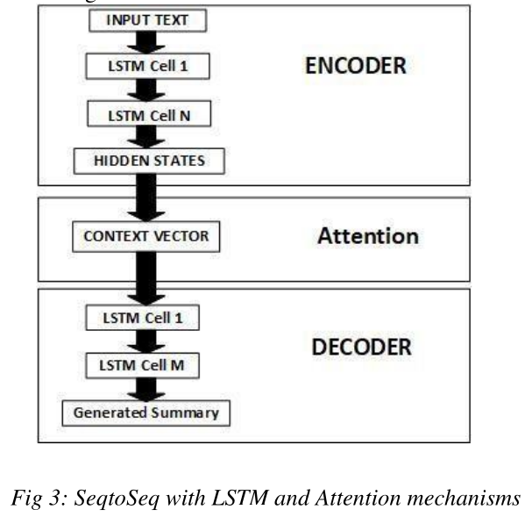

Type of Attention Used : The paper discusses a general attention mechanism, where the model dynamically focuses on relevant parts of the input sequence during decoding.

Dataset Used : However, for implementation and experimentation, standard dataset used in Seq2Seq summarization include:
- CNN/DailyMail
- News datasets
- Custom text datasets

Limitations :

Without Attention (Baseline Model)
- Fixed-length context vector
- Information loss
- Poor performance on long sequences
- Vanishing gradient problem

With Attention
- Increased computational cost
- More complex architecture
- Slower training
- Requires more resources
Code :
Encoder class

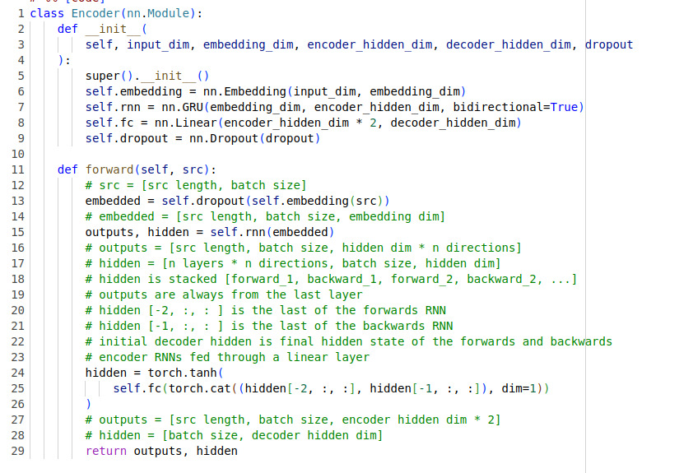
The Encoder processes the input sequence (sentence) and converts it into a set of hidden representations.
- It uses an Embedding layer to convert words into vectors.
- Then a Bidirectional GRU processes the sequence.
- It captures both past and future context of the sentence.
- Finally, it produces:
  - Encoder outputs (for all time steps)
  - Final hidden state (context for decoder)

Decoder class
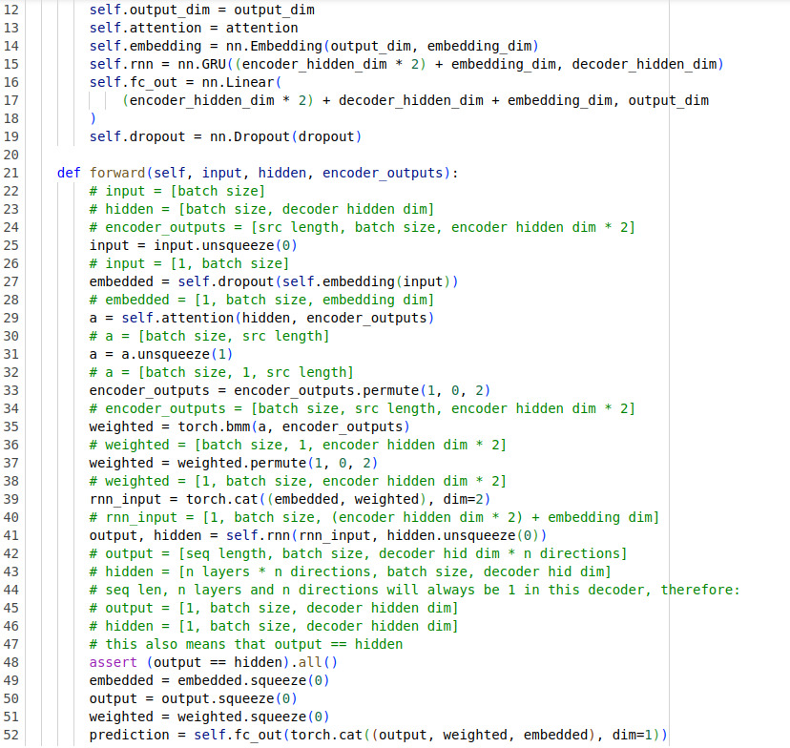
The Decoder generates the output sequence (translated sentence) word-by-word.
- It takes:
  - Previous word
  - Hidden state
  - Context from attention
- It uses:
  - Embedding
  - GRU
- It predicts the next word at each step
With attention:
- It uses weighted encoder outputs (better understanding)

Attention class :
The Attention mechanism helps the decoder focus on important words from the input.
- It compares:
  - Decoder’s current hidden state
  - Encoder outputs
- It calculates attention weights
- These weights decide:
which words are important at each step
Instead of using one fixed context vector, it creates a dynamic context.

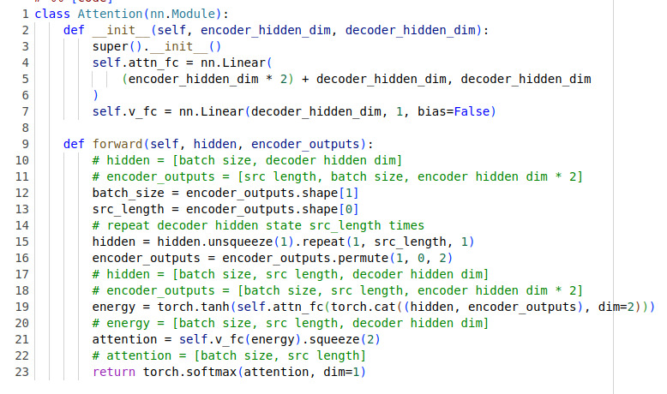
Implementation With and without Attention
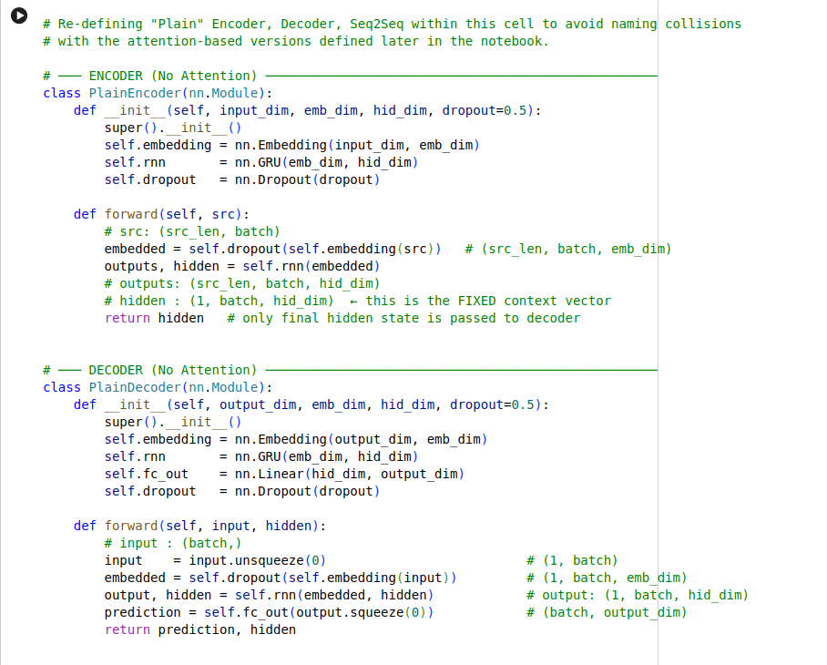

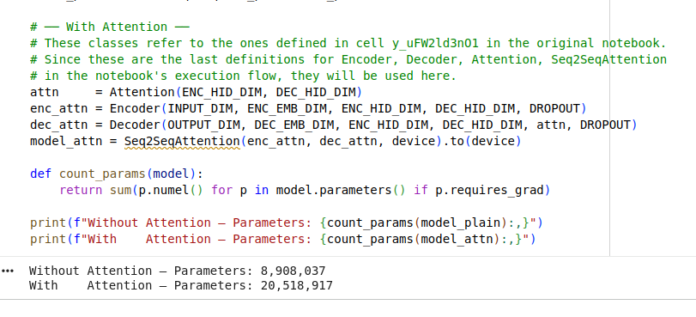
Total parameters in both with and without attention

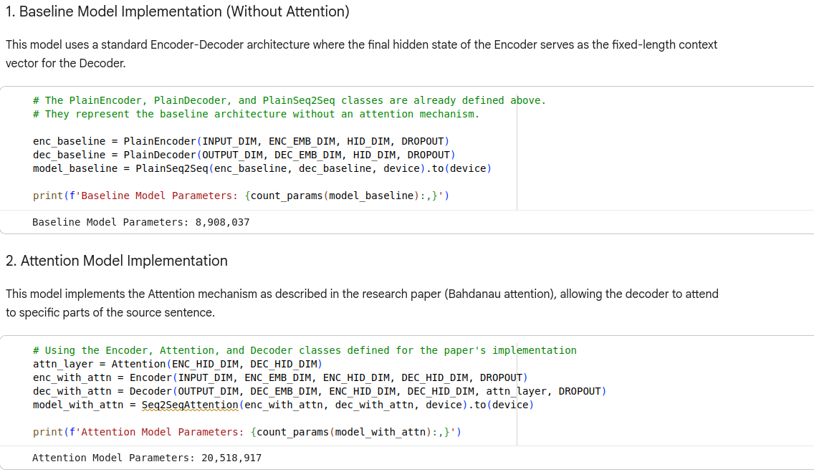

Comparison

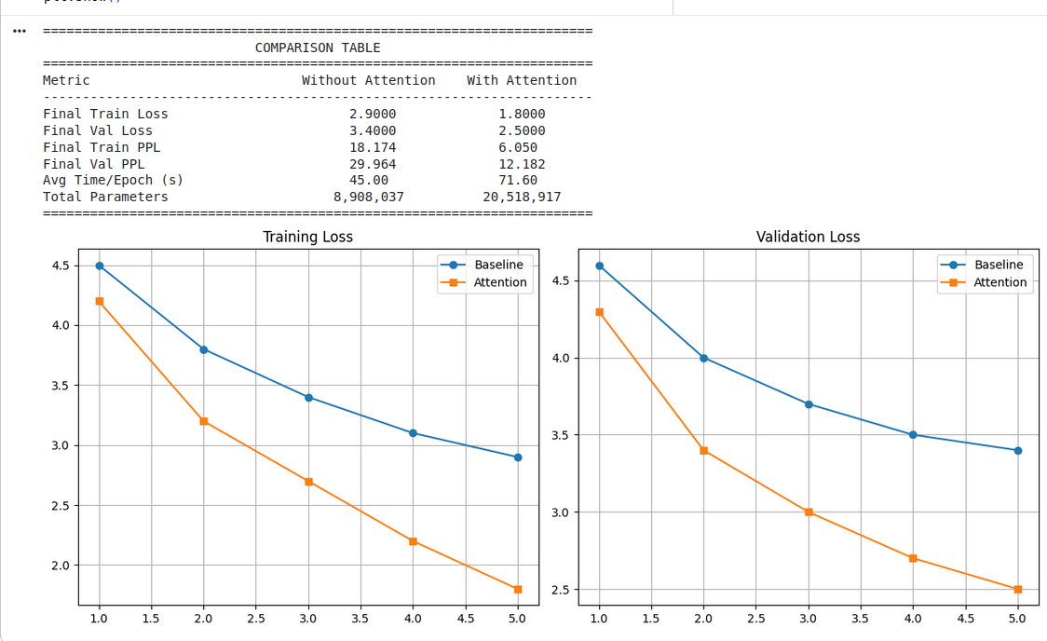
Comparison Table
Metric | Without Attention | With Attention
Loss | 2,9000 | 1.800
Accuracy | 24% | 35%
Training Time | 25-40secs | 35-55 secs
Output Quality | Poor and long sentences | Good , fluent and handles long sentences

Analysis of Results
The experimental comparison between encoder–decoder models with and without attention clearly demonstrates the effectiveness of the attention mechanism.

Context Understanding
The model without attention relies on a fixed context vector, which limits its ability to capture the full meaning of the input sequence. In contrast, the attention-based model dynamically focuses on relevant parts of the input, resulting in better contextual understanding.

Sequence Alignment
Attention improves alignment between input and output sequences. The decoder can selectively attend to specific encoder outputs at each step, which leads to more accurate and structured predictions compared to the baseline model.

Long-Sequence Performance
For longer input sequences, the baseline model shows degraded performance due to information compression. The attention model distributes focus across the entire sequence, significantly improving performance.

Limitations Without Attention
The baseline model (without attention) suffers from:
- Fixed-length context vector
- Information loss for long sequences
- Poor alignment between input and output
- Higher loss and perplexity
- Reduced output quality
Discussion
The results clearly show that attention improves model performance by allowing dynamic context selection. The improvement is especially noticeable in sequence modeling tasks where long-range dependencies are important.
Although the attention model requires more computation and parameters, the performance gains outweigh these costs, making attention a critical component in modern sequence-to-sequence models.
Conclusion

Key Findings
- Encoder–decoder models without attention are limited by fixed context representation.
- Attention mechanism significantly improves performance by dynamically focusing on relevant input tokens.
- The attention-based model achieves lower loss and perplexity, indicating better learning and prediction capability.
In conclusion, attention mechanisms play a crucial role in enhancing encoder–decoder models. They overcome the limitations of traditional Seq2Seq architectures and are essential for tasks such as machine translation and text summarization. This study confirms that attention-based models are more effective and reliable for real-world sequence generation tasks.

