;l

Foundations of Programming

Assignment No. : 4
- PROBLEM STATEMENT: Write a C Program to calculate the salary of an employee given his basic pay (taken as input from the user). Calculate gross salary of employee. Let HRA be 10 % of basic pay and TA be 5% of basic pay. Let employees pay professional tax as 2% of total salary. Calculate net salary payable after deductions.

OBJECTIVE:

- To understand the importance of flowchart for any programming model.
- To learn simple flowchart symbols and arrows to define relationships.
- To understand and develop visual representations of flow of data.

THEORY:
- Define Algorithm.
- What are the different characteristics of an algorithm.
PLATFORM: Linux

INPUT:

CODE:
“””

#include <stdio.h>

int main() {
float basic, hra, ta, gross, tax, net;

printf("Enter Basic Pay: ");
scanf("%f", &basic);

hra = 0.10 * basic;
ta = 0.05 * basic;

gross = basic + hra + ta;

tax = 0.02 * gross;

net = gross - tax;

printf("\nBasic Pay = %.2f\n", basic);
printf("HRA = %.2f\n", hra);
printf("TA = %.2f\n", ta);
printf("Gross Salary = %.2f\n", gross);
printf("Professional Tax = %.2f\n", tax);
printf("Net Salary = %.2f\n", net);

return 0;
}

“””
OUTPUT:
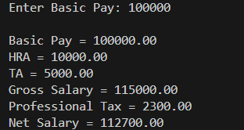
CONCLUSION: Thus, we have learned to write algorithms and to draw its representation in terms of flowchart.

FAQs:
- Describe various symbols and their use in flowchart.
- Difference between Algorithm and Flowchart.

