**READ ME for Chandy-Misra-Haas OR Deadlock Detection Algorithm**

**Source files:** ChandyMishraOR.c

**Complier:** gcc.

The files are compiled using gcc.

**Build Command:** gcc ChandyMishraOR.c

**Output:** a.out.

**Run command:** ./a.out

**Execution instruction:**

1. Enter the number of processes: (number between 1 to 10)
2. Enter N or Y only.

Example: node i and j, if process(node) i is waiting for a resource held by j then there is a edge from i->j, then mark Y.

Else N.

1. Enter the initiating process: (0 to n-1)

Examples :

1. **Input graph**

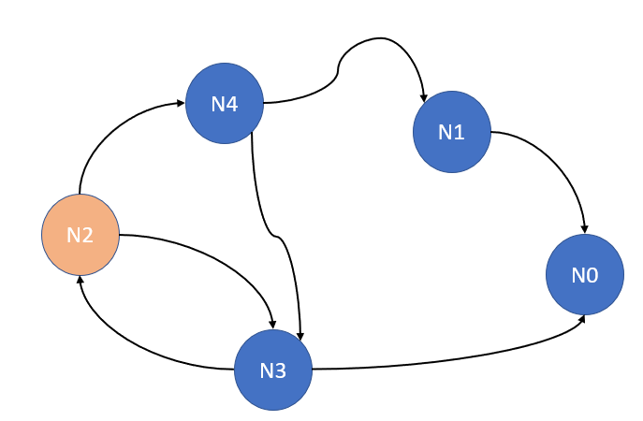

***N2 is the initiator***

Graph to input conversion:

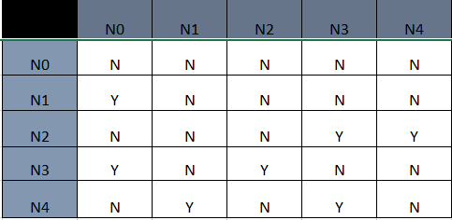

**Graph (Matrix) Creation after input is entered:**

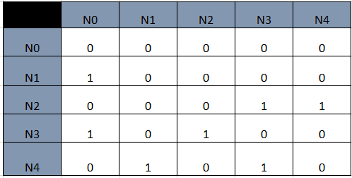

**Sample Input:**

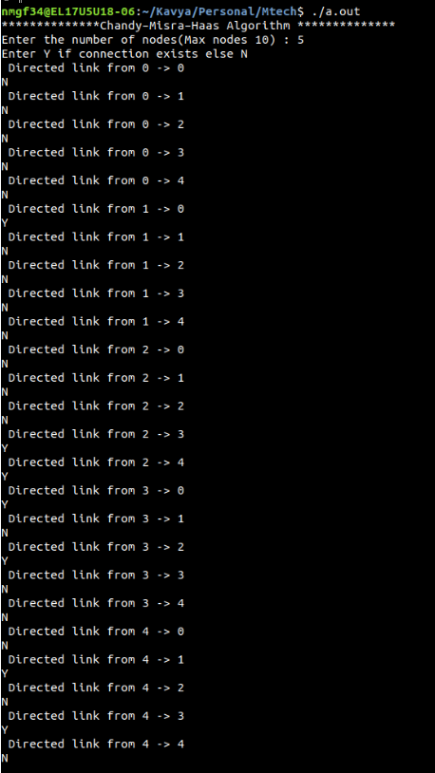

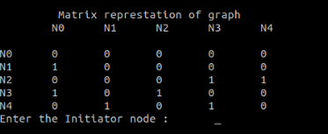

**Initiator: 2**

**Output:**

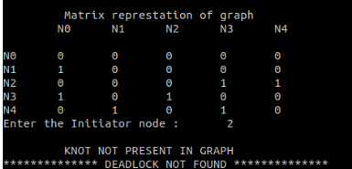

1. **Input graph:**

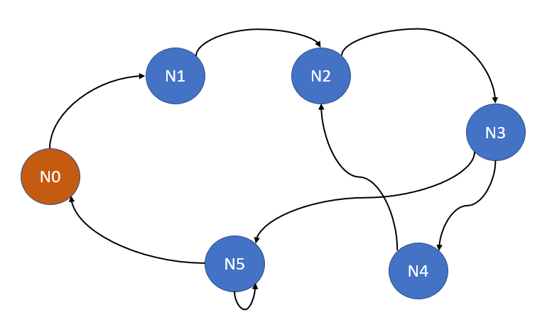

***N0 is the initiator***

**Graph to input conversion:**

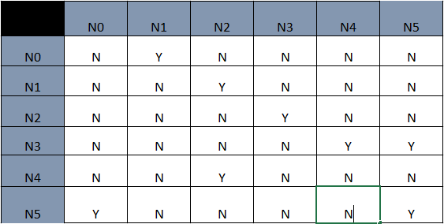

**Graph (Matrix) Creation after input is entered:**

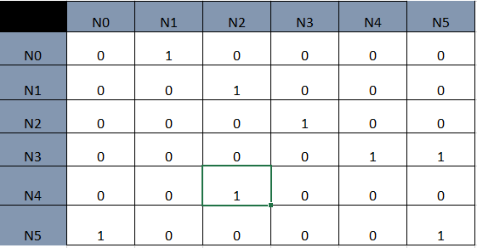

**Sample Input:**

I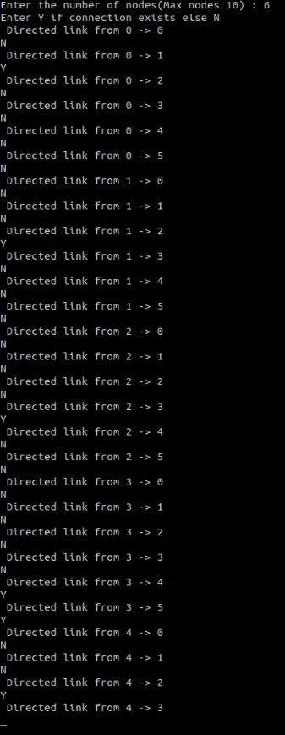

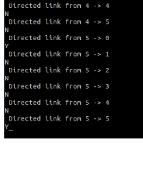

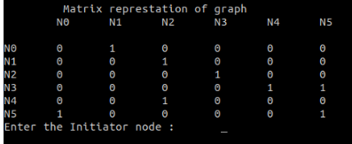

**Initiator: 0**

**Output:**

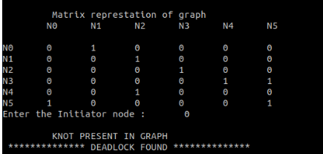

1. **Input Graph:**

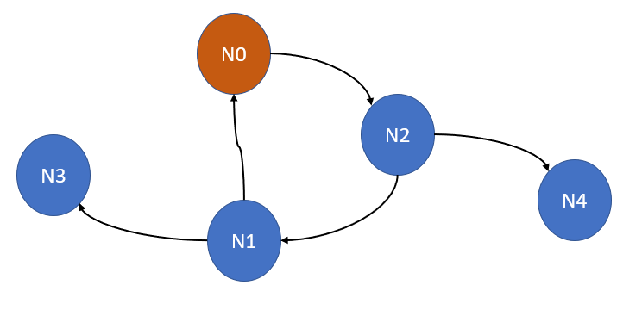

***N0 Is the initiator***

**Graph to input conversion:**

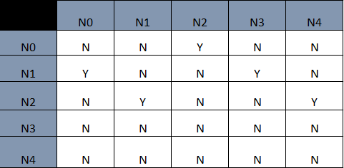

**Graph (Matrix) Creation after input is entered:**

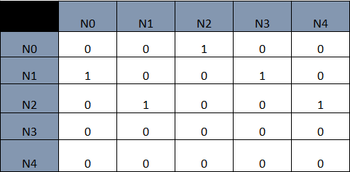

**Sample Input:**

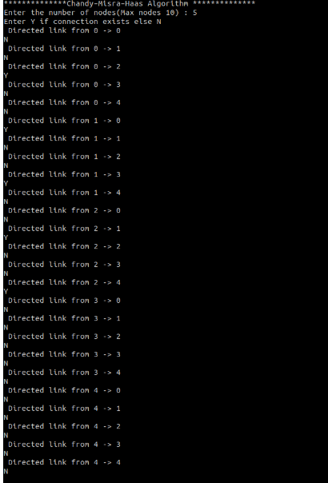

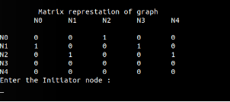

**Initiator: 0**

**Output:**

