before node to run js it was necessary to use script tag inside html but in node its possible to run with html

console.log("hello world , welcome to node js learning session");

to run js file in node js environment syntax followed is

node <file name> eg: node index.js

------------------------------------------------------------------------

**what is node.js ?**

-> runtime environment for executing js code outside of browser.

-> used to built backend services called APIs.

the fontend of the application has to connect to some backend services in order to get required data

**\*\*why node.js?\*\***

** Its ideal for building highly scalable, data-intensive and real time applications or backend services** (Data-intensive is used to describe applications that are I/O bound or with a need to process large volumes of data.)

-> great for agile development

->fast (bcoz it runs on google v8 engine )and scalable

->uses js so no need to learn another language for backend development

->consistent code base

-> have large open source libraries (can concentrate core of app instead of worring for building setup of initials)

**\*\*tools used to build backend services\*\***

-> ASP.Net(c#)

-> rails(ruby) frameworks

-> django (python)

-> Node.js(javasctipt) used in paypal , uber , netflix , walmart etc

**\*\*node.js architecture\*\***

when we run js in browser

js code --> js engine --> machine code

browser : js engine used

Edge : Chakra

Mozilla : SpiderMonkey

Chrome : V8

bcoz of this various engines js could behave diffently

Hence

```with help of runtime environment it could be able to achieve uniform behaviour of code

``**`**Ryan Dahl**\*\* took out fastest js engine i,e V8 and integrated with cpp to make runtime environment calle node.exe

So, node.exe

->it has js engine

-> has objects provide env for js code

-> they provide interesting capabilities of : working with file system

creating server (req, res)

**Node is a pgm tht includes v8 js engine and additional modules that gave capabilities that not present inside browser. it allows to work with network , file system so on.**

Eg: fs.readFile()

http.CreateServer()

How node works?

Node has **asynchronous architecture** means single thread is used to handle multiple requests. That means request and response is independent, no need to wait for closure of previous requests.

Analogy: single waiter serving to multiple tables.

A thread used to carry request can be used to take other request instead of waiting at database . when data is fetched from database a message is put in event queue which is constantly monitored by node in background. When it find data in event queue it take it out and process it there by reduces waiting time.

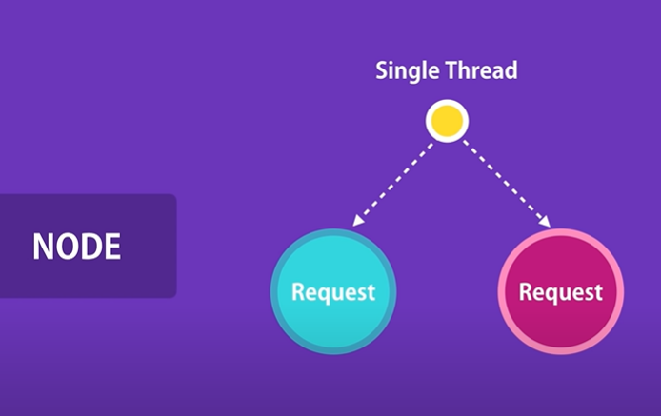

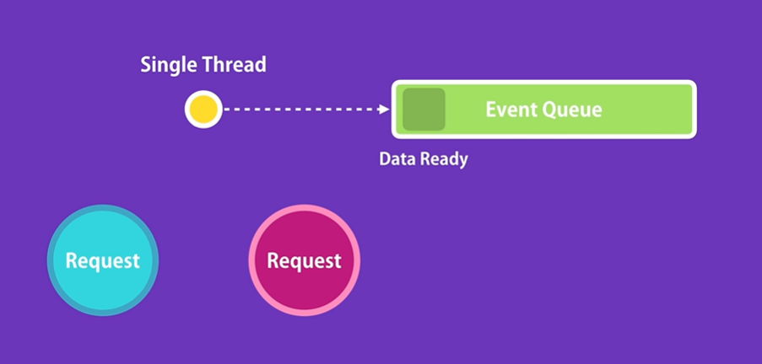

Where as **ASP.Net (with extra asynchronous can be made) and ruby rails are synchronous** (blocking)

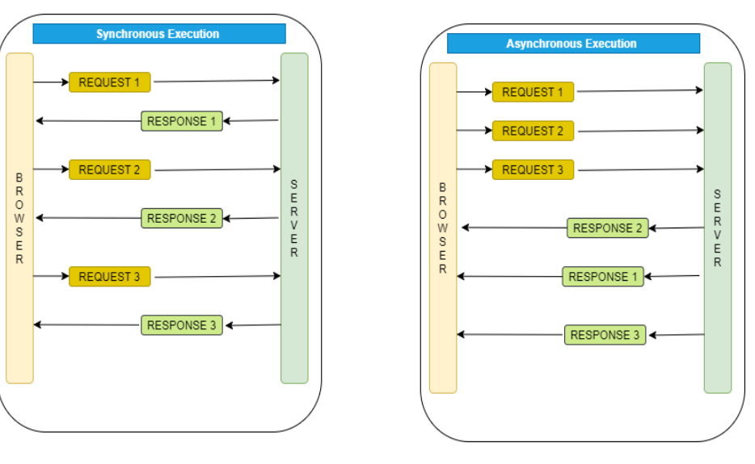

**Node shd be used only in data intensive and real world application , it should not be used on CPU intensive app bcoz it includes lots of calculation.**

Installation

Download and install node from official website.

**To check node version : node -v or node –version.**

Note : In node there is no window or document object