**Assignment-4**

**Develop and demonstrate a HTML5 file that includes JavaScript script that uses functions for the following problems:**

**a. Parameter: A string**

**b. Output: The position in the string of the left-most vowel**

**c. Parameter: A number**

**d. Output: The number with its digits in the reverse order**

***Program4.html***

<!DOCTYPE HTML>

<html>

<head>

    <title>Program-4</title>

</head>

<body>

    <script type="text/javascript">

        var str = prompt("Enter the Input", "");

        if (!(isNaN(str))) //isNaN means is Not a Number

        {

            var num, rev = 0, remainder;

            num = parseInt(str);

            while (num != 0) {

                remainder = num % 10;

                num = parseInt(num / 10);

                rev = rev * 10 + remainder;

            }

            alert("Reverse of " + str + " is " + rev);

        }

        else {

            str = str.toUpperCase();

            for (var i = 0; i < str.length; i++) //0,1,2,3

            {

                var chr = str.charAt(i);

                if (chr == 'A' || chr == 'E' || chr == 'I' || chr == 'O' || chr == 'U')

                    break;

            }

            if (i < str.length)

                alert("The position of the left most vowel is " + (i + 1));

            else

                alert("No vowel found in the entered string");

        }

    </script>

</body>

</html>

**Output:**

**Input as Integer value**

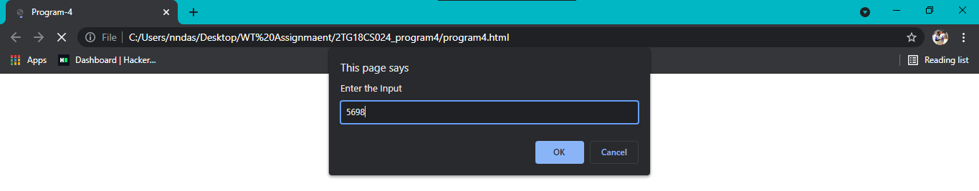

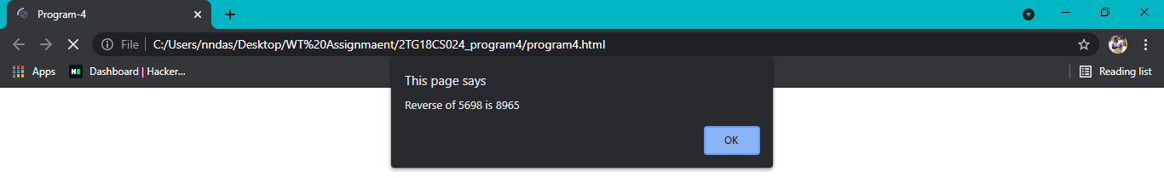

**Input as String value**

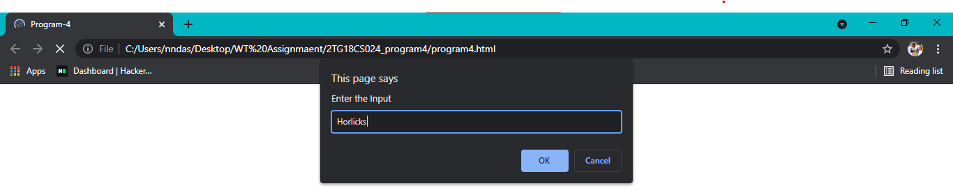

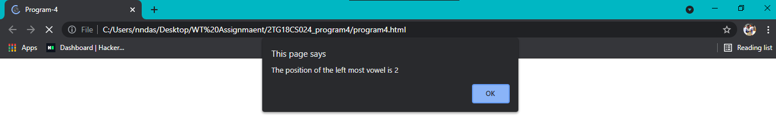

**Test cases:**

|  |  |  |  |  |
| --- | --- | --- | --- | --- |
| |  |  | | --- | --- | | **Test** **No**. |  | | Input Parameters | Obtained  Output |
| 1. | Integer Value:    Text Value: | **Integer Value:**      **Text Value:** |
| 2. | Negative Integer value:  Text Value: | **Negative Integer value:**      **Text Value:** |
| 3. | Integer Value:  Alpha numerical value: | **Integer Value:**      **Alpha numerical value:** |
| 4. | Integer Value:  Non vowel string: | **Integer Value:**      **Non vowel string:** |
| 5. | Floating point value:  Special characters value: | **Floating point value:**      **Special characters value:** |

***Challenge4.html***

<!DOCTYPE HTML>

<html>

<head>

    <title>challenge-4</title>

</head>

<body>

    <script type="text/javascript">

        var str = prompt("Enter the Input", "");

        if (!(isNaN(str))) //isNaN means is Not a Number

        {

            var num, rev = 0, remainder, product;

            num = parseInt(str);

            while (num != 0) {

                remainder = num % 10;

                num = parseInt(num / 10);

                rev = rev * 10 + remainder;

            }

            product = parseInt(str) * rev;

            alert("Reverse of " + str + " is " + rev + "and their product is : " + product);

        }

        else {

            str = str.toUpperCase();

            count =0;

            for (var i = 0; i < str.length; i++) //0,1,2,3

            {

                var chr = str.charAt(i);

                if (chr == 'A' || chr == 'E' || chr == 'I' || chr == 'O' || chr == 'U')

                {

                    count++;

                }

            }

            if (count>0)

                alert("The given string :" + str + " has " + count + " number of vowels.");

            else

                alert("No vowel found in the entered string");

        }

    </script>

</body>

</html>

**Output:**

**Input as Integer value**

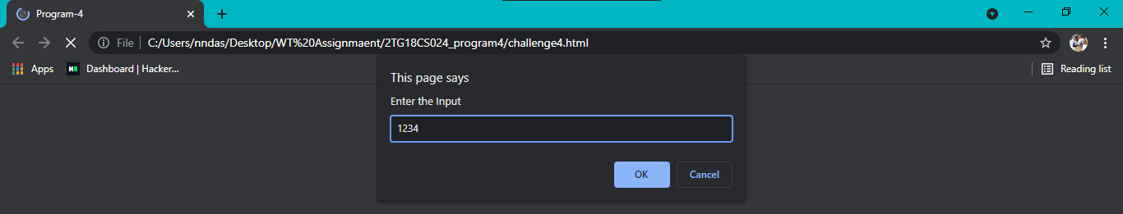

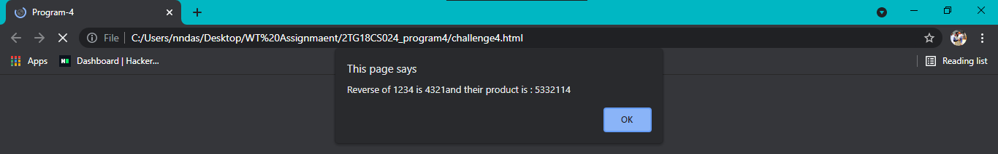

**Input as String value**

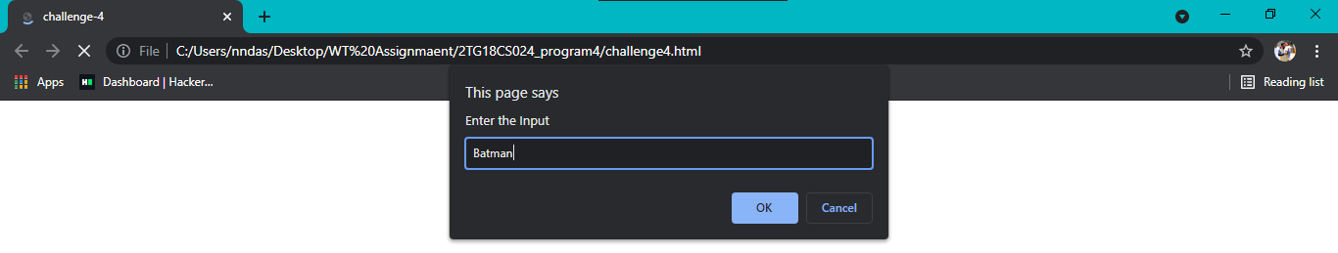

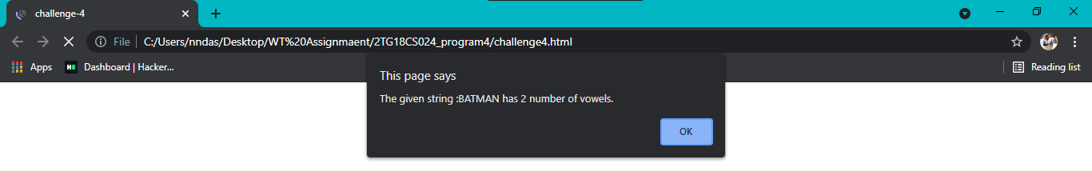

**Test cases:**

|  |  |  |  |  |
| --- | --- | --- | --- | --- |
| |  |  | | --- | --- | | **Test** **No**. |  | | Input Parameters | Obtained  Output |
| 1. | Integer Value:    Text Value: | **Integer Value:**      **Text Value:** |
| 2. | Negative Integer value:  Text Value: | **Negative Integer value:**      **Text Value:** |
| 3. | Integer Value:  Alpha numerical value: | **Integer Value:**      **Alpha numerical value:** |
| 4. | Integer Value:  Non vowel string: | **Integer Value:**      **Non vowel string:** |
| 5. | Floating point value:  Special characters value: | **Floating point value:**      **Special characters value:** |
| 6. | Arithmetic expression value:  Polynomial equation value: | **Arithmetic expression value:**      **polynomial equation value:** |