**Assignment-2**

**Write a JavaScript that calculates the squares and cubes of the numbers from 0 to 10 and outputs HTML text that displays the resulting values in an HTML table format.**

***Program2.html***

<!DOCTYPE html>

<html>

<head>

    <title>Squares and Cubes</title>

</head>

<body>

    <table border="1" align="center">

        <tr>

            <td>Number</td>

            <td>SQUARE</td>

            <td>CUBES</td>

        </tr>

        <script type="text/javascript">

            for (var i = 0; i <= 10; i++) {

                document.write("<tr align='center'><td>" + i + "</td><td>" + i * i

                    + "</td><td>" + i * i * i + "</td></tr>")

            }

        </script>

    </table>

</body>

</html>

**Output:**

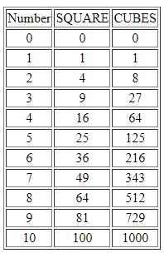

**Test cases:**

|  |  |  |  |  |
| --- | --- | --- | --- | --- |
| |  |  | | --- | --- | | **Test** **No**. |  | | Input Parameters | Obtained  Output |
| 1. | i=0 to 10, increment of i+1 |  |
| 2. | i=10 to 100, increment of i+10 |  |
| 3. | i=100 to 1000,  increment of i+100 |  |

***Challenge2.html***

<!DOCTYPE html>

<html>

<head>

    <title>Squares and Cubes</title>

    <style>

        pre {

            font-size: 15px;

        }

        table {

            border-collapse: collapse;

            background-color: #06b8af;

            margin: auto;

        }

        table,

        td,

        th {

            border: 1px solid black;

        }

        h2 {

            text-align: center;

            color: blue;

        }

        #blinking {

            Animation: blinkingText 1.5s infinite;

        }

        @Keyframes blinkingText {

            0% {

                opacity: 100%;

            }

            25% {

                opacity: 0%;

            }

            50% {

                opacity: 100%;

            }

            75% {

                opacity: 0%;

            }

            100% {

                opacity: 100%;

            }

        }

    </style>

</head>

<body>

    <table>

        <tr>

            <td colspan="3">

                <pre> NUMBERS FROM 0 TO 10 WITH THEIR SQUARE AND

                    CUBES</pre>

            </td>

        </tr>

        <script type="text/javascript">

            for (var i = 1; i <= 10; i++) {

                document.write("<tr align='center'><td>" + i + "</td><td>" + i * i

                    + "</td><td>" + i * i * i + "</td></tr>")

            }

        </script>

    </table>

    <h2 id='blinking'>Assignmen-2 Challenge Completed</h2>

</body>

</html>

**Output:**

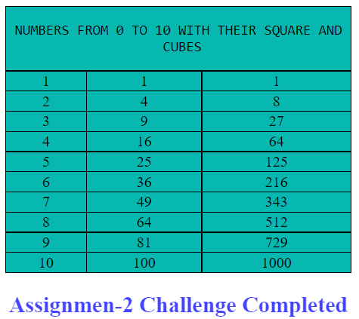 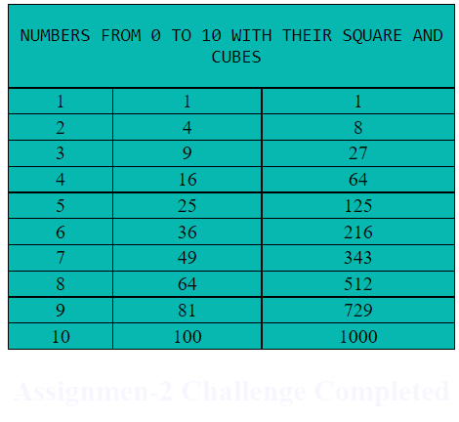

Blinking Text

**Test cases:**

|  |  |  |  |  |
| --- | --- | --- | --- | --- |
| |  |  | | --- | --- | | **Test** **No**. |  | | Input Parameters | Obtained  Output |
| 1. | i=0 to 10, increment of i+1 |  |
| 2. | i=10 to 100, increment of i+10 |  |
| 3. | i=100 to 1000,  increment of i+100 |  |