**Assignment-5**

**Design an XML document to store information about a student in an engineering college affiliated to VTU. The information must include USN, Name, and Name of the College, Program, Year of Joining, and email id. Make up sample data for 3 students. Create a CSS style sheet and use it to display the document.**

***Prog5.xml***

<?xml-stylesheet type="text/css" href="prog5.css"?>

<!DOCTYPE HTML>

<html>

    <head>

        <h1> STUDENTS DESCRIPTION </h1>

    </head>

    <students>

        <student>

            <USN>ID : 1JT21IS001</USN>

            <name>Name : AJAY</name>

            <college>COLLEGE : JIT</college>

            <branch>BRANCH : Information Science and Engineering</branch>

            <year>YEAR : 2021</year>

            <e-mail>E-Mail : ajay@gmail.com</e-mail>

        </student>

        <student>

            <USN>USN : 1JT21IS034 </USN>

            <name>NAME : Ramya </name>

            <college>COLLEGE : JIT</college>

            <branch>BRANCH : Information Science and Engineering</branch>

            <year>YEAR : 2021</year>

            <e-mail>E-Mail : ramya@gmail.com</e-mail>

        </student>

        <student>

            <USN>USN : 1JT21IS055</USN>

            <name>NAME :Thanu</name>

            <college>COLLEGE : JIT</college>

            <branch>BRANCH : Information Science and Engineering</branch>

            <year>YEAR : 2021</year>

            <e-mail>E-Mail : tanu@gmail.com</e-mail>

        </student>

    </students>

</html>

***Prog5.css***

student {

        display: block;

        margin-top: 10px;

        color: Navy;

    }

USN {

        display: block;

        margin-left: 10px;

        font-size: 14pt;

        color: Red;

    }

name {

        display: block;

        margin-left: 20px;

        font-size: 14pt;

        color: Blue;

    }

college {

        display: block;

        margin-left: 20px;

        font-size: 12pt;

        color: Maroon;

    }

branch {

        display: block;

        margin-left: 20px;

        font-size: 12pt;

        color: Purple;

    }

year {

        display: block;

        margin-left: 20px;

        font-size: 14pt;

        color: Green;

    }

e-mail {

        display: block;

        margin-left: 20px;

        font-size: 12pt;

        color: Blue;

    }

**Output:**

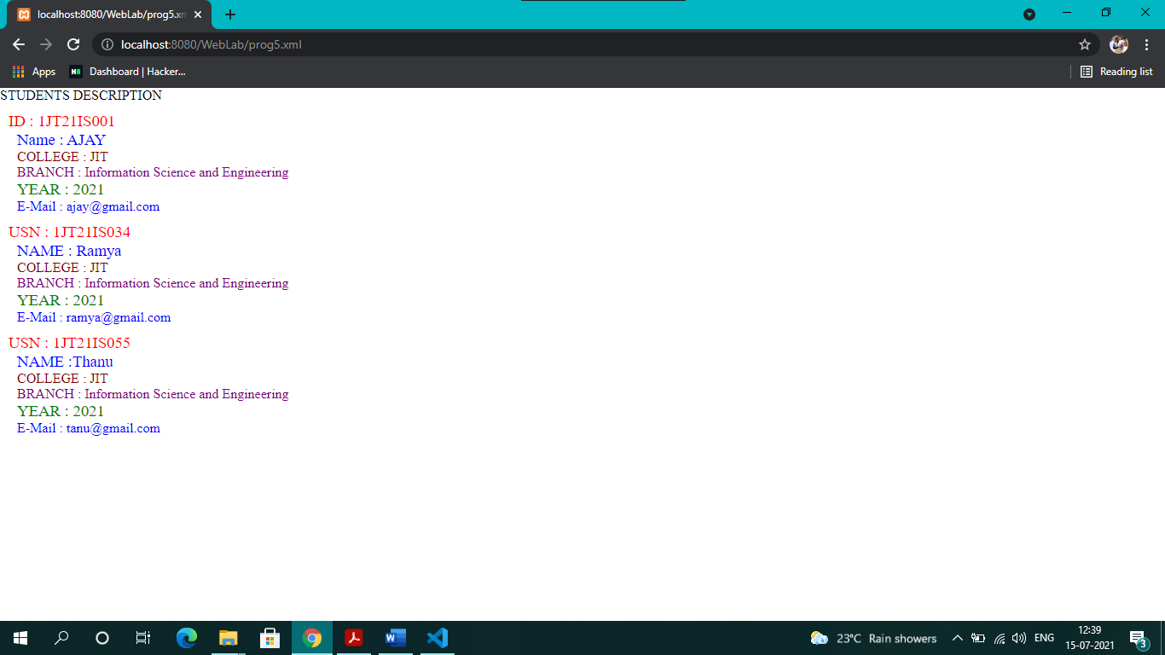

***Prog5_a.xml***

<?xml-stylesheet type="text/css" href="prog5_a.css"?>

<!DOCTYPE HTML>

<html>

    <head>

        <h1> STUDENTS DESCRIPTION </h1>

    </head>

    <students>

        <student>

            <USN>USN: 2TG18CS024</USN>

            <name>Name : Naveen Dasapalli</name>

            <college>COLLEGE : TCE Gadag</college>

            <branch>BRANCH : Computer Science and Engineering</branch>

            <year>YEAR : 2018</year>

            <e-mail>E-Mail : naveen@gmail.com</e-mail>

        </student>

        <student>

            <USN>USN : 3MT21IS999 </USN>

            <name>NAME : Rony </name>

            <college>COLLEGE : MIT</college>

            <branch>BRANCH : Information Science and Engineering</branch>

            <year>YEAR : 2021</year>

            <e-mail>E-Mail : rony@gmail.com</e-mail>

        </student>

        <student>

            <USN>USN : 5RV21IS777</USN>

            <name>NAME :Boby</name>

            <college>COLLEGE : RVC</college>

            <branch>BRANCH : Information Science and Engineering</branch>

            <year>YEAR : 2021</year>

            <e-mail>E-Mail : boby@gmail.com</e-mail>

        </student>

    </students>

</html>

***Prog5_a.css***

student {

        background-color: rgb(233, 219, 92);

        margin-left: 5px;

        text-align: center;

        border: 1.5px solid rgb(230, 10, 10);

        height: 100%;

        width: 50%;

        display: block;

        margin-top: 10px;

        color: Navy;

    }

USN {

        display: block;

        margin-left: 10px;

        font-size: 14pt;

        color: Red;

    }

name {

        display: block;

        margin-left: 20px;

        font-size: 14pt;

        color: Blue;

    }

college {

        display: block;

        margin-left: 20px;

        font-size: 12pt;

        color: Maroon;

    }

branch {

        display: block;

        margin-left: 20px;

        font-size: 12pt;

        color: Purple;

    }

year {

        display: block;

        margin-left: 20px;

        font-size: 14pt;

        color: Green;

    }

e-mail {

        display: block;

        margin-left: 20px;

        font-size: 12pt;

        color: Blue;

    }

    h1{

        margin-left: 5px;

    }

**Output:**

