**Assignment-7**

**Write a PHP program to display a digital clock which displays the current time of the server.**

***Prog7.php***

<!DOCTYPE HTML>

<html>

<head>

    <meta http-equiv="refresh" content="1" />

    <style>

        p {

            color: white;

            font-size: 90px;

            position: absolute;

            top: 50%;

            left: 50%;

            transform: translate(-50%, -50%);

        }

        body {

            background-color: black;

        }

    </style>

    <p><?php echo date(" h: i: s A"); ?></p>

</head>

</html>

**Output:**

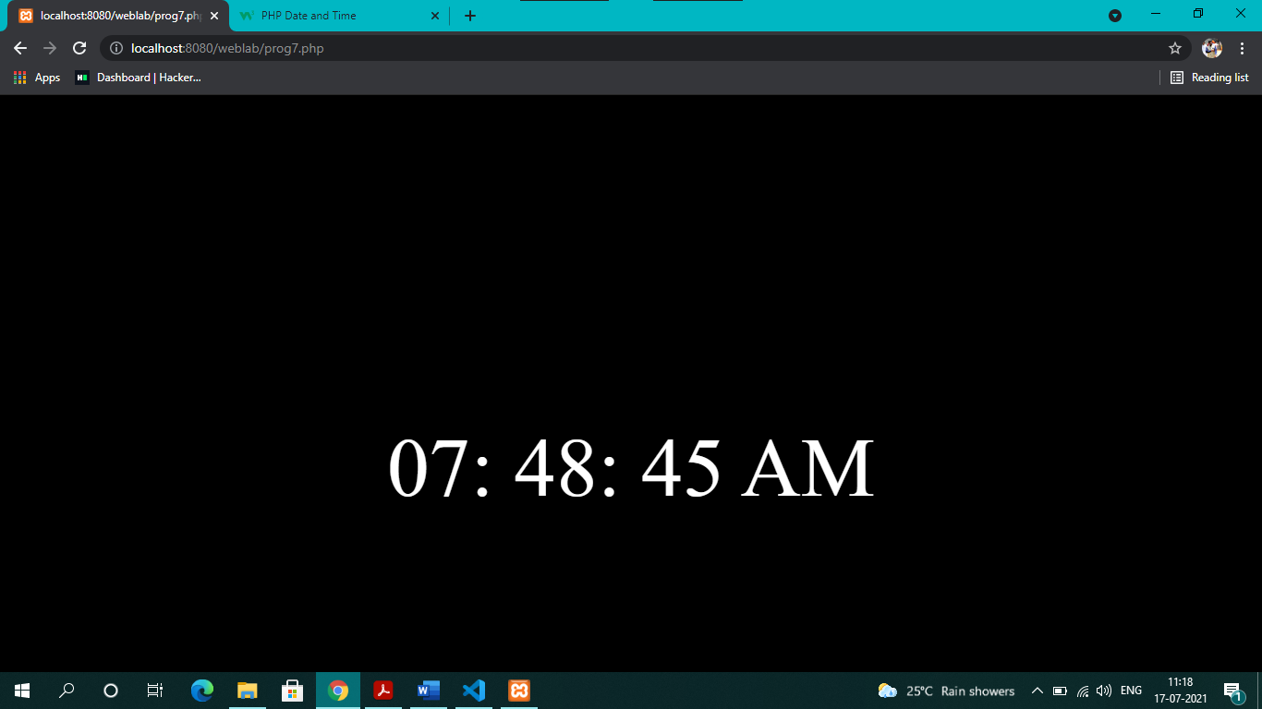

***Prog7_a.php***

<!DOCTYPE HTML>

<html>

<head>

    <meta http-equiv="refresh" content="1" />

    <style>

        p {

            border: 5px solid black;

            border-radius: 15px;

            padding: 25px 25px 25px 25px;

            font-size: 50px;

            position: absolute;

            top: 50%;

            left: 50%;

            transform: translate(-50%, -50%);

        }

        body {

            background-color: blue;

        }

    </style>

</head>

<body>

    <p>server time is <?php echo date(" h: i: s A"); ?> <br>

        Today is <?php echo date(" y/m/d"); ?> <br>

        Today is <?php echo date(" y.m.d"); ?> <br>

        Today is <?php echo date(" y-m-d"); ?> <br>

        Today is <?php echo date("l"); ?>

    </p>

</body>

</html>

**Output:**

