**IOT Based Smart Home –Software Requirements Specification**

**Version 10.0**

**Prepared by,**

Anju. V (1JT13CS009)

Deepthi Das V (1JT13CS017)

Kavya.R (1JT13CS021)

Vidya. G (1JT13CS052)

**Contents**

Description

Architecture

Product Functions System Decomposition View

Functional Requirements Views

Primary List of Functional Requirements

Requirement 1: Sign up Form

1.1: Installation of app

1.2: Details of user.

1.3: Network availability.

Requirement 2: Login Page

2.1: Text box.

2.2: Validation.

2.3: Submit button

2.4: Forgot password

Requirement 3: Light Module

3.1: Light on button

3.2: Light off button

Requirement 4: Fan Module

4.1: Fan on

4.2: speed control

4.3: Fan off

Requirement 5: Camera Module

5.1: Camera on

5.2: To record in the dark room.

5.3: Audio recording.

Requirement 6: Door Locking

6.1: Door lock

6.2: Door unlock

Requirement 7: Update and Share

7.1: Report

7.2: Update

7.3: Share

Non-Functional Requirements Views

1.1: Availability

1.2: Security

1.3: Upgradability

Architecture

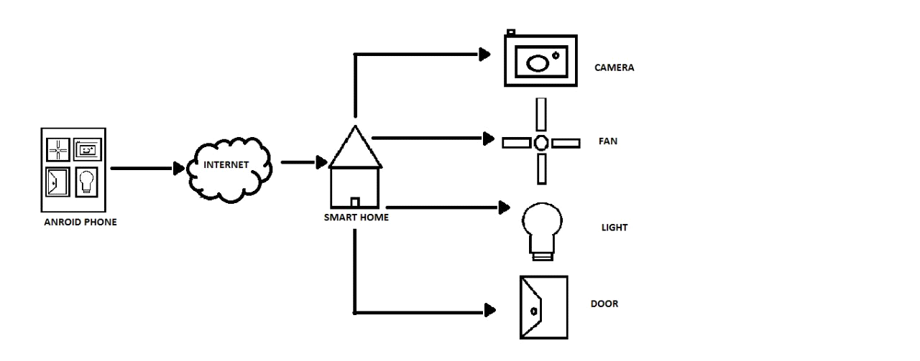

Product Functions System Decomposition View

Preliminary functional components of the product are as follows :

Screen 1: Application Opening

Screen 2: Home Screen with GUI Elements

Screen 3: List of requirements

Screen 4: Selection of requirements

Screen 5: Selection of requirements

**Functional Requirements Views**

**Primary List of Functional Requirements**

Requirement 1: Sign up form

1.1: Installation of app:

* The user get a sign-up form.

1.2: Details of user:

* This collects the details of the user like name, email-id and mobile number.

1.3: Network availability:

* The internet connection should be available to use the application.

Requirement 2: Login page

2.1: Text box:

* The user gets a text box to enter user name.
* The user has to enter password which has special characters and capital letters.

2.2: Validation:

* The password is verified and validated.

2.3: Submit button:

* This page will have a submit button.

2.4: Forgot password:

* It will display a message “*forgot password*” to help the user in case he has forgotten the password by sending a mail to the email-id given immediately.

Requirement 3: Light Module

3.1: light on button:

• This icon will have a button to turn on light.

3.2: light of button:

• This icon will have a button to turn off light.

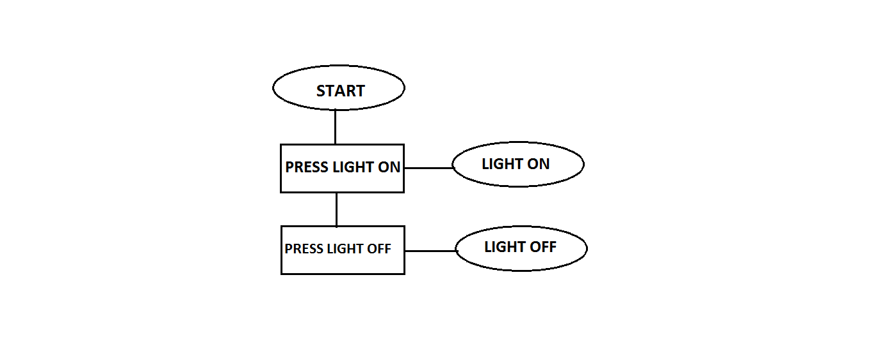

Sequence Diagram

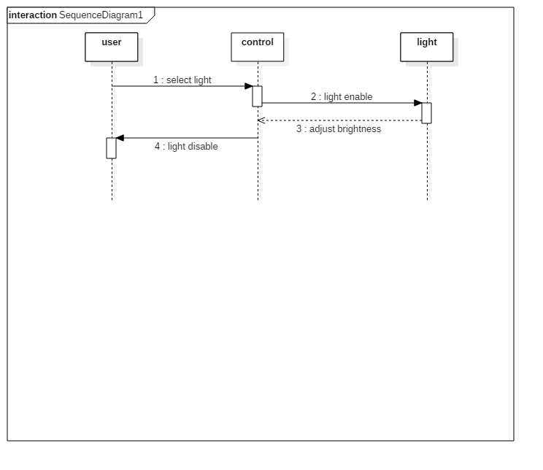

Use case Diagram

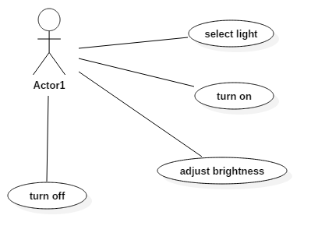

Requirement 4: Fan Module

4.1: Enable/Disable of Fan

* Click on enable which allows the fan to on
* Click on disable which disables the fan to off

4.2: fan to be enabled

* Living room
* Bed room

4.3: Speed of the Fan

* Low speed
* Moderate speed
* High speed

Data flow Diagram

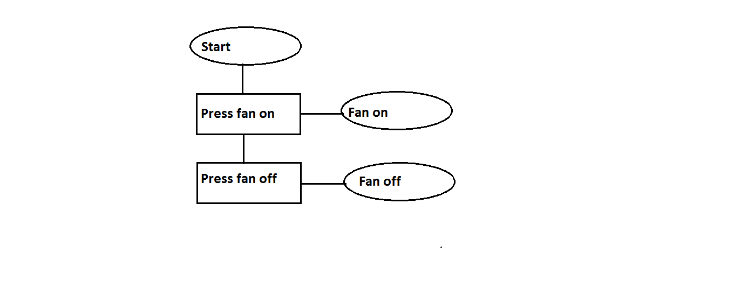

Sequence Diagram

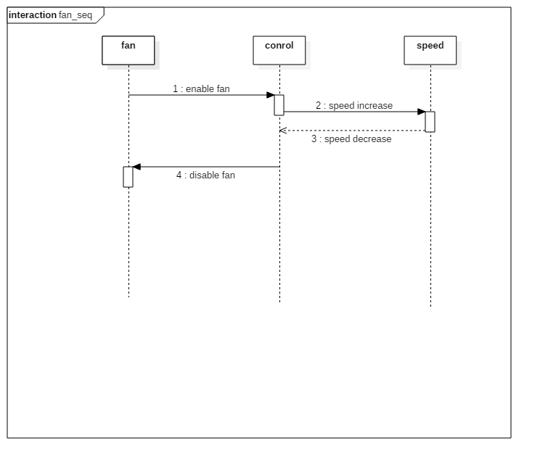

Use Case Diagram

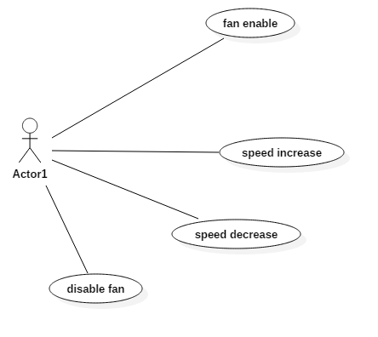

Requirement 5: Door locking

5.1: Door lock

• The button which locks the door

5.2: Door unlock

• The button which unlocks the door.

Data flow Diagram

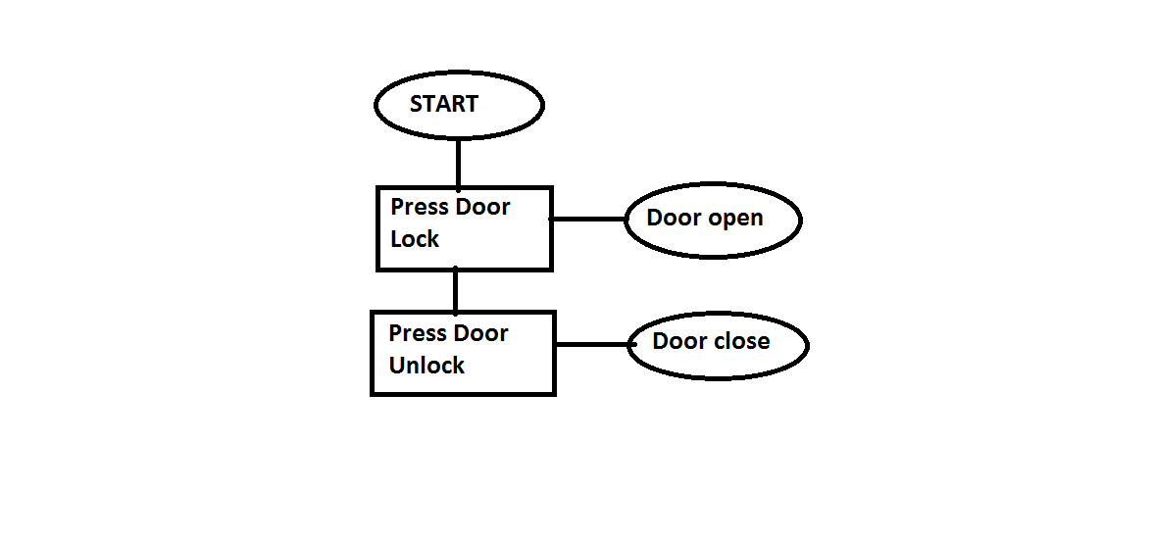

Sequence Diagram

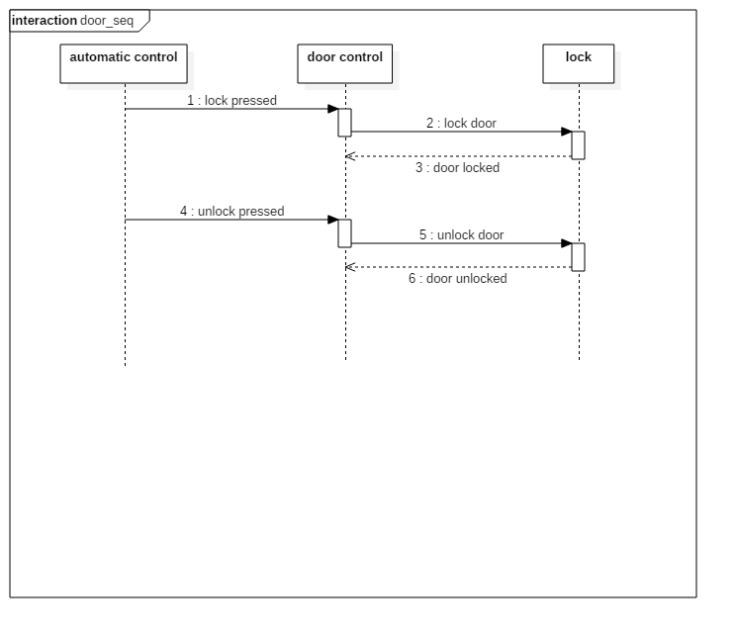

Use case Diagram

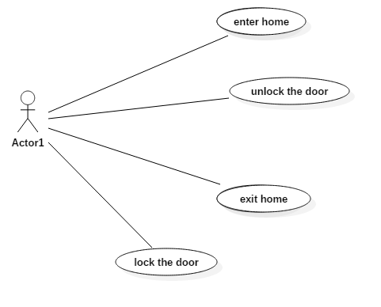

Requirement 6: Camera Detection

6.1: Enable/disable of camera

* Click on enable which allows the camera to record.
* And disable to stop the process.

6.2: Camera to be enabled.

* Front Door.
* Back Door.
* Living Room.
* Locker Room.
* All region.

6.3: Angle of the camera.

* Fixed.
* 360 degree.
* 180 degree.

6.4: To record in the dark room.

* Enable night mode.

6.4: Audio recording.

* On
* Off

Data flow diagram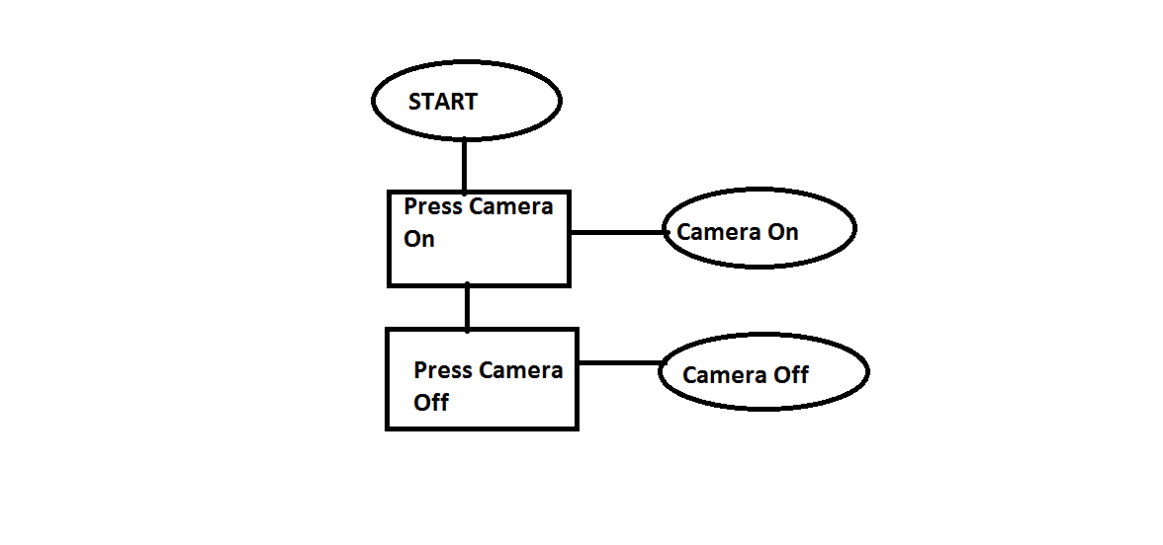

Sequence Diagram

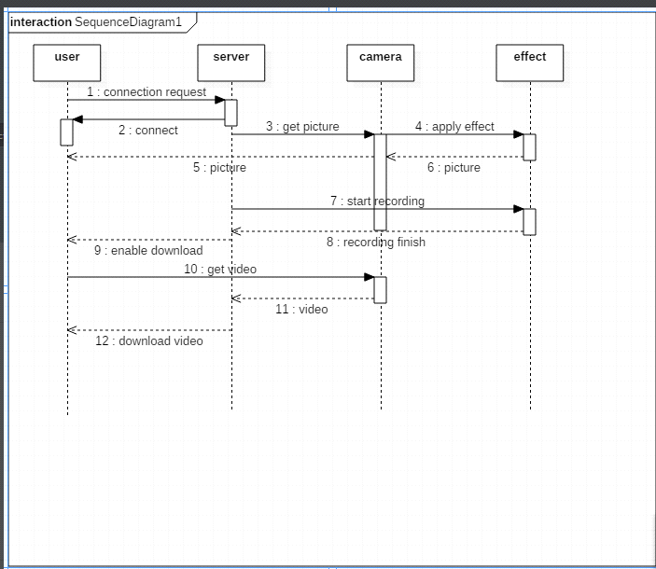

Use case Diagram

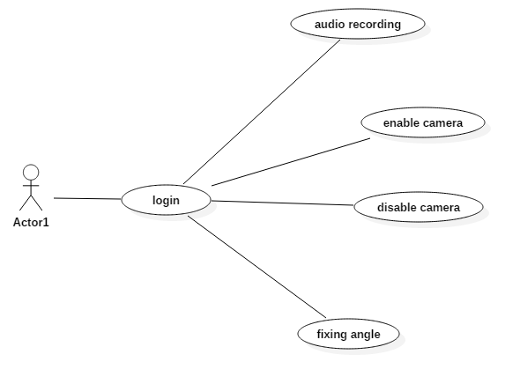

Requirement 7: update and share

7.1: Problem report

• App has an option where the user can report their problems through e-mail.

3.2: Update

• This helps the developer check and provide updated version to the user.

3.2: Share

• The app can be shared.

**Non-Functional Requirement**

The application runs only if the user is online, we do not provide offline operation.

The user has to keep his internet connection on when he wants to use the requirements.

1.1: Availability

The application is available for use after installation. A single installation package allows the user to install the application. After the installation is done, the user must register by providing his/her name, email-id and contact number. After the registration is done, the user can use this application whenever he wants.

1.2: Security

The security issues which might occur are:

* Duplicate accounts
* Redundancy

1.3: Upgradability

* This application can be updated which extra features as per user requirements