NAME: P. KAVYA SAI
ROLL NUMBER : 2420030322
Experiment 1: Case Study
Problem Statement: Choose a real-world case study on KL ERP System, create user stories, select an appropriate software development process model, identify a suitable programming language, and propose an implementation and evaluation strategy.
Real-World case study a KL ERP System
1. Functional Requirements
Customer
- Register and login
- Search products
- View product details
- Add products to cart
- Place orders
- Make online payments
- Track order status
- View purchase history
- Submit product reviews
Admin
- Manage products
- Manage categories
- Update inventory
- View customer details
- Process orders
- Generate sales reports

2. User Stories
USER ID | User Story | Priority
FA-01 | As a faculty member, I want to view and manage my teaching timetable so that I can plan classes effectively. | High 8
FA-02 | As a faculty member, I want to upload assignments and grade them online so that students receive timely feedback. | High 6
FA-03 | As a faculty member, I want to send announcements or messages to my class so that students stay informed. | High
FA-04 | As a faculty member, I want to record attendance so that student attendance can be tracked accurately. | High
FA-05 | As a faculty member, I want to enter internal and examination marks so that the student can view their academic pereformance | Medium3
FA-06 | As a faculty member, I want to upload course materials so that students can access learning resources. | High8
FA-07 | As a faculty member, I want to post assignments so the students know their academic tasks. | High6
Administrator User Stories
User ID | User Story | Priority
AUS-01 | As an administrator, I want to generate and manage institutional timetables so that classes are scheduled without conflicts. | High
AUS-02 | As an administrator, I want to oversee fee collection and financial records so that institutional accounts remain accurate. | High
AUS-03 | As an administrator, I want to schedule examinations and publish results so that academic processes run smoothly. | High
AUS-04 | As an administrator, I want to manage user roles and permissions so that system security is maintained. | High
AUS-05 | As an administrator, I want to manage student records so that all student information remains updated. | High
AUS-06 | As an administrator, I want to generate reports so that institutional performance can be monitored | High
AUS-07 | As an administrator, I want to assign faculty members to course so that teaching responsibilities are organized. | Medium

3. Selected Software Development Process Model
Agile Scrum
Reason for Selection
- Requirements change frequently across departments.
- Continuous feedback from students, faculty, and administrators.
- Incremental delivery of ERP modules.
- Faster development cycles with sprint reviews.
- Easy bug fixing and adaptability.
- Well-suited for web-based academic applications.

Sprint Plan
Sprint | Features
Sprint 1 | User Registration & Login
Sprint 2 | Course Registration Module
Sprint 3
  Attendance Tracking (Faculty entry + Student view)
Sprint 4 | Examination Management (marks entry, results publishing)
Sprint 5 | Payment Gateway
Sprint 6 | Timetable Scheduling & Faculty Assignment
Sprint 7 | Reports & Admin Dashboard
Sprint 8 | Testing (Unit, Integration, UAT) & Deployment
Sprint 9 | Maintenance & Continuous Improvement

4. Programming Language Selection
Backend
- Java (Spring Boot)
Reasons
- Secure
- Scalable
- Enterprise-level applications
- REST API support
- Excellent database connectivity
Frontend
- HTML5
- CSS3
- JavaScript
- React.js

Database
- MySQL
Other Technologies
- REST API
- JWT Authentication
- Stripe/Razorpay Payment Gateway
- Git
- Docker
- AWS Cloud

5. System Architecture

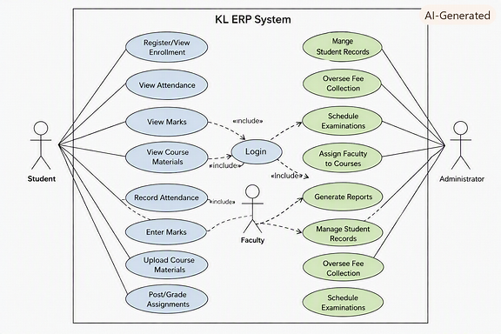

Phase 1 – Requirement Analysis
- Gather requirements from students, faculty, and administrators.
- Create the Software Requirement Specification (SRS) document.
- Prepare use case diagrams for each module (Student, Faculty, Admin).
Phase 2 – System Design
- Design database schema for student, course, attendance, exam, and fee modules.
- Create UI wireframes for dashboards and forms.
- Develop UML diagrams (class, sequence, activity).
- Define system architecture using Spring Boot + React + MySQL.
Phase 3 – Development
- Implement user authentication and role-based access control.
- Develop course registration and timetable modules.
- Build attendance and examination management features.
- Integrate online fee payment and report generation.
- Create admin dashboard for institutional monitoring.
Phase 4 – Testing
Unit Testing
- Login
- Registration
- Course registration
- Attendance tracking
Integration Testing
- Attendance + Marks entry
- Fee payment + Reports
System Testing
- End-to-end ERP workflow validation
User Acceptance Testing (UAT)
- Verify academic and administrative requirements with real users.
Phase 5 – Deployment
- Deploy using Docker containers.
- Host on AWS EC2 for scalability.
- Use MySQL database for persistent storage.
- Configure Nginx web server for load balancing and security.
7. Evaluation Strategy
Evaluation Parameter | Method
Functional Accuracy | Requirement verification and module validation
Performance | Load testing using JMeter
Security | Authentication, authorization, and penetration testing
Reliability | Continuous monitoring and backup validation
Usability | User feedback from students, faculty, and admin
Scalability | Concurrent user testing under peak load
Maintainability | Code review, documentation, and version control (GitHub)
10. Expected Outcomes
- Centralized academic and administrative management.
- Secure and scalable ERP platform.
- Faster course registration and result processing.
- Reduced manual workload and paperwork.
- Improved communication among students, faculty, and administrators.
- Reliable data storage and reporting.
- Continuous enhancement through Agile iterations.

