NAME: P. KAVYA SAI
ROLL NUMBER : 2420030322
Experiment 1: Case Study
Problem Statement: Choose a real-world case study on an E-Commerce System, create user stories, select an appropriate software development process model, identify a suitable programming language, and propose an implementation and evaluation strategy.
Real-World case study: A Multi-Vendor E-Commerce System
1. Functional Requirements
Customer
- Register and login
- Search and filter products
- View product details
- Add products to cart and wishlist
- Place orders
- Make online payments
- Track order status
- View purchase history
- Submit product reviews and ratings
Seller / Vendor
- Register and login as a seller
- Add/list new products
- Update product details and prices
- Remove or deactivate products
- Update product stock and availability
- View orders containing their products
- Update order/fulfillment status
- View sales and revenue reports
Admin
- Manage products
- Manage categories
- Update inventory
- View customer details
- Process and manage orders
- Manage discounts and offers
- Generate sales reports
2. User Stories
Customer User Stories
USER ID | User Story | Priority
CU-01 | As a customer, I want to register and login so that I can securely access my account. | High
CU-02 | As a customer, I want to search and filter products so that I can quickly find the items I need. | High
CU-03 | As a customer, I want to view product details so that I can make an informed purchase decision. | High
CU-04 | As a customer, I want to add products to my cart so that I can purchase multiple items together. | High
CU-05 | As a customer, I want to make online payments so that I can complete my order conveniently. | High
CU-06 | As a customer, I want to track my order so that I know its current delivery status. | High
CU-07 | As a customer, I want to view my purchase history so that I can review previous orders. | Medium
CU-08 | As a customer, I want to submit product reviews and ratings so that I can share my experience with other customers. | Medium
USER ID | User Story | Priority
SU-01 | As a seller, I want to register and login so that I can securely manage my products. | High
SU-02 | As a seller, I want to add products so that customers can purchase them from the platform. | High
SU-03 | As a seller, I want to update product details and prices so that the catalog remains accurate. | High
SU-04 | As a seller, I want to update product stock so that customers can see product availability. | High
SU-05 | As a seller, I want to view orders for my products so that I can process them efficiently. | High
SU-06 | As a seller, I want to update order status so that customers can track their orders. | High
SU-07 | As a seller, I want to view sales reports so that I can monitor my business performance. | Medium
Seller / Vendor User Stories
Administrator User Stories
USER ID | User Story | Priority
AUS-01 | As an administrator, I want to manage products so that the online catalog remains accurate. | High
AUS-02 | As an administrator, I want to manage categories so that products are organized properly. | High
AUS-03 | As an administrator, I want to update inventory so that product availability is maintained accurately. | High
AUS-04 | As an administrator, I want to process customer orders so that purchases are fulfilled on time. | High
AUS-05 | As an administrator, I want to manage users and permissions so that system security is maintained. | High
AUS-06 | As an administrator, I want to generate sales reports so that business performance can be monitored. | High
AUS-07 | As an administrator, I want to manage discounts and offers so that promotional campaigns can be controlled. | Medium
3. Selected Software Development Process Model
Agile Scrum
Reason for Selection
- E-commerce requirements change frequently based on customer and business needs.
- Continuous feedback can be obtained from customers, administrators, and business stakeholders.
- Modules can be delivered incrementally through short sprints.
- Faster development cycles with regular sprint reviews.
- Easy bug fixing and adaptability to changing market requirements.
- Well-suited for web-based and mobile-friendly e-commerce applications.
Sprint Plan
Sprint | Features
Sprint 1 | Customer, Seller & Admin Registration/Login
Sprint 2 | Product Catalog, Categories & Seller Product Listing
Sprint 3 | Product Search, Shopping Cart & Wishlist
Sprint 4 | Order Management, Seller Order View & Checkout
Sprint 5 | Payment Gateway & Seller Sales/Revenue Tracking
Sprint 6 | Order Tracking, Seller Fulfillment & Customer Reviews
Sprint 7 | Admin Dashboard, Inventory, Seller Management & Sales Reports
Sprint 8 | Testing (Unit, Integration, UAT) & Deployment
Sprint 9 | Maintenance & Continuous Improvement
4. Programming Language Selection
Backend
- Java (Spring Boot)
Reasons
- Secure
- Scalable
- Suitable for enterprise-level applications
- REST API support
- Excellent database connectivity
- Strong support for transaction management
Frontend
- HTML5
- CSS3
- JavaScript
- React.js
Database
- MySQL
Other Technologies
- REST API
- JWT Authentication
- Stripe/Razorpay Payment Gateway
- Git
- Docker
- AWS Cloud
Multi-Vendor Features
- Seller-specific dashboard and role-based access
- Seller product and inventory management
- Seller order fulfillment and sales tracking
- Admin approval and monitoring of seller accounts/products
5. System Architecture
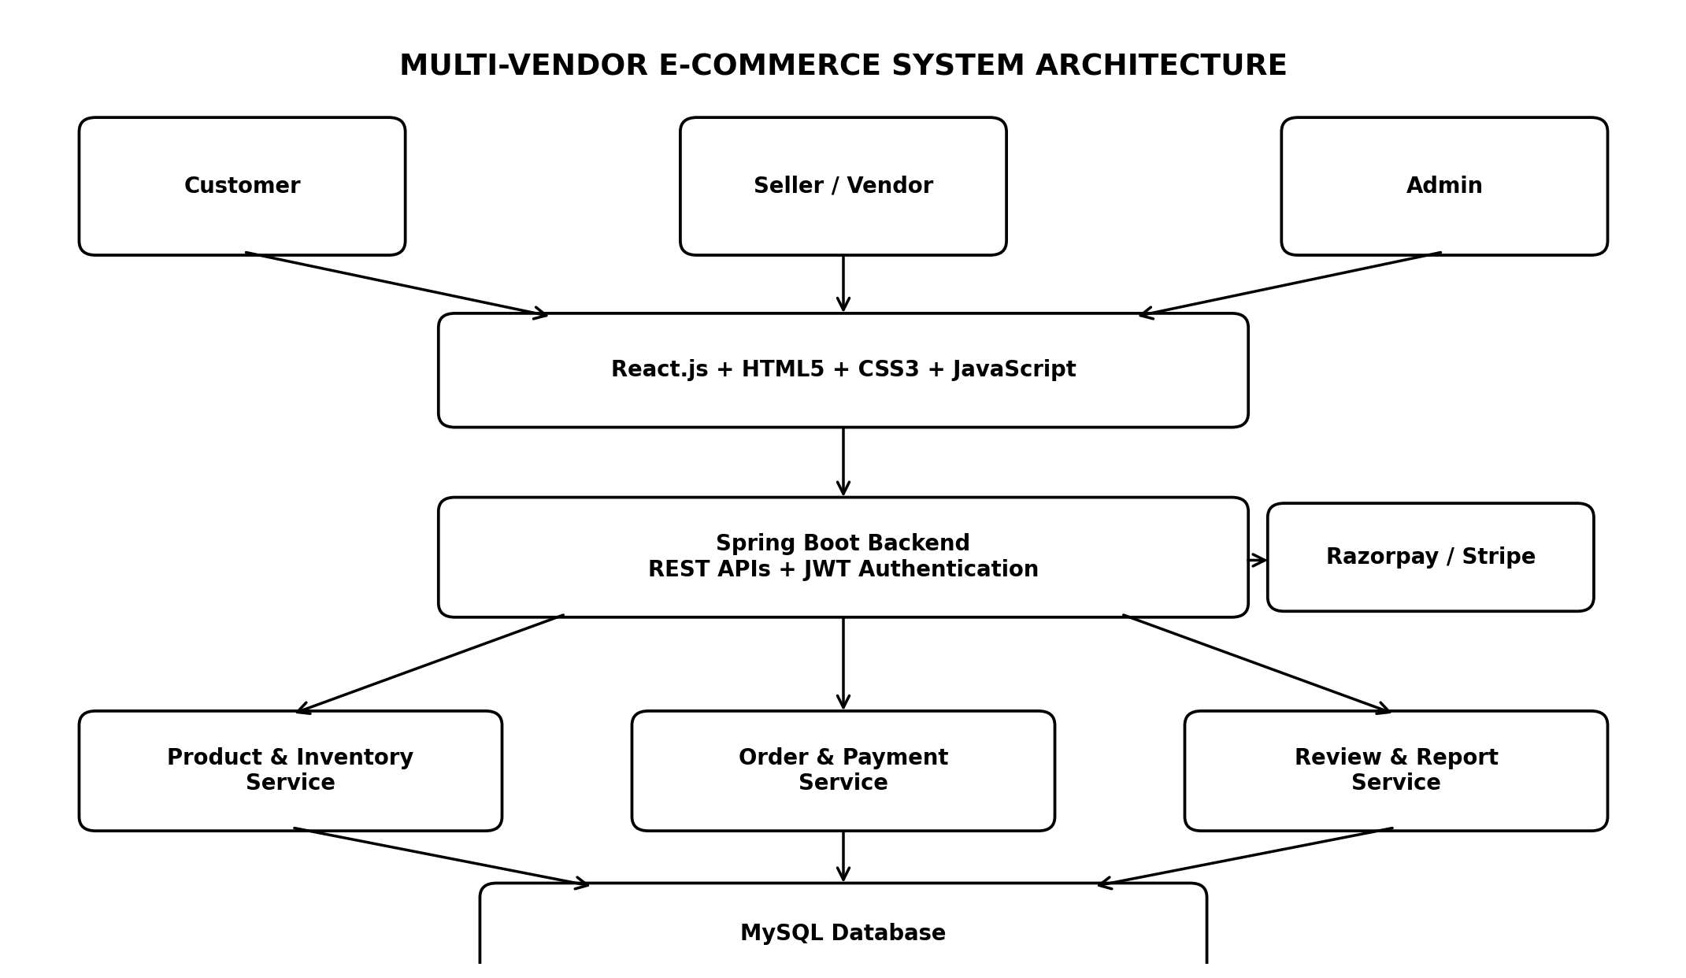
Figure 1: Multi-Vendor E-Commerce System Architecture
Architecture Explanation: Customers, sellers/vendors, and administrators access the React-based frontend. The Spring Boot backend provides REST APIs and JWT-based authentication. Separate services handle products and inventory, orders and payments, and reviews and reports. MySQL provides persistent storage, while Razorpay/Stripe is used for online payments.
Phase 1 – Requirement Analysis
- Define separate functional and access requirements for Customer, Seller, and Admin roles.
- Gather requirements from customers, sellers/vendors, and administrators.
- Gather requirements from customers, administrators, and business stakeholders.
- Create the Software Requirement Specification (SRS) document.
- Prepare use case diagrams for Customer and Admin modules.
Phase 2 – System Design
- Design database schema for sellers, products, inventory, orders, payments, and reviews.
- Design separate dashboards for customers, sellers, and administrators.
- Design database schema for users, products, categories, cart, orders, payments, and reviews.
- Create UI wireframes for product pages, cart, checkout, and admin dashboard.
- Develop UML diagrams (class, sequence, activity).
- Define system architecture using Spring Boot + React + MySQL.
Phase 3 – Development
- Implement seller registration, seller dashboard, and seller role-based access.
- Develop seller product listing, inventory, order fulfillment, and sales modules.
- Implement user authentication and role-based access control.
- Develop product catalog, search, cart, and wishlist modules.
- Build order management, checkout, and payment features.
- Integrate order tracking, reviews, and report generation.
- Create admin dashboard for product, inventory, order, and sales monitoring.
Phase 4 – Testing
- Unit Testing: Login, registration, product search, cart, and checkout.
- Integration Testing: Cart + Order placement; Payment + Order confirmation.
- System Testing: End-to-end e-commerce workflow validation.
- User Acceptance Testing (UAT): Verify customer and administrative requirements with real users.
Phase 5 – Deployment
- Verify seller workflows including product listing, inventory updates, order processing, and sales reporting.
- Deploy using Docker containers.
- Host the application on AWS EC2 for scalability.
- Use MySQL database for persistent storage.
- Configure Nginx web server for load balancing and security.
System Roles: Customer → purchases products; Seller/Vendor → lists and fulfills products; Admin → manages the marketplace and monitors all users.
7. Evaluation Strategy
Evaluation Parameter | Method
Functional Accuracy | Requirement verification and module validation
Performance | Load testing using JMeter
Security | Authentication, authorization, and penetration testing
Reliability | Continuous monitoring and backup validation
Usability | User feedback from customers and administrators
Scalability | Concurrent user testing under peak load
Maintainability | Code review, documentation, and version control (GitHub)
Seller Functionality | Validation of product listing, inventory, order fulfillment, and seller reporting
10. Expected Outcomes
- Dedicated seller portal for managing products, stock, orders, and sales.
- Better coordination between customers, sellers, and administrators.
- Centralized product, order, inventory, and customer management.
- Secure and scalable e-commerce platform.
- Faster product search, checkout, and order processing.
- Reduced manual workload for administrators.
- Improved customer shopping experience.
- Reliable payment, data storage, and sales reporting.
- Continuous enhancement through Agile iterations.

